HANOI UNIVERSITY OF SCIENCE AND TECHNOLOGY

School of Information and Communications Technology

Software Requirement Specification

Version 1.1

An Internet Media Store

Capstone Project

Subject: Software Design and Construction

Function : Manage Media

Group 21

Hoang Duc Thanh 20204689

# **Overall requirements**

## ***Actors***

The function has actor admin

## ***General use case diagram***

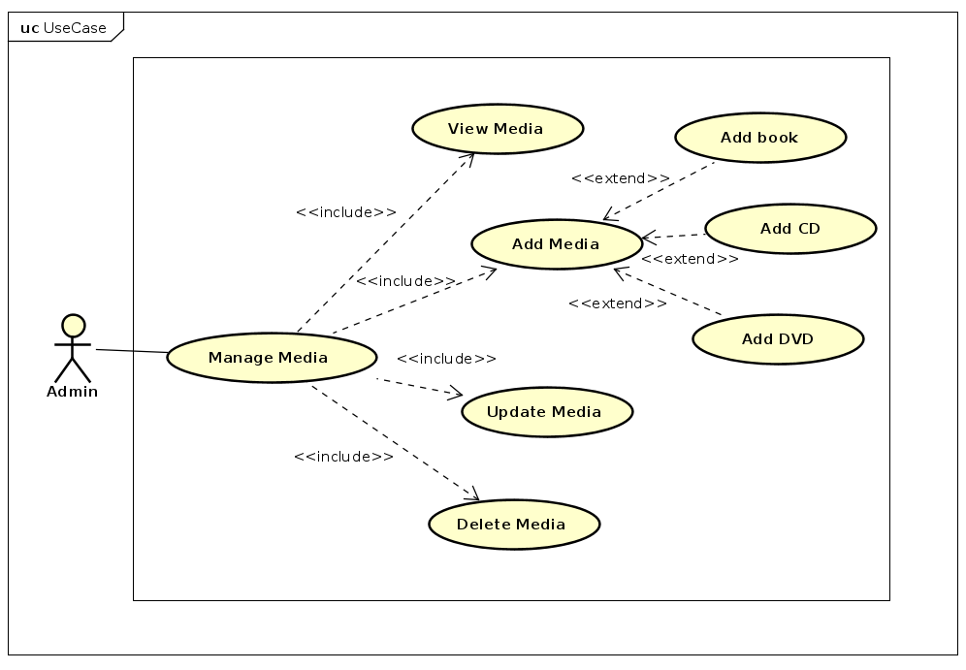

The administrator can manage media The use cases of the administrator in this overall use case diagram are complex use cases that consist of a group of sub-use cases. Details about these composite use cases are provided in the subsequent decomposition diagrams."

## ***Business processes***

### 2.4.1.Add Media Activity

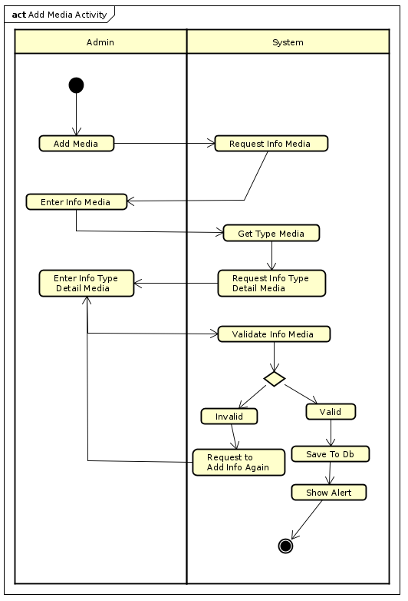

### 2.4.2.View Media Activity

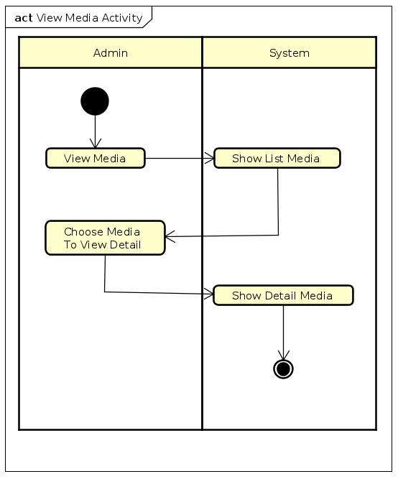

### 2.4.3.Update Media Activity

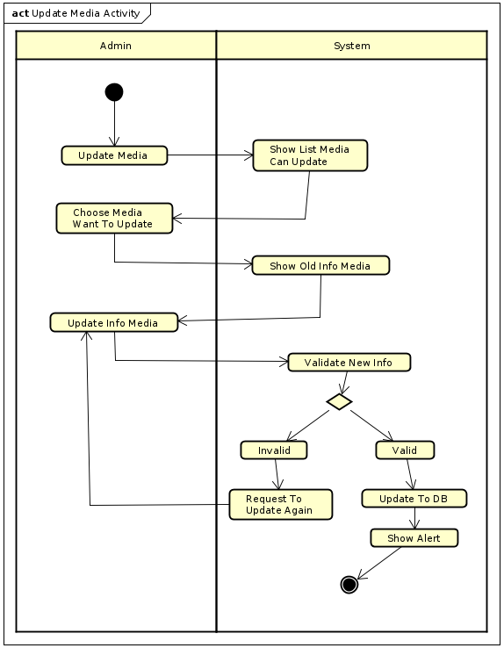

### 2.4.4.Delete Media Activity

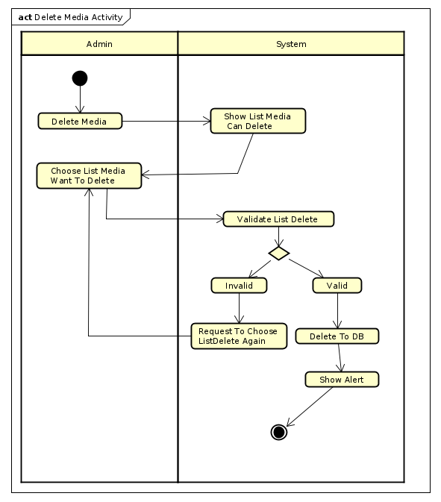

# **Detail requirements**

Details of the use cases given in the following sections are specified below.

## ***Specification of Use case UC001 - “View Media”***

1. **Use case code**

UC001

1. **Brief Description**

This use case describes the interaction between admin and system when the admin wishes to View Media

1. **Actor**

Administrators

1. **Preconditions**
2. **Basic Flow of Events**
3. The actor select view Media

2. The software displays list of Media

3. The actor select to view detail Media

4. The software displays detail of Media

1. **Alternative flows**
2. **Input data**

**No**

1. **Output data**

**Table 1 output of Info Media**

| **No** | **Data fields** | **Description** | **Display format** | **Example** |
| --- | --- | --- | --- | --- |
|  | title | Name of Media | String | Book3 |
| 2. | category |  | String | Story |
| 3. | value | market value of the product | Int with currency unit 1000 VND | 32 |
| 4. | price | tax not included | Int with currency unit 1000 VND | 150.000VND |
| 5. | quantity | quantity of Media | Int | 13 |
| 6. | type | Type Of Media | String | Book |
| 7. | image | Image Of Media | jpg,png,.. |  |

1. **Postconditions**

## ***Specification of Use case UC002 - “Add Media”***

1. **Use case code**

UC002

1. **Brief Description**

This use case describes the interaction between admin and system when the admin wishes to Add New Media

1. **Actors**

Admin

1. **Preconditions**
2. **Basic Flow of Events**

1.Admin select Add Media function

2.System display form to input Info Media

3.Admin Input Info Media

4.System get type and show type detail form

5.Admin Input type detail Info Media

6.System save Info Media to Db

1. **Alternative flows**

**Table 2 flows of events for UC Add Media**

| **No** | **Location** | **Condition** | **Action** | **Resume location** |
| --- | --- | --- | --- | --- |
| 1. | After step 3 | If Admin input invalid info | System Notify warning | Use case ends |
| 2. | Before step 6 | If Admin want cancel process | Revert data maybe save to database | Use case ends |

1. **Input data**

**Table 3 Input of Media**

| **No** | **Data fields** | **Description** | **Mandatory** | **Valid condition** | **Example** |
| --- | --- | --- | --- | --- | --- |
|  | Info Media | Info of Media | Yes | -Have all require Info  -price isn’t over 150% or less than 30% of value | -type:Book  -category:story  -price:32  -quantity:12  -title:Harry Potter  value:30  -image:Image |
| 2. | Info Book | Info of Book Media |  | -cover type is hardcover or paperback | -author:CircleRow  cover type:Hard Cover  -publisher:Kim Dong  -publish Date:14/11/2010  -nums of Page:130  -language:English -book category:comic |
| 3 | Info CD | Info of CD Media |  |  | -Artist:CircleRow  -Record Label:kingtop  -Music Type:Pop  -Released Date: 14/11/2020 |
| 4 | Info DVD | Info Of DVD Media |  |  | -Disc Type:Blu-ray  -Director:CircleRow -Runtime:2h -Studio:Subpile  -Subtitle:English  -Released Date:14/11/2002  -Film Type:Single Film |

1. **Output data**

**Table 4 Output of Add Media**

| **No** | **Data fields** | **Description** | **Display format** | **Example** |
| --- | --- | --- | --- | --- |
| 1. | Status | Status of result add Media | String | SUCCESS |

1. **Postconditions**

No

## ***3.3 Specification of Use case UC003 - “Update Media.”***

1. **Use case code.**

UC003

1. **Brief Description**

This use case describes the interaction between admin and system when the admin wishes to Add New Media

1. **Actors**

Admin

1. **Preconditions**
2. **Basic Flow of Events**

1. Admin request to update media product

2. The system displays list media product

3. The customer chooses media want to update

4. The system display old media info and access to update media

5. The customer add new info to update

6. The system validate and notify

1. **Alternative flows**

**Table 5 flows of events for UC Update Media**

| **No** | **Location** | **Condition** | **Action** | **Resume location** |
| --- | --- | --- | --- | --- |
| 1. | At Step 3 | If admin reach to limit media in day | System denied request | Use case ends |
| 2. | At Step 5 | New Info is Invalid | System notify to admin | Continue step 5 |

1. **Input data**

**Table 6 Input data of “Update Media”**

| **No** | **Data fields** | **Description** | **Mandatory** | **Valid condition** | **Example** |
| --- | --- | --- | --- | --- | --- |
|  | Info Media | Info of Media | Yes | -Have all require Info  -price isn’t over 150% or less than 30% of value | -type:Book  -category:story  -price:32  -quantity:12  -title:Harry Potter  value:30  -image:Image |
| 2. | Info Book | Info of Book Media |  | -cover type is hardcover or paperback | -author:CircleRow  cover type:Hard Cover  -publisher:Kim Dong  -publish Date:14/11/2010  -nums of Page:130  -language:English -book category:comic |
| 3 | Info CD | Info of CD Media |  |  | -Artist:CircleRow  -Record Label:kingtop  -Music Type:Pop  -Released Date: 14/11/2020 |
| 4 | Info DVD | Info Of DVD Media |  |  | -Disc Type:Blu-ray  -Director:CircleRow -Runtime:2h -Studio:Subpile  -Subtitle:English  -Released Date:14/11/2002  -Film Type:Single Film |

1. **Output data**

| **No** | **Data fields** | **Description** | **Display format** | **Example** |
| --- | --- | --- | --- | --- |
| 1. | Status | Status of result update Media | String | SUCCESS |

1. **Postconditions**

## ***3.4. Specification of Use case UC004 - “Delete Media”***

1. **Use case code**

UC004

1. **Brief Description**

The admin choose list media to delete

1. **Actors**

Admin

1. **Preconditions**
2. **Basic Flow of Events**

1. Admin request to delete media

2. The system shows list media can be delete

3. Admin choose list media to delete

4. The system delete media

1. **Alternative flows**

**Table N-Alternative flows of events for UC Place order**

| **No** | **Location** | **Condition** | **Action** | **Resume location** |
| --- | --- | --- | --- | --- |
| 1 | After step 3 | If quality of list delete media over limit of session or day | Warning to admin adjust list delete media | Resumes at Step 3 |

1. **Input data**

**Table 7 Input data of “Delete Media"**

| **No** | **Data fields** | **Description** | **Mandatory** | **Valid condition** | **Example** |
| --- | --- | --- | --- | --- | --- |
| 1 | List Media | List Media Need To delete | Yes | list size <=10 | [Media1,Media2] |

1. **Output data**

**Table 8 Output data of “Delete Media"**

| **No** | **Data fields** | **Description** | **Display format** | **Example** |
| --- | --- | --- | --- | --- |
| 1. | Status | Status of result update Media | String | SUCCESS |

1. **Postconditions**