Download our iOS Apple iPhone App “DMXSmartLink Hub” from the App Store or by scanning the following QR code with your iPhone.
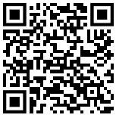
OR
- Connect to monitor via HDMI cable, connect keyboard, mouse and ethernet cable.
- Plugin power cord.
- Click terminal icon to open terminal
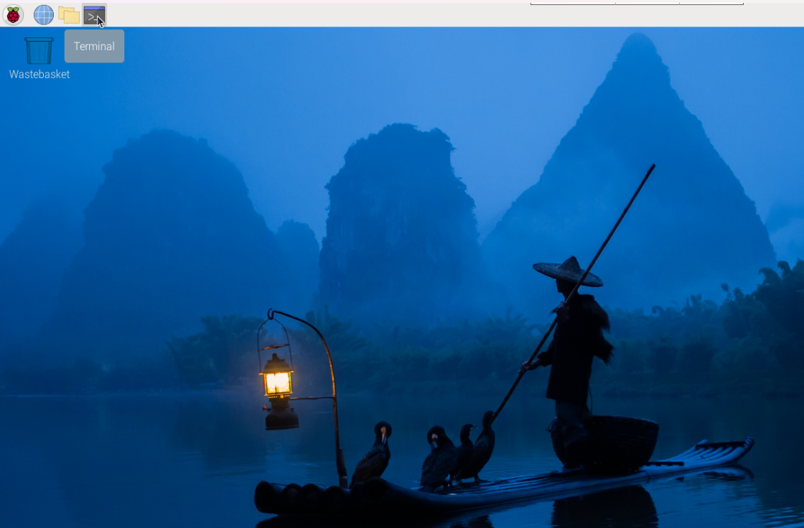
- Type “ifconfig” and press enter.
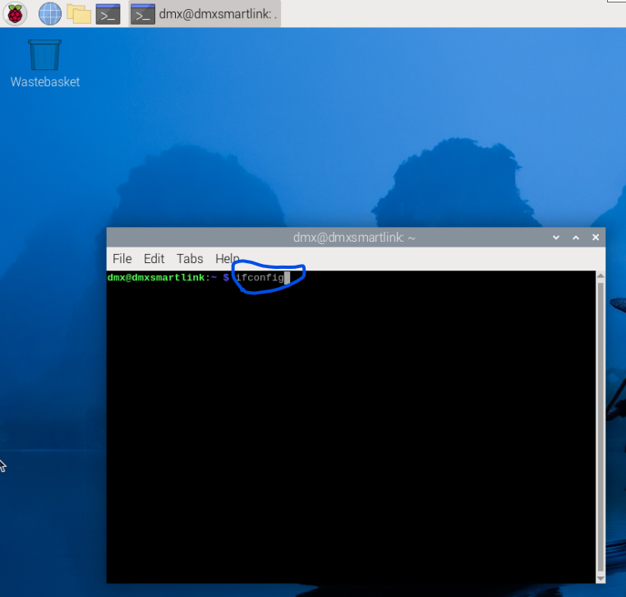
- Your dmxsmartlink ip is right after inet under eth0: 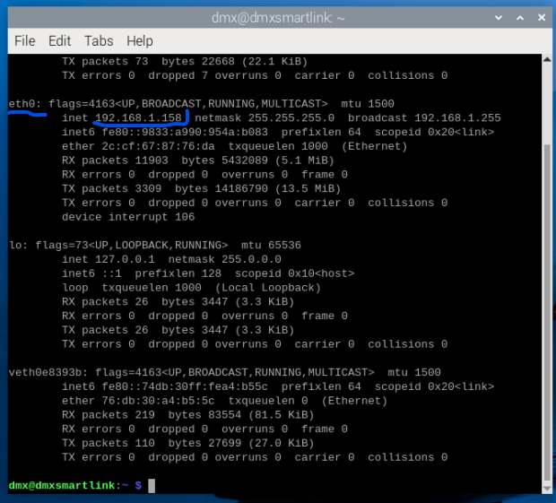
- Open browser on your computer or phone and type “https://<your ip address>:5000 and click advanced 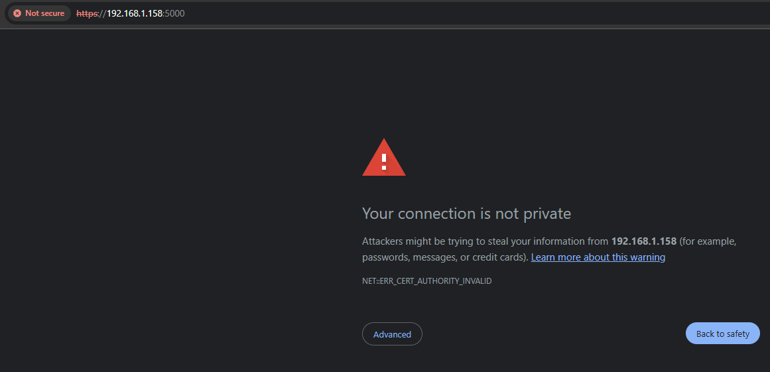
- Then click “Proceed to <your ip address> (unsafe) to access your dmxsmartlink web UI. 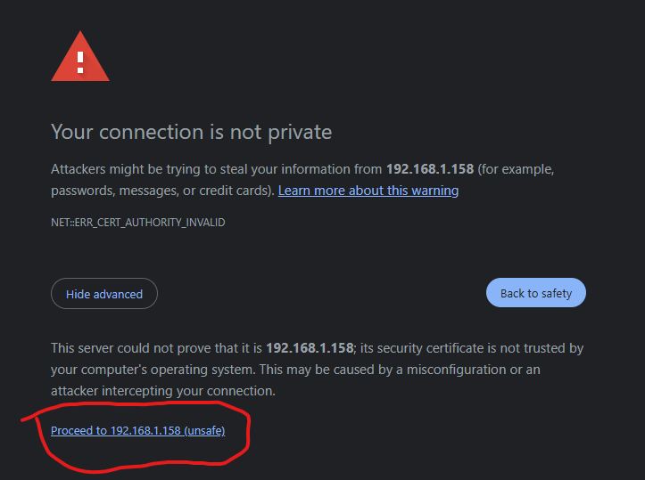
- In your Homebridge UI do NOT update your Plugins for Govee if you are using Govee lights. The plugin will be updated after each HUB reboot if one is available from the dmxsmartlink site instead of the developers site due to a required patch that is needed for brightness levels to work correctly. Otherwise brightness levels will be random with the official updates.
- Tutorial on how to setup the rest of the bridge is at https://www.youtube.com/watch?v=X10Le7R0New

