Maxwell Stephens

MIS 442

Google Analytics Summary

To Get Google Analytics working, I first used my Gmail account to sign up for Google Analytics. I then pasted the code provided in all my webpages:

<!-- Global site tag (gtag.js) - Google Analytics -->

<script async src="https://www.googletagmanager.com/gtag/js?id=UA-114843719-1"></script>

<script>

window.dataLayer = window.dataLayer || [];

function gtag(){dataLayer.push(arguments);}

gtag('js', new Date());

gtag('config', 'UA-114843719-1');

</script>

This allows Google to track visitor data to my site. As you can see below, I was able to visit the site and it tracked it, meaning that the analytic API is working.

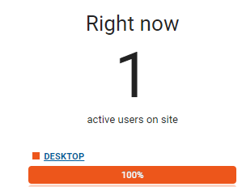

The API provides information such as number of visitors, frequencies, location of visitors, time spent, type of device, and time of visit of all visitors to a site.