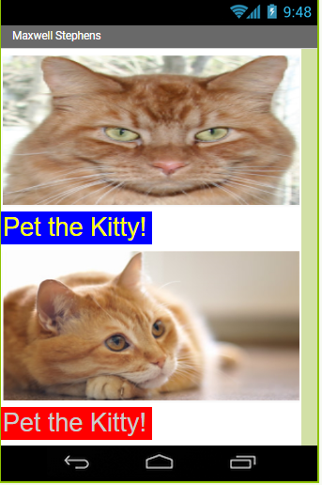

**Hello Purr App-builder App**

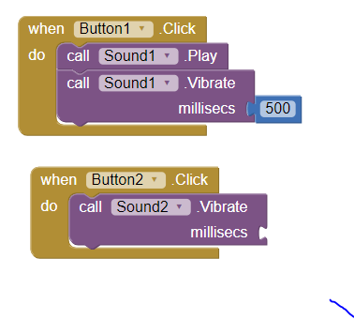 This app plays a sound of a purr when the pet the kitty button is pressed. In this app the foundations of the app-builder gui were learned, in addition to using an audio file. In addition, vibration was used to simulate purring, using the functions of a phone through the MIT app-builder.