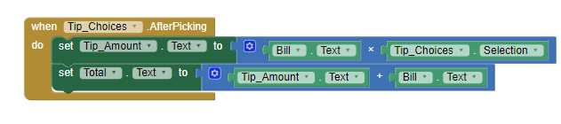

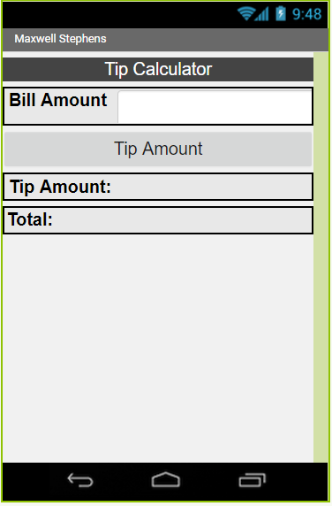

**Tip Calculator App-builder App**

For this MIT app builder project a fully featured tip calculator was made with some math in the code block logic side. The bill is entered, then there is a drop-down that allows the user to select a tip amount. After doing so the tip amount is displayed and a new total that adds the tip amount to the total.