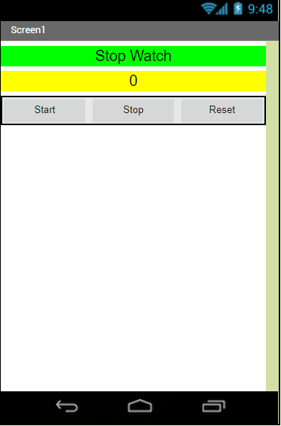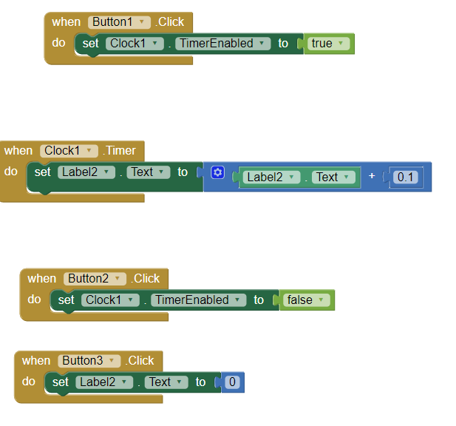Stopwatch App

This program used the timer component to increment the label called label2 to 0.1 more than its last value every 0.1 seconds. The app was a simple build, using only two Boolean statements, one math function, and a variable assignment (setting the label2 field to 0 when button 3 is clicked). The app provides a nice stopwatch the is a small file and has a gui interface.