Game Design Document

Fill up the following document

1. Write the title of your project.
2. What is the goal of the game?

To break out a facility, defeat a nuclear monster & escape from the nuclear earthquake of Africa.

1. Write a brief story of your game.

You’re a blue alien trapped in an Area 51 facility, that can destroy many things with his mind powers, After escaping the facility with a new form, you have to defeat a creature made of nuclear waste, and finally run

1. Which are the playing characters of this game?

* Playing characters are the ones who respond to the user based on the input from the user.
* Cars, monkeys, dinos, wizards, etc., are the playing characters in the game.

|  |  |  |
| --- | --- | --- |
| Number | Character Name | What can this character do? |
| 1 | Bluu | Uses psycic powers to attack enemies, but is low on health. |
| 2 | Indigoo | Can’t attack enemies, but is invurlnable to its enemies, and can interact with objects to indirectly attack the enemy. |
| 3 | Turqlime | Can attack enemies and has high health, but can’t move.  It can move by using it’s eggshell vehicle, but that means he can’t attack, but can crush enemies in his path. |
| 4 |  |  |
| 5 |  |  |
| 6 |  |  |
| 7 |  |  |
| 8 |  |  |

1. Which are the Non-Playing Characters of this game?

* Non-Playing characters are the ones that don't have an action or behavior when the user interacts with the game.
* Hurdles, stones, bananas, coins, etc., are non-playing characters in the game.

|  |  |  |
| --- | --- | --- |
| Number | Character Name | What can this character do? |
| 1 | Reapers | Attacks you within the visual radius |
| 2 | Asphalt | Same as Reapers, but does more damage and moves faster. |
| 3 | Nuclear Monster | Dragon in an egg and is the key element to unlock Turqlime |
| 4 |  |  |
| 5 |  |  |
| 6 |  |  |
| 7 |  |  |
| 8 |  |  |

Draw your imagination of this game. What does this game look like?

* Draw the game either on your computer or on paper.
* Add images of the game scenes to show each of the playing and non-playing characters at least once.

Playable Characters:



Bluu:



Indigoo:

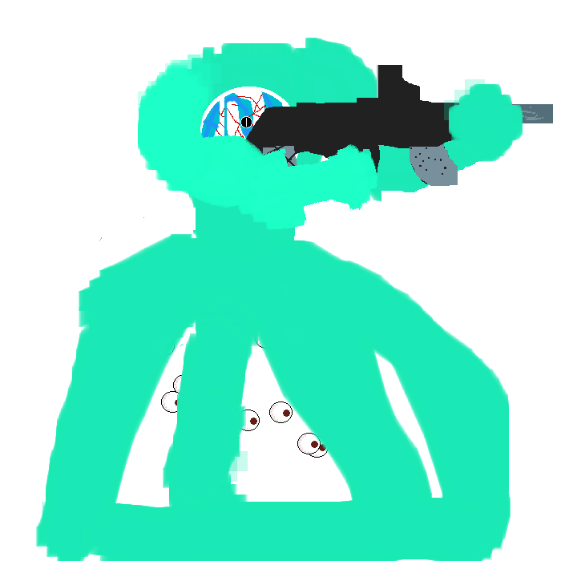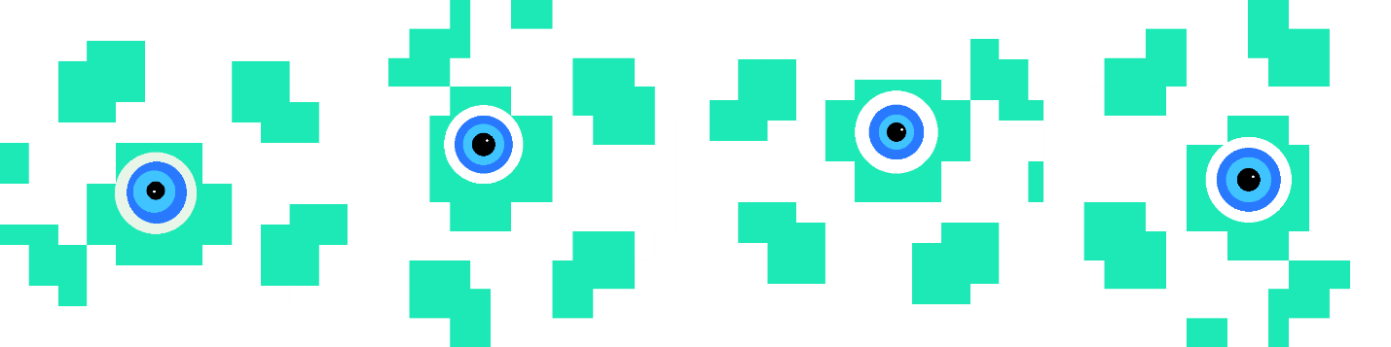



Turqlime:

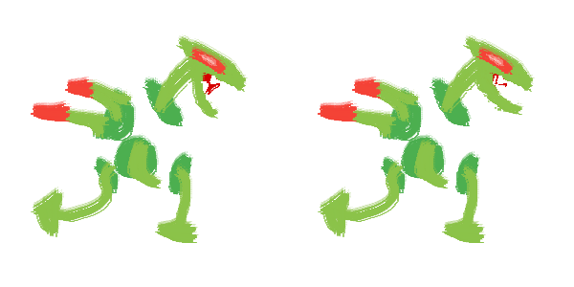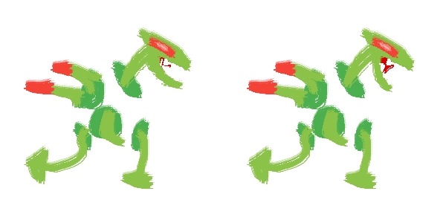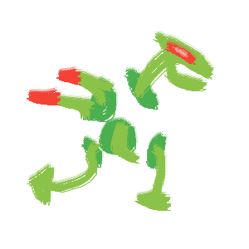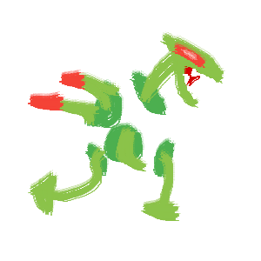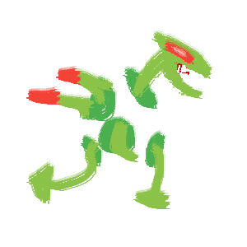

Nuclear Monster:

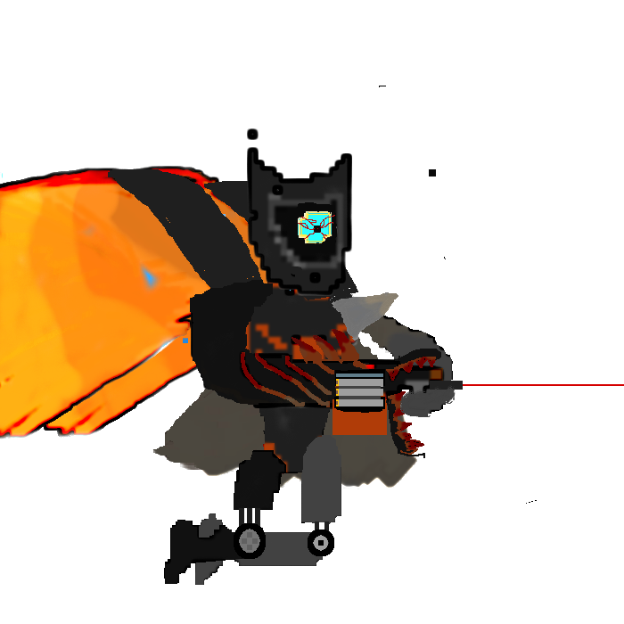

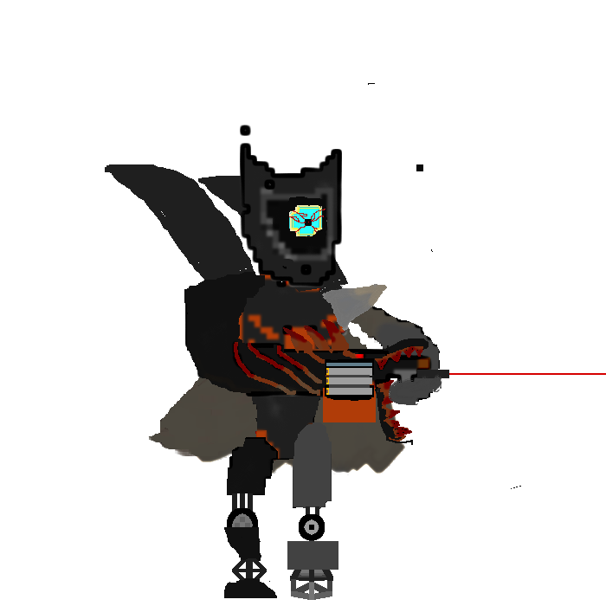

Asphalt:



Reapers:

How do you plan to make your game engaging?

The whole game will be made up of three indiviual mini games with varying genres(i.e: side scroller in the first, puzzle game in the second, and runner game in the third.)