## CS 443 Database Systems

## MyDB 2 (50 points)

## Due Thursday June 29th as a single document in the drop box

**MyDB 2: Step 2 of your own Database application (MyDB)**

Note: This assignment is a modification of material developed by Stanford Database Group

1. (20 pts.) Insert your final schema from MyDB 1 with updates suggested from grading MyDB 1.

Note: Some of the key names changed to avoid conflicts with coding in mySQL (e.g. date and name)

Employee( empID, empName)

Customer( custID)

CustomerOrder( orderNo, orderDate, totalPrice, empID, custID)

IncludedIn( orderNo, itemID, quantity)

Item( itemID, itemName, description, releaseDate, price)

1. (20 pts.) Write an SQL database schema for your MyDB, using the CREATE TABLE commands described in the document, *Getting Started With MySQL*, (also in the textbook and lecture notes). You may use the user interface to in MySQL Workbench to create the tables and keys. Pick suitable data types for each attribute. Hand in a printout of the commands you used to create your database schema (it is a good idea to keep this file for the balance of the course). Show the response of MySQL Query Browser to a request to describe each of your relation schemas. For example, to see the schema for relation Movie, type:

DESCRIBE movie;

For each command and its response, record the screen shots to include in your document.

Customer Table

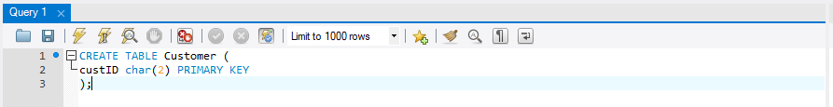

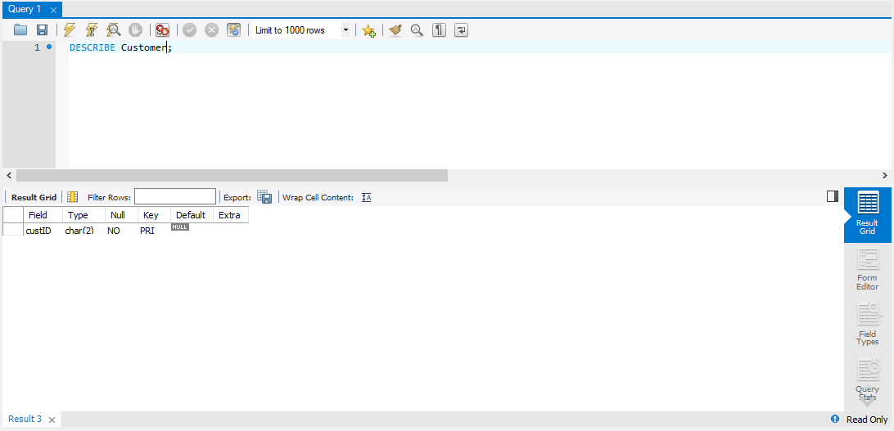

CustomerOrder Table

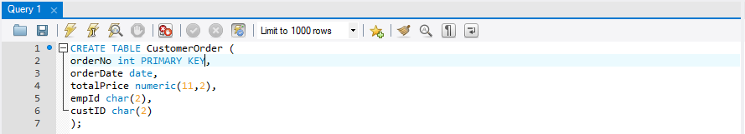

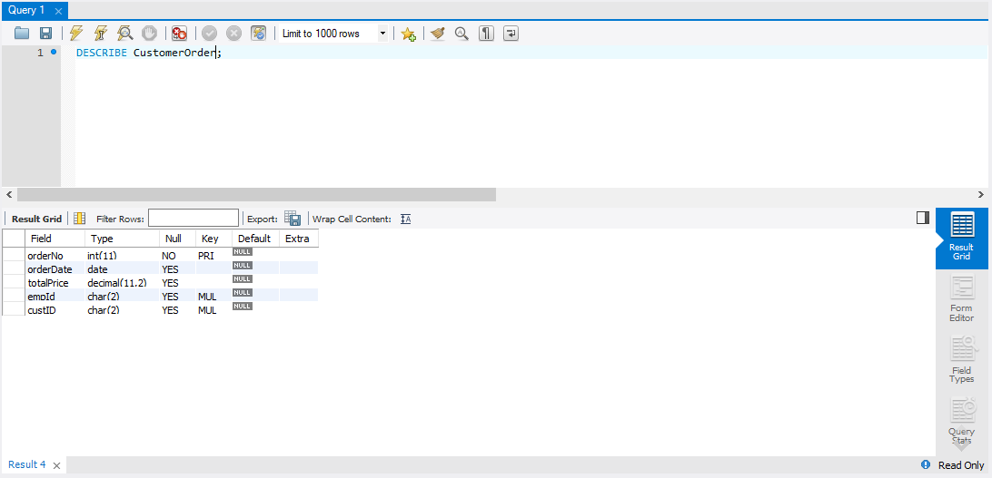

Employee Table

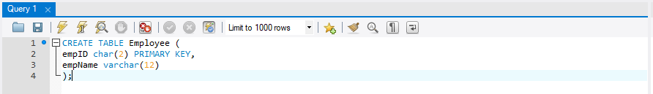

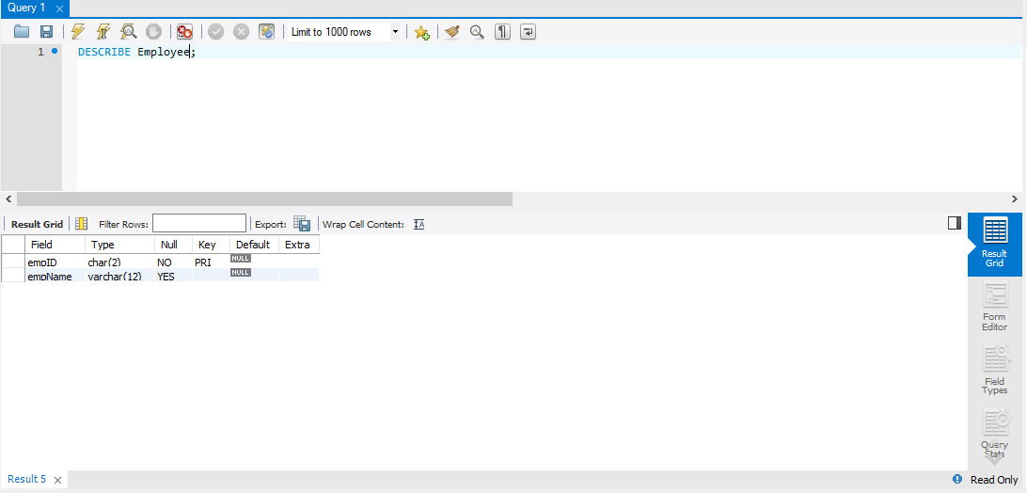

IncludedIn Table

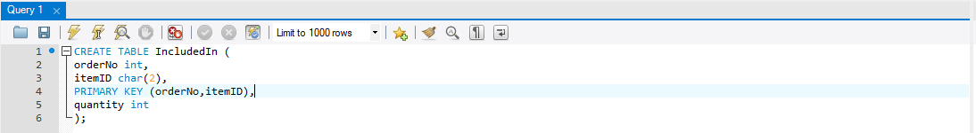

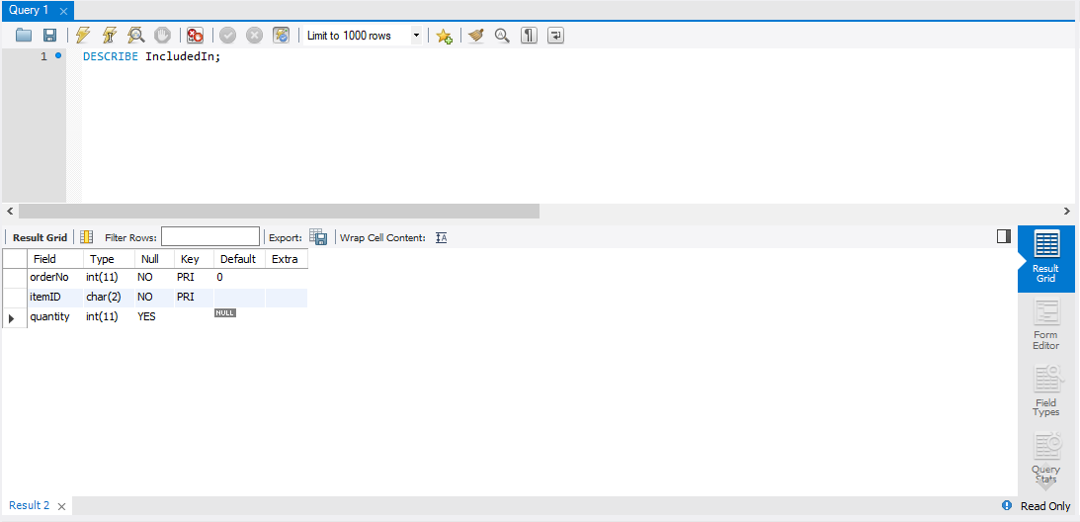

Item Table

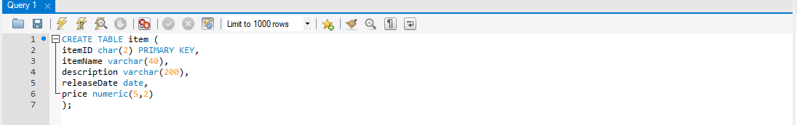

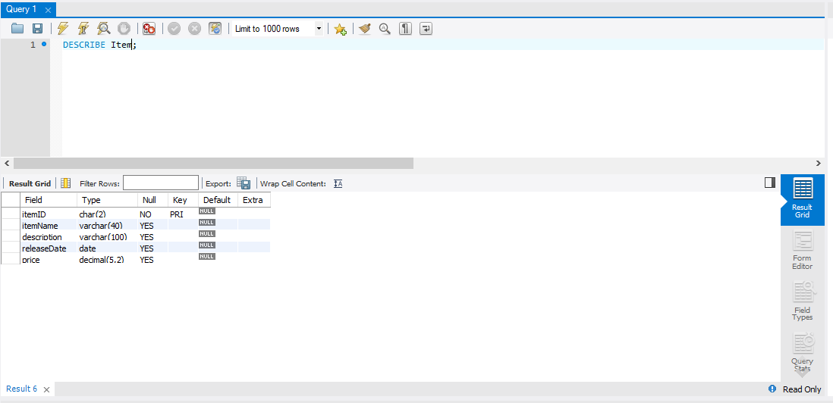

custID as Foreign Key in CustomerOrder

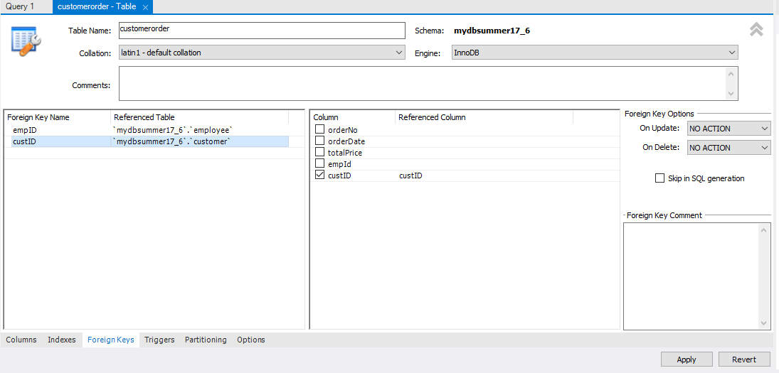

empID as Foreign Key in CustomerOrder

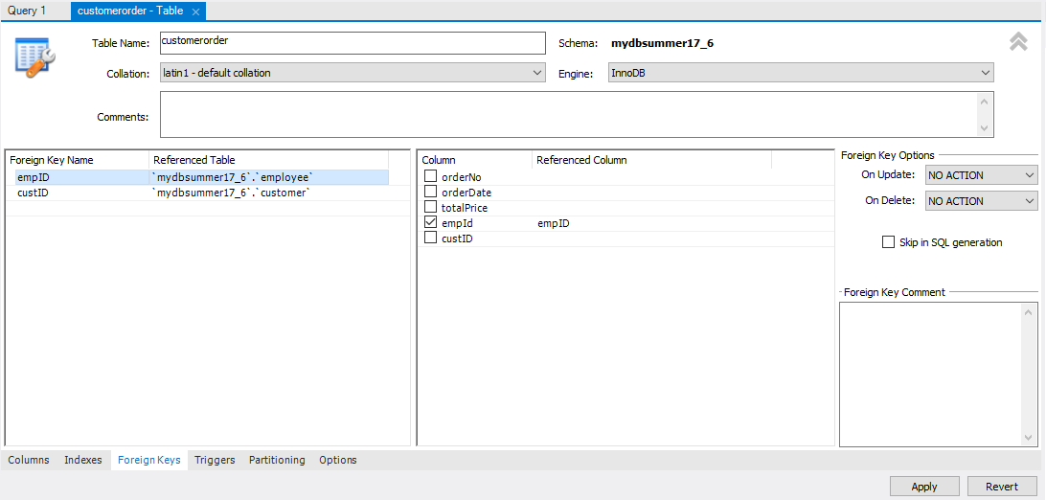

itemID as Foreign Key in IncludedIn

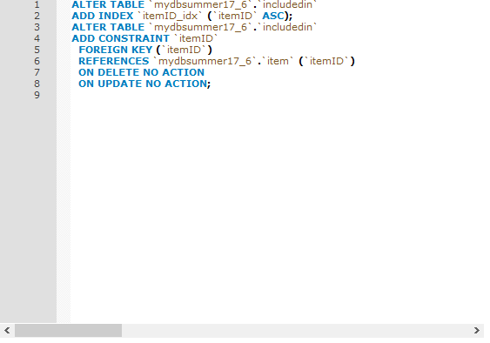

orderNo as Foreign Key in IncludedIn

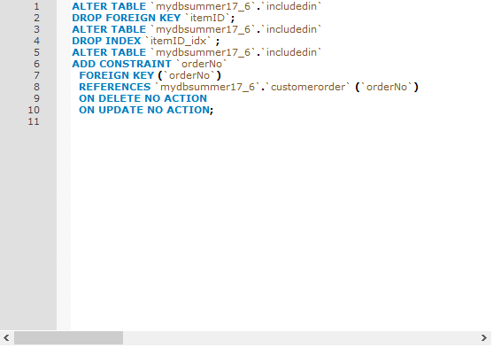

1. (10 pts.) Execute about five insert commands to insert tuples into one of your relations. Show the response of MySQL Query Browser and the relation that results when you issue a SELECT * command. Again, the information on how to do this step is in *Getting Started with MySQL.*

**Submit as a single document containing the screen shots.**

Customer Table

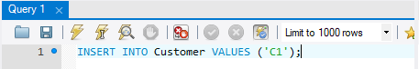

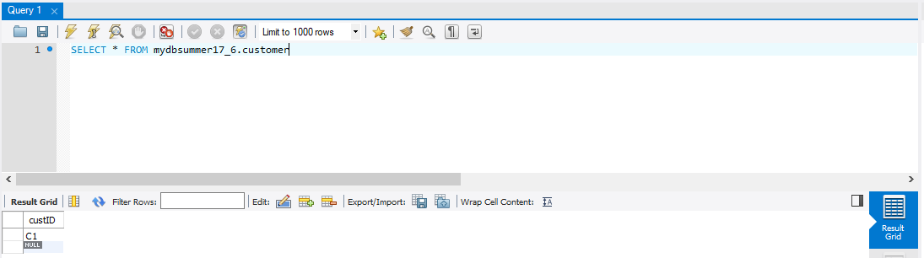

CustomerOrder Table



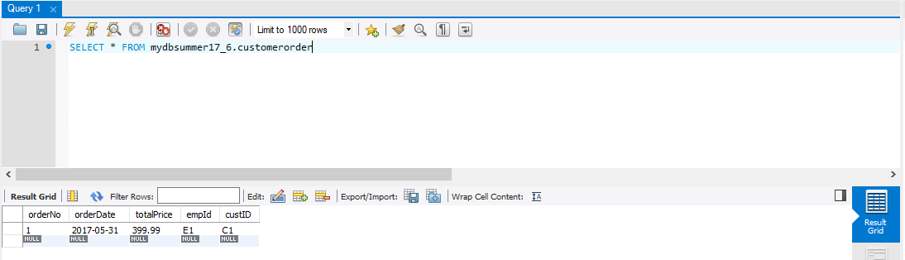

Employee Table 

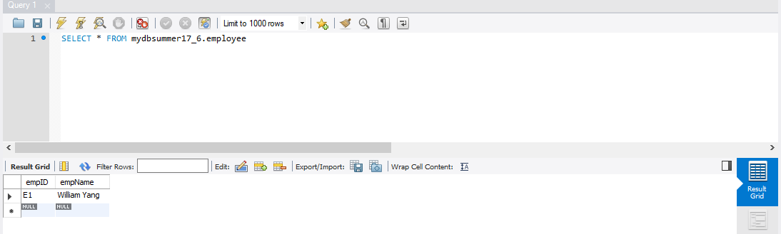

IncludedIn Table



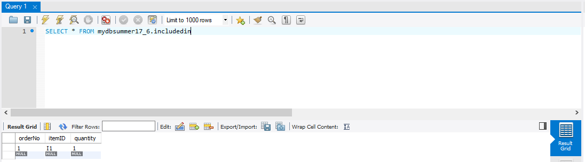

Item Table



