## CS 443 Database Systems

## MyDB 5 (50 points) due Wednesday July 19th

**Part a)** Backup your Database Schema (30 points)

Click on Data Export

1. On Data Export Screen
   1. Select your Schema
   2. Export to Self-Contained File
   3. Include Create Schema
2. Press Start Export

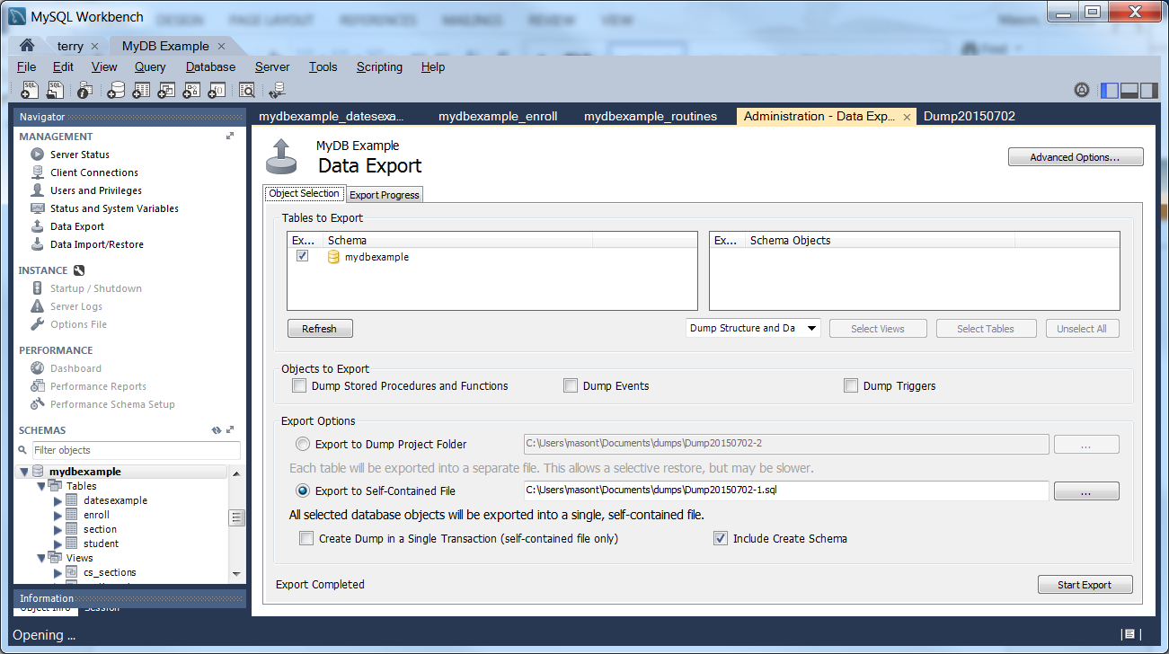

Open with new SQL Query (it will be on your computer):

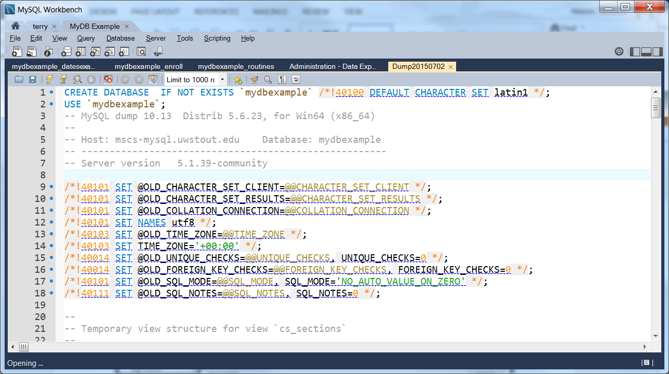

Look at the export. Notice the tables and data. Submit both screen shots for your database.

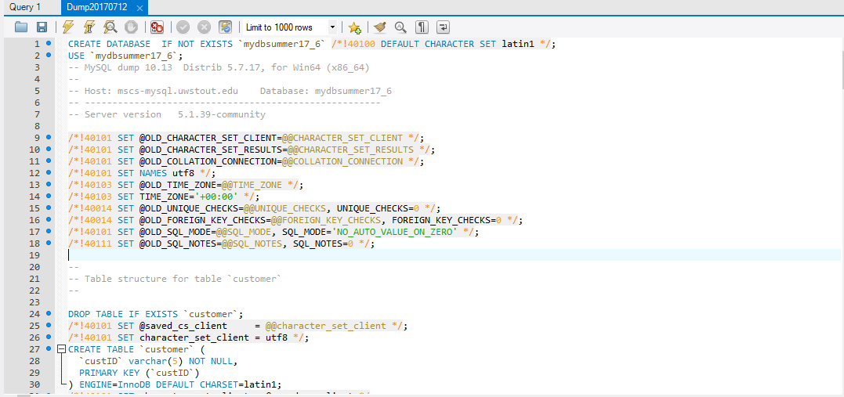

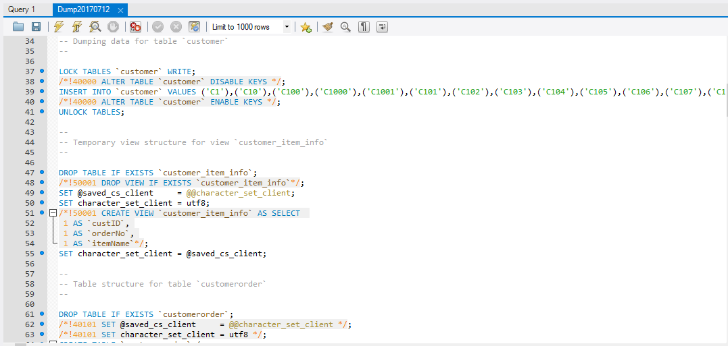

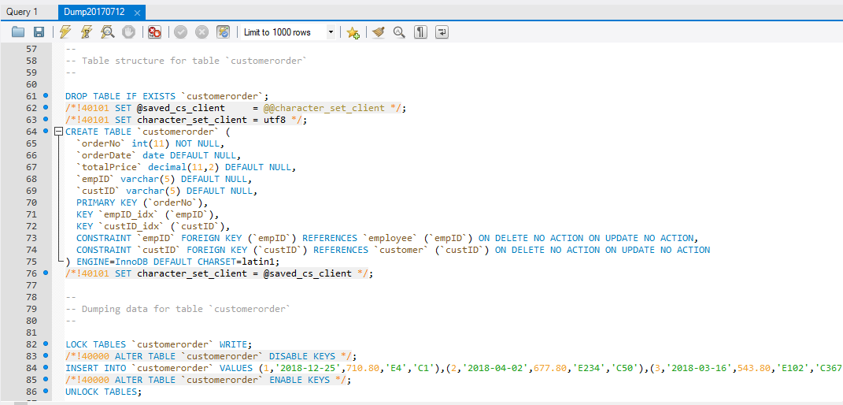

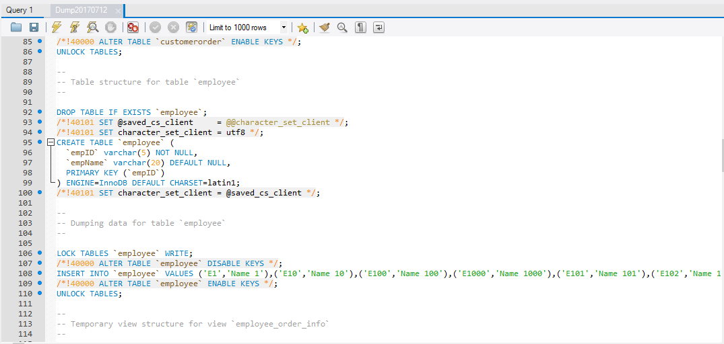

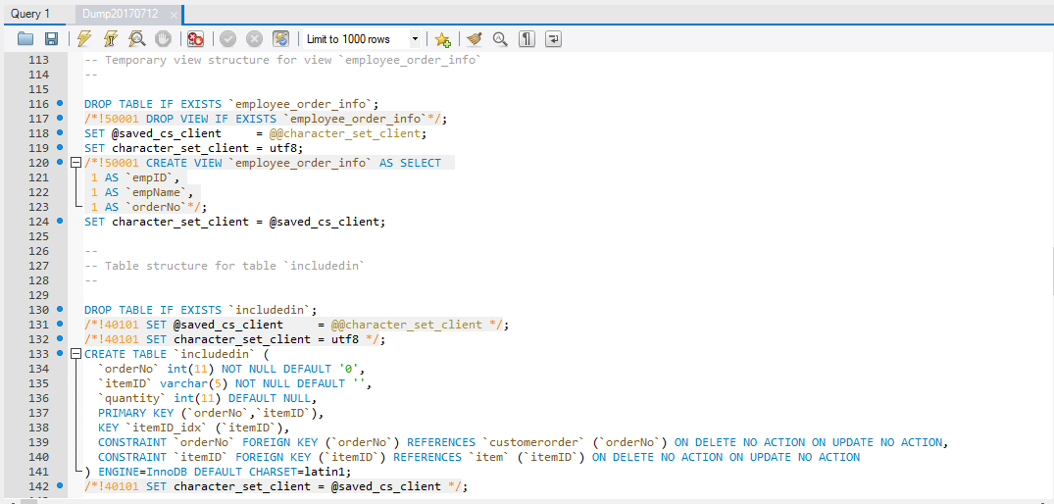

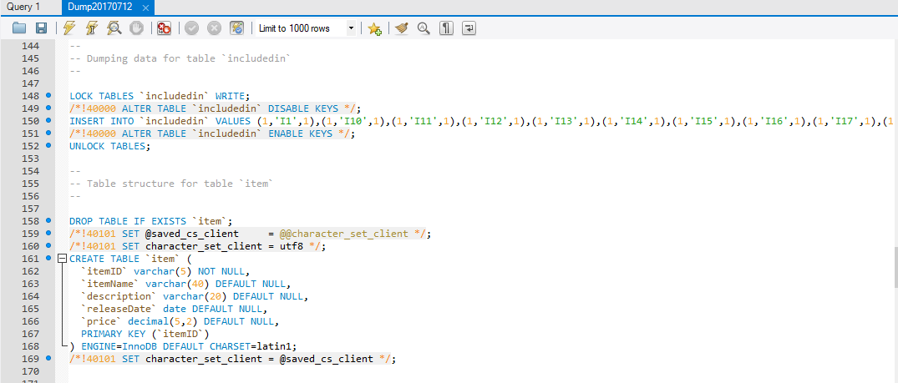

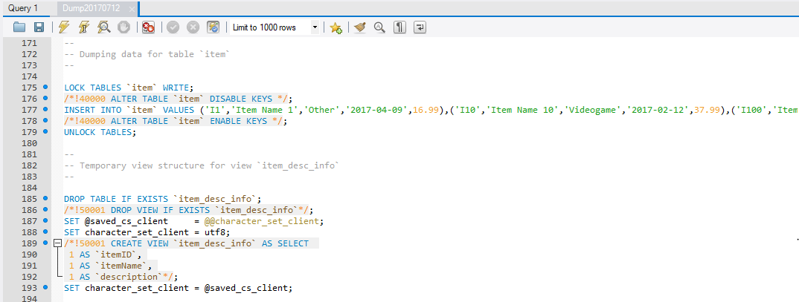

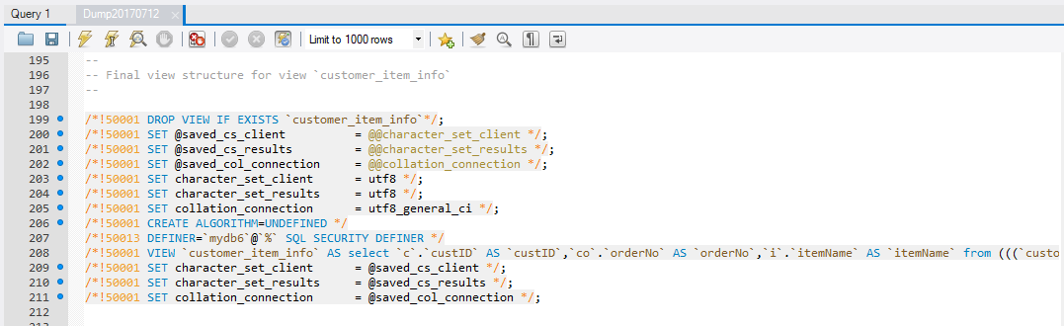

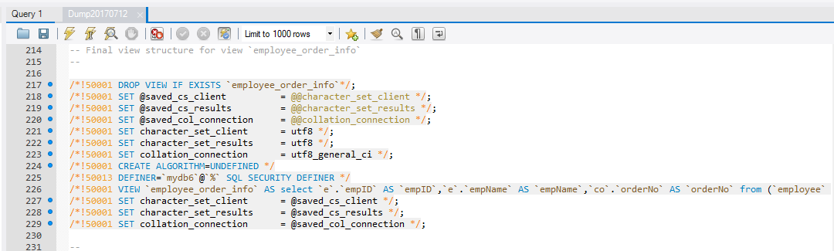

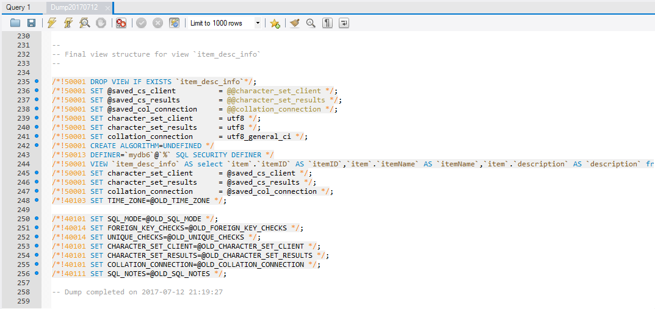

**Part b)** (20 pts.) You should never use your fully privileged user to allow users to connect to your database. You should only give the required privileges and no more. You should make multiple users to do different work. This makes it so that someone querying cannot update the database. They need to use two different users and passwords. List the privileges (no need to write the grant statement) that the following users would require to connect to your database:

mydbQuery user to Query information from your databases:

SELECT

mydbModify user to insert and remove rows as well as updating current data:

SELECT

INSERT

UPDATE

DELETE

mydbCreate user to create tables, triggers, views, foreign keys(references) and to add another column and even to delete the tables.

SELECT

INSERT

UPDATE

DELETE

REFERENCES

USAGE

TRIGGER