ECE/CS 552: INTRODUCTION TO COMPUTER ARCHITECTURE

Project Description – Stage 2

The project should be completed in a group of two or three students.

Review of the First Stage Project
Before you start the second stage of the project, you should have a working design pipelined design that implements the following instructions.

Table 1: Table of opcodes
Function | Opcode
ADD | 0000
PADDSB | 0001
SUB | 0010
AND | 0011
NOR | 0100
SLL | 0101
SRL | 0110
SRA | 0111
LW | 1000
SW | 1001
LHB | 1010
LLB | 1011
B | 1100
JAL | 1101
JR | 1110
HLT | 1111

To see the detailed information of the ISA, please refer to the first stage project description. You cannot proceed if you do not have a working 5-stage pipe design for these 16 instructions.

- Memory System
In this stage of the project we add both an instruction cache (Icache) and a data cache (Dcache) that remain single cycle access, but share a single main memory which has a latency of 4 cycles for read and write. This shared main memory will be a 2nd level store, that is accessed upon misses from the Icache or Dcache. Verilog models for the shared memory (unified_mem.v) and for the basic caches (cache.v) will be provided. Both caches are direct-mapped, and have a block size of 4 words (8-bytes) and a data array size of 256 words (organized as 64 4-word lines). Therefore, The address[1:0] is the block offset, address[7:2] is the index and address[15:8] are tag bits.
The cache model provided (to be used for both the Icache and Dcache) has a hit output, and a dirty output. The cache memory includes a valid bit for each line that is cleared on reset (because no entries in the cache are valid at first). The hit output is set on a cache read or write if the tag bits match the address, and the valid bit is set. The dirty output is used for implementing write back. If the cache line has been modified (dirty bit in cache line set) and the cache line is valid the dirty output will be high. The dirty output can be ignored when implementing the Icache control because we should never be writing to the Icache (we do not support self modifiying code).
Figure 1 shows a possible memory structure for use with the WISC_F14. Depending on how you choose to partition your design this may not work well for you, and you may have to partition another way.
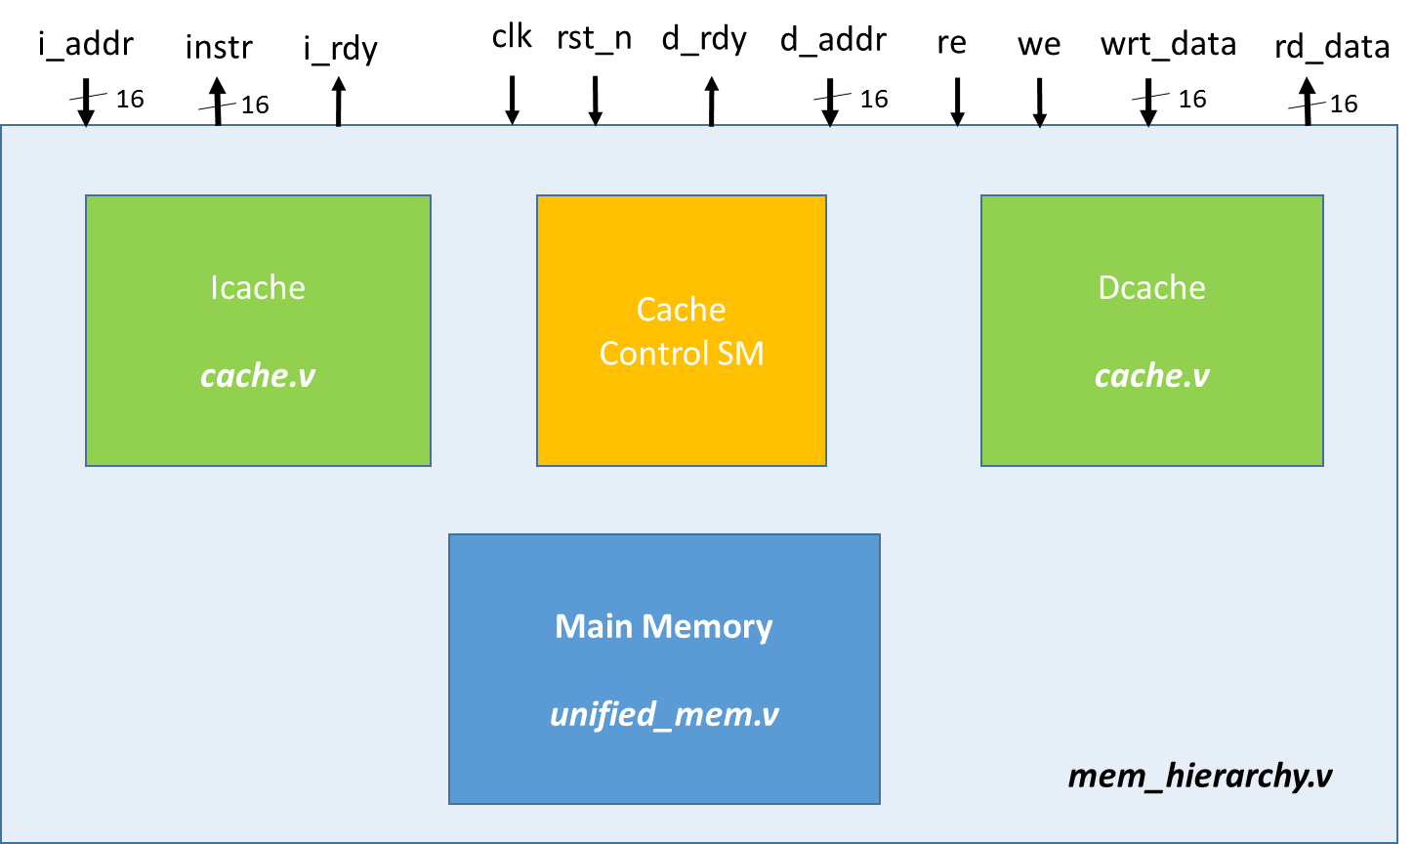
Figure 1: System Memory
From figure 1 we can see that I-cache and D-cache share one main memory. There will be times in which both the Icache and Dcache will be experiencing a miss simultaneously. They will both have to access the main memory to fulfill their access. In such instances the Dcache miss should be serviced first. Since the main memory only has one read port only one miss can be serviced at a time, so there is only need for a single cache controller. This cache controller, however, is not a simple thing. There is also a lot more going on in Figure 1 than shown. There are, of course, many interconnections forming the address to the unified memory, the write data to the Dcache, the control signals to the Dcache, … Some of these interconnections are intentionally left vague for the student to figure out.
You can assume that the I-cache is never written by the processor. Writes to the I-cache only happen on fetch misses. In this case your controller will fill a cache line in the Icache by reading the data from the main memory. The address space is shared, however, be careful to ensure the address space you use for data is much higher in the address space than that used for instructions. Don’t inadvertently make your life miserable by writing self modifying code.
Having to service writes makes controlling the Dcache considerably more complex than controlling the Icache. You will be implementing a write back policy for the Dcache. When there is a write instruction (SW) in your pipeline, your cache needs to first check if the data is in the cache. If it is a hit, the new data word will be placed in the proper position in the 4-word cache line, and the cache line will be written. This will all happen in a single cycle because the cache model read on clock high (we then have the hit signal in first half of clock), and writes on clock low. This is actually a bit unrealistic of a memory model, however, our alternative was to have you implement a write buffer, and this project is complex enough already. Remember when a cache write happens from the CPU you must set the dirty bit to indicate that line is now different than is corresponding location in main memory. If it is a write miss, the cache controller will have to check if the current line in the cache is dirty. If it is dirty, that line will have to be written back to main memory. Then a read access will be performed to main memory to get the line that the word to be written resides in. The word to be written will then be placed in the proper position in the 4-word line read from the main memory. This new line will be written to the Dcache and the dirty bit will be set. At the end of these operations the d_rdy line is asserted.
Verilog modules are provided (cache.v for both Icache and Dcache, and unified_mem.v for the main memory). The interface of these memories is described below:

  - Cache Interface

Signal: | Dir: | Description:
clk | in | clock
rst_n | in | Active low reset
addr[13:0] | in | Address. Lowest 2-bits not used (4-words/line)
wr_data[63:0] | in | Data to be written to cache line
wdirty | in | Hold high while writing to mark a line as dirty
we | in | Write enable to write a line to the cache
re | in | Read enable
rd_data[63:0] | out | Cache line read out
tag_out[7:0] | out | Tag bits for the cache line. Need this when evicting line from cache
hit | out | Hit means the tag bits matched and the line was valid
dirty | out | Cache line has been modified. Need to write back.
toggle | in | Used to maintain LRU for 2-way set associative data cache, will be discussed in the following bonus part

  - Cache Timing

The caches are single cycle access. Address and re/we should be presented and valid in the first half of the clock. Data is read on clock high (so Hit and dirty bits are available in first half of cycle) and written on clock low. Since the read and writes happen in opposite phases of the clock it is possible to assert re & we in the same clock cycle, however, address cannot change (have to read and write same cache line). Basically a read modify write operation.

  - Unified Memory Interface
Signal: | Dir: | Description:
clk | in | Clock
rst_n | in | Active low reset
addr[13:0] | in | Address. Lowest 2-bits not used (4-word access)
re | in | Read enable
we | in | Write enable
wdata[63:0] | in | Data to write to 4-word line
rd_data[63:0] | out | 64-bit line read
rdy | out | Indicates operation (read/ write) is complete this cycle

  - Unified Memory Timing:

The main memory has a timing of 4-cycles for a read or write. The read and write both occur on the clock high phase of the 4th clock cycle. Rdy is also asserted on the clock high phase of the 4th cycle. Both re & we and addr should be asserted prior to the rising edge of the first clock cycle of access. See the timing diagram below for clarification.
Figure 2: Timing Diagram of Main Memory
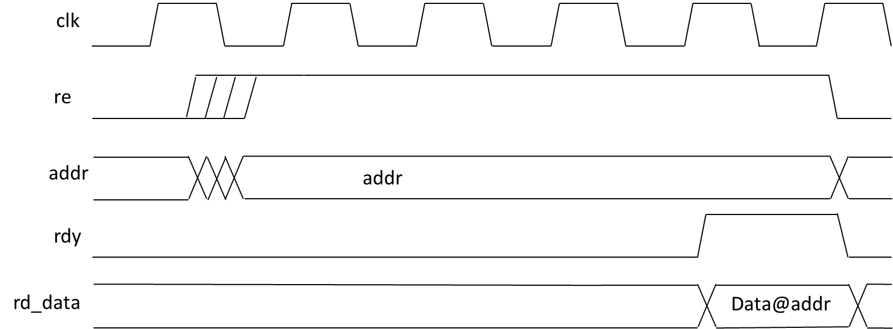

A write is similar to Figure 2 above in that the write occurs during the clock high of the 4th clock cycle.

- Bonus part
For this part, we will give extra bonus credits (up to 30% more) for the groups that implement 2-way set associative data cache and/or 1-bit branch predictor.

  - 2-way set associative data cache (up to 20%)

In this part, you need to change the direct-mapped data cache to 2-way set associative one based on the cache module we supply. The data cache has the same size as the module we supply, which has a block size of 4 words (8-bytes) and a data array size of 256 words (organized as 32 2-way lines with each set 4-word). The address[1:0] is the block offset, address[6:2] is the index and address[15:7] are tag bits. Notice that there is one more tag bit, the corresponding tag storage each line should be changed, with one more bit added for each set.
When the cache performs a read, the 2 tags of a same cache line should be compared at the same time. If there is a hit, the corresponding data of the hit set should be given. Otherwise there is a miss.
When the cache performs a write, a least recently used (LRU) replacement policy should be implemented. In order to do that, the LRU set of each cache line should be recorded. When there is write, if it is write hit, just directly write the data to the correct position and update the LRU set number to the other one in the same cache line. If it is a write miss, always write the LRU set back to unified memory. And after write the new data to data cache, the LRU set number should be updated.
As for the interface, only one input, named toggle, is needed to add to the supplied cache module. The toggle is used to update the recorded LRU set number of each cache line. When there is a read or write, the toggle signal should be asserted to the 2-way set associative data cache. Once receiving the toggle signal, the data cache should update the least recently used set number of corresponding cache line.

  - 1-bit branch predictor (up to 5%)

The 1-bit branch predictor should be used implemented in the IF stage. In the branch predictor, a 1-bit branch prediction register should be used to store the prediction. Initially, the 1-bit branch prediction register should be reset to Not-Taken on the rst_n signal. Once the instruction is read from the instruction cache, the branch predictor decodes the opcode. If it is a branch instruction, based on the content of the branch prediction register, the PC should go to the branch target address or the next pc as there is no branch predictor in the next clock cycle. Once the branch instruction is executed in the EX stage, the result should be compared to the branch prediction register. If the branch prediction was correct, nothing needs to be done. If it was wrong, the branch prediction register should be updated to the executed branch result. PC should be set to the correct address, and all the instructions in the wrong path should be flushed.

- Project Grading

This phase of the project will be worth 70% of the project score (bonus part is not included), and will be graded largely based on quantitative metrics.

60% Quantitative
10% Code readability & commenting, and test suit comprehensiveness.

  - Quantitative Grade

The quantitative grade is based on the following metrics:
- % of tests passed from functional test suite
- Geometric mean of your IPC for our performance test suite
- Relative area of your synthesized netlist

Your design must meet the minimum synthesis frequency target of 800MHz. If your design does not synthesize it area will be taken as 120% of the largest class project that does synthesize.

- Project Demonstration
Each group will be asked to demonstrate their project on November 8th. All team members should be present at the demo.
- You must provide a tarball of all your verilog files like you did for Stage I
- A code review will be performed. This review will look at code readability and commenting as well as at test suite comprehensiveness.

