Xiao5uCompany v1.7 has XSS vulnerability

This article mainly analyzes the XSS exploit of Xiao5uCompany_v1.7.

Downloadlink: http://note.youdao.com/yws/public/resource/2171184ec42f8aded66f136979c46562/xmlnote/WEBRESOURCE53a9f0aaf08ce97761ea57f11e401cf4/464

- Go to the Feedback.asp and you will see the message window.
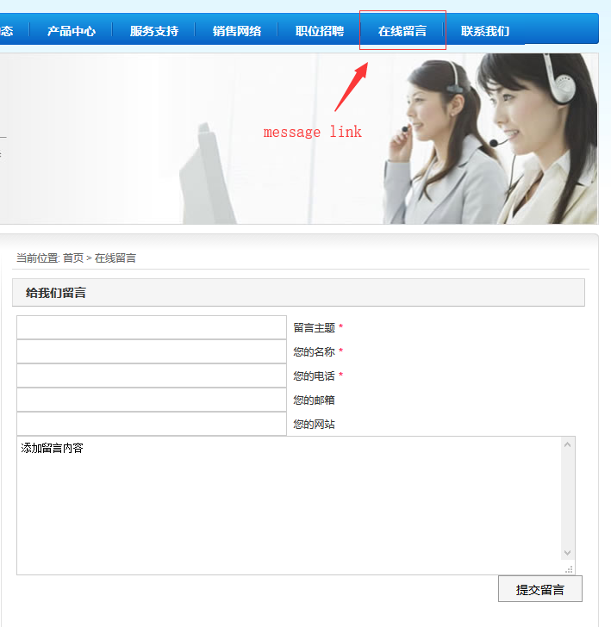
- Your request will be blocked by system if you submit the message including "img", "script", "alert", etc.
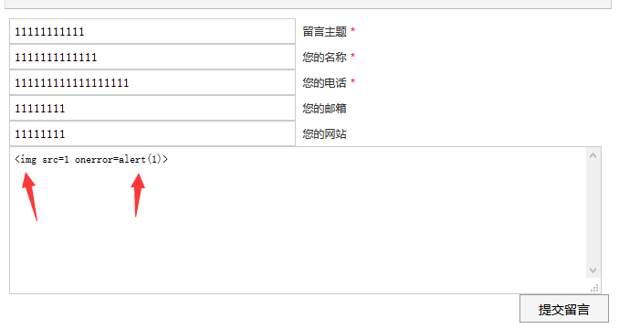
Response：
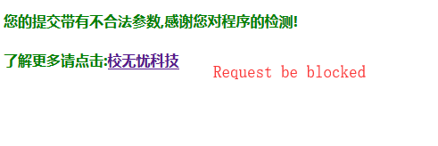

- We can analyse it in inc/Safe.asp, it uses a regular match to limit input, such as ‘script’, ’img’, ‘alert’, etc.
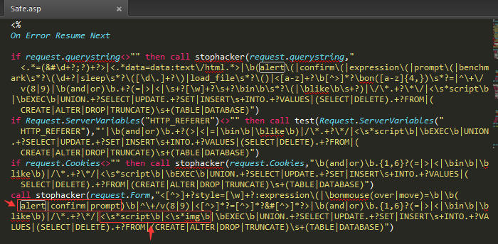
- Although he restricted a lot of keywords, but did not prevent the JS code execution. So we use the ‘video’ tag to execute JS and get the cookie directly.

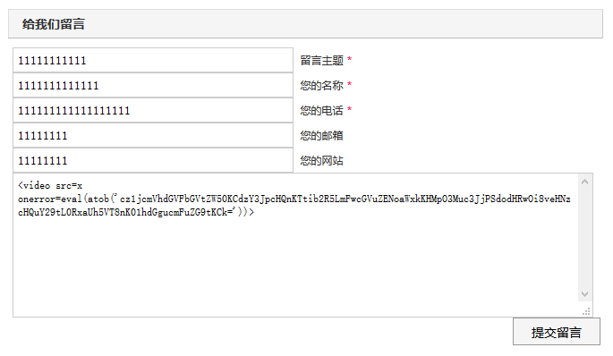
Response:
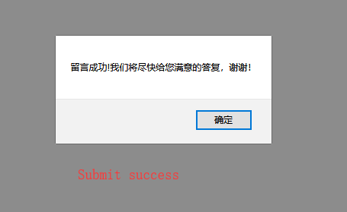
- If admin watch this message:
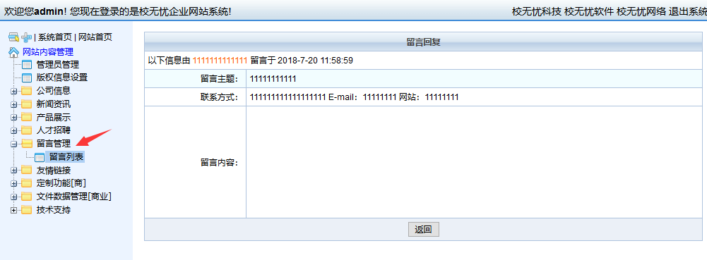

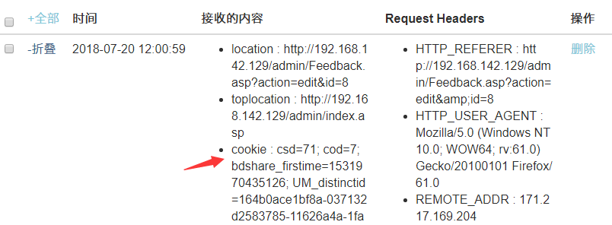

We get the cookie of admin.(In my xss platform.)

