DKCMS v9.4 has sql injection vulnerability

This article mainly analyzes the sql injection vulnerability of DKCMS v9.4.

CMS Official Website: http://www.dkcms.com/
⊙. We consider about asp version of DKCMS, and the latest version(v9.4) download link is following:

Download link:
http://www.mycodes.net/do/job.php?job=down_encode&fid=25&id=2241&rid=2255&i_id=937&mid=106&field=softurl&ti=1

Description: This is a sql injection vulnerability that can bypass administrator verification and go directly to the website background.

Process:
- At first, I tried to construct the Post and Get parameters for SQL injection. However, due to the strict anti-injection mechanism and limit by Access database, I did not find a good way to bypass.
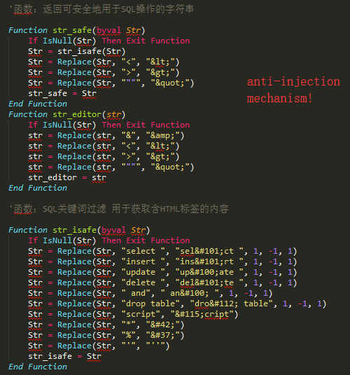

- When audited the code of cms, I found that the authentication of the website background relies on cookies: check.asp.
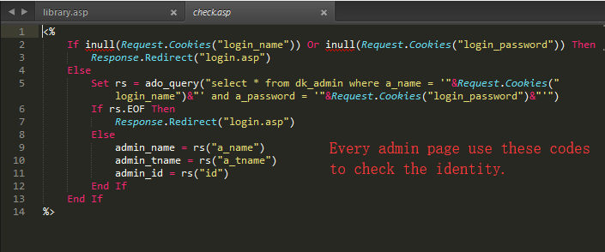
- We analyzed this verification code and found that there was no sql injection filtering on the cookie.
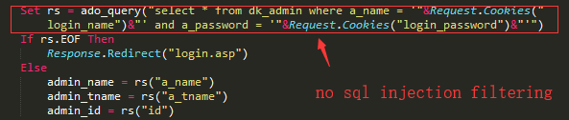
- We can use this vulnerability to directly enter the website background.
- We sign in in the website background and fetch packets with burp suite.
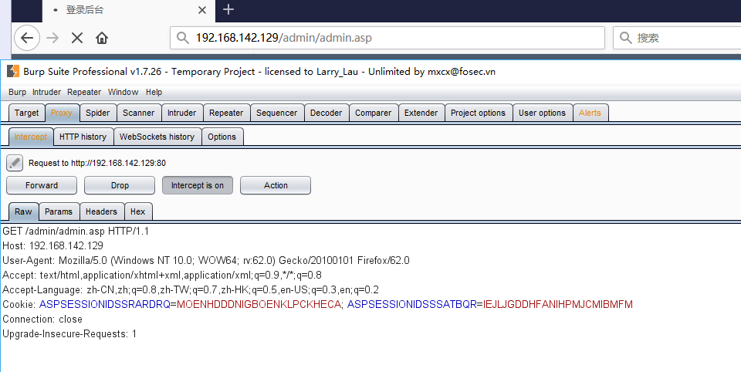
- Then we modify the packet and inject it at the Cookie.(because of the length verification, the length of login_password should be 32)
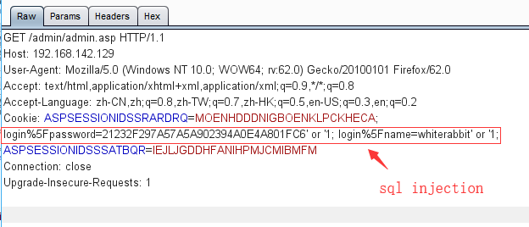
- Submit the modified data package and successfully enter the website background.
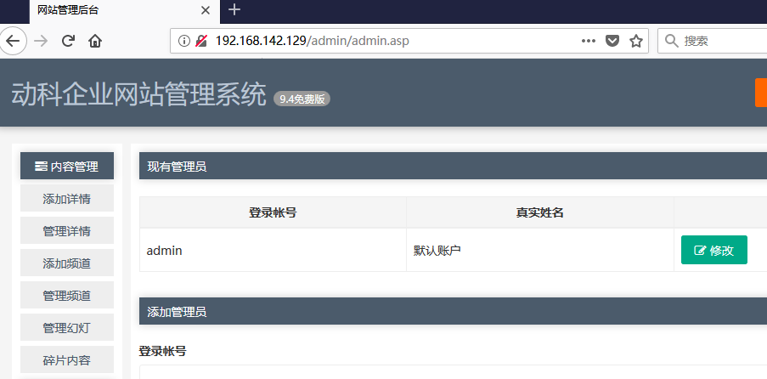

POC:
login%5Fpassword=21232F297A57A5A902394A0E4A801FC6' or '1; login%5Fname=whiterabbit' or '1;

