SDCMS v1.6 has directory traversal vulnerability

This article mainly analyzes the directory traversal vulnerability of SDCMS v1.6.

CMS Official Website: https://www.sdcms.cn/
⊙. We consider about PHP version of SDCMS, and the latest version(v1.6) download link is following:
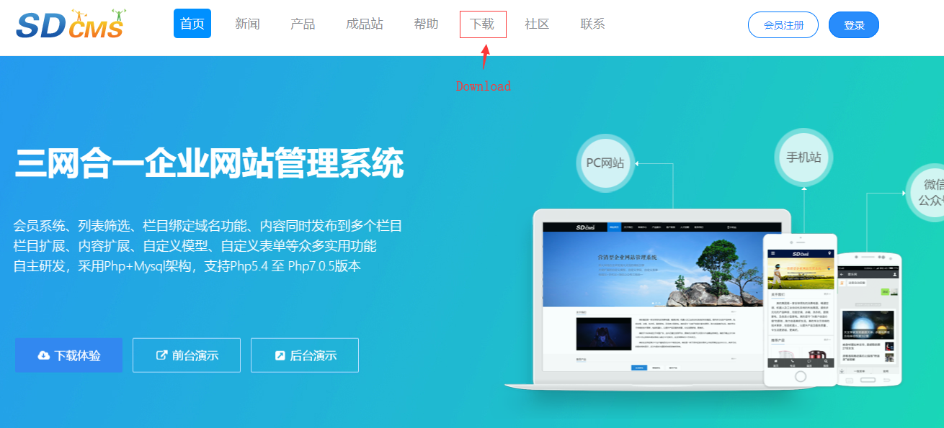
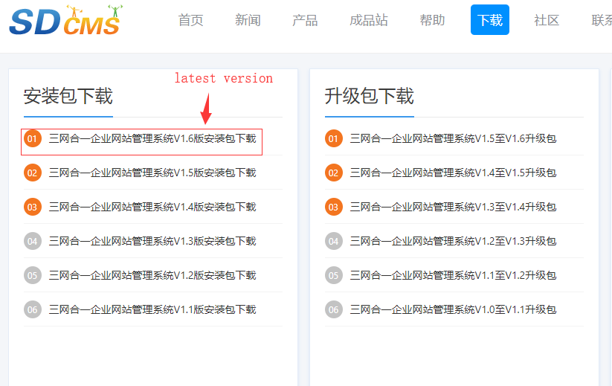

Download link:
https://www.sdcms.cn/down-98.html

Description: This is a directory traversal vulnerability that we can submit the constructed parameters in the website background to achieve the purpose of traversing the server root directory.
Test Environment:
Server: Apache 2.4.35
Language: PHP 5.6.38
Database: MySQL 5.7.23

Process:
- At first, we had to login the website background:
(http://127.0.0.1:8000/?m=admin&c=index&a=login).
When I entered the website background, I found that some plugins can be installed here.
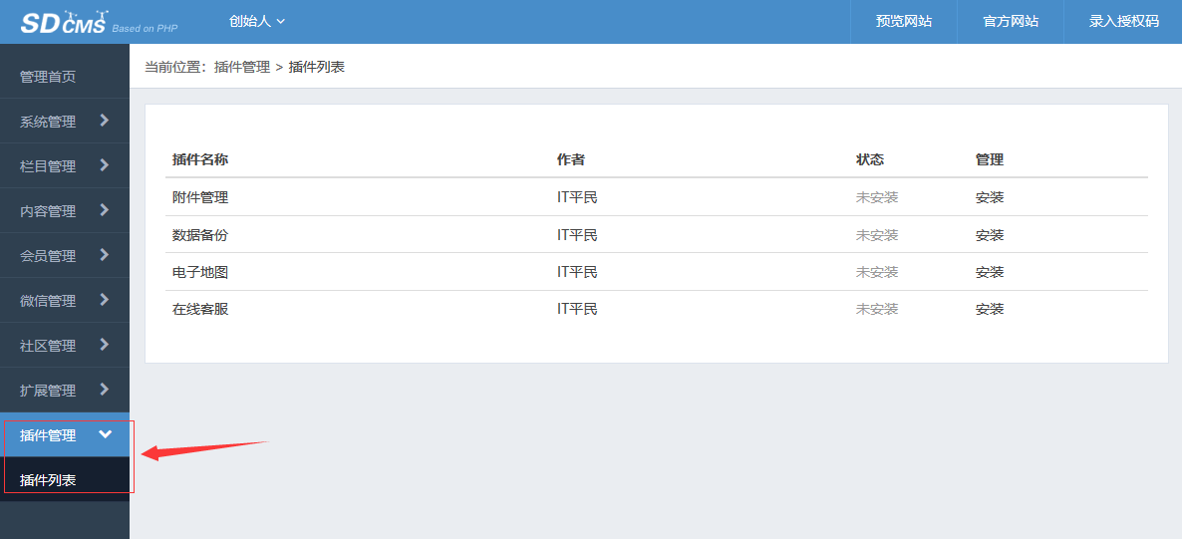

- We installed the first plugin, and this plugins could manage the file in the "upfile" directory.
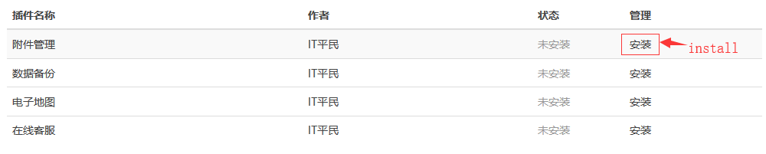
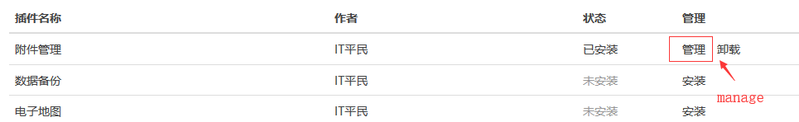
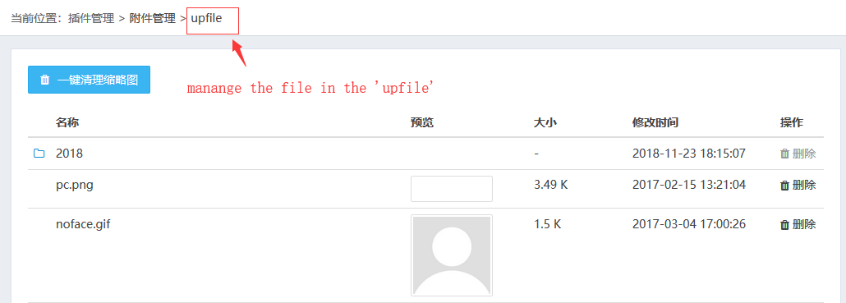

- But When I click on the "2018" folder and use burp suit to capture packets, I found it seems to be able to construct parameters to achieve directory traversal.
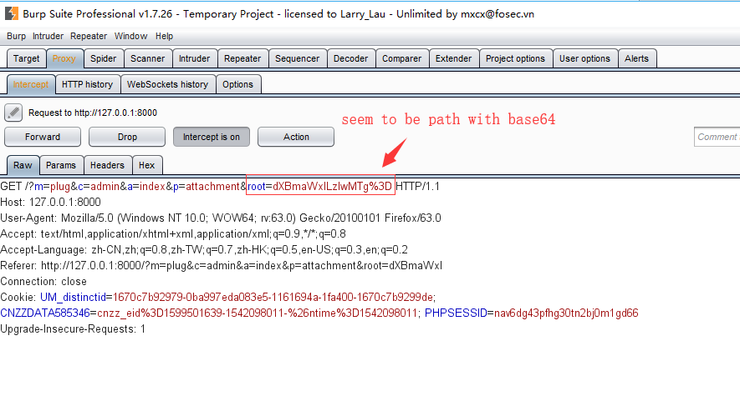
I used the base64 decoding parameter and find that it is indeed the path, so we can try to construct the parameters.
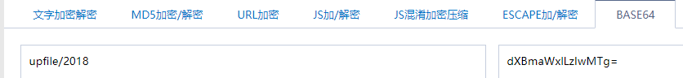

- I am used base64 encoding to construct a path parameter '../'
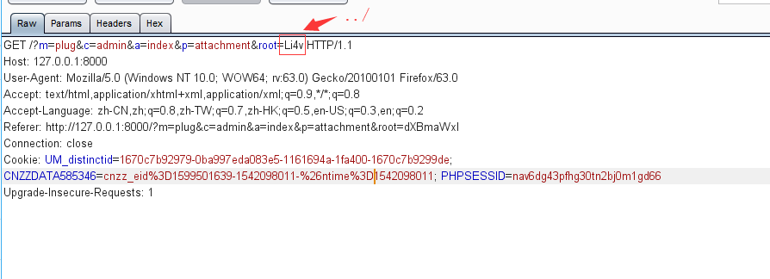
- When I submit the packet, I find the directory traversal vulnerability.
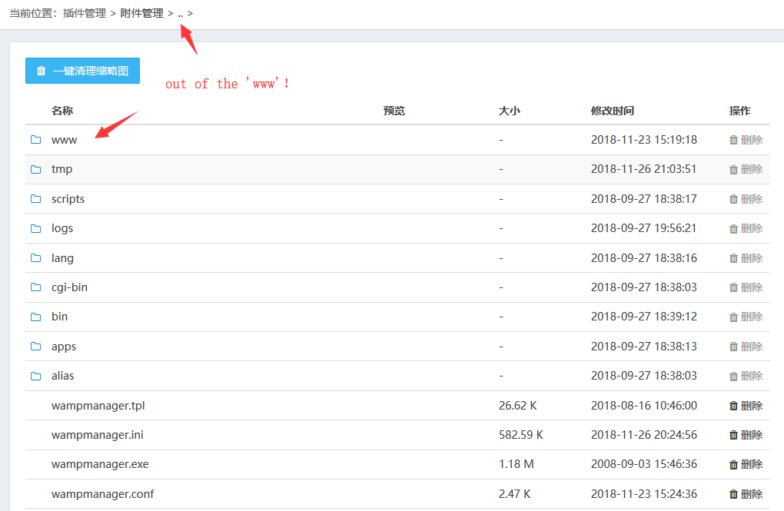

- We can click on the 'www' to see the website file, and also use ../../ to get more information.
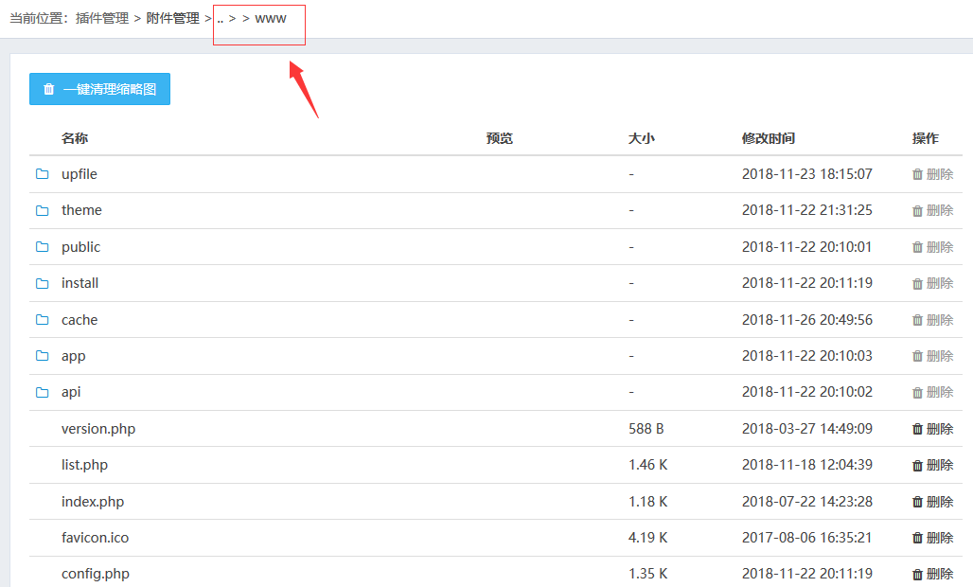

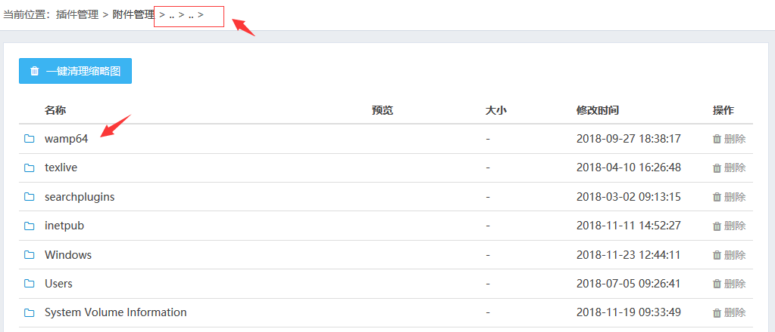

Source code:
app/plug/attachment/controller/admincontroller.php
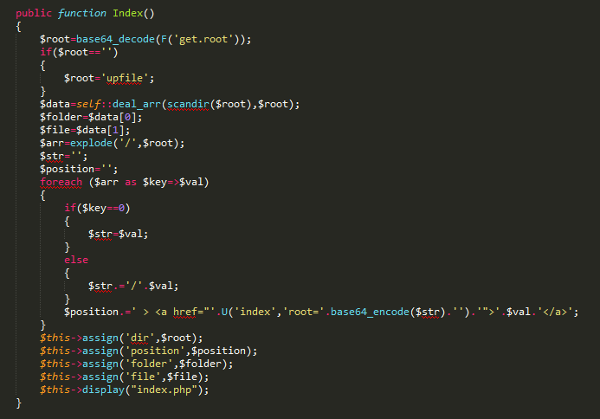
We can see there are not filtering with '../' , that’s why make directory traversal vulnerability.

POC:
http://127.0.0.1/?m=plug&c=admin&a=index&p=attachment&root=Li4vLi4v

