SaxueArticle v2.0 has XSS vulnerability

This article mainly analyzes the XSS exploit of SaxueArticlev2.0

Downloadlink:
http://download.saxue.com/SaxueArticle/SaxueArticle_V2.0_R20160526.zip

Before Everything
- After the CMS is deployed locally, we register a user to log in.
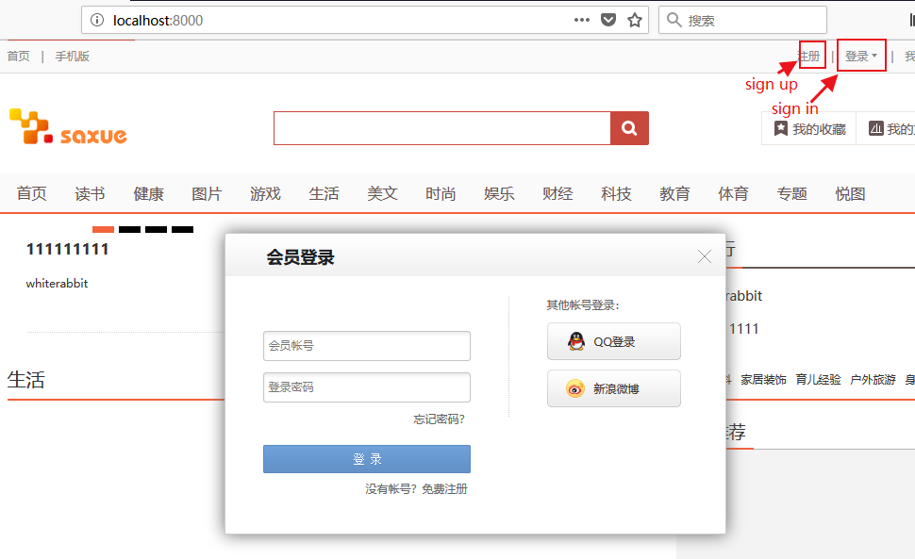
- First of all, I want to test if the CMS has xss protection mechanism, so i find an input box and insert xss.
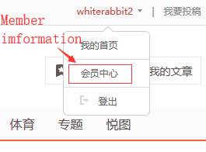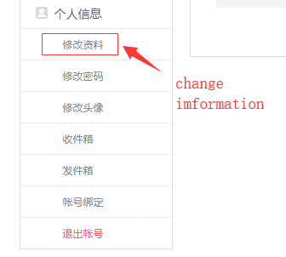
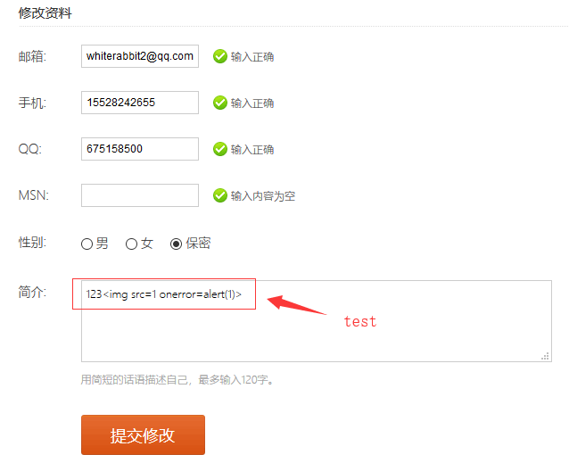

- After submitting, I found that the information stored in the database has been changed, so the xss cannot be triggered.
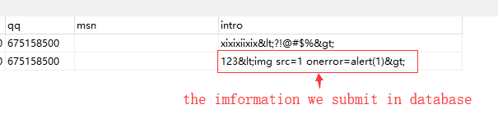

- I looked at the source code and found that they used server authentication and filtering to prevent xss injection.
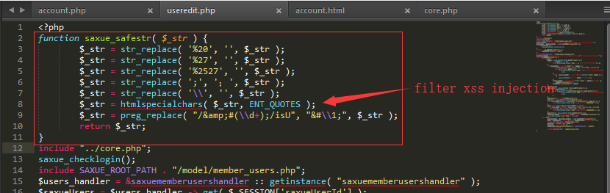
And verify the input with a regular match on the server side, which makes special characters almost impossible to use. For example, check email input:
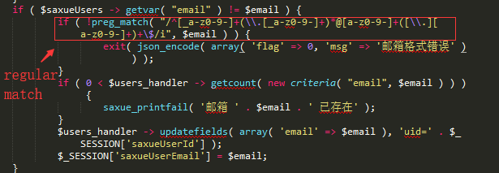
XSS Vulnerability
- This vulnerability exists in the Financial Information module. This module is used to input the bank account information of the payment.
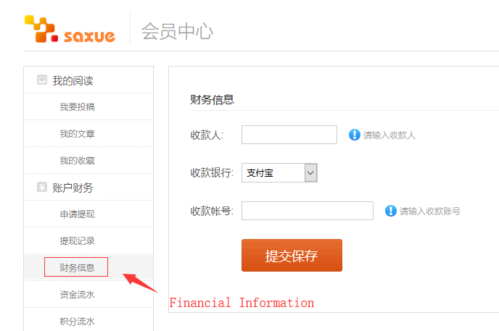
- I input ‘<’ in the account field and the display is illegal.
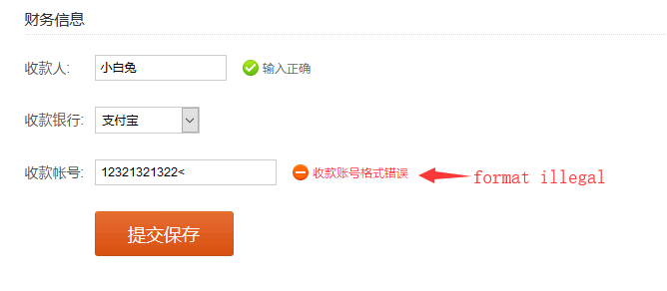
So I just submit the legal input, but I use BurpSuite to intercept the request and then modify the packet.
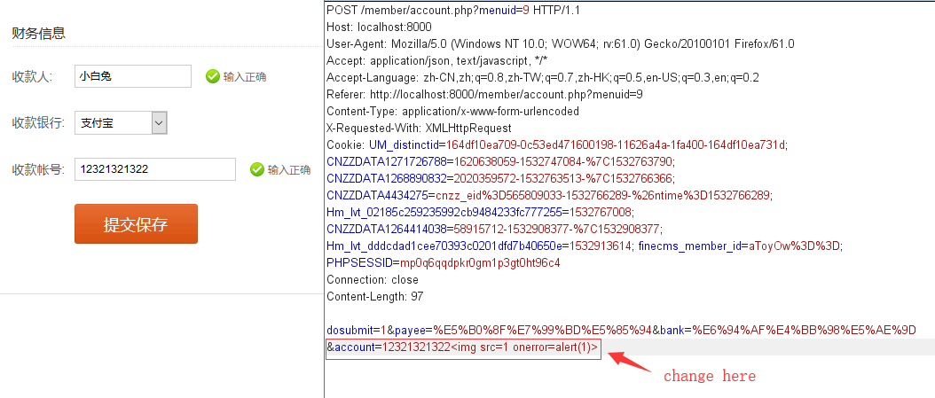
Response:
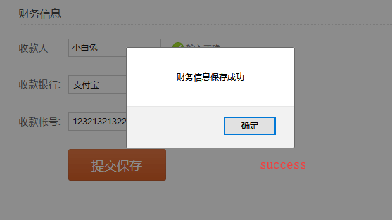
- I check the input in database:
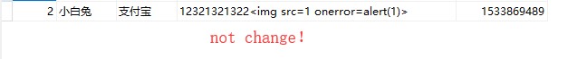
- When the admin click financial information list, Xss is triggered..
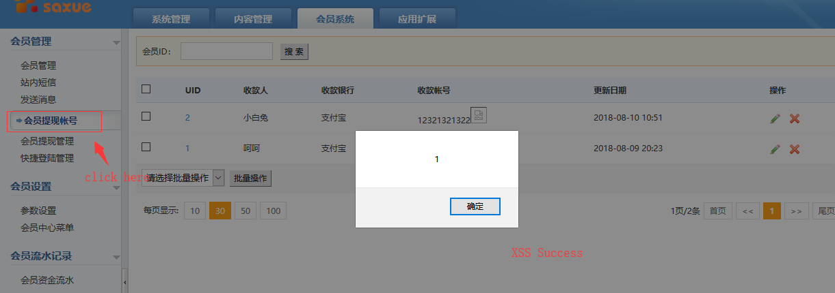

Vulnerability analysis:
- Looking at the page source, you can see that xss is successfully injected.
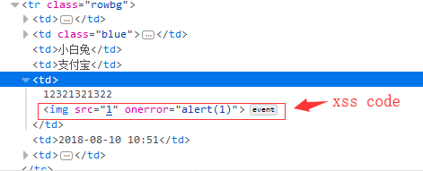

- I looked at the source code and found that the account.php page was not validated and filtered on the server side, only verified on the front-end page (account.html) with javascript.
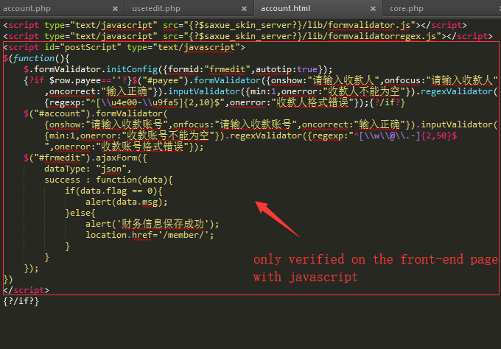
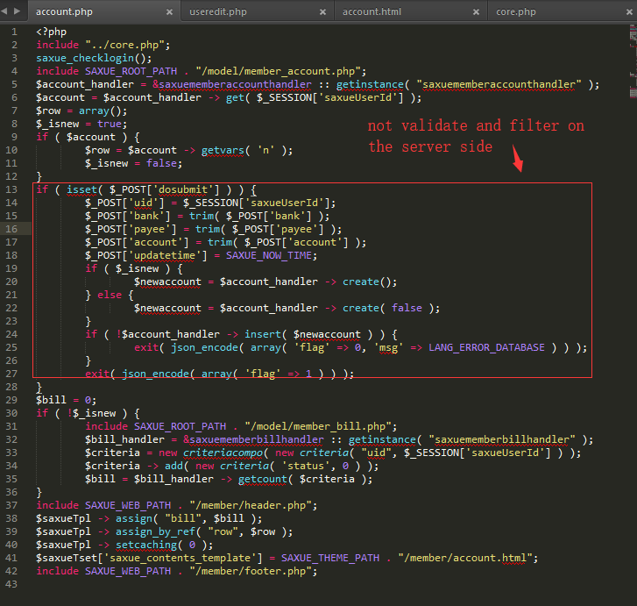
- Therefore, we can bypass and perform xss injection in the form of packet capture.

- The vulnerability seems to be caused by the carelessness of the programmer, but similar vulnerabilities have not been found on other pages.

Discoverer: WhiteRabbit

