FeiFeiCMS v4.1 has code execution vulnerability

This article mainly analyzes the code execution vulnerability of FeiFeiCMS v4.1.

CMS Official Website: http://www.feifeicms.com/
⊙. We consider about the latest version(v4.1) of FeiFeiCMS, and download link is following:
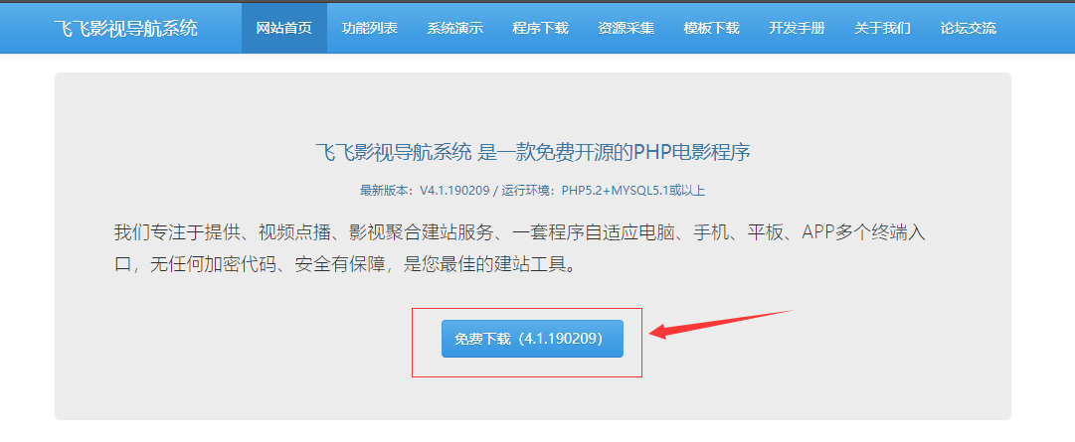
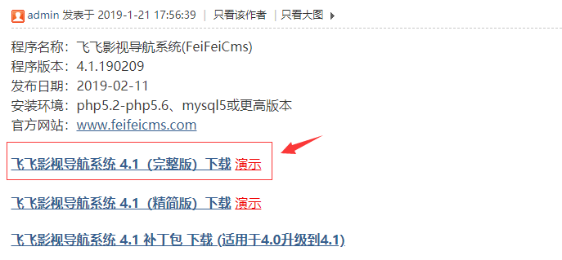

Download link:
http://code.daicuo.cc/feifeicms/4.1.190209.zip

Description: This is a code execution vulnerability that we can upload PHP files with malicious code by modifying the website configuration in the background of the website.

Test Environment:
Server: Apache 2.4.35
Language: PHP 5.6.38
Database: MySQL 5.7.23

Process:
- At first, we had to login the website background:
(http://127.0.0.1:8000/index.php?s=Admin-Index).
When I entered the website background, I found there can modify the configuration of uploading attachment.
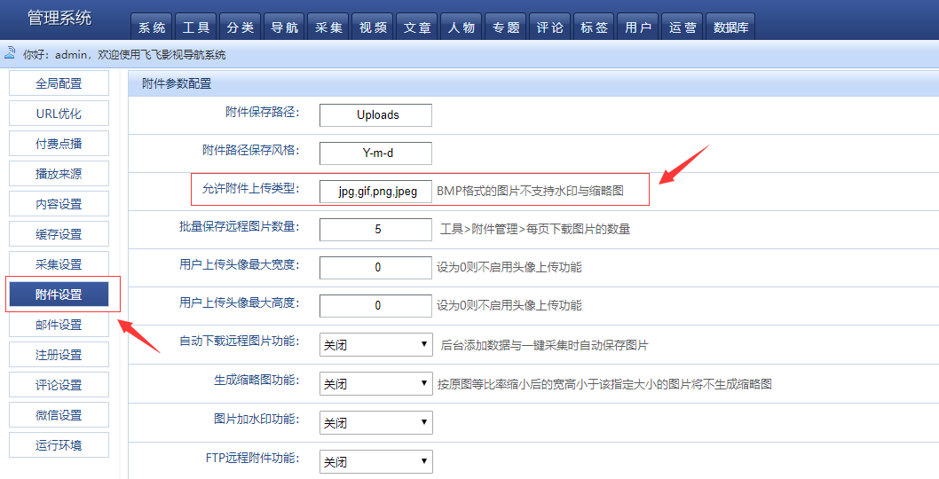

- In this position, we can directly set the filename extension of the file that is allowed to upload.

We add ‘php’ and submit:
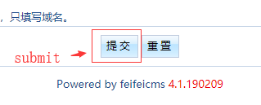
- After that, we will add an article where you can upload attachments:
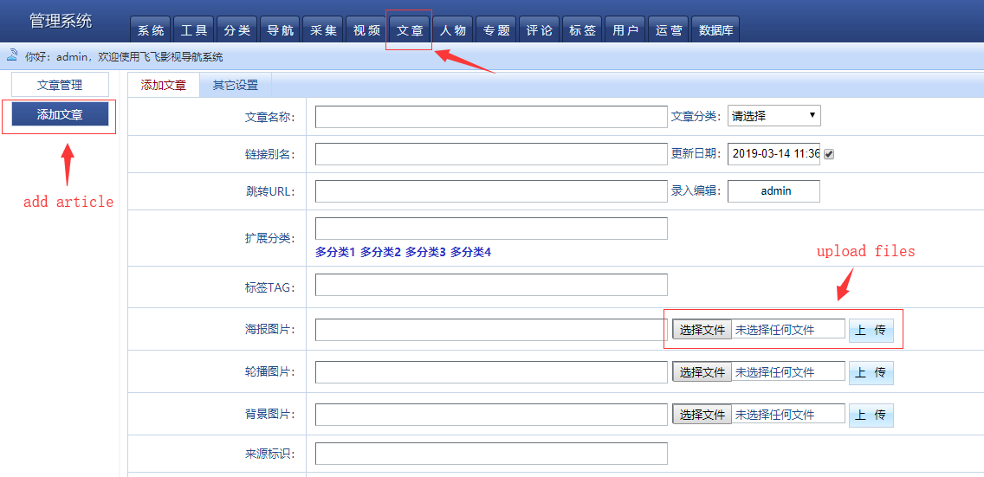

- We upload the webshell directly and can see the uploaded path directly.
(/Uploads/news/2019-03-14/5c89cfa7634dd.php).

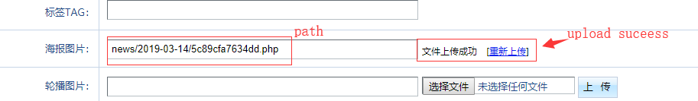

- Now, we can test the webshell:
