CS 131: Lab 1

For **each lab**, copy your source code and paste it to Visual Studio Code. Then copy from there and paste it under the place where it says “Paste your source code below”

**Lab 1a:**

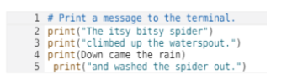

Implement the code then fix the errors (2 syntax, 1 logical) so that the program produces the following output:

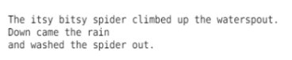

|  |
| --- |
| *Paste your source code below:*  *print*("The itsy bitsy spider climbed up the waterspout.")  *print*("Down came the rain")  *print*("and washed the spider out.") |

|  |
| --- |
| *Copy and paste a screenshot of your test results below:*   |

**Lab 1b:**

Write an **algorithm** and **pseudocode** for the following problem.

**Problem:** Given two positive numbers, x and y, find xy

**Example**

Problem:Calculate the factorial of a given positive integer n.

Algorithm:

1. *Initialize a variable result to 1.*
2. *Start a loop from 1 to n. a. Multiply result by the current loop variable.*
3. *After the loop, result will contain the factorial of n.*

Pseudocode:

*Set result to 1*

*For i from 1 to n:*

*Multiply result by i*

*End For*

*Display result*

**Your Answer:**

|  |
| --- |
| *Your Algorithm goes here.*   1. *Initialize a variable result to 1* 2. *Repeat y times multiplying the variable by x* 3. *The variable contains the value of the result* |

|  |
| --- |
| *Your pseudocode goes here.*  *let variable z equals to 1*  *for I from 1 to y do*  *let the value of variable z equals to the value of variable z times the value of x*  *end for*  *return variable z* |

**Lab 1c:**

Write a python program where you display your name on the screen by using asterisk characters, like in the picture below:

|  |
| --- |
| *Paste your source code below:*  *print*("** * *** * * * *")  *print*("* * * * * * * ** *")  *print*("** * * * * * * * *")  *print*("* * * * * * * * **")  *print*("** * ** *** * *") |

|  |
| --- |
| *Copy and paste a screenshot of your test results below:*   |