

**ITC511: Application, Testing, & Maintenance**

Documentation of End Users Help

**Group Project**

* **Anush Baduwal**
* **Krishna Bhandari**

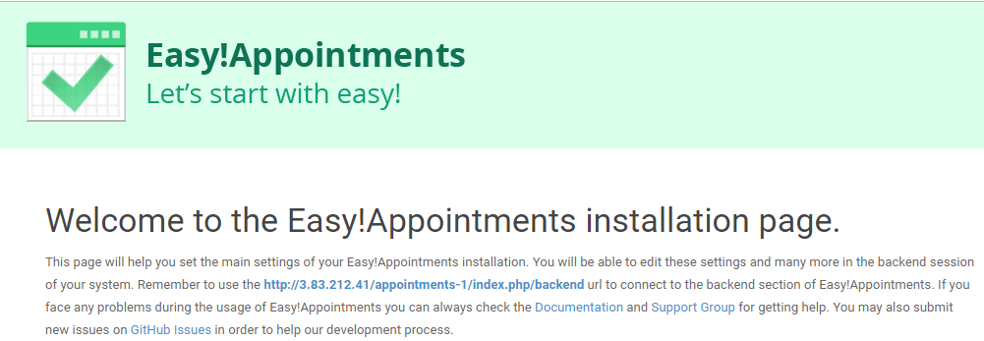

Introduction

This document is for the help to the new users to install and do many stuffs in the easy appointment application to book the meeting with different service provider.

We have made this documentation by giving the answers of question which the new users have in mind.

This document will help to the new users to do everything in backend section of Easy appointments.

**Some Questions which users might have at the beginning**

1. How to open Easy Appointments Application?
2. How to get in the backend section of Easy Appointment?
3. What would happen if I forgot my Password?
4. How to login if I forgot Password?
5. How to change the date format?
6. How can we activate the customer notifications option?
7. How can we activate the CAPTCHA option?
8. How to add a new Customer to the Backend Section?
9. How to add new Service to the Backend Section?
10. How to edit customer details at Backend Section?
11. How to edit services details at Backend Section?
12. How to delete services details at the Backend Section?
13. How to delete customers details on Backend Section?
14. How to get logged off from the Backend Section?
15. How to change company details?
16. How to edit personnel information’s?
17. How to change Password?
18. How to add break on working days?
19. How to know the version of easy appointments?
20. How to add new administrator?
21. How to add an unavailable day?

**User Help (Answer of Above Question)**

**How to open Easy Appointments?**

Step 1: Go to your browser and search as in the figure below:



Step 2: You will get the following screen as in figure.

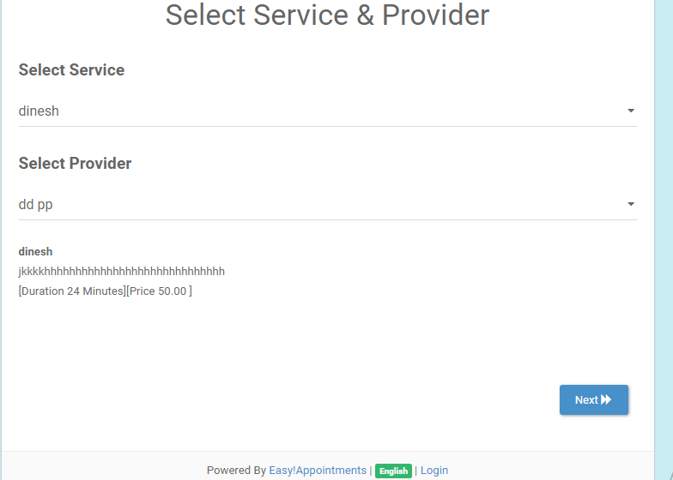

How to get in the backend section of Easy Appointment?

Step 1: Open the Easy appointment Application.

Step 2: Click in the Login Button at the footer of the page.

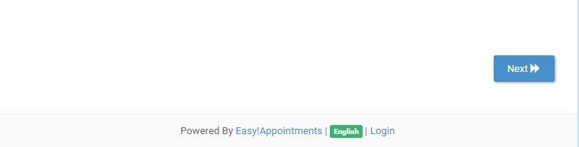

Step 3: You will get the following form

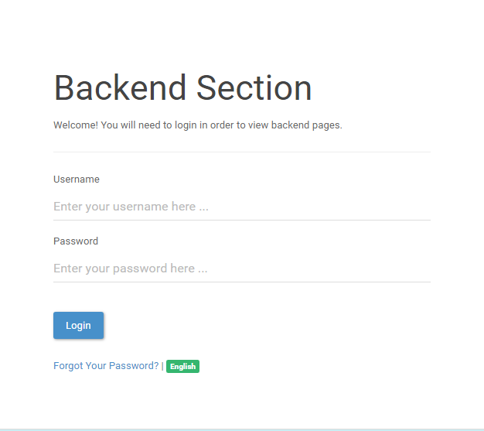

Step 4: Enter Correct username and password and you will enter to the Backend Section.

What would happen if I forgot my Password?

If you lost the password, you will receive the following message

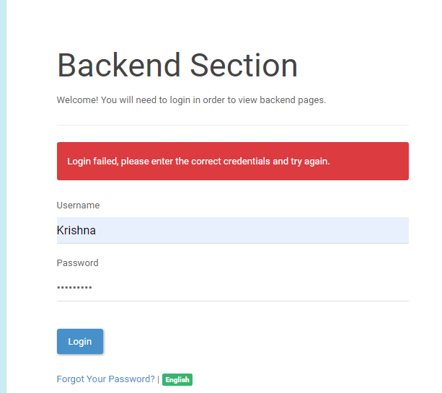

**How to login if I forgot Password?**

Step 1: Click on Forgot your Password at the bottom of the Screen.



Step 2: You will get the following things to register.

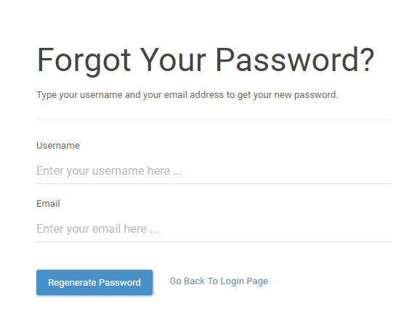

Step 3: Fill in the forms with the required information and click on Regenerate Password.



Step 4: you will get the following details if you enter incorrect information.

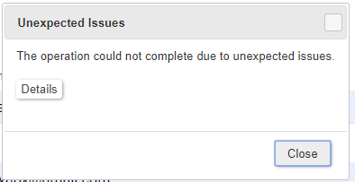

# **How do I change the time format at Backend Section?**

Step 1: Select the setting Button



Step 2: you will get the Screen as below:

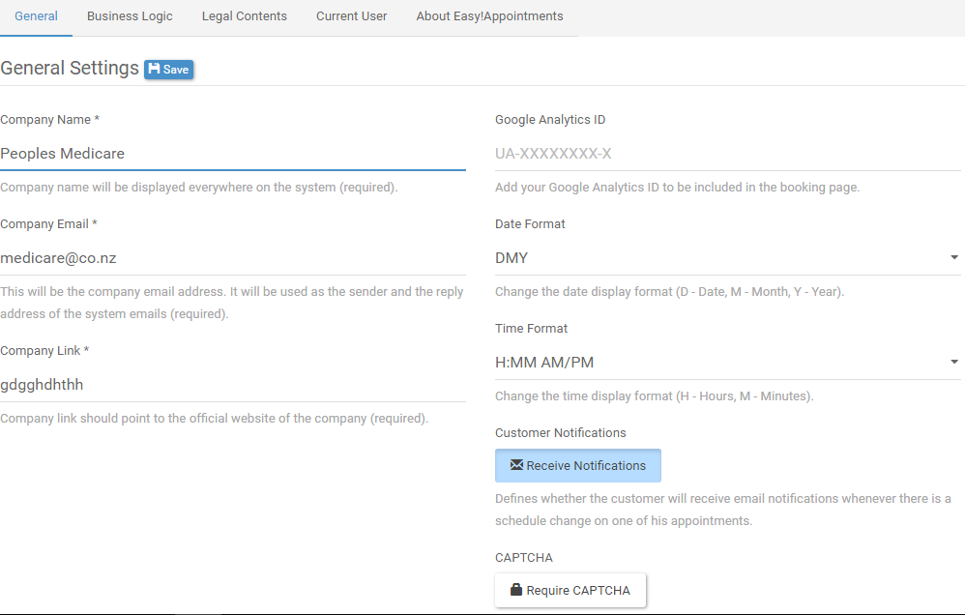

Step 3: In the General setting page look for the following options

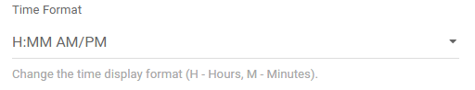

Step 4: Check the check box for different options.

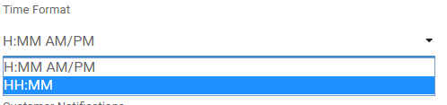

Step 5: Click  button on top to save your update.

# **How do we activate the customer notifications option?**

Step 1: Select the Settings button on top navigation menu bar at Back-End Homepage.



Step 2: Then you will able to enter General settings section of Back-end.



Step 3: Click once to activate and click again to de activate.

Step 4: Click save to update your change.

# How to activate the CAPTCHA option?

Step 1: Select the Settings button on top navigation menu bar at Back-End Homepage.



Step 2: Then you will enter to General settings section of Back-end.



Step 3: Click once to the receive Notifications and click again to deactivate the Notifications

Step 4: And then, click  button on top to save your update.

# **How to add a new customer into back end section?**

Step 1: Select the customers section on back-end homepage.



Step 2: Then you will be able to enter following interface;

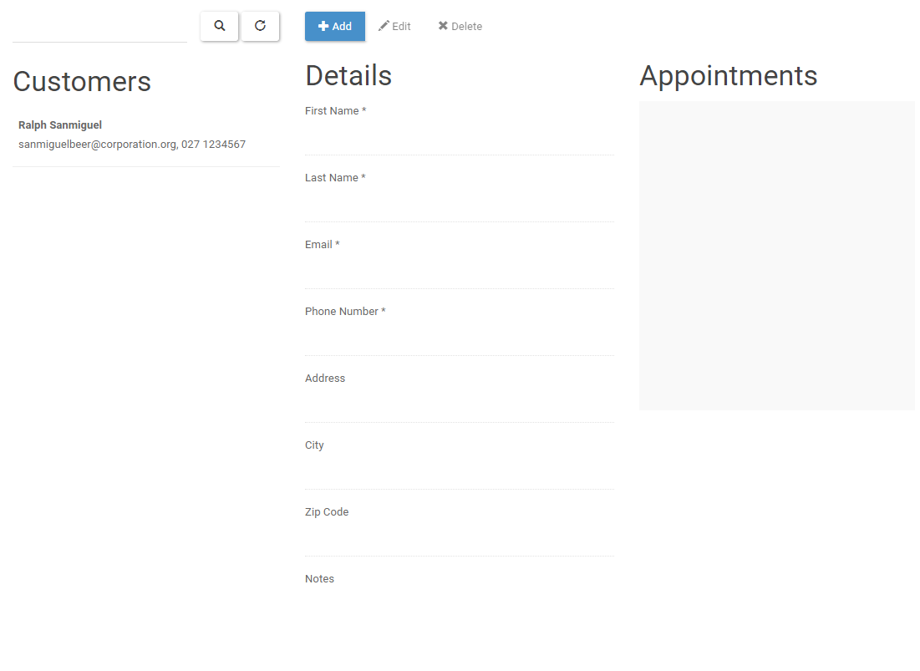

Step 3: Then click on add button.

Step 4: Then, fill the required as you prefer;

Step 5: Then click save button to save you work.

Step 6: Then you will have your entered data right side.

# How to add new service on back end section?

Step 1: Select the customers section.



Step 2: You will see the following screen.

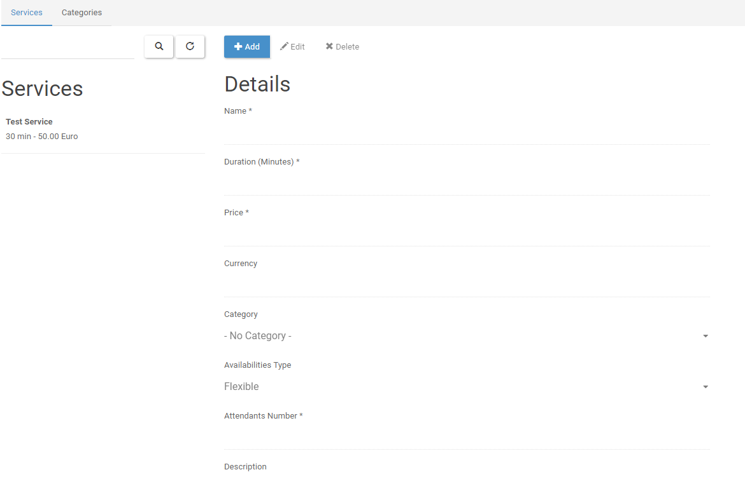

Step 3: click on add button to procced further.

Step 4: fill the form

Step 5: Click save button.

# How to edit customer details on back-end?

Step 1: Select the customers section.



Step 2: You will see the following screen.

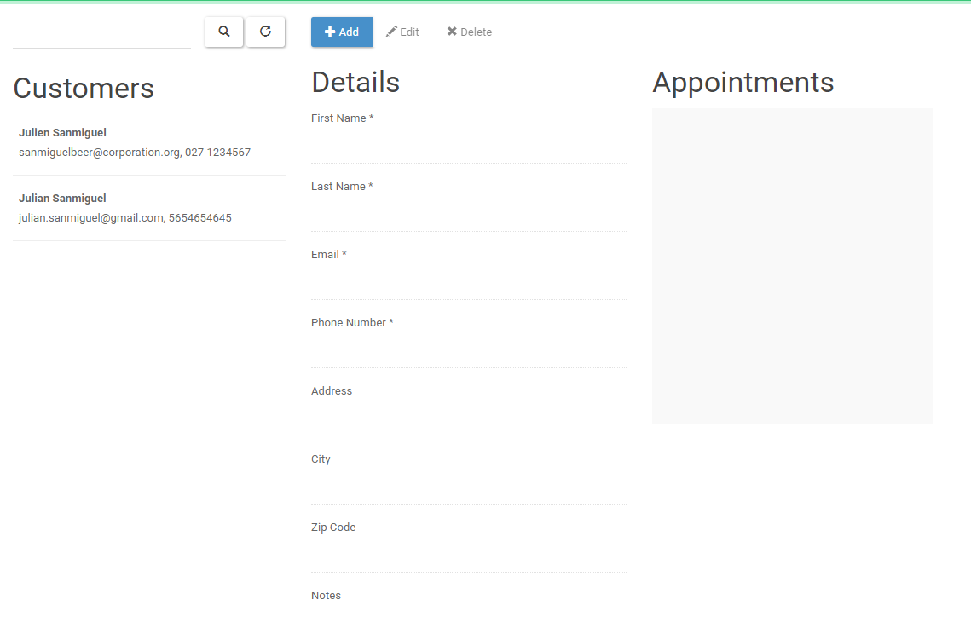

Step 3: Click on add button to procced further.

Step 4: fill the form

Step 5: Click save button.

# **How to edit services details on back-end?**

Step 1: Select the service section.



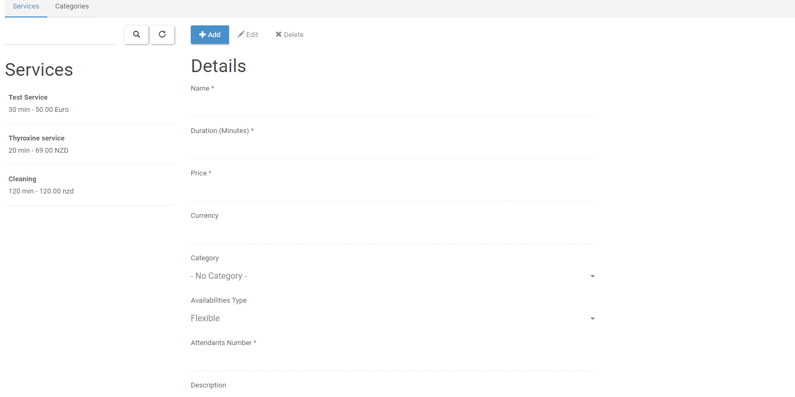

Step 2 : Select the service you want edit.

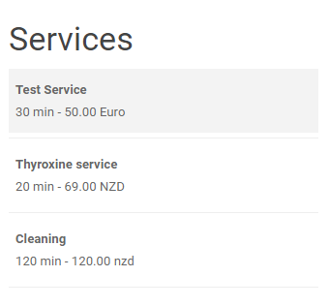

Step 3: select the button.

Step 4: edit the form as you prefer.

Step 5: select the  button to save your work.

**How to delete services details on back-end?**

Step 1: select services



Step 2: You will see the following screen.



Step 3: select the service you want edit.



Step 4: select the button.

Step 5 :Then it will pop out a confirmation message.

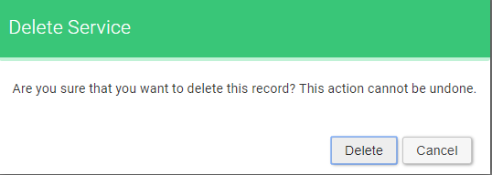

Step 6 :Then select button.

# **How to delete services details on back-end?**

Step 1: Click at services



Step 2: You will see the following screen.



Step 3 :select the service you want edit.



Step 5: Select the button.

Step 6: Then it will pop out a confirmation message.



Step 7: Select button.

# **How to delete customer details on back-end?**

Step 1: Click on Customer



Step 2: you will see the following screen.

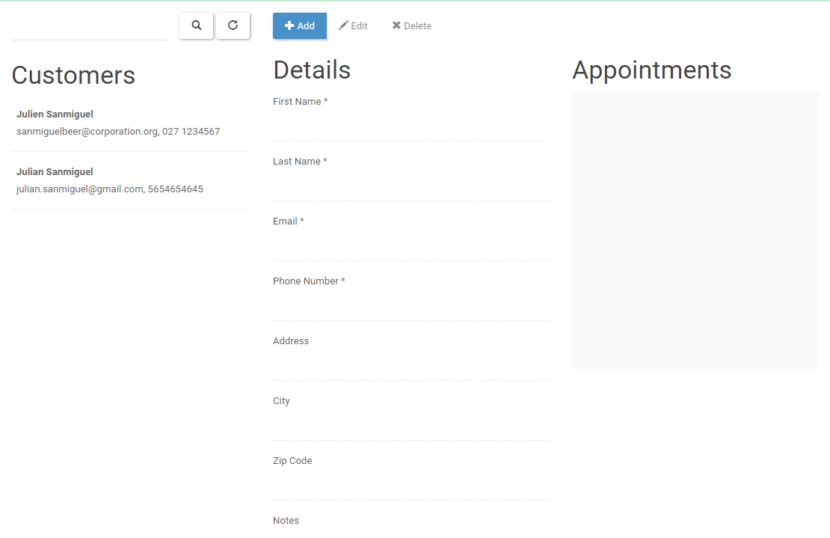

Step 3 :Select the customer you want delete.

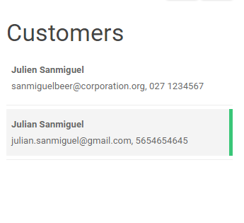

Step 4: Select the button.

Step 5: it will pop out a confirmation message.



Step 6 :Then select button.

**How to change company details?**

Step 1: Go to the settings from the menu.

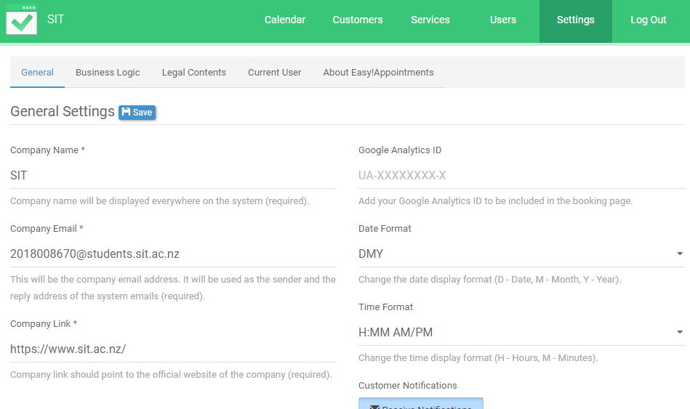

Now click on the settings below general settings change the details and save it.

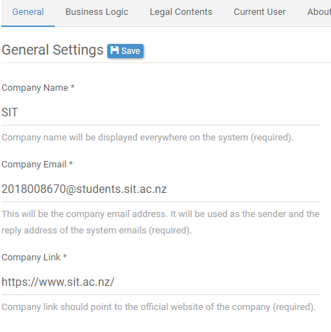

# **How to edit personal information’s?**

Go to current user in settings.

Edit the information’s.

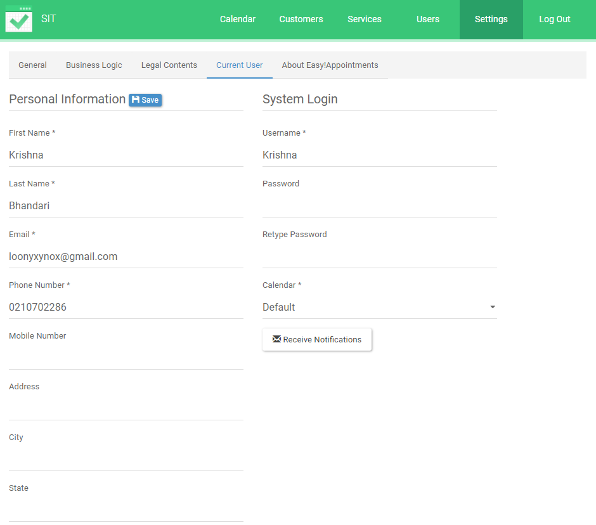

# **How to change the password?**

Go to current user under settings.

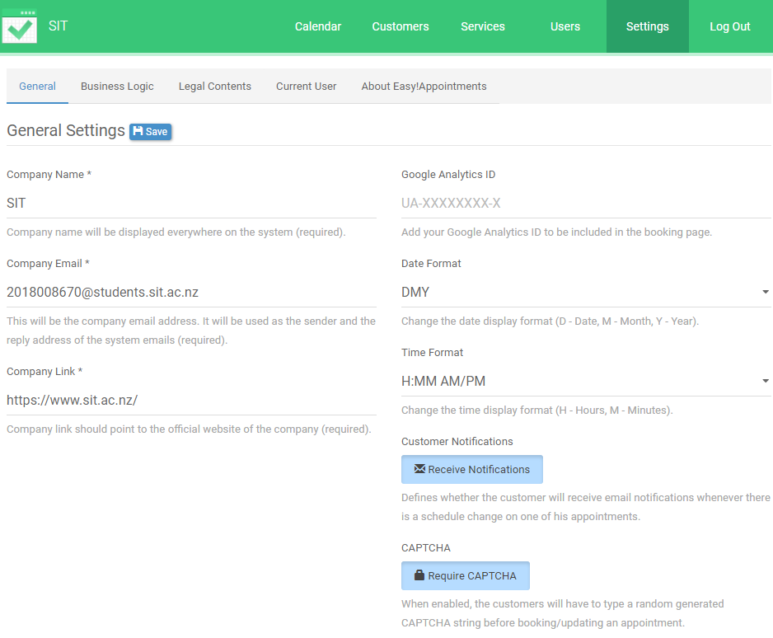

Type new password on the password section and save it

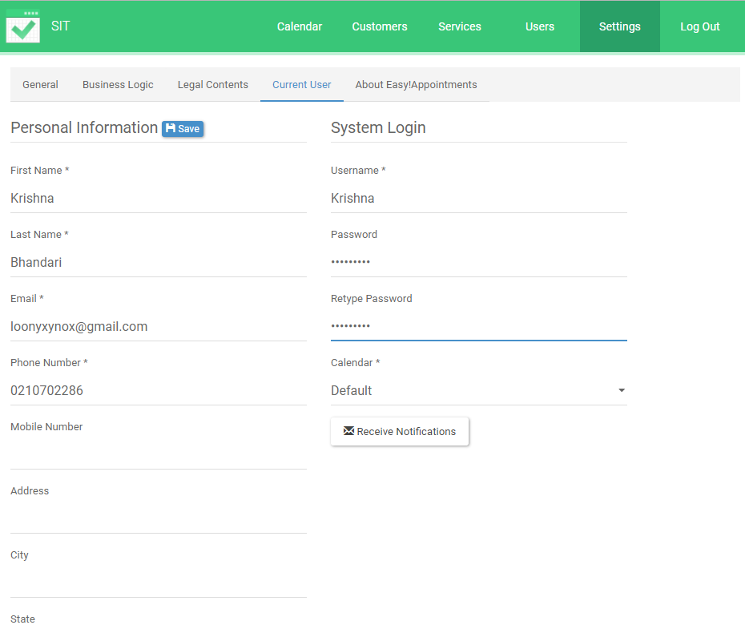

# **How to add break on working day?**

Go to business logic under settings

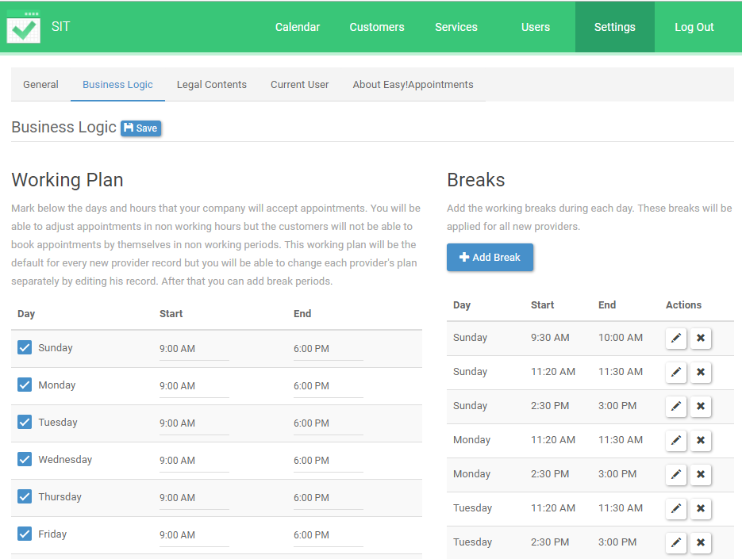

Then click on add break on Breaks.



Then select any days and add break as per needed.

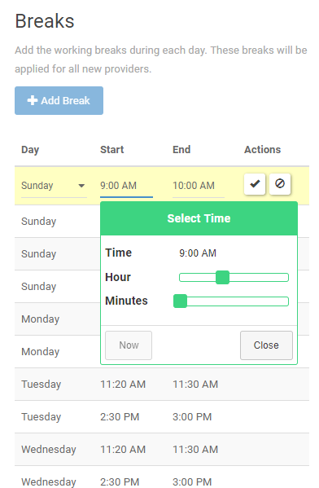

# **How to know the version of easy appointments?**

Go to about easy appointments under settings.

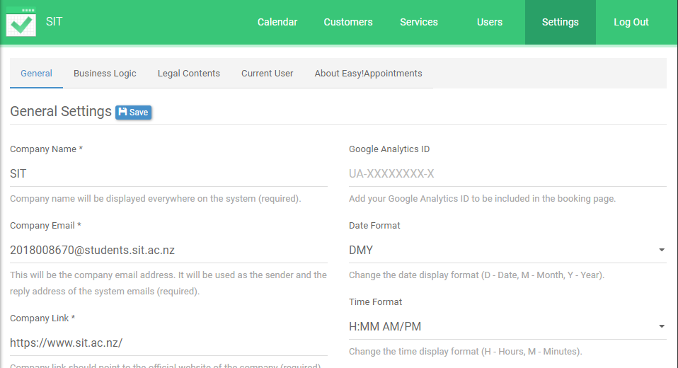

You will find the version under easy appointments

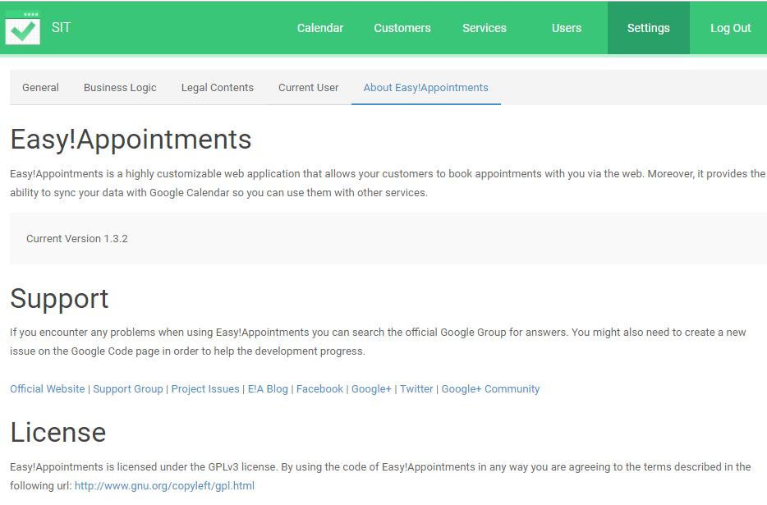

# **How to add new admin?**

Go to admins under users

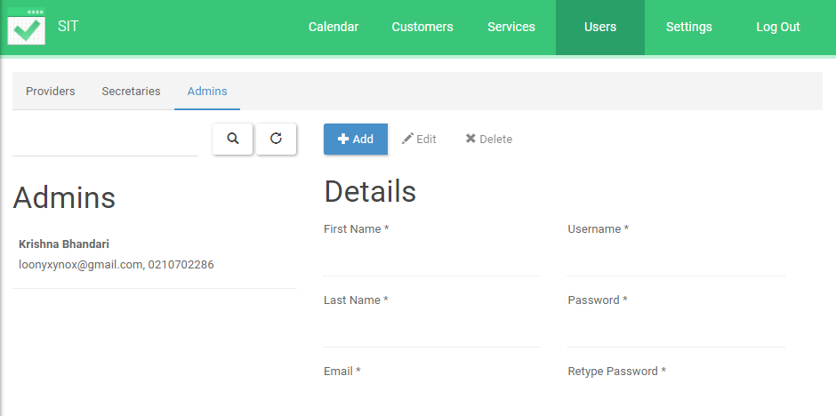

Click on add



Fill up the required information’s and save it.

# **How to add any unavailable day?**

Go to calendar on the menu

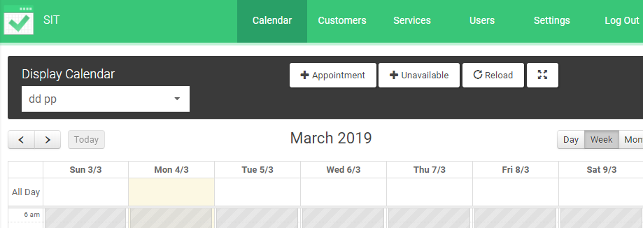

Click on un available



Chose the date till when you are going to be unavailable and save it.

