Aileron System Requirements
Revision 2.0

- Overall System Requirements
The following requirements apply to the aileron actuator system
  - Range of travel: Aileron must move through a range of travel from -60 degrees to +75 degrees
  - Aerodynamic load: Aileron must withstand wind speeds of 1000 km/h at full extension with less than 1mm deflection.
  - Speed requirement: Aileron must track a 2 Hz signal within 0.5 degrees deflection

- Mechanical System Requirements
The following requirements apply to the functionality of this module
  - The mechanical system is as shown below in Figure 1:
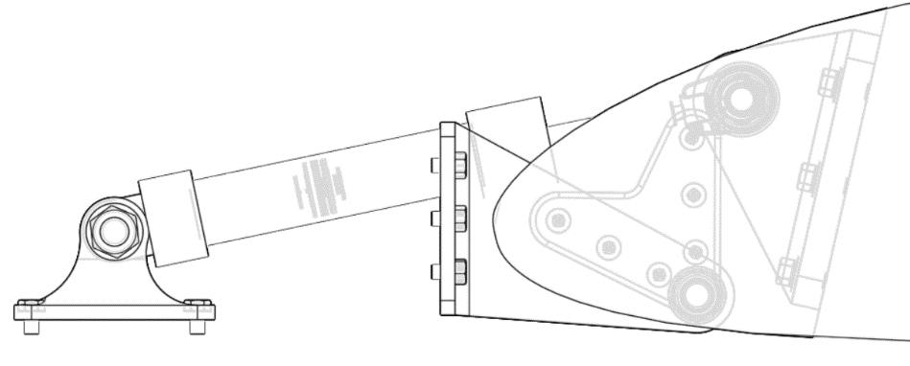

- Actuator System Requirements 
The following requirements apply to the Aileron System:
  - Force characteristics: The system must not require more than XXX N force to track any text signal.
  - Tracking requirement: The actuator must track the required angle within 0.1 degree at all times

- Speed Controller Module Requirements
The following requirements apply to the Speed Controller module.
  - Upon a change of angle, the system must be within 5% of the final value within 0.1 seconds (Settling Time).
  - Upon a change of 10% of angle the system must achieve 10% of the final value within 0.7 seconds

- Current Controller Module Requirements
The following requirements apply to the Current Controller module of the aileron.
  - The current must remain within 1% of the command value during flight.
  - The current may not exceed XXX amperes.

- Aero Load Requirements 
The system must provide adequate performance on the following flight cycles
  - Constant speed at varying altitude and varying angle of attack
  - Varying speed at constant altitude and varying angle of attack

