[Dhwani.patel21@gmail.com](mailto:Dhwani.patel21@gmail.com)

Rally123

Rally-> Online Tool to manage Agile base s/w.

So we can say Project Management tool../ Application life cycle management.

(Req, analysis, design, dev, test, main)

(need to store all this things early we used excel sheet. We need pass that sheet all team member.)

Features of Rally:-

1. Easy to Understand flow
2. Workspace based management tool that allows users to manage projects of multiple domains or Organizations in a single tool.

(You can create separate domain for each project , and in that domain you can create different

Different workspace.)

1. Free community edition that provides free subscription for to users and 5 projects.
2. Fully customized environment which allows users to make their own customized page according to usage.
3. Provides Integration with version control system.

(Combine your user stories.)

Explain story point……

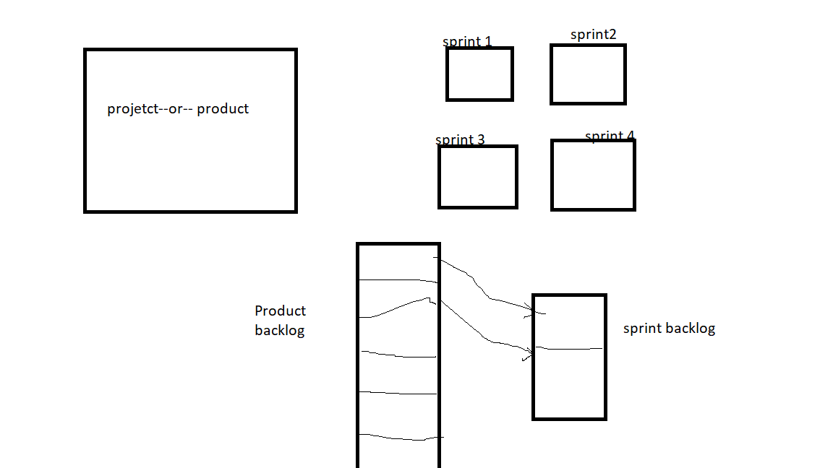

Here in sprint back log we took 2 user stories.. so in sprint 1 we all will work for only that 2 user stories….

**Story grooming :-** Analyze requirements and any questions to be discussed

**Story points:-**

It is used to discuss the difficulty of the story with assigning actual hours.

Let assume,

We are working for 8 hrs.

2 hours for meetings and checking mails and update in GIT. 1 hour break.

So now we have 5 hrs.

5 hrs 🡪 1 story point

Login page🡪 3 pt

Logout page🡪2pt

registration page🡪5 pt

**What is velocity?**

Velocity is a metric that is calculated by addition of all efforts estimates associated with user stories completed in a iteration. It predicts how much work Agile can complete in a sprint and how much time will require completing a project.

It is a Project management tools/ Application lifecycle management- managing the project.

Defect Management tools—managing the defect

Jira- DMT+PMT

Rally-PMT

QC-DMT

Bugzilla-DMT

1. Create Project

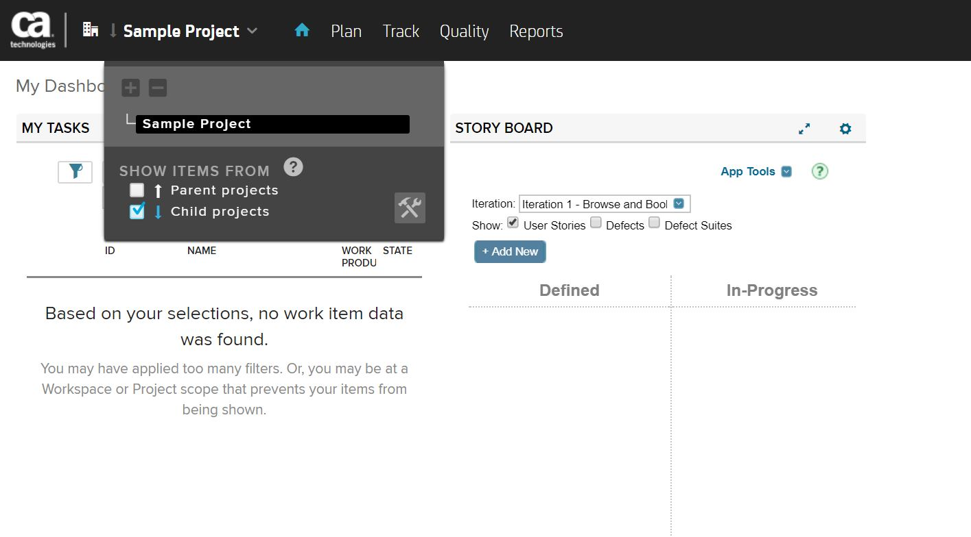

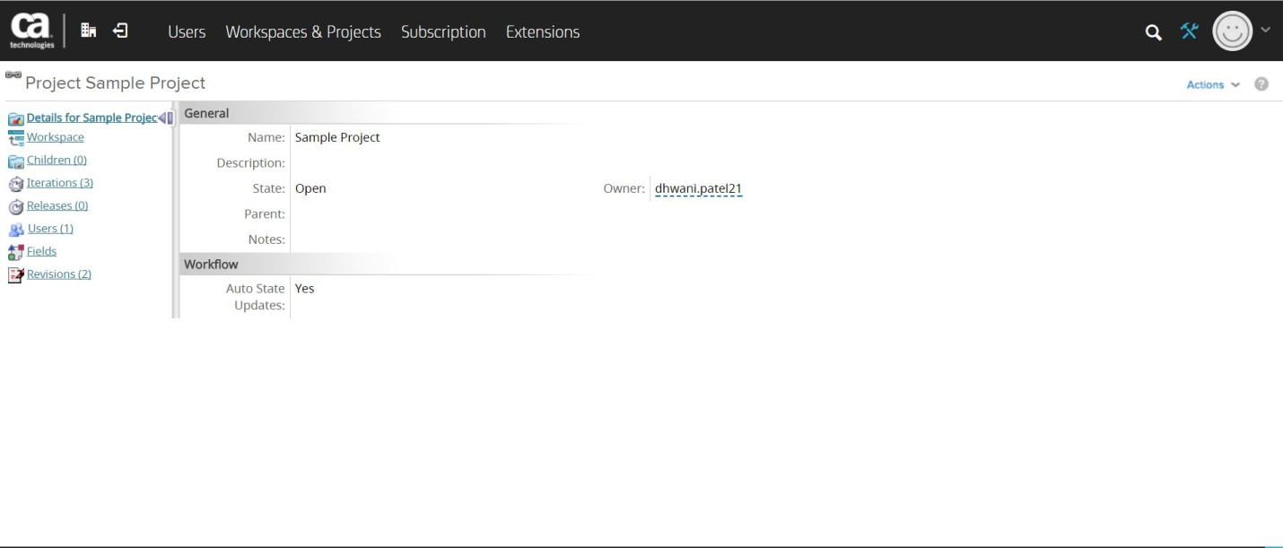

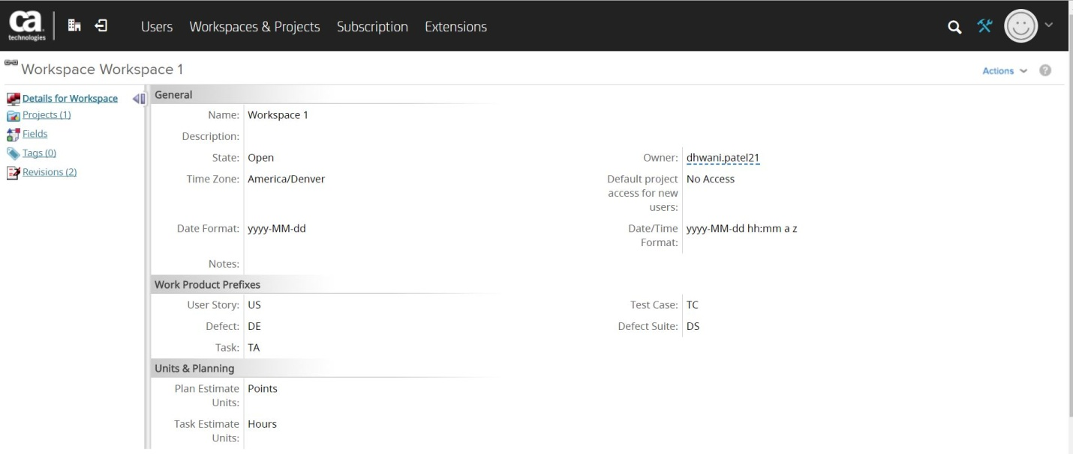

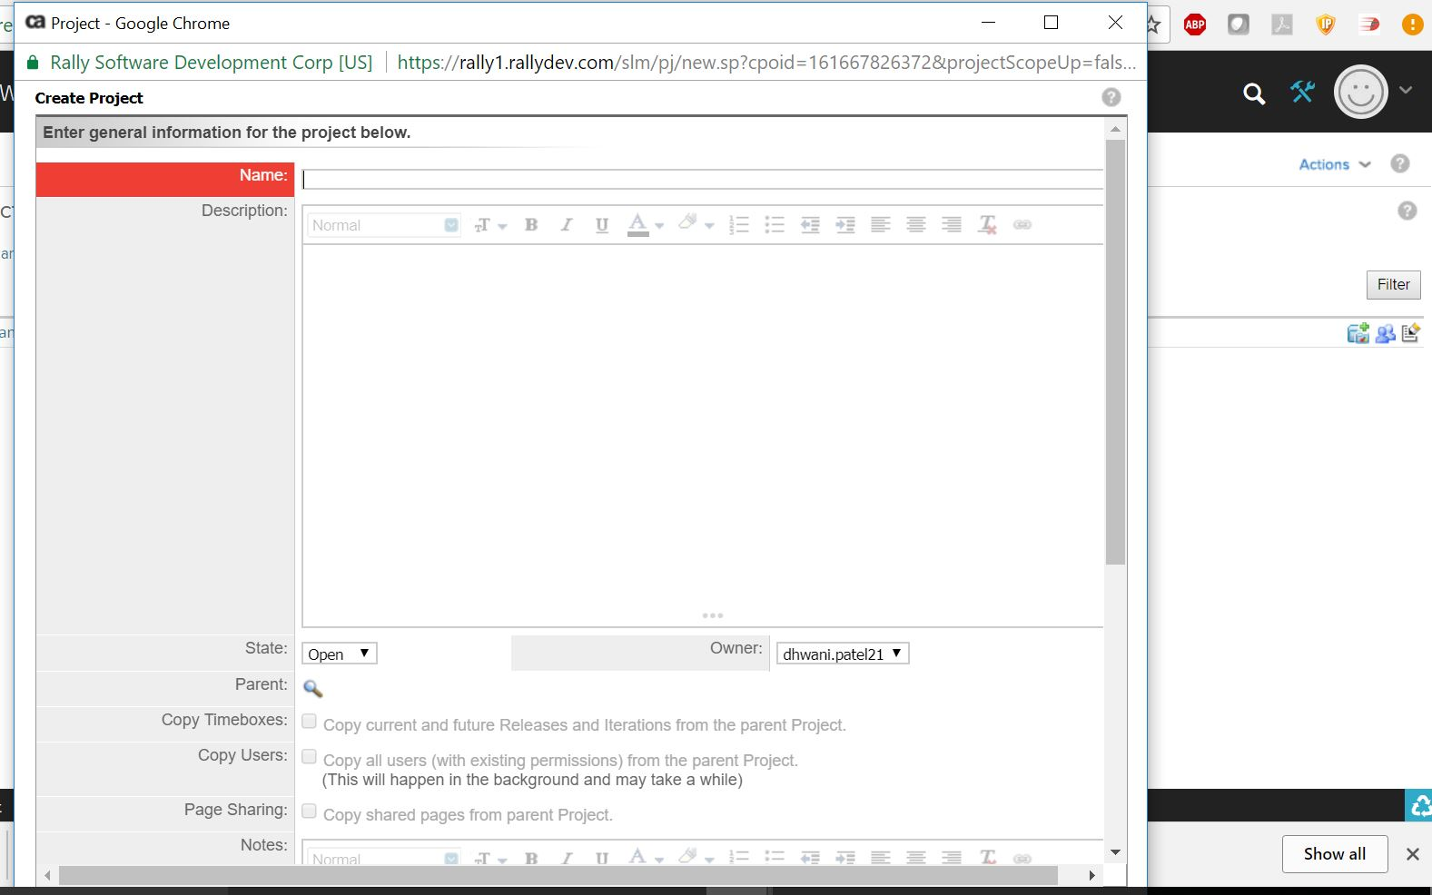

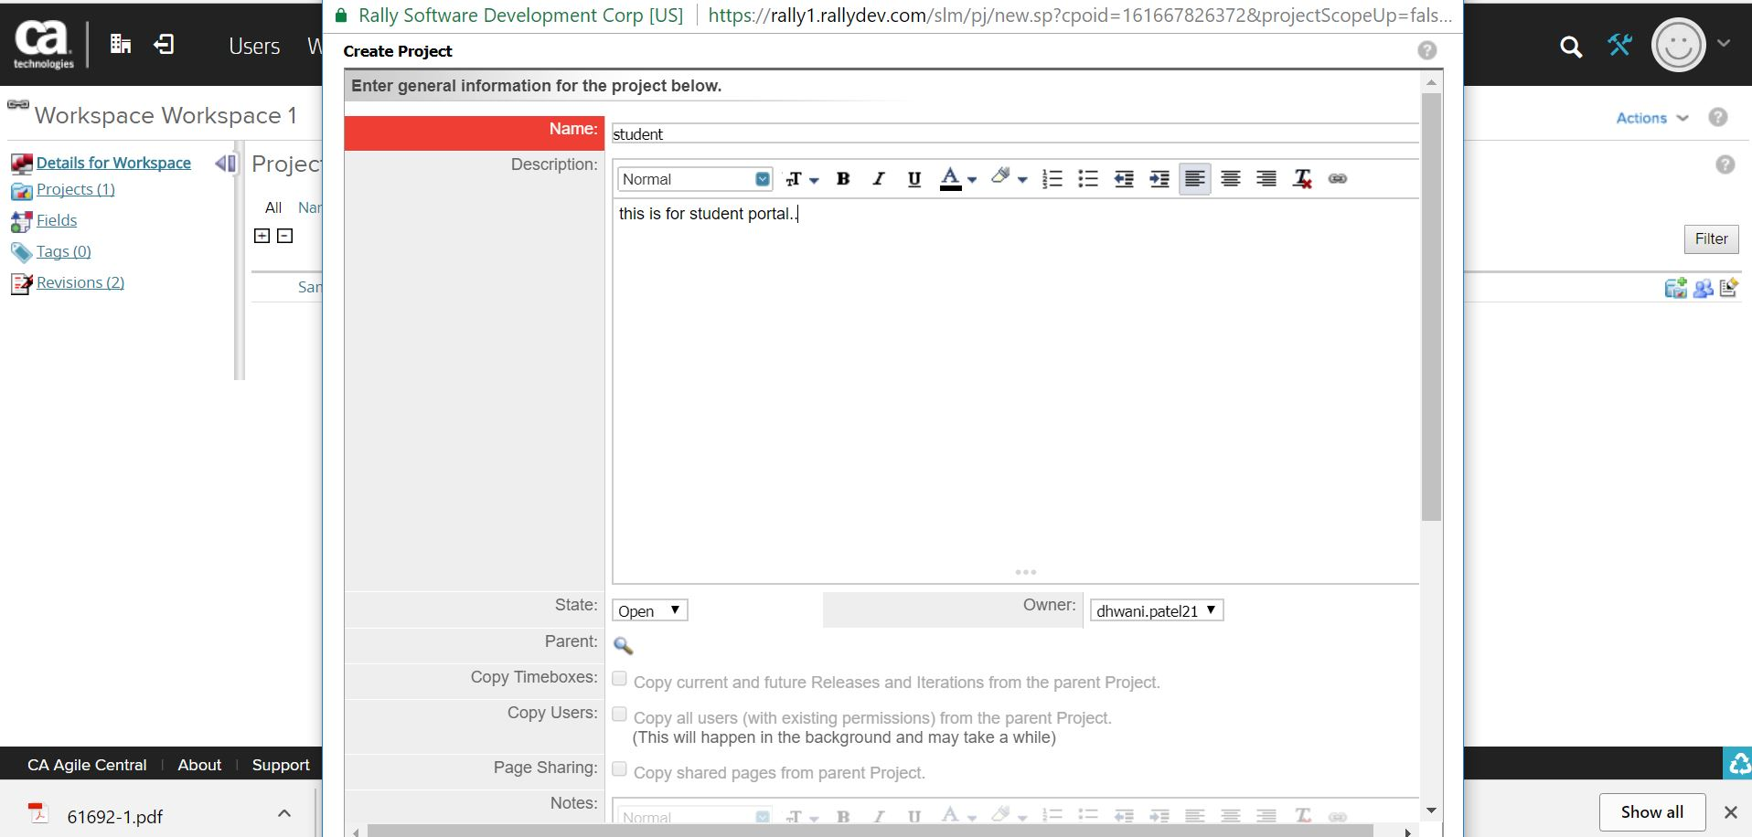

1. Create Module

D:\WBL Material\Rallay_Create Module_SC-6.JPG

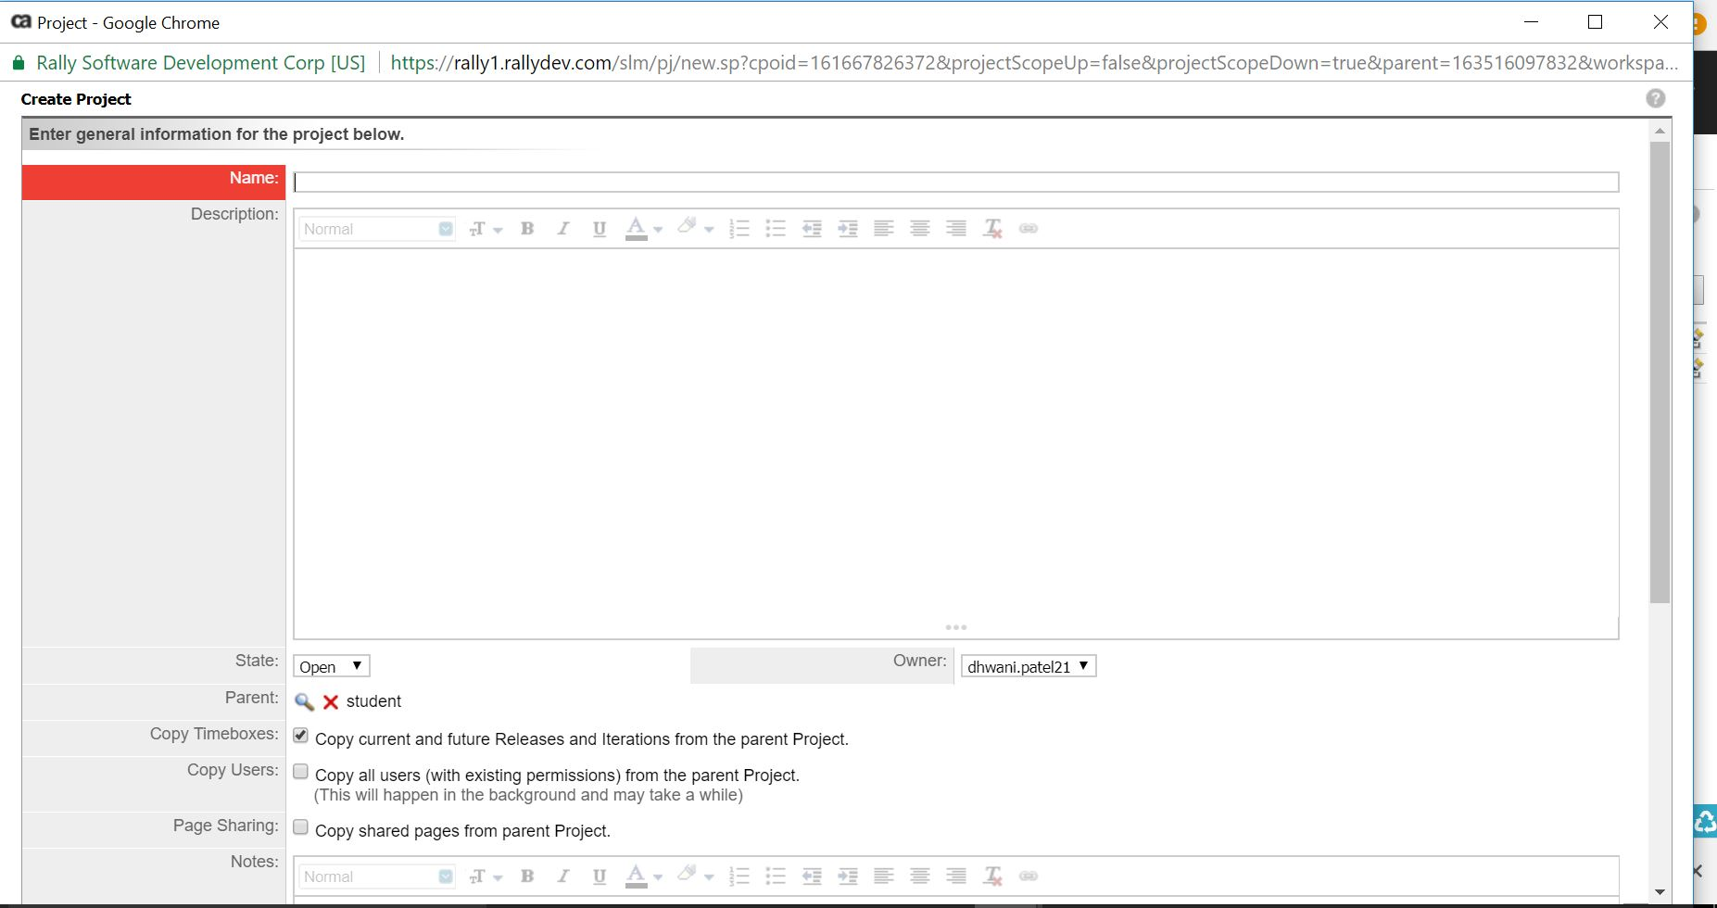

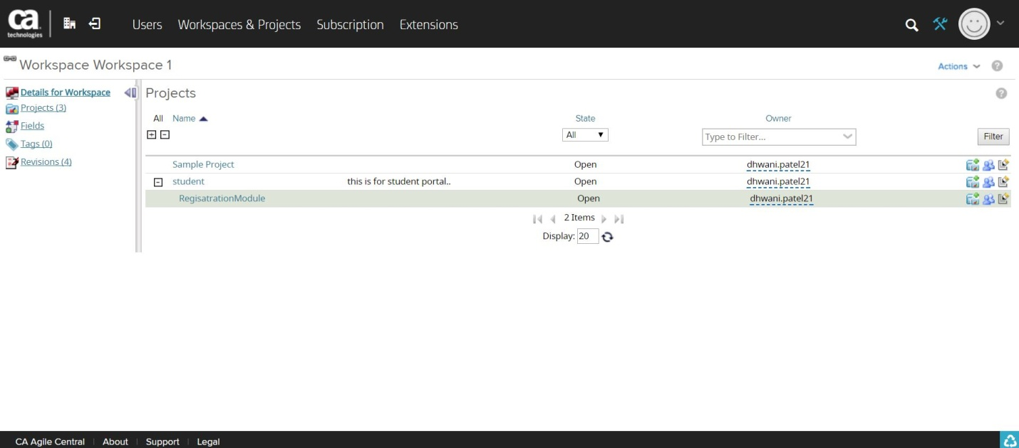

1. Add Backlog

D:\WBL Material\Rallay_Backlog_SC-9.JPG

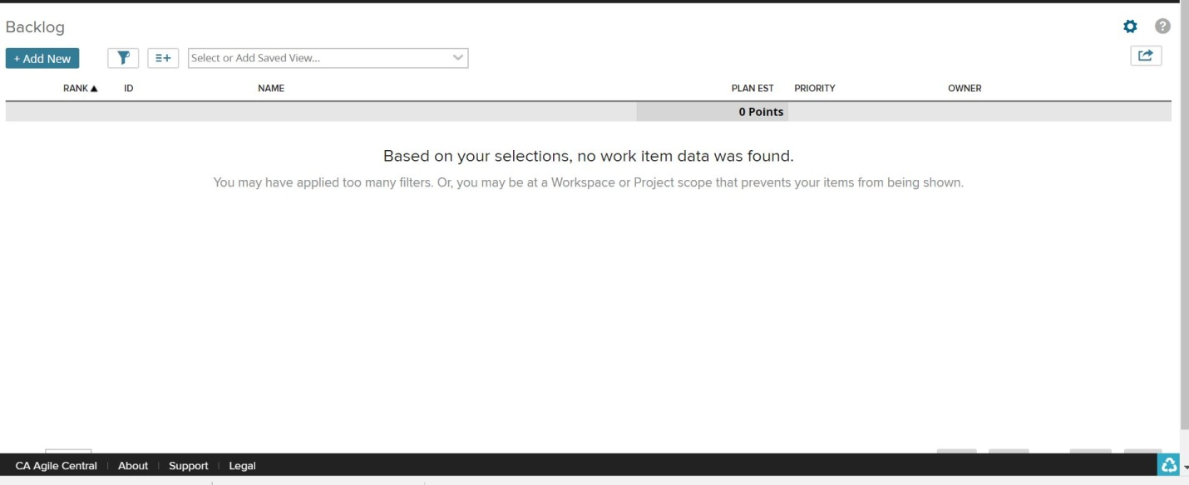

1. Create Story.

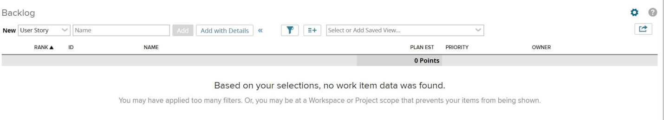

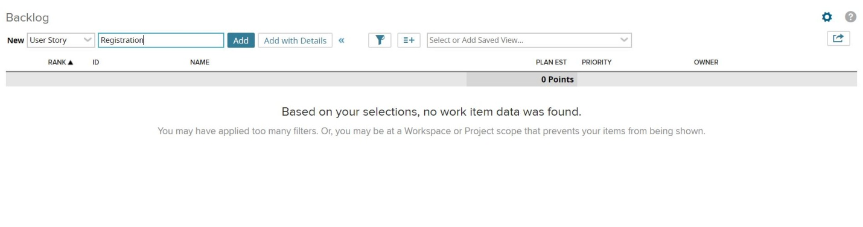

Add details for user strory.

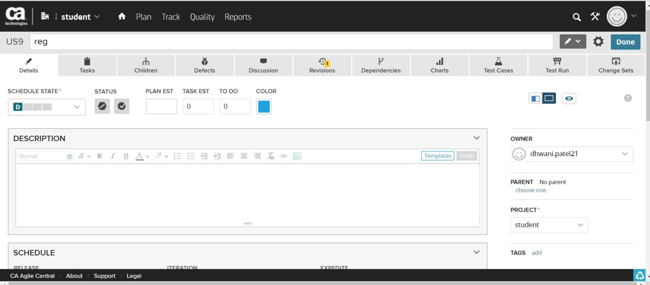

1. Create child story

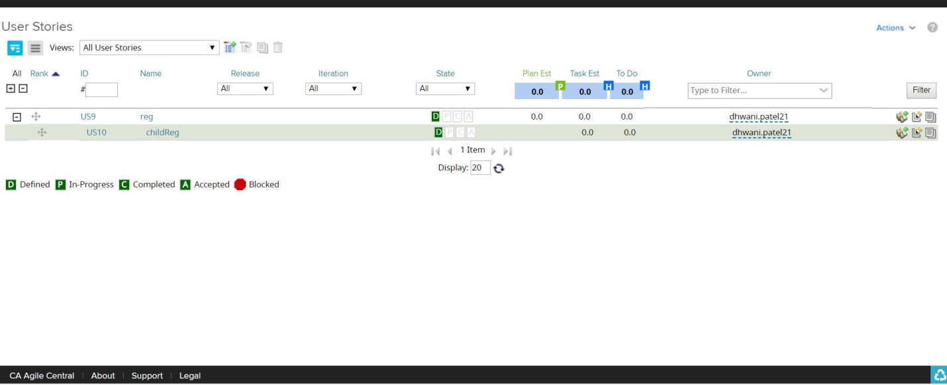

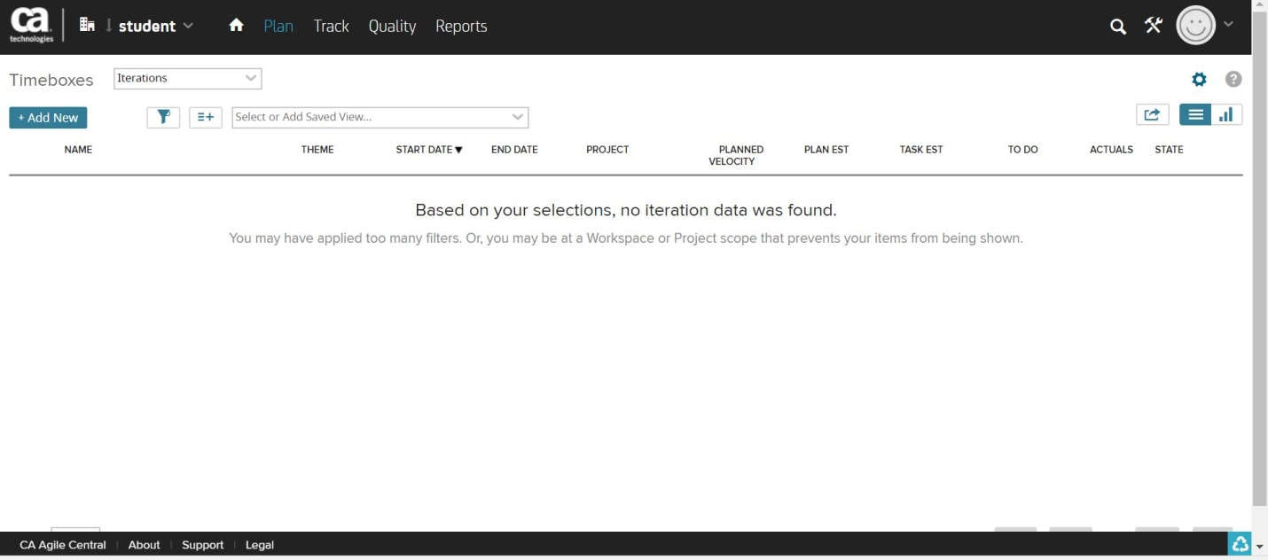

6.Create Iteration

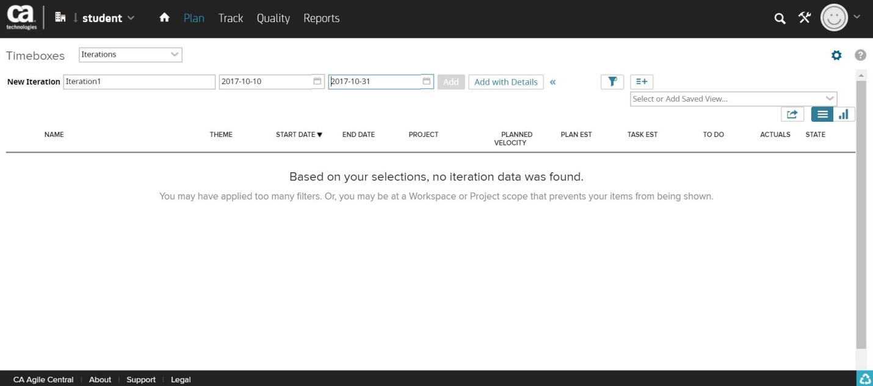

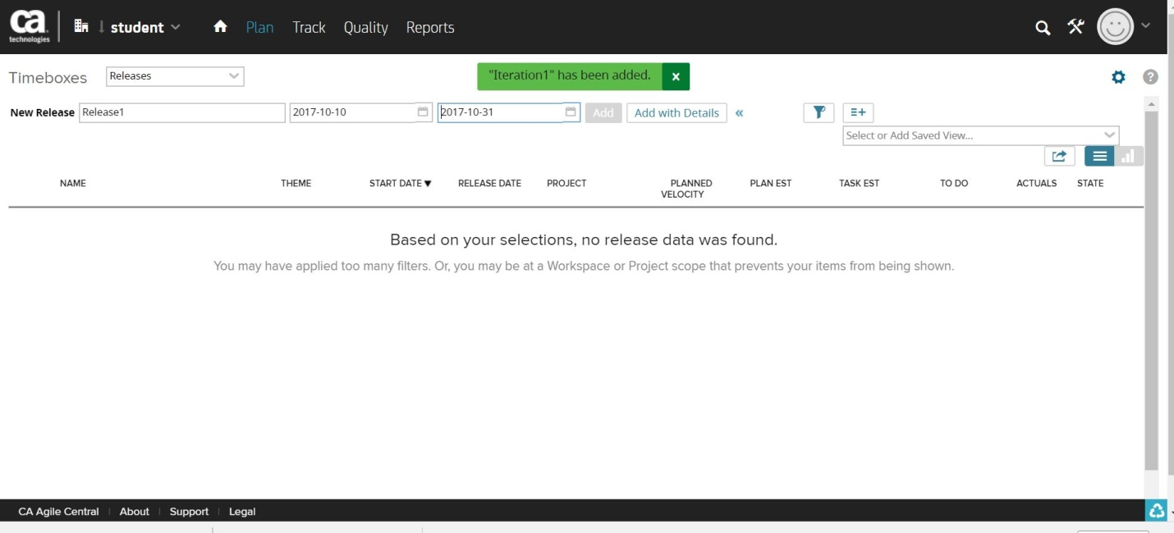

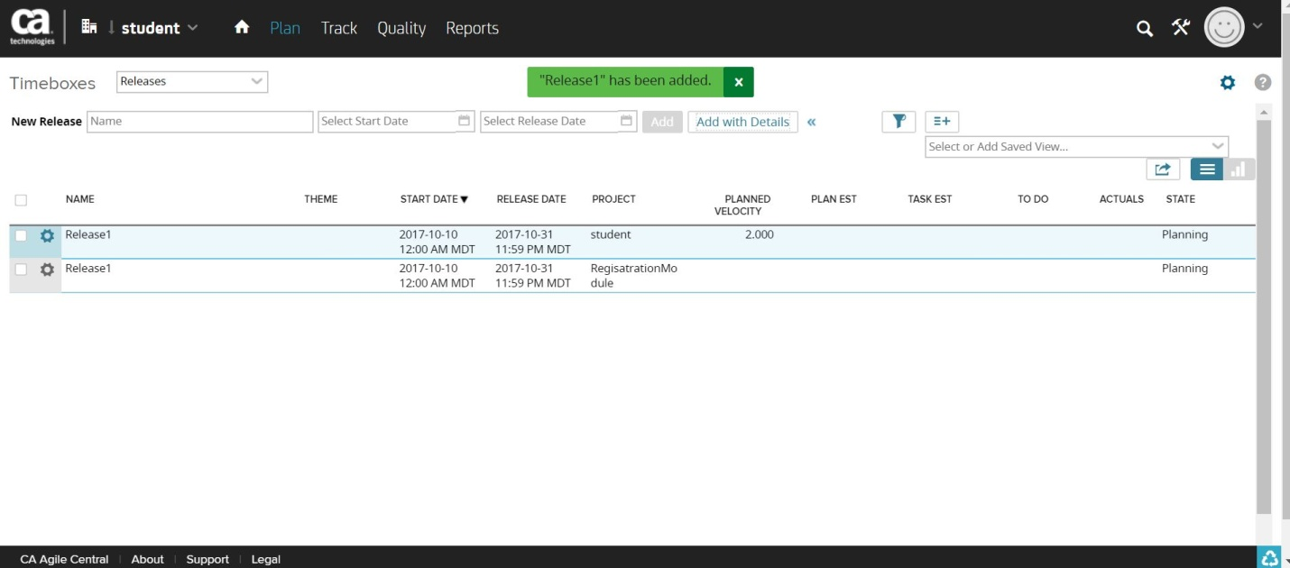

7.Iteraiton status

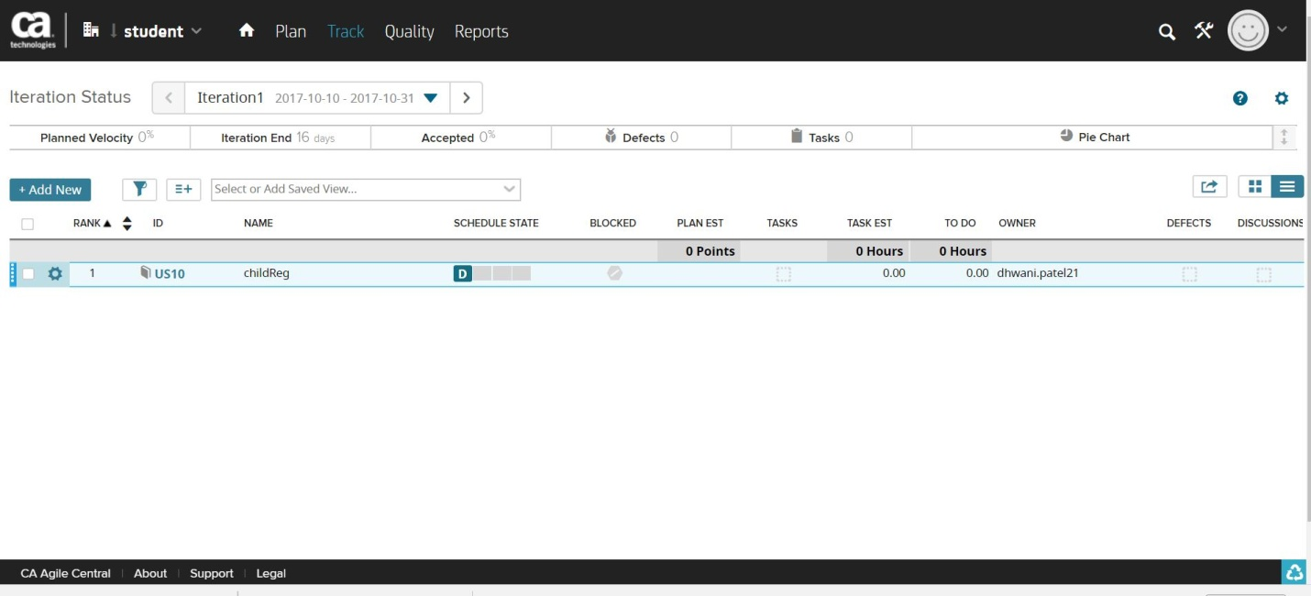

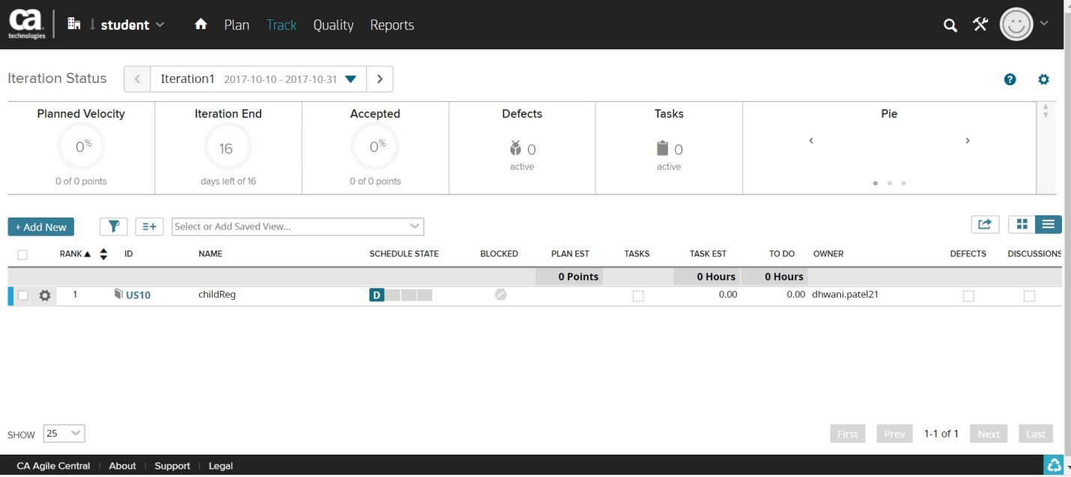

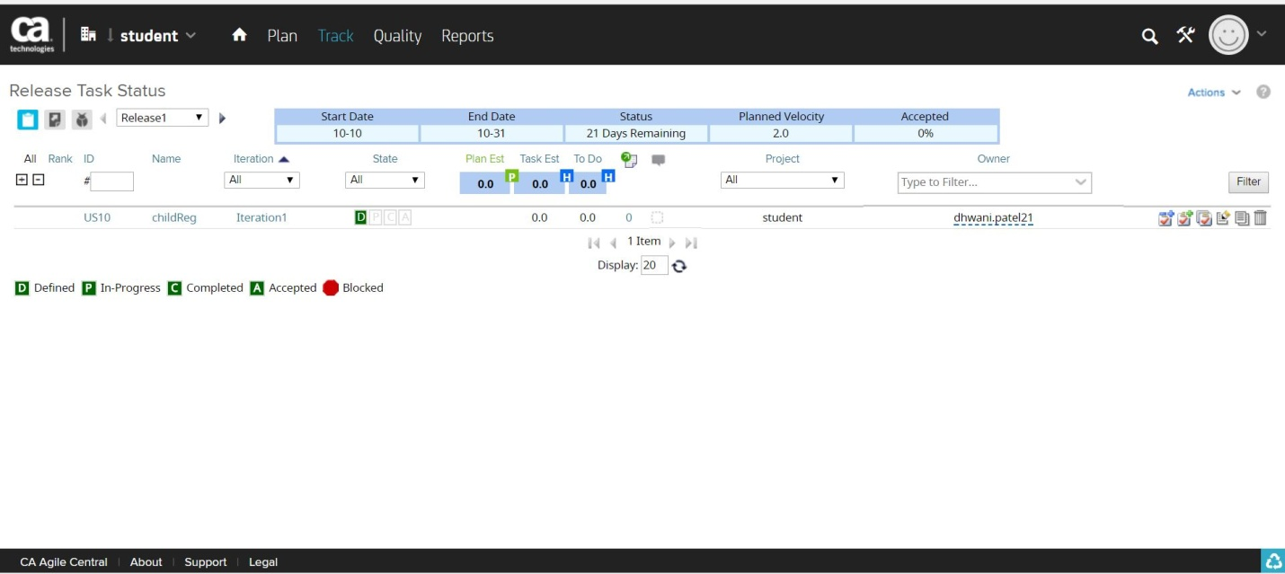

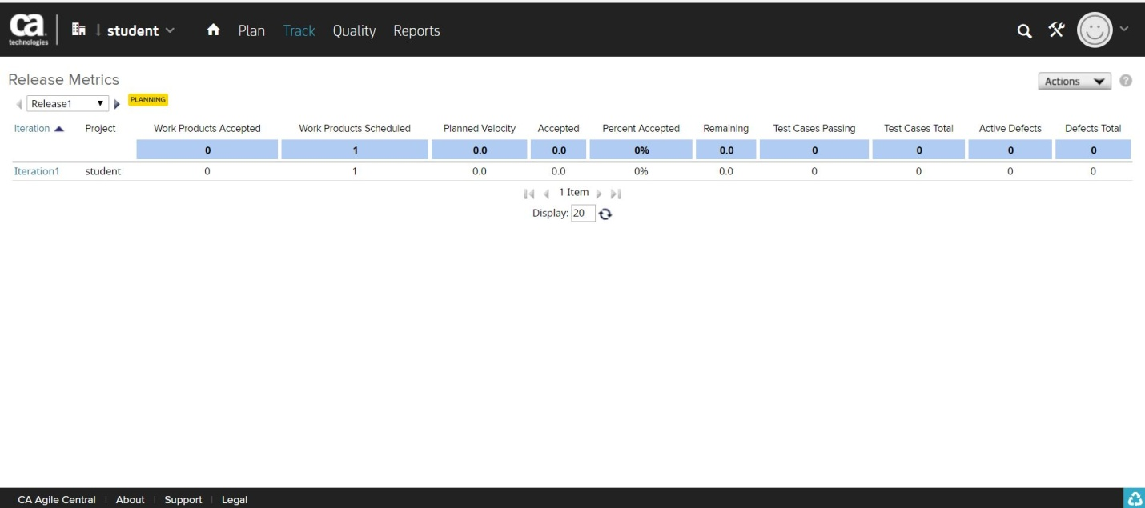

8.CREATE USER STORY

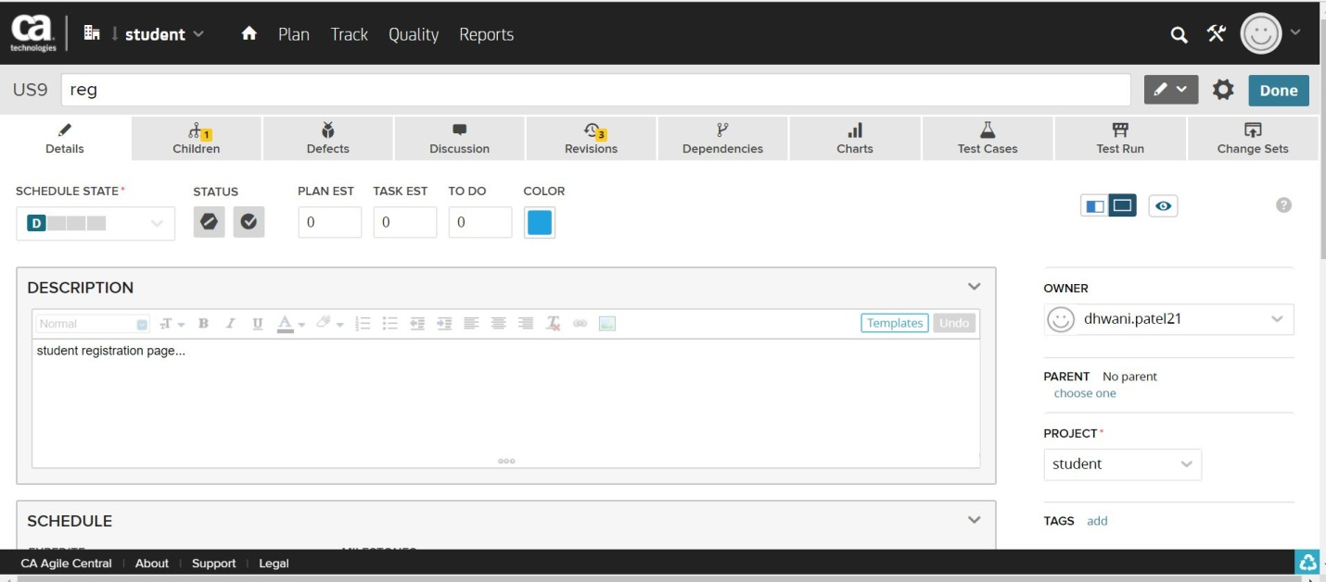

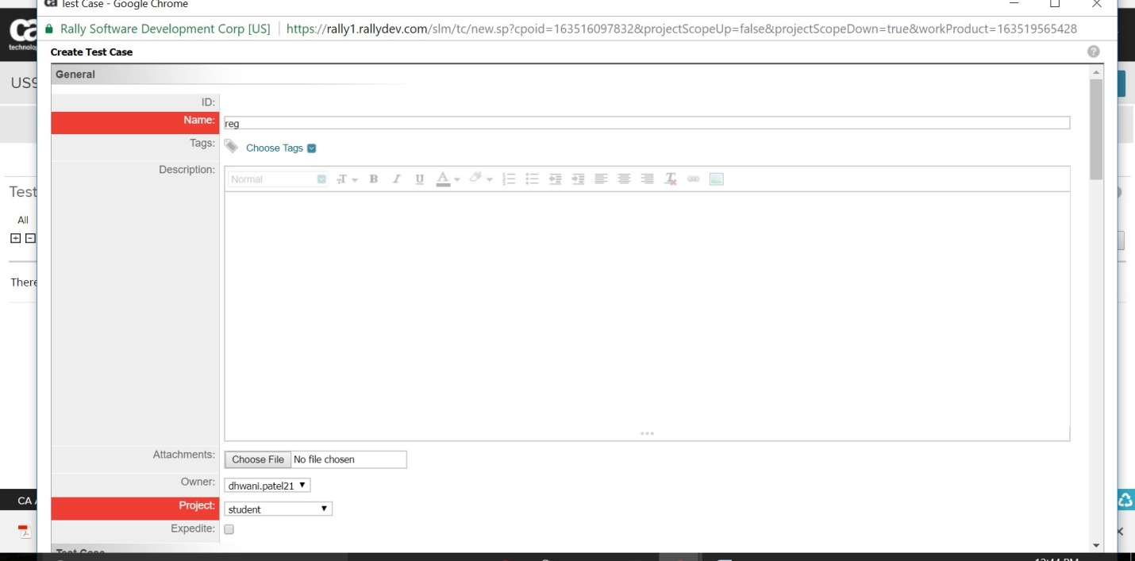

9.ADD USER.

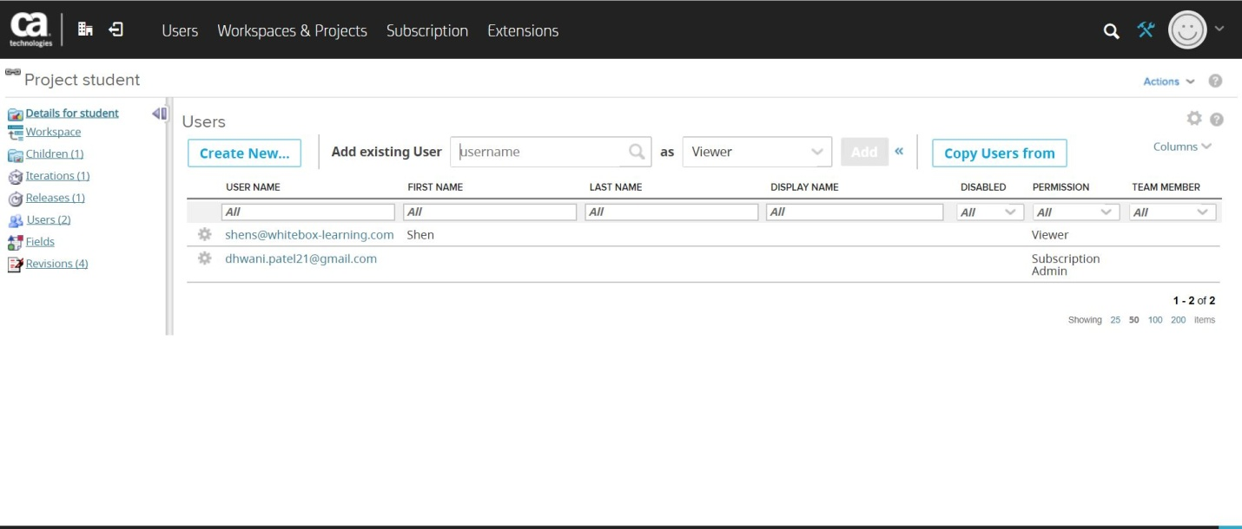

**TimeBoxes:-**

Iterations- no of iteration

Releases-

**What is velocity?**

**Team planning:-**

Drag user story to iteration.

**What is testcase?**