**What is Webservices?**

Service available over the web

Enables communication between application over the web provides a standard protocol/format for communication

Platform independent communication

Using web services two different application(implementation) can talk to each other and exchange data/information.

A software that makes itself available through out the web and which connects two systems.

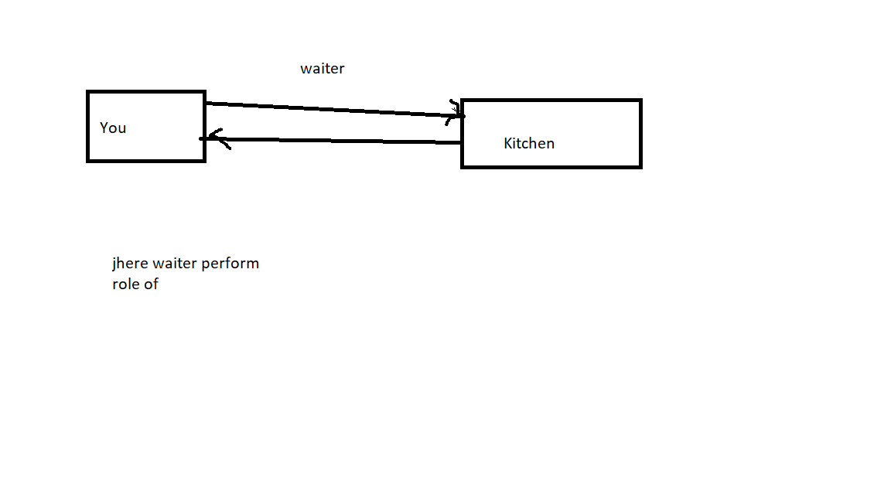

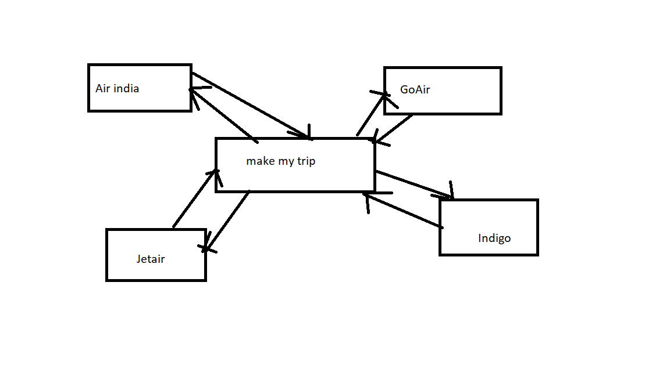

Server(Service Provider):- A web service Provider Develops/ Implements the application (web service) and makes it available over the internet (web).

Client sends request

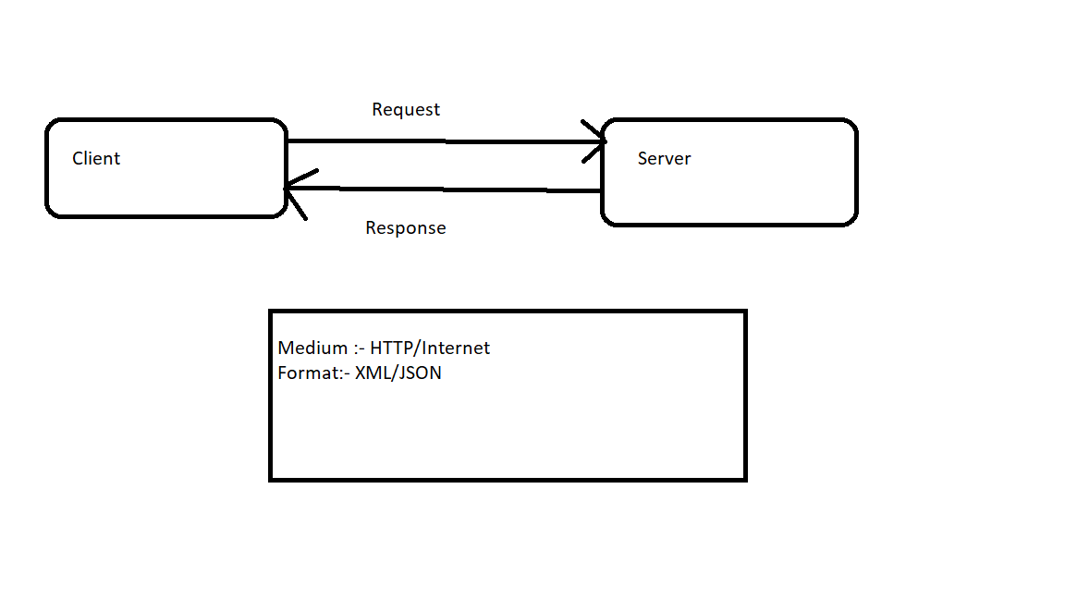

Web services implements in two types::-

1. SOAP:-

Simple Object Access Protocol

Medium- HTTP (POST)

Format- XML

1. REST

Representational state Transfer

Medium:- HTTP(POST, GET, PUT, DELETE…)

Format:- XML/JSON/TEXT

**WSDL**

If you are consumer you need to know

1. What are the services available?
2. What are the request and response parameters?
3. How to call the web services?

* Service provider publishes that describes all attributes of the web services. This is XML based interface and is called Web Services Description Language (WSDL)
* WSDL- It is an XML based interface that is used to describe the functionaries of the web services.

Server creates wsdl and clients get it.

Who provides WSDL? What is the full form of WSDL? Contents of WSDL?

Developer provides WSDL (Web Service Description Language) which contains

-Definition of webservice

-Messages

-Service end point

-Bindings (SOAP request and Response)

**UDDI:-(** **Universal Description, Discovery and Integration.)**

* If client and server don’t know each other all the service provider publishes his web services (theory wsdl) on an online directory from where consumer can query and search the web services. This is online register/directory is called UDDI.
* UDDI-Universal Description, Discovery and Integration. It is an XML based standard for publishing and finding web services.

**SOAP**

* Protocol (http/sftp/..)
* Platform /Language independent s
* WSDL (web service description Language)
* In built security
* Xml
* Heavy weight
* In built security(w3c standard)

**REST**

It will be available on libraries

It will be available on web

-Architecture

-It follows https protocol

-JSON/XML/PlainText/CSV

-Light weight

-Easy to understand

- Implements some methods to get security

**What we have to test in webservice..?**

-Functional testing, Security testing, Load testing, Status code, Schema compliance, Content-type, Response data, Data types, Valid/invalid status code

**SOAPUI🡪 Tool test SOAP Webservices..now a days use to test RestAPI also.**

* **Open source and paid version**

**TestSuite🡪Combination of test cases🡪 test steps**

**Assertions🡪 Expected Value vs Actual value 🡪 Success/Failure**

**What is functional testing?**

CRUD🡪

**Web services:-** Request and Response(Headers and body(payload))

Request🡪 Header, Body(Payload), Authentication,Request payload🡪 Request body

Response🡪 Header, body (payload)

Content type, Content length, Data count, Data order, Element present , Value present Payload🡪Response body, Content type

Status code

**HTTP Error Message:**

200 OK

201 Created

**400 Bad requests**

**404 Page not found**

**401 Unauthorized**

405 Method Not Allowed

409 conflicts

**500 Internal Server Errors**

**REST Commands are:**

1. **GET** - Provides a **read only access** to a resource.
2. **PUT** - Used to **Update Resource**
3. **DELETE** - Used to **remove a resource**.
4. **POST** - Used to **Create resource**
5. **OPTIONS** - Used to **get the supported operations on a resource**.