**What is Webservices?**

Service available over the web

Enables communication between application over the web provides a standard protocol/format for communication

Platform independent communication

Using web services two different application(implementation) can talk to each other and exchange data/information.

A software that makes itself available through out the web and which connects two systems.

**Real time simple example:-**

Waiter performs roles of web services.

Communicate between two application and making sure the communication is proper and successful.

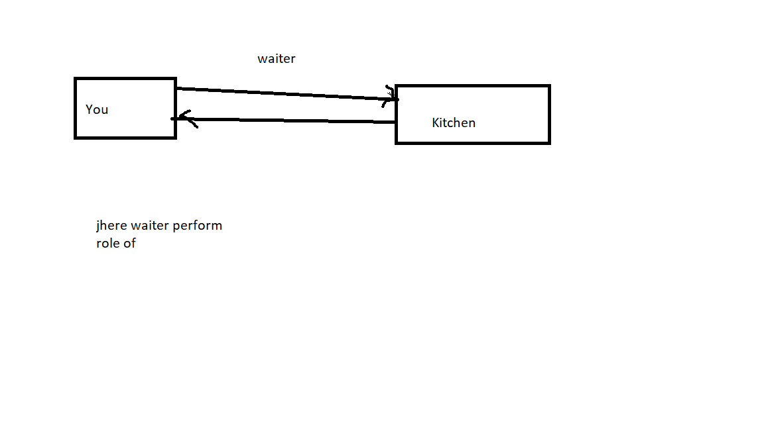

Airlines never allow to access databases.

Cancel fight but its takes hour to update ..so possible in real time.

So we can do one thing.api🡪 all websites expose with API common format Req. and Respose.

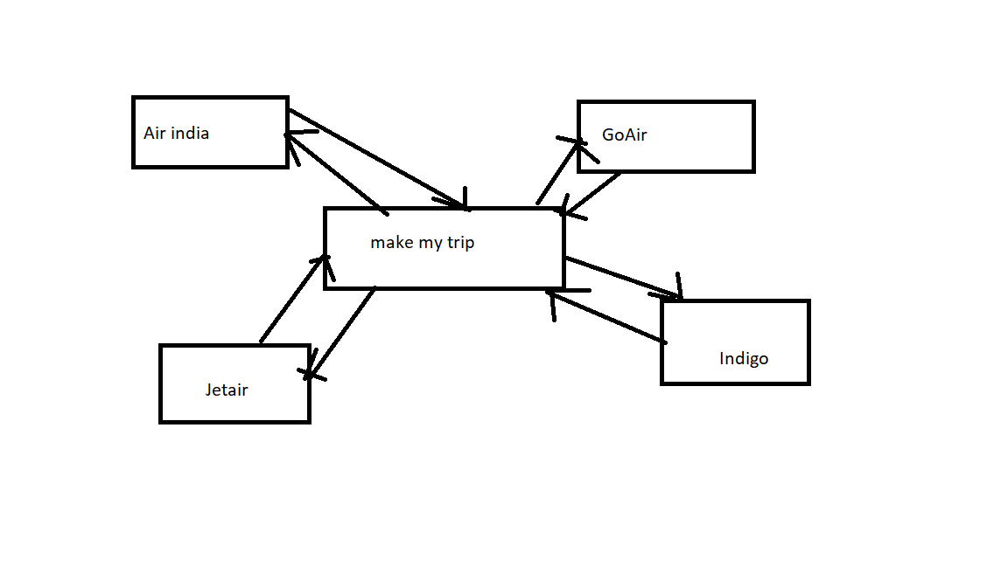

Server(Service Provider):- A web service Provider Develops/ Implements the application (web service) and makes it available over the internet (web).

Client sends request

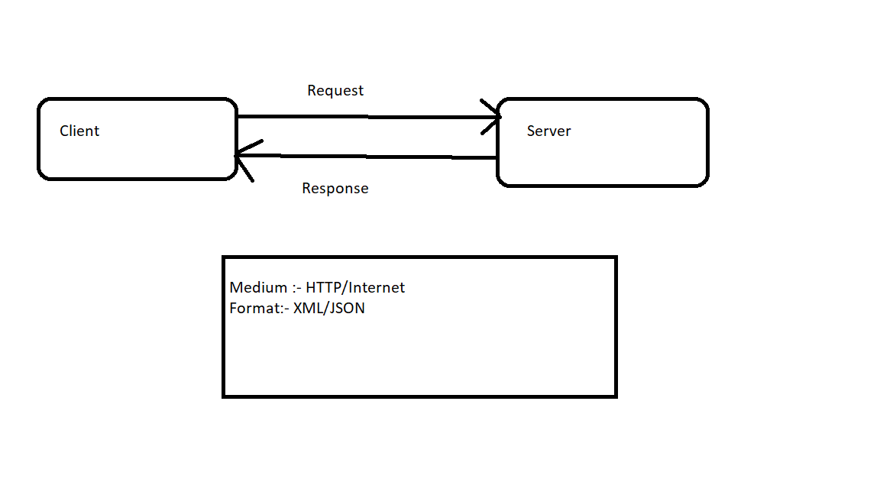

Web services implements in two types::-

1. SOAP:-

Simple Object Access Protocol

Medium- HTTP (POST)

Format- XML

1. REST

Representational state Transfer

Medium:- HTTP(POST, GET, PUT, DELETE…)

Format:- XML/JSON/TEXT

**WSDL**

If you are consumer you need to know

1. What are the services available?
2. What are the request and response parameters?
3. How to call the web services?

* Service provider publishes that describes all attributes of the web services. This is XML based interface and is called Web Services Description Language (WSDL)
* WSDL- It is an XML based interface that is used to describe the functionaries of the web services.

Server creates wsdl and clients get it.

Who provides WSDL? What is the full form of WSDL? Contents of WSDL?

Developer provides WSDL (Web Service Description Language) which contains

-Definition of webservice

-Messages

-Service end point

-Bindings (SOAP request and Response)

**UDDI:-(** **Universal Description, Discovery and Integration.)**

* If client and server don’t know each other all the service provider publishes his web services (theory wsdl) on an online directory from where consumer can query and search the web services. This is online register/directory is called UDDI.
* UDDI-Universal Description, Discovery and Integration. It is an XML based standard for publishing and finding web services.

SOAP

* Protocol (http/sftp/..)
* Platform /Language independent s
* WSDL (web service description Language)
* In built security
* Xml
* Heavy weight
* In built security(w3c standard)

**API(Application program Inteface): An Interface which connects two programs/softwares.**

Eg. REST

It will be available on libraries

It will be available on web

-Architecture

-It follows https protocol

-JSON/XML/PlainText/CSV

-Light weight

-Easy to understand

- Implements some methods to get security

**What we have to test in webservice..?**

-Functional testing, Security testing, Load testing, Status code, Schema compliance, Content-type, Response data, Data types, Valid/invalid status code

**SOAPUI🡪 Tool test SOAP Webservices..now a days use to test RestAPI also.**

* **Open source and paid version**

**TestSuite🡪Combination of test cases🡪 test steps**

**Assertions🡪 Expected Value vs Actual value 🡪 Success/Failure**

**What is functional testing?**

CRUD🡪

**Web services:-** Request and Response(Headers and body(payload))

Request🡪 Header, Body(Payload), Authentication,Request payload🡪 Request body

Response🡪 Header, body (payload)

Content type, Content length, Data count, Data order, Element present , Value present Payload🡪Response body, Content type

Status code

**HTTP Error Message:**

200 OK

201 Created

**400 Bad requests**

**404 Page not found**

**401 Unauthorized**

405 Method Not Allowed

409 conflicts

**500 Internal Server Errors**

**REST Commands are:**

1. **GET** - Provides a **read only access** to a resource.
2. **PUT** - Used to **Update Resource**
3. **DELETE** - Used to **remove a resource**.
4. **POST** - Used to **Create resource**
5. **OPTIONS** - Used to **get the supported operations on a resource**.

**Valid/invalid inputs/boundary values**

**Authentication test**

**Explain WSDL:-**

It is in xml format.

WSDL: definition -> main root tag for WSDL

**Steps:-**

1. Services:- what are service available inside that we have “port name” and “binding”

* These are types of ports available within the service.
* That particular port name binding

1. “binding “ contains which type of “operation” you can perform.
2. Inside “operation” you can see message tag. Two types of message. “Input” and “output”
3. Inside “message” you can see “parameter”
4. “types” data types present in SOAP

1. Test Structure (interview)

SoapUI structures functional tests into three levels; TestSuites, TestCases and TestSteps.

1. A **TestSuite** is a collection of TestCases that can be used for grouping functional tests into logical units. Any number of TestSuites can be created inside a soapUI project to support massive testing scenarios.
2. A **TestCase** is a collection of TestSteps that are assembled to test some specific aspect of your service(s). You can add any number of TestCases to a containing TestSuite and even modularize them to call each other for complex testing scenarios.
3. **TestSteps** are the "building blocks" of functional tests in soapUI. They are added to a TestCase and used control the flow of execution and validate the functionality of the service(s) to be tested.

What is Property transfer in SOAPUI? Steps to perform Property transfer?

Property transfer is retrieving the value from the response and storing in test case, test suite or project level and use that particular value as an input in other test steps.

We can do property transfer by groovy scripting.

Steps:

* Add property transfer step in test case
* Add property name
* Then provide Source – from test step, property as Response and XPath
* Provide Target – which level to store the property
* In that particular level go to Custom Properties and provide the name for property.
* After this give that property name as Property in the target step and run.

Steps for soapui testing:-

1. Create project:- Now depending upon the project, we need to import SOAP/REST protocol. We will create a new SOAP Project.
2. Enter the path of the WSDL request.
3. Create test suite
4. Create test case
5. Add test step(Test Request, ,REST Test Request, HTTP Test Request, JDBC Request, create property files, Groovy scripts)
6. Add assertion (