

TRIBHUVAN UNIVERSITY
Institute of Science and Technology
A CASE STUDY REPORT
ON
DISTRICT ADMINISTRATION OFFICE (DAO), KATHMANDU
CENTRALIZED E-PASSPORT DELIVERY & TRACKING
SYSTEM By
Dipson Adhikari(HCE080CSIT16)
Pamisha Bhattarai (HCE080CSIT24)
Prayag Nepal (HCE080CSIT29)

Supervisor:
Hari Prasad Pokhrel
A CASE STUDY REPORT SUBMITTED TO THE DEPARTMENT OF COMPUTER SCIENCE AND INFORMATION TECHNOLOGY IN PARTIAL FULFILMENT OF THE REQUIREMENTS FOR THE DEGREE OF BACHELOR IN SCIENCE IN COMPUTER SCIENCE AND INFORMATION TECHNOLOGY
Himalaya College of Engineering
Chyasal, Lalitpur, Nepal
Department of Computer Science and Information Technology
Himalaya College of Engineering
Tribhuvan University
Chyasal, Lalitpur
30th August 2026

EXECUTIVE SUMMARY
This report presents a comprehensive case study of the District Administration Office (DAO), Kathmandu, located at Babarmahal, undertaken as part of an E-Governance Case Study and Digital Transformation Proposal. The primary focus centers on the operational dynamics and bottlenecks of the e-passport service environment at DAO Kathmandu, which operates as a citizen-facing enrollment and collection facility within the national e-passport ecosystem governed centrally by the Department of Passports (DoP). Structurally, DAO Kathmandu's Passport Section processes a regulated daily volume of 150 to 250 applicants under strict online quota allocations, aggregating to 3,500 to 5,500 applications handled monthly. To manage this demand, the office deploys 8 to 12 dedicated personnel spanning executive, verification, biometric, and support roles across 4 to 6 service counters and 3 to 4 live biometric stations, connected to DoP's central infrastructure via secure GIDC VPN tunnels.

Operational analysis reveals that while front-end intake, live biometrics, and verification are digitally managed, downstream passport delivery remains overwhelmingly manual and physically dependent. At present, DAO Kathmandu occasionally facilitates passport delivery for select applicants, but relies entirely on informal, staff-driven coordination lacking standard procedures or digital tracking. Furthermore, DoP maintains no central delivery channel of its own. Consequently, most citizens must make a mandatory second visit ("Visit 2") simply to retrieve their document, generating counter congestion, staff overhead spent sifting through stored booklets, and unpredictable 2-to-3-week turnarounds. These inefficiencies are compounded by appointment slot scalping, discrepancies between NID and citizenship databases, peak-hour GIDC gateway latency, and a complete absence of citizen-facing transit visibility.

Recognizing these systemic challenges alongside DoP’s own recommendations for tracked distribution, this report proposes an actionable blueprint: the Centralized E-Passport Delivery & Tracking System. Designed to transform DAO Kathmandu’s manual dispatch into an end-to-end logistics platform, the architecture introduces barcode/QR parcel identification, dispatch-desk scanning workflows, and standardized REST API integration with Nepal Post and courier services. To ensure chain of custody, the framework incorporates a two-factor verification handover protocol (automated OTP matched against physical government ID) alongside a real-time tracking portal for citizens. Technically, the system is built on Node.js and Express.js, backed by PostgreSQL for transactional persistence and Redis queues for asynchronous notifications and courier webhooks.

Ultimately, the proposed platform is conceived not to replace DoP's core issuance database, but to function as a modular, interoperable delivery-management middleware layer. Embracing a "Digital First, Physical Exception" operating model, the transformation roadmap advocates a phased implementation plan. Initial deployment will be piloted locally at DAO Kathmandu to validate counter workflows and establish operational benchmarks. Following validation, system ownership will transition directly to the Department of Passports at the central level, enabling a standardized rollout across all 77 District Administration Offices nationwide.

TABLE OF CONTENTS
EXECUTIVE SUMMARY ii
TABLE OF CONTENTS iii
LIST OF TABLES v
LIST OF FIGURES vi
LIST OF ABBREVIATIONS vii
CHAPTER 1: INTRODUCTION 1
1.1 Background 1
1.2 Problem Statement 2
1.3 Objectives 2
1.4 Scope 3
1.5 Methodology 3
CHAPTER 2: ORGANIZATION PROFILE 4
2.1 Organization Identity 4
2.2 Vision, Mission and Objectives 4
2.3 Major Public Services and Service Recipients 5
2.4 Organizational Hierarchy 5
2.5 Roles and Functions 6
CHAPTER 3: ORGANIZATIONAL STRUCTURE 8
3.1 Departments and Divisions 8
3.2 Coordination and Reporting Hierarchy 8
CHAPTER 4: INFRASTRUCTURE ASSESSMENT 10
4.1 Physical Infrastructure 10
4.2 ICT Infrastructure 10
4.3 Human Resources 11
4.4 Legal and Policy Framework 11
CHAPTER 5: EXISTING INFORMATION SYSTEMS 13
CHAPTER 6: BUSINESS PROCESS ANALYSIS 15
6.1 As-Is Process Description 15
6.2 As-Is Business Process Flow Diagram 16
CHAPTER 7: PROBLEMS AND CHALLENGES 17
CHAPTER 8: PROPOSED DIGITAL SOLUTION 19
8.1 Problem Statement 19
8.2 Objectives 19
8.3 Scope 19
8.4 Users 20
8.5 Proposed Modules 21
8.6 Functional Requirements 22
8.7 Non-Functional Requirements 23
8.8 Expected Benefits 23
8.9 Suggested Technologies 24
CHAPTER 9: RECOMMENDATIONS 25
CHAPTER 10: CONCLUSION 27
REFERENCES 28
APPENDIX: INTERVIEW QUESTIONNAIRE AND RESPONSES 29

LIST OF TABLES
Table 1: Organization Profile Summary
Table 2: Major Public Services and Service Recipients
Table 3: Roles and Functions
Table 4: Departments and Divisions – Staffing Overview
Table 5: Passport Section Headcount Breakdown
Table 6: Physical Infrastructure Summary
Table 7: ICT Infrastructure Summary
Table 8: Legal and Policy Framework
Table 9: Inter-Agency Responsibilities
Table 10: As-Is Business Process Steps
Table 11: Business Process Volumes and Timing Benchmarks
Table 12: Problems and Challenges Identified
Table 13: Proposed System Scope (In-Scope vs. Out-of-Scope)
Table 14: Proposed Modules
Table 15: Functional Requirements of the Proposed System
Table 16: Non-Functional Requirements of the Proposed System
Table 17: Expected Benefits by Stakeholder Group
Table 18: Suggested Technology Stack

LIST OF FIGURES
Figure 1: Organizational Hierarchy Diagram – DAO Kathmandu Passport Section
Figure 2: As-Is Business Process Flow – E-Passport Enrollment and Collection
Figure 3: Proposed (To-Be) Business Process Flow

LIST OF ABBREVIATIONS
API – Application Programming Interface
BS – Bikram Sambat (Nepali calendar)
CCTV – Closed-Circuit Television
CDO – Chief District Officer
DAO – District Administration Office
DoIT – Department of Information Technology
DoNIDCR – Department of National ID and Civil Registration
DoP – Department of Passports
GIDC – Government Integrated Data Center
ICT – Information and Communication Technology
MFA – Multi-Factor Authentication
MoFA – Ministry of Foreign Affairs
MoHA – Ministry of Home Affairs
NID – National Identity
OTP – One-Time Password
POD – Proof of Delivery
QR – Quick Response (Code)
RBAC – Role-Based Access Control
REST – Representational State Transfer
SMS – Short Message Service
TLS – Transport Layer Security
UPS – Uninterruptible Power Supply
VPN – Virtual Private Network
WAN – Wide Area Network

CHAPTER 1: INTRODUCTION

1.1 Background
The transformation of public administration through information and communication technologies has become a central component of contemporary governance reform worldwide. Nepal has progressively adopted policies, institutional mechanisms, and digital initiatives aimed at modernizing public administration, guided in large part by the Digital Nepal Framework and the broader national commitment to citizen-centric e-governance.
Within this landscape, Nepal's transition from conventional machine-readable passports toward biometric electronic passports (e-passports) represents a significant technological and administrative undertaking. The e-passport program requires coordinated data capture, secure biometric processing, centralized production, and physical distribution back to citizens across the country a chain that spans multiple institutions, including the Department of Passports (DoP), District Administration Offices (DAOs), and postal or courier logistics providers.
Within this chain, delivery capability currently exists only in a limited and informal form. DAO Kathmandu has, on its own initiative, arranged manual passport delivery for certain applicants, but this arrangement operates entirely outside any formal system it is undocumented, untracked, and dependent on staff-level coordination rather than a defined process. The Department of Passports, which owns the national passport-issuance system, does not provide any delivery mechanism whatsoever; the default national expectation remains in-person collection at the enrollment office. Having recognized this as a gap, the Department of Passports has recommended that an online, trackable delivery and tracking system be developed, with DAO Kathmandu proposed as the pilot site before the system is adopted at the Department of Passports' central level.
This issue provides the principal context for the present case study, “Centralized E-Passport Delivery & Tracking System: DAO Kathmandu.” The District Administration Office (DAO), Kathmandu, located at Babarmahal, provides an appropriate institutional setting for examining the operational realities of this chain, as it functions as one of the busiest enrollment and collection points in the national e-passport service network.
The resulting operational challenge is fundamentally an inter-organizational systems problem rather than a single-agency deficiency. The question is not merely whether an individual office can digitize its own counter operations, but whether information can flow reliably across DoP, DAO Kathmandu, and downstream logistics partners so that a citizen's passport can be tracked, and ultimately delivered, without requiring a second physical office visit.
In an ideal digitally integrated environment, passport delivery would operate as a continuous information chain: passport processing, passport ready, delivery record created, dispatch, courier acceptance, in transit, delivery office, out for delivery, and finally delivered. Where an exception occurs, the same system should support an alternative lifecycle of delivery attempted, failed delivery, reattempt or hold, return, and reconciliation.
Such a model requires more than a conventional database; it requires process standardization, inter-agency interoperability, API-based information exchange, and clearly assigned accountability at every handoff point. The present case study therefore examines the existing service environment at DAO Kathmandu, identifies information and process bottlenecks in the current “last mile” delivery model, and proposes a conceptual digital solution to close this gap.

1.2 Problem Statement
The existing e-passport service at DAO Kathmandu provides digital application intake and biometric enrollment capability, and the Department of Passports notifies applicants by SMS or email once a passport is ready. DAO Kathmandu does, in practice, already provide a form of passport delivery to certain applicants; however, this delivery process is entirely manual handled through ad hoc, staff-coordinated arrangements without any digital tracking, standardized procedure, shipment identifier, or citizen-facing visibility. At the central level, the Department of Passports does not operate any delivery mechanism at all; no centrally owned or standardized delivery capability exists across the national passport service. In recognition of this gap, the Department of Passports has recommended the development of a proper online delivery and tracking system, to be trialed at DAO Kathmandu before being implemented at the Department of Passports centrally. The absence of a structured, trackable delivery mechanism at either level creates avoidable counter congestion, unpredictable turnaround for citizens, and manual administrative overhead for DAO staff, none of which is addressed by the current digital application or status-notification systems.

1.3 Objectives
The study is guided by the following objectives:
- To analyze the existing operational processes of DAO Kathmandu relating to e-passport receipt, handling, delivery, collection, and status communication, and to identify the specific ICT, information-flow, and interoperability gaps affecting service delivery.
- To document quantifiable service parameters daily and monthly applicant volumes, average wait times, and the turnaround period between enrollment and collection as a baseline against which the proposed system's expected benefits can later be evaluated.
- To propose a conceptual system design (modules, functional and non-functional requirements, and a supporting workflow diagram) that can realistically be piloted at a single DAO using existing government infrastructure and standard, well-understood technologies, rather than requiring a wholesale replacement of the Department of Passports' core systems.
- To directly address the second-visit bottleneck identified as the most citizen-visible pain point in the current process, in alignment with the Digital Nepal Framework's goals of citizen-centric, interoperable public service delivery.
- To frame the proposed solution as a phased, pilot-first initiative at DAO Kathmandu within an academic-year case-study timeframe, with a defined pathway toward broader rollout to other District Administration Offices.

1.4 Scope
This study is limited to the passport-related service environment of DAO Kathmandu, Babarmahal, and is based on information gathered through field observation and semi-structured interviews with relevant personnel, supplemented by publicly available information on the Department of Passports' official processes. The study concentrates specifically on the e-passport enrollment-to-collection lifecycle and the proposed last-mile delivery and tracking layer, it does not extend to citizenship, National ID, or other administrative functions performed at DAO Kathmandu except where they intersect directly with passport processing (for example, upstream data verification against citizenship records).
The proposed digital solution is similarly scoped as an integration and delivery-management layer. It does not attempt to redesign or replace the Department of Passports' core passport-issuance system, nor does it address national passport production infrastructure, biometric data governance, or citizenship/National ID record-keeping, all of which remain outside the boundary of this case study.

1.5 Methodology
This case study adopts a qualitative, exploratory, and systems-analysis-oriented research approach. The methodology combines field observation, and staff interviews as primary data sources, supplemented by review of the Department of Passports' official published process descriptions. This approach is appropriate because the study seeks not only to determine what problems exist but also to understand how the existing process operates in practice, including informal workarounds and staff-level coping mechanisms that are rarely captured in formal documentation. The methodological framework follows the sequence: field observation, staff interviews, process mapping, requirements analysis, and conceptual system design.
A primary component of the study is direct field observation of the operational environment at DAO Kathmandu, Babarmahal, focusing on the actual sequence of activities performed by personnel rather than relying exclusively on formal descriptions of procedure. The observation examines the physical workflow of applicants, documents, staff, and records moving through the service environment; the information workflow, including where data originates, is stored, and communicated to applicants; and staff activities that consume disproportionate administrative time, such as record searching, status verification, and exception handling.
Semi-structured interviews with relevant DAO personnel constitute the second major primary-data source. This format is appropriate because it allows consistent coverage of a defined set of topics while remaining flexible enough to probe unexpected operational details. Interview topics include current passport handling procedures, staff responsibilities, existing ICT systems, methods used to verify passport status, communication mechanisms with DoP and Nepal Post, common citizen inquiries, frequent operational bottlenecks, failed-delivery scenarios, and staff perceptions regarding automation. A summary of the questionnaire and the areas covered is provided in the Appendix.

CHAPTER 2: ORGANIZATION PROFILE

2.1 Organization Identity
The District Administration Office (DAO), Kathmandu, located at Babarmahal, is a district-level government administrative institution under the Ministry of Home Affairs (MoHA). It exercises a broad mandate of local administration, public order, and citizen-facing regulatory services within Kathmandu district, and operates under the legal authority of the Local Administration Act, 2028 B.S., alongside sector-specific legislation such as the Passport Act, 2076 and Passport Rules, 2077 for its passport-related functions.
It is important to note that DAO Kathmandu and the Department of Passports (DoP) fall under two different parent ministries. DAO Kathmandu, as a district administration office, is governed by the Ministry of Home Affairs (MoHA), whereas the Department of Passports the agency that owns the core e-passport application, biometric-processing, and passport-issuance system is a department under the Ministry of Foreign Affairs (MoFA). Passport enrollment therefore already functions as a cross-ministry service delivered jointly by a MoHA field office (DAO Kathmandu) acting as an enrollment agent and an MoFA department (DoP) acting as the issuing authority. This two-ministry structure is central to why the proposed solution in Chapter 8 is framed as an inter-agency interoperability layer rather than an internal DAO system upgrade: any delivery-tracking platform must be designed for data exchange across ministry boundaries, not merely across offices within the same ministry.
Table 1: Organization Profile Summary
Profile Element | Details
Organization | District Administration Office (DAO), Kathmandu
Location | Babarmahal, Kathmandu, Nepal
Parent Ministry (DAO Kathmandu) | Ministry of Home Affairs (MoHA), Government of Nepal
Parent Ministry (Department of Passports) | Ministry of Foreign Affairs (MoFA), Government of Nepal a separate ministry from DAO Kathmandu's own
Head of Office | Chief District Officer (CDO), assisted by the Assistant CDO
Legal Basis | Local Administration Act, 2028 B.S.; Passport Act, 2076; Passport Rules, 2077
Case-Study Focus | The Passport Section and its e-passport enrollment, verification, and collection functions

2.2 Vision, Mission and Objectives
DAO Kathmandu's implicit vision, as a district-level arm of the Ministry of Home Affairs, is to serve as an efficient, accountable, and citizen-responsive administrative institution that upholds public order while delivering essential government services to the residents of Kathmandu district. Its mission is to implement national administrative policy at the district level, coordinate between citizens and multiple national agencies, and facilitate access to services such as citizenship documentation, National ID enrollment, and passport processing.
Within the specific context of this case study, DAO Kathmandu's objective is to support the passport-service lifecycle effectively verifying applicant documentation, capturing biometric data accurately, and ensuring that completed passports reach applicants in a timely and secure manner. This last objective, passport delivery, is precisely where the present study identifies room for digital transformation.

2.3 Major Public Services and Service Recipients
DAO Kathmandu's broader service environment spans several functional areas, of which passport-related services are the subject of this case study. Table 2 summarizes DAO Kathmandu's major public services and their corresponding recipients.
Table 2: Major Public Services and Service Recipients
Service Area | Service Recipients | Relevance to This Case Study
District-level general administration | General public and local institutions | Establishes the administrative authority under which the Passport Section operates.
Document verification and administrative recommendations | Citizens requiring certified documents or endorsements | Underpins the document-verification stage of passport enrollment.
Coordination with government agencies and security institutions | Other government bodies; security agencies | Relevant to inter-agency data exchange with DoP, DoNIDCR, and security clearance.
Passport-related citizen services | Passport applicants (Kathmandu district) | The direct focus of this case study enrollment, biometric capture, and collection.
Citizenship and National ID support functions | Citizens applying for citizenship or NID records | Adjacent service that occasionally intersects with passport document verification.
The present case study concentrates specifically on the e-passport service and its downstream delivery and tracking process, while acknowledging that this function operates alongside and occasionally competes for staff and counter resources with DAO Kathmandu's other citizen-facing responsibilities.

2.4 Organizational Hierarchy
Figure 1 illustrates the internal reporting hierarchy of DAO Kathmandu's Passport Section, from the Chief District Officer down to the biometric and computer operators responsible for live data capture.
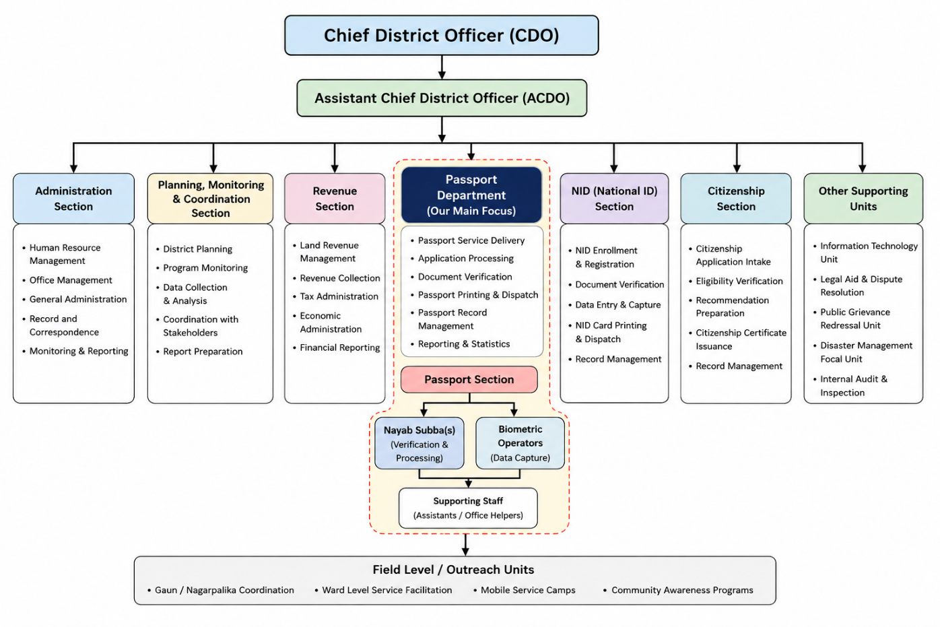
Figure 1: Organizational Hierarchy Diagram – DAO Kathmandu Passport Section
The CDO and Assistant CDO primarily represent governance and supervisory levels, whereas the Section Head, Nayab Subbas, biometric operators, and support staff represent the operational layer directly responsible for day-to-day passport-service delivery. Coordination between the verification and support functions is carried out primarily through direct supervision by the Section Head, with the Assistant CDO serving as the escalation point for grievances or cases requiring administrative discretion beyond the Section Head's authority.

2.5 Roles and Functions
Table 3 summarizes the key organizational roles observed during the field study, along with their major functions within the passport-service environment.
Table 3: Roles and Functions
Position / Unit | Major Functions
Chief District Officer (CDO) | Joint Secretary level; overarching administrative authority for DAO Kathmandu, including ultimate accountability for the Passport Section.
Assistant CDO | Under Secretary level; administrative supervision of the Passport Section, escalation handling, and public grievance redressal.
Administrative Officer (Section Head) | Gazetted Class III officer heading the Passport Section (Room No. 130); day-to-day operational responsibility.
Nayab Subba (Verification Officer) | Non-Gazetted First Class; handles original document verification, endorsement seals, and physical record cross-checks.
Biometric / Computer Operators | Operate Live Enrollment Stations — facial portrait capture, iris scans, ten-print fingerprint biometrics, and digital signature capture.
Karyalaya Sahayogi (Support Staff) | Manages queue sequencing, document bundles, passport ledger logging, dispatch packaging, and archival retrieval.

CHAPTER 3: ORGANIZATIONAL STRUCTURE

3.1 Departments and Divisions
DAO Kathmandu's overall operating strength spans approximately 75 to 95 personnel across all administrative and service divisions, excluding permanent armed police detachments deployed for premises security. Table 4 summarizes the major departments and divisions within DAO Kathmandu and their approximate staffing levels.
Table 4: Departments and Divisions – Staffing Overview
Department / Division | Approx. Staff Count | Function
Citizenship & Duplicate (Pratilipi) Section | 15–20 | Handles citizenship certificate issuance and duplicate document requests.
National ID (NID) Station Unit | 10–14 | Biometric station operators and technical supervisors linked with DoNIDCR.
Passport Section | 8–12 | Enrollment, verification, biometric capture, and collection for e-passports — the focus of this study.
General Administration, Legal & Judicial, Arms & Ammunition, Registration/Panchayat Units | 25–35 | Broader administrative, legal, and regulatory functions of DAO Kathmandu.
Support & Auxiliary Staff | 15–20 | Office helpers, logistical assistants, and assigned security personnel.
The Passport Section, which is the direct focus of this case study, therefore represents a modest but operationally intensive share of DAO Kathmandu's total workforce, reflecting the high daily applicant volume relative to its staffing level (see Chapter 6).

3.2 Coordination and Reporting Hierarchy
Within the Passport Section specifically, staff are organized into the four functional groups shown in Table 5, coordinated through the reporting hierarchy illustrated earlier in Figure 1.
Table 5: Passport Section Headcount Breakdown
Role Group | Composition | Approx. Count
Executive Leadership | CDO (1), Assistant CDO (1), Section Head / Administrative Officer (1) | 3
Verification Officers | Nayab Subbas handling document verification and endorsement | 2–3
Biometric / Computer Operators | Operators of Live Enrollment Stations | 3–5
Support Staff | Karyalaya Sahayogis – queue, logistics, ledger, archival | 2–3
Coordination across departments for example, between the Passport Section and the National ID Station Unit when applicant records require upstream verification is handled informally through direct staff-to-staff communication rather than a documented inter-departmental workflow, a gap discussed further in Chapter 7.

CHAPTER 4: INFRASTRUCTURE ASSESSMENT
Infrastructure assessment is necessary because the success of a centralized e-passport delivery and tracking system depends not only on application software but also on the physical counters, biometric hardware, network connectivity, and human capacity already in place at DAO Kathmandu. The assessment below focuses specifically on the passport-service environment at Babarmahal, and maintains a distinction between field-verified figures (presented as ranges reflecting normal operational variation) and proposed infrastructure specifications discussed later in Chapter 8.

4.1 Physical Infrastructure
The physical arrangement of the Passport Section directly influences service throughput. A typical passport-service environment at DAO Kathmandu requires separate functional zones for applicant arrival and information, document and application verification, biometric processing, administrative review, completed-passport handling, citizen collection, staff workstations, and secure document storage. Table 6 summarizes the physical infrastructure observed.
Table 6: Physical Infrastructure Summary
Infrastructure Element | Details
Service Counters / Desks | 4–6 operational windows: Document Verification, Biometric Enrollment (1–4), Verification/Status Desk, and Delivery/Dispatch Counter.
Biometric Stations | 3–4 live enrollment setups, each with a high-resolution portrait camera, ten-print optical fingerprint scanner, digital signature pad, and iris scanner.
Waiting Area Capacity | Indoor seating for 60–80 persons, with an outdoor sheltered overflow courtyard accommodating 150+ citizens during peak periods.
Document / Record Storage | Controlled physical storage for completed passports pending collection, managed by support staff (Karyalaya Sahayogis).
The indoor waiting capacity of 60–80 persons is regularly exceeded during peak appointment windows, which is why the outdoor courtyard functions as a de facto overflow waiting area a physical constraint that compounds the counter-congestion problems discussed in Chapter 7.

4.2 ICT Infrastructure
The Passport Section's ICT infrastructure is substantially more developed than a typical local-government office, reflecting its role as a live biometric-enrollment node connected to a national central system. Table 7 summarizes the ICT infrastructure observed.
Table 7: ICT Infrastructure Summary
ICT Component | Details
Workstations | 12–18 desktop PCs with enterprise-grade operating systems, security policies, and biometric-peripheral drivers.
Network Infrastructure | Closed government intranet connected to the Department of Passports' central cluster via a secure VPN tunnel over the Government Integrated Data Center (GIDC); wired LAN via managed Gigabit / Cat6 switches.
On-Site Server / Gateway | Local gateway caching router and network switch stack; data is validated and synchronized in real time or securely batched to the central DoP core no independent passport database is hosted locally.
Power Resilience | Centralized online industrial UPS providing zero-switchover runtime for counters, backed by a heavy-duty automatic diesel generator covering the complex during municipal outages.
Surveillance | CCTV system with 16+ high-definition dome and bullet cameras covering waiting halls, verification counters, biometric booths, and server closets.
Two aspects of the ICT infrastructure are particularly relevant to the proposed system. First, because all biometric and application data is synchronized to the central DoP/GIDC cluster rather than stored independently at DAO Kathmandu, any new delivery-tracking layer must integrate with this central system via API rather than duplicating passport records locally. Second, the reliance on a single shared GIDC VPN tunnel for all real-time enrollment traffic means that additional API traffic introduced by a delivery-tracking system should be designed to avoid contending with peak-hour biometric-enrollment bandwidth (see Chapter 7).

4.3 Human Resources
Technical proficiency among dedicated computer and biometric operators is high with respect to standard enrollment interfaces, peripheral calibration, and data entry, reflecting their specialized daily use of these systems. Digital literacy among clerical and supervisory administrative staff, including Nayab Subbas and the Section Officer, is moderate sufficient for status lookups and basic record management but not necessarily for troubleshooting technical faults. Periodic technical update workshops and refresher modules are organized by the Department of Information Technology (DoIT) and the Department of Passports during major e-passport firmware or software revisions, providing an existing training channel that could be extended to cover any new delivery-tracking module.

4.4 Legal and Policy Framework
DAO Kathmandu's passport-related operations, and any proposed extension into delivery and tracking, are governed by a body of legislation summarized in Table 8.
Table 8: Legal and Policy Framework
Legal Instrument | Relevance
Electronic Transactions Act, 2063 | Provides the legal basis for electronic records, digital signatures, and electronic transactions relevant to any future API-based data exchange.
Local Administration Act, 2028 B.S. | Establishes the administrative authority and structure of District Administration Offices, including DAO Kathmandu.
Passport Act, 2076 | Governs the issuance, renewal, and administration of Nepali passports, including e-passports.
Passport Rules, 2077 | Provides detailed procedural rules under the Passport Act for enrollment, verification, and issuance.
Privacy Act, 2075 | Governs the collection, storage, and processing of personal data, directly relevant to biometric and delivery-address data handled by the proposed system.
Digital Nepal Framework | Sets the national policy direction for e-governance and digital transformation initiatives such as the one proposed in this report.

CHAPTER 5: EXISTING INFORMATION SYSTEMS
The Department of Passports operates the official Nepal e-passport portal at nepalpassport.gov.np. The current portal provides online passport-related services, including pre-enrollment applications and related payment functionality. According to the Department's published process description, after completing the online form the applicant must visit the selected enrollment center in this case, DAO Kathmandu where the application is verified in person and biometric data is captured before it is transmitted to the central processing system. Beyond pre-enrollment and status notification, the portal does not currently expose any citizen-facing delivery-tracking capability. Once an application enters the “processing” state, the applicant's only source of further information is the SMS or email notification issued when the passport becomes ready for collection.
With respect to delivery specifically, two distinct realities exist side by side. At DAO Kathmandu, staff have informally arranged manual delivery of completed passports for certain applicants typically coordinated by phone or in person, without any digital record, tracking identifier, or standardized procedure. This manual practice, while helpful to the individual applicants it serves, is not part of any documented system, cannot be audited, and does not scale beyond the goodwill and capacity of individual staff members. At the central level, the Department of Passports does not operate a delivery mechanism of any kind manual or digital for the country as a whole. Recognizing that DAO Kathmandu's informal practice pointed toward genuine citizen demand for delivery, but that no sustainable or trackable system existed to support it, the Department of Passports has recommended the development of an online delivery and tracking platform, to be trialed at DAO Kathmandu and subsequently implemented at the Department of Passports' central level.
The e-passport lifecycle, as it currently exists and as extended by the proposed system, spans several institutions with distinct responsibilities. Table 9 summarizes these responsibilities.
Table 9: Inter-Agency Responsibilities
Institution | Role in Existing / Proposed Lifecycle
Department of Passports (DoP) -Ministry of Foreign Affairs | Owns and operates the core e-passport application, biometric processing, and central production system; issues passport-ready notifications; would own the authoritative passport-status feed consumed by the proposed system.
DAO Kathmandu -Ministry of Home Affairs | Performs enrollment, biometric capture, document verification, and (under the current process) passport collection; would operate the dispatch desk under the proposed system.
Nepal Post / Courier Partners | Not currently integrated into the passport lifecycle for regular applicants; would provide last-mile physical delivery and transit-tracking events under the proposed system.
Department of National ID and Civil Registration (DoNIDCR) | Maintains citizenship and National ID records referenced during document verification; source of the upstream data-incongruence issues discussed in Chapter 7.
As Table 9 makes clear, DAO Kathmandu (MoHA) and the Department of Passports (MoFA) are accountable to two different ministries, with Nepal Post and DoNIDCR adding a third and fourth institutional boundary. Any proposed information-sharing layer must therefore be designed as a genuine inter-ministry interoperability solution with clearly defined API contracts and data-ownership boundaries rather than as an internal system extension within a single ministry's IT environment.
The central integration gap identified in this chapter is straightforward: DoP's core system tracks an application through processing and printing, and DAO Kathmandu tracks an applicant through enrollment and eventual manual collection, but no system tracks the physical passport once it leaves the printing stage and before it reaches the applicant's hands. There is no shared tracking identifier, no API contract between DoP/DAO and any logistics provider, and no citizen-facing interface for transit status. This gap is precisely the “last mile” layer that the proposed system in Chapter 8 is designed to close, without altering the core systems operated by DoP or DoNIDCR.

CHAPTER 6: BUSINESS PROCESS ANALYSIS

6.1 As-Is Process Description
The current e-passport service process at DAO Kathmandu can be represented as two major physical visits for a regular, non-expedited applicant. In Visit 1, the applicant completes online pre-enrollment, selects DAO Kathmandu as the service location, appears physically for document verification and fee payment, and undergoes biometric capture (photograph, fingerprints, and iris scan) before leaving the office. The application then proceeds through the Department of Passports' central processing pipeline, at the end of which the applicant is notified by SMS or email that the passport is ready. In Visit 2, the applicant returns to DAO Babarmahal, waits in the collection queue, and staff manually search for, verify, and retrieve the passport from controlled storage before handing it over.
This second visit is the principal target of the transformation proposed in Chapter 8. Table 10 breaks the process down into discrete steps, indicating which steps are digital, physical, or manual in nature.
Table 10: As-Is Business Process Steps
Step | Activity | Nature
1 | Applicant completes online pre-enrollment and selects DAO Kathmandu as the enrollment location. | Digital
2 | Applicant appears physically at DAO Babarmahal for Visit 1 (enrollment). | Physical
3 | Counter staff perform document verification against submitted citizenship and supporting records. | Physical / Manual
4 | Applicant completes fee / revenue payment procedures. | Physical
5 | Biometric capture: photograph, fingerprints, and iris scan at a live enrollment station. | Digital (device-level)
6 | Application proceeds to central processing at the Department of Passports; passport is printed centrally and freighted to DAO Kathmandu. | Digital + Physical logistics
7 | Applicant is notified by SMS or email once the passport is ready for collection. | Digital
8 | Applicant returns physically to DAO Babarmahal for Visit 2 (collection), waits in queue, and presents identification. | Physical
9 | Staff manually search for and verify the record, retrieve the passport from controlled storage, and hand it to the applicant. | Physical / Manual
Of these nine steps, only steps 1, 5 (at device level), 6, and 7 involve meaningful digital processing; the remaining steps including the entirety of Visit 2 are physical and dependent on manual staff verification.
Table 11 summarizes the volume and timing benchmarks observed for the passport service at DAO Kathmandu, which form the quantitative baseline for evaluating the proposed system's expected impact in Chapter 8.

Table 11: Business Process Volumes and Timing Benchmarks
Metric / Stage | Benchmark / Observation
Daily Application Volume | 150 – 250 applicants per day, strictly regulated by daily online appointment quotas.
Monthly Throughput | 3,500 – 5,500 applications processed per month.
Average Wait Time per Visit | 45 minutes to 2 hours, contingent on appointment-slot adherence, queue length, and GIDC gateway latency.
Biometric Enrollment to “Passport Ready” | 7 – 15 business days for regular district applications (printed centrally at DoP Tripureshwor and freighted to DAO Kathmandu).
Turnaround Between Visit 1 and Visit 2 | 2 – 3 weeks on average; urgent/expedited requests are redirected to the DoP central office for a 2–3 business day turnaround.

6.2 As-Is Business Process Flow Diagram
Figure 2 illustrates the current (as-is) business process flow, from the applicant's initial online pre-enrollment through to final passport handover at the collection counter.
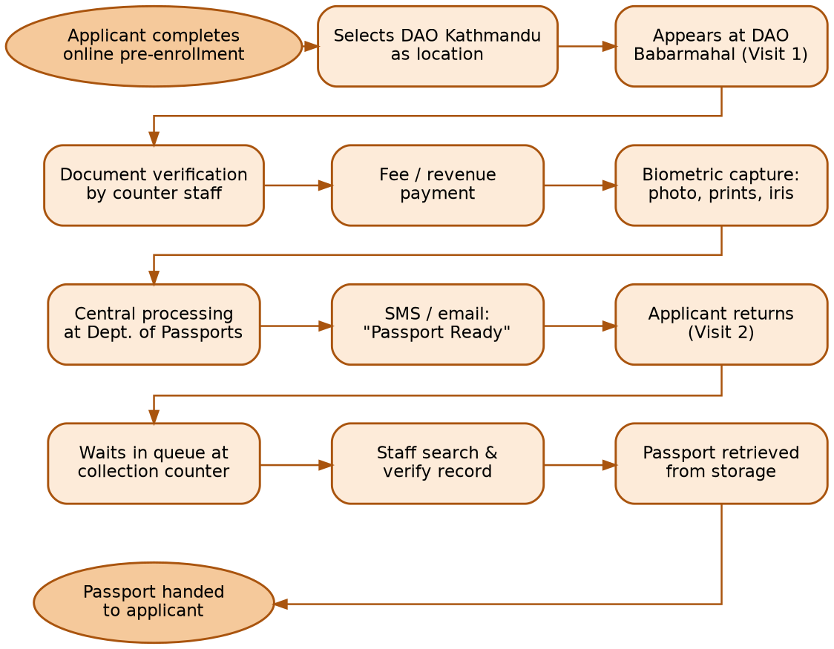
Figure 2: As-Is Business Process Flow – E-Passport Enrollment and Collection

CHAPTER 7: PROBLEMS AND CHALLENGES
The field observation and staff interviews surfaced a consistent set of operational problems affecting DAO Kathmandu's ability to deliver fast, transparent, and predictable passport services. Table 12 summarizes the five most significant challenges identified; each is discussed in further detail below.
Table 12: Problems and Challenges Identified
Problem / Challenge | Effect
Absence of a standardized, trackable delivery mechanism | DAO Kathmandu's existing passport delivery is manual and informal, arranged ad hoc by staff without documentation or tracking, while the Department of Passports operates no delivery mechanism at all nationally — leaving delivery entirely dependent on local goodwill rather than a scalable system.
Mandatory physical “Visit 2” collection | Requiring citizens to physically visit DAO Babarmahal a second time solely to collect a printed passport adds counter congestion, long wait times, and travel overhead across the whole of Kathmandu district.
Appointment-quota “slot scalping” | Daily online appointment quotas exhaust within seconds, locking out digitally underprivileged citizens and fostering an exploitative secondary market in which cyber cafés and middlemen hoard slots.
Upstream NID / citizenship data incongruence | Discrepancies in name transliteration, BS/AD date-format conversion, or marital name updates between physical citizenship certificates and digitized NID records force applicants into multi-counter rejection loops before enrollment can proceed.
Peak-hour gateway latency and counter blocking | Biometric stations rely on real-time synchronous uploads to the central DoP/GIDC servers. High nationwide traffic between 11:00 AM and 1:30 PM causes client timeouts, blocking enrollment counters and cascading delays down the queue.
Black-box transit tracking | Citizens have no visibility into when their printed passport physically arrives at the DAO, resulting in speculative in-person visits and unnecessary counter crowding as applicants “check in person” rather than trust the SMS notification alone.
Absence of a standardized, trackable delivery mechanism. This is the most fundamental gap identified by the study, and the direct motivation for the system proposed in Chapter 8. DAO Kathmandu already delivers passports to certain applicants in practice, but does so manually and informally, without a defined procedure, tracking identifier, or digital record meaning the practice cannot be audited, replicated consistently, or relied upon by applicants as a formal service option. At the central level, the Department of Passports has no delivery mechanism at all, leaving every other DAO in the country without even an informal equivalent of DAO Kathmandu's arrangement. The Department of Passports has acknowledged this gap itself and recommended the development of a proper online, trackable delivery system, to be piloted at DAO Kathmandu and subsequently adopted centrally.
Mandatory physical “Visit 2” collection overhead. The collection stage creates a second wave of citizen traffic after passport processing has already been completed, independent of and in addition to the queues generated by new enrollments. This produces compounding queues, additional staff workload for record search and verification, counter congestion, repetitive identity verification, and disproportionate pressure during peak periods.
The “slot scalping” and appointment quota bottleneck. Because daily online appointment quotas are exhausted within seconds of release, citizens without fast internet access, digital literacy, or awareness of the release schedule are effectively locked out of the formal booking channel. This has given rise to an informal secondary market in which cyber cafés and intermediaries capture slots and resell access, undermining the equity of the appointment system.
Upstream NID / citizenship data incongruence. Discrepancies between physical citizenship certificates and digitized National ID records arising from name transliteration inconsistencies, Bikram Sambat / Anno Domini date-format conversion errors, or unupdated marital name changes frequently surface only at the verification counter. These forces affected applicants into multi-counter rejection loops, consuming both applicant time and staff capacity before enrollment can even begin.
Peak-hour gateway latency and counter blocking. Because biometric enrollment stations depend on real-time synchronous uploads to the central DoP/GIDC infrastructure, periods of high nationwide traffic observed between approximately 11:00 AM and 1:30 PM produce client timeouts at the counter level. A single stalled upload can block an entire enrollment counter, with cascading delays for every applicant queued behind it.
Black-box transit tracking. Once a passport leaves the processing and printing stage, citizens have no visibility into its physical location or expected arrival at DAO Kathmandu. In the absence of reliable transit information, many applicants make speculative in-person visits to “check” on their passport rather than trust the SMS notification, adding avoidable counter traffic that a citizen-facing tracking interface could eliminate.
Where operational registers, paper logs, or manually maintained records supplement the digital systems described in Chapter 5, several second-order problems also arise, including duplicate entries, transcription errors, delayed updates, difficult historical searching, weak real-time visibility, and inconsistent status information across counters.

CHAPTER 8: PROPOSED DIGITAL SOLUTION

8.1 Problem Statement
DAO Kathmandu currently provides passport delivery to certain applicants, but only through an informal, manual arrangement coordinated directly by staff with no digital tracking, standardized procedure, or shipment record. The Department of Passports, which owns the national e-passport system, does not operate any delivery mechanism whatsoever, leaving in-person collection as the only formal option nationwide. Having identified this gap, the Department of Passports has recommended the development of an online, trackable passport delivery and tracking system. The core problem this case study addresses is therefore how to formalize and digitize DAO Kathmandu's existing manual delivery practice into a proper trackable system, trial it at DAO Kathmandu, and design it so that it can subsequently be adopted by the Department of Passports at the central level closing the “last mile” gap identified in Chapters 5 and 7 without altering the Department's core issuance system.

8.2 Objectives
- Formalize and digitize DAO Kathmandu's existing manual passport-delivery practice into a standardized, trackable platform, in direct response to the Department of Passports' recommendation for an online delivery and tracking system.
- Develop a centralized delivery-management platform connecting DAO Kathmandu, the Department of Passports, and Nepal Post through standardized REST APIs.
- Enable tracking of defined delivery events from dispatch through final delivery, allowing the turnaround time between enrollment and collection (currently 2–3 weeks) to be measured and progressively reduced.
- Trial the solution as a pilot at DAO Kathmandu, integrating with existing government and postal capabilities rather than replacing core systems, using widely available, well-supported technologies.
- Reduce unnecessary physical visits, improve citizen information access, reduce manual administrative workload at the collection counter, and strengthen delivery accountability through cryptographic proof-of-delivery.
- Following a successful DAO Kathmandu trial, transition ownership and operation of the platform to the Department of Passports at the central level, consistent with the Department's own recommendation and its role as the only institution connected to every DAO nationally.

8.3 Scope
The proposed platform is an integration and delivery-management system, not a replacement for national identity or passport-production systems. Table 13 defines the boundary between in-scope and out-of-scope functionality.

Table 13: Proposed System Scope (In-Scope vs. Out-of-Scope)
Item | Scope
Passport dispatch registration and barcode/QR generation | In-Scope
DAO dispatch-desk scanning to create shipment records | In-Scope
Nepal Post / courier API integration | In-Scope
Delivery-status synchronization and central tracking database | In-Scope
Citizen status interface and SMS notifications | In-Scope
Failed-delivery / exception management | In-Scope
Administrative dashboard and audit logging | In-Scope
Two-factor secure delivery handover (OTP + physical ID) | In-Scope
Core passport issuance decisions | Out-of-Scope – remains DoP's sole responsibility
Modification of biometric data | Out-of-Scope – governed by DoP's core system
National passport production infrastructure | Out-of-Scope – unaffected by this proposal
Replacement of DoP's core passport system | Out-of-Scope – this system integrates rather than replaces
Alteration of citizenship or National ID records | Out-of-Scope – remains under DoNIDCR's exclusive authority
Changing passport eligibility rules or policy | Out-of-Scope – remains with DoP and MoHA

8.4 Users
- Citizens / Applicants residents of Kathmandu district (and, following national rollout, other districts) applying for or awaiting delivery of an e-passport.
- DAO Dispatch Desk Staff responsible for scanning completed passports, generating shipment records, and handling delivery exceptions.
- Department of Passports (DoP) source of the authoritative passport-ready status feed and ultimate process owner.
- Nepal Post / Courier Agents responsible for physical transport, in-transit status updates, and OTP-verified handover at the citizen's doorstep.
- System Administrators responsible for RBAC management, audit oversight, and dashboard-level monitoring across DAOs.

8.5 Proposed Modules
The proposed system is organized into seven core modules, summarized in Table 14, which together replaces the manual Visit 2 collection process with an automated dispatch-to-doorstep delivery chain.
Table 14: Proposed Modules
Module | Description
Dispatch Registration Module | Allows DAO dispatch-desk staff to register a completed passport as ready for delivery and generate a unique barcode/QR tracking identifier.
Delivery Opt-In Module | Allows applicants to opt in to doorstep delivery during pre-enrollment or after passport-ready notification, and to capture a structured delivery address (GPS, ward, landmark).
Courier Integration Module | Exchanges shipment and status data with Nepal Post / courier partners via REST APIs, covering shipment creation, acceptance, and in-transit events.
Citizen Tracking Dashboard | Web and SMS interface through which applicants can view real-time delivery status and receive stage-by-stage notifications.
Secure Handover Module | Enforces OTP and physical ID verification at the point of delivery, and records a cryptographically verifiable proof-of-delivery (POD).
Exception Management Module | Handles failed-delivery workflows, including reattempt scheduling, hold status, and return-to-DAO reconciliation.
Administrative Dashboard | RBAC-protected interface for DAO and DoP staff to monitor shipments, intervene in exceptions, and review audit logs.
Figure 3 illustrates how these modules combine into a proposed (to-be) business process flow, showing that the existing Visit 1 (enrollment) process remains unchanged while the previous manual Visit 2 (collection) is replaced by the automated delivery chain, with a defined exception path for failed deliveries.
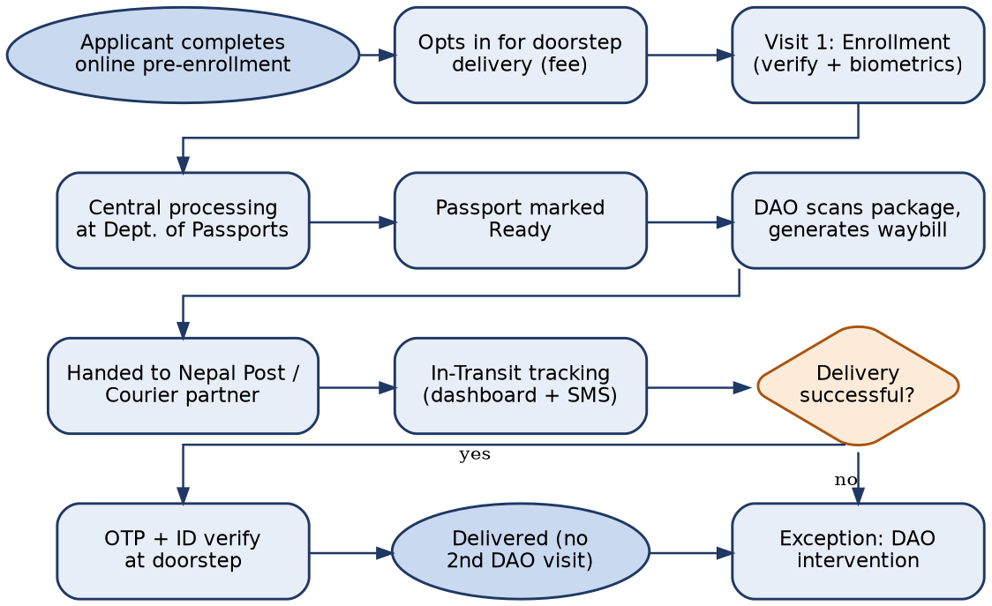
Figure 3: Proposed (To-Be) Business Process Flow

8.6 Functional Requirements
Table 15: Functional Requirements of the Proposed System
ID | Requirement
FR-01 | The system shall allow DAO dispatch-desk staff to register a completed passport as ready for delivery.
FR-02 | The system shall generate a unique, machine-readable shipment/tracking identifier (barcode or QR code) for each dispatched passport.
FR-03 | The system shall allow applicants to opt in to doorstep delivery during pre-enrollment or after passport-ready notification, subject to a delivery fee.
FR-04 | The system shall capture and store a structured delivery address, including GPS coordinates, ward, and nearest landmark.
FR-05 | The system shall integrate with Nepal Post / courier partner APIs to create shipment records and receive status updates.
FR-06 | The system shall record and display a defined sequence of tracking events (Dispatched, In Transit, Out for Delivery, Delivered, Failed Delivery).
FR-07 | The system shall send automated SMS notifications to the applicant at each major status transition.
FR-08 | The system shall provide a citizen-facing web interface for real-time shipment status lookup.
FR-09 | The system shall require OTP verification and physical ID cross-check at the point of delivery handover before a shipment can be marked Delivered.
FR-10 | The system shall record a cryptographically verifiable proof-of-delivery (POD) upon successful handover.
FR-11 | The system shall support failed-delivery workflows, including reattempt scheduling, hold status, and return-to-DAO reconciliation.
FR-12 | The system shall provide an administrative dashboard for DAO and DoP staff to monitor shipment status and intervene in exceptions.
FR-13 | The system shall enforce role-based access control (RBAC) distinguishing citizen, DAO staff, courier, and administrator permissions.
FR-14 | The system shall maintain an immutable audit log of all status changes and administrative actions.
FR-15 | The system shall be able to synchronize passport-ready status from the Department of Passports' core system via API.

8.7 Non-Functional Requirements
Table 16: Non-Functional Requirements of the Proposed System
Category | Requirement
Security | The platform shall use strong encryption and secure API practices. AES-256 should be used for encryption of sensitive stored data where appropriate, with TLS 1.2 or higher for all data in transit.
Access Control | Multi-factor authentication (MFA) shall be required for privileged administrative users; role-based access control shall govern all other users.
Reliability | The system shall maintain dependable event and delivery-status synchronization, with automatic retry for failed API calls to courier or DoP endpoints.
Availability | The citizen-facing tracking interface should target high availability (e.g., 99.5% uptime) given its role in reducing unnecessary physical DAO visits.
Auditability | All status changes, administrative actions, and delivery confirmations shall be logged and retained in a tamper-evident audit trail.
Scalability | The architecture shall be designed to onboard additional DAOs without requiring separate, siloed deployments (see Chapter 9).
Usability | The citizen interface shall support Nepali and English, and remain usable via SMS for citizens without smartphone or internet access.
Additional security controls should include secure API keys/tokens, strong password policies, database encryption, endpoint security, network segmentation, and ongoing vulnerability management, consistent with the sensitivity of passport-delivery and citizen-address data.

8.8 Expected Benefits
Table 17: Expected Benefits by Stakeholder Group
Stakeholder | Expected Benefit
Citizens | Elimination of the mandatory second physical visit for eligible delivery cases; real-time visibility into passport transit status; reduced travel cost and time, particularly for applicants outside Kathmandu Valley.
DAO Staff | Reduced counter congestion and repetitive record-search workload during the collection stage; clearer accountability for dispatched shipments; fewer speculative in-person status inquiries.
Department of Passports | An interoperability layer that extends visibility beyond the printing stage without requiring changes to core issuance systems; improved data on delivery outcomes nationally.
Nepal Post / Courier Partners | A defined, standardized API contract for high-value government shipments, with structured exception handling for failed deliveries.
Government of Nepal (Policy Level) | Demonstrable progress toward Digital Nepal Framework goals of citizen-centric, interoperable public service delivery, with an architecture that can scale nationally.

8.9 Suggested Technologies
Table 18: Suggested Technology Stack
Layer | Technology | Purpose
Frontend UI | Next.js / React with Tailwind CSS | Multilingual citizen dashboard, interactive address picker (OpenStreetMap / Leaflet), and real-time package-tracking view.
Backend & APIs | Node.js with Express.js | Microservices for booking queues, dispatch registration, payment-gateway integration (eSewa / Khalti / ConnectIPS), and delivery routing.
Database | PostgreSQL | Relational data integrity, audit logs, encrypted address vaults, and delivery chain-of-custody ledgers.
Cache & Task Queue | Redis + BullMQ | Fast appointment/lock caching, background delivery-notification webhooks, and asynchronous batch synchronization.
Courier & SMS Integration | Postal / Courier REST API + Sparrow / NTC SMS Gateway | Dispatch-manifest synchronization, dynamic OTP generation for secure delivery handoff, and stage-by-stage SMS alerts.
Security Layer | TLS 1.2+, AES-256, RBAC, MFA | Encrypts data in transit and at rest; restricts access by role; strengthens privileged-account protection.

CHAPTER 9: RECOMMENDATIONS
The central recommendation of this study is that DAO Kathmandu and the Department of Passports adopt a “Digital First, Physical Exception” model for passport delivery. Under this model, doorstep delivery via the proposed tracking platform becomes the default pathway for applicants who opt in, while physical counter collection at DAO Babarmahal is retained only as a fallback for applicants who decline delivery, for failed-delivery cases, or for exceptional circumstances such as unresolved identity verification. This preserves citizen choice and institutional continuity while directing most routine collections away from the physical counter, directly addressing the Visit 2 bottleneck identified in Chapter 7.
Because DAO Kathmandu already runs an informal, manual version of passport delivery, while the Department of Passports operates no delivery mechanism at all, the recommended rollout path is deliberately sequenced to trial the system where informal practice and staff familiarity already exist, before transferring ownership to the Department of Passports at the national level consistent with the Department's own recommendation that such a system be built. A phased rollout is recommended over a single “big-bang” deployment, given the sensitivity of passport data and the need to validate the courier-integration model before scaling it:
- Phase 1 Pilot at DAO Kathmandu: Deploy the dispatch-desk scanning module and citizen tracking dashboard at DAO Kathmandu only, formalizing and digitizing the office's existing manual delivery practice, integrated with a single courier/Nepal Post partner and covering a limited volunteer cohort of applicants who opt in to doorstep delivery.
- Phase 2 Evaluation and Refinement: Extend the pilot to full volume at DAO Kathmandu, incorporate lessons learned on exception handling and OTP-verification friction, and formalize the API contract with Nepal Post and any additional courier partners, producing a validated reference implementation.
- Phase 3 Central Department of Passports Adoption: Following a successful DAO Kathmandu trial, implement the platform at the Department of Passports' central level (Tripureshwor), transferring ownership and operational responsibility to DoP directly fulfilling the Department's own recommendation and addressing the fact that no delivery mechanism currently exists at the central level at all.
- Phase 4 National Rollout via the Department of Passports: With the platform centrally owned and operated by DoP, extend delivery-tracking capability to all District Administration Offices nationwide. Because DoP already interfaces with every DAO for passport issuance, it is the natural institution to administer the platform as a shared national service once the DAO Kathmandu trial has proven the model.
This sequencing pilot at DAO Kathmandu, then adoption by the Department of Passports centrally, then national extension to all DAOs under DoP's administration reflects both the practical reality that DAO Kathmandu already has hands-on experience with manual delivery, and the institutional logic that only the Department of Passports, as the central issuing authority connected to every DAO, is positioned to operate the platform as a genuinely national service in the long run.
Because DAO Kathmandu (Ministry of Home Affairs) and the Department of Passports (Ministry of Foreign Affairs) report to two different ministries, it is recommended that the platform be architected from the outset as a shared, centrally-hostable service rather than a DAO Kathmandu–specific application, so that the transfer of ownership from DAO Kathmandu (Phase 1–2) to the Department of Passports (Phase 3–4) requires migrating operational responsibility rather than rebuilding the system. It is further recommended that this transition be accompanied by a standardized training module (building on the existing DoIT/DoP refresher-workshop channel described in Chapter 4) and a formal inter-ministry data-sharing agreement between MoFA/DoP, MoHA, and Nepal Post clarifying data-ownership boundaries and liability for lost or damaged shipments in transit.

CHAPTER 10: CONCLUSION
This case study examined the e-passport service environment at the District Administration Office, Kathmandu, with particular attention to the operational, infrastructural, and information-systems context surrounding passport enrollment, processing, and collection. The study found that while DAO Kathmandu operates a well-resourced and technically capable enrollment environment supported by biometric infrastructure, a secure government intranet connection to the Department of Passports, and reasonably high staff proficiency on enrollment systems passport delivery beyond the processing stage remains entirely manual: DAO Kathmandu currently arranges delivery informally for certain applicants without any digital tracking or standardized procedure, while the Department of Passports operates no delivery mechanism at all at the national level.
The mandatory physical collection process that most applicants still rely on was identified as the single most consequential bottleneck, compounding counter congestion that is already strained by an inequitable appointment-quota system, upstream data-verification friction with citizenship and National ID records, and peak-hour network latency on the shared GIDC link. Perhaps most significantly, the complete absence of any standardized, trackable delivery mechanism at either the DAO or central level was found to be the root cause underlying nearly every other symptom identified in this study, from speculative in-person status inquiries to the inability to scale delivery beyond individual staff goodwill.
The proposed Centralized E-Passport Delivery & Tracking System responds directly to these findings, and to the Department of Passports' own recommendation, by formalizing and digitizing DAO Kathmandu's existing manual delivery practice into a structured platform built on dispatch-desk scanning, REST API integration with Nepal Post and courier partners, two-factor secure delivery handover, and a citizen-facing tracking dashboard without altering the Department of Passports' core issuance system or DoNIDCR's identity records. This positions the proposal as a targeted interoperability solution rather than a wholesale system replacement, which in turn makes a phased, pilot-first implementation at DAO Kathmandu both technically and administratively realistic.
If adopted, the “Digital First, Physical Exception” model recommended in Chapter 9 trialed at DAO Kathmandu and subsequently transferred to the Department of Passports for central and eventual nationwide operation would allow DAO Kathmandu to serve as a proof-of-concept for a broader transformation of last-mile government-document delivery in Nepal, directly advancing the citizen-centric, interoperable service-delivery goals articulated in the Digital Nepal Framework.

REFERENCES
Government of Nepal. (2006). Electronic Transactions Act, 2063.
Government of Nepal. (1971). Local Administration Act, 2028 B.S.
Government of Nepal. (2018). Privacy Act, 2075.
Government of Nepal. (2019). Passport Act, 2076.
Government of Nepal. (2020). Passport Rules, 2077.
Ministry of Communication and Information Technology, Government of Nepal. Digital Nepal Framework.
Department of Passports, Government of Nepal. Official e-Passport Portal. Retrieved from nepalpassport.gov.np
District Administration Office, Kathmandu. Field observation and staff interview records (case study primary data).

APPENDIX: INTERVIEW QUESTIONNAIRE AND RESPONSES
The following semi-structured questionnaire guided staff interviews conducted at DAO Kathmandu, Babarmahal, as part of the field-study methodology described in Section 1.5. Responses below summarize the consistent themes reported across interviews rather than verbatim transcripts, and directly informed the headcount, infrastructure, process-timing, and challenge data presented in Chapters 3, 4, 6, and 7 of this report.
Q1. Can you describe the current step-by-step procedure for passport enrollment at this office, from an applicant's arrival to the end of Visit 1?
A: Staff described the process as beginning with the applicant's online pre-enrollment, followed by in-person document verification, fee payment, and biometric capture (photo, fingerprints, and iris scan) at one of the live enrollment stations, consistent with the As-Is process mapped in Chapter 6.
Q2. What system(s) do you use to verify an applicant's citizenship and National ID information, and how often do discrepancies arise?
A: Verification is performed against citizenship records and, where applicable, National ID data linked through DoNIDCR. Staff indicated that discrepancies particularly name transliteration and BS/AD date-format mismatches are a recurring, though not constant, source of delay at the verification counter.
Q3. How is biometric data captured, and what happens if a live enrollment upload fails or times out?
A: Biometric data is captured at dedicated enrollment stations and uploaded in real time to the central DoP/GIDC servers. Staff confirmed that upload timeouts occur more frequently during the 11:00 AM to 1:30 PM peak window, at which point the affected counter is effectively blocked until the upload completes or is retried.
Q4. Once an application leaves this office, how do you or the applicant find out when the passport is ready for collection?
A: Applicants are notified via SMS or email directly by the Department of Passports once the passport is ready; DAO staff generally do not have an independent, real-time view of a specific passport's transit or printing status.
Q5. Can you describe the collection process for Visit 2, including how staff locate and verify a specific applicant's passport?
A: On Visit 2, applicants queue at the collection counter; staff manually search physical storage and cross-check applicant identification before releasing the passport. Staff noted that record search is one of the more time-consuming manual tasks during peak collection periods.
Q6. Does this office currently offer any form of passport delivery, and if so, how is it handled?
A: Staff confirmed that DAO Kathmandu does informally arrange delivery for certain applicants, coordinated directly by phone or in person on a case-by-case basis. This is not a documented or tracked process there is no shipment record, no standardized procedure, and no way for the applicant to check status beyond contacting the office directly. Staff were clear that this practice exists because of citizen demand, not because a formal system supports it.
Q7. Does the Department of Passports provide any delivery mechanism at the national level?
A: Staff confirmed that, to their knowledge, the Department of Passports does not operate any delivery mechanism centrally; the national default remains in-person collection, and any delivery that occurs such as DAO Kathmandu's informal arrangement exists only because an individual office has chosen to accommodate it.
Q8. Approximately how many applicants does this office serve on a typical day, and how does that vary by season or appointment-quota release?
A: Staff estimated daily volumes of roughly 150 to 250 applicants under the current appointment-quota system, with noticeably higher pressure immediately after each daily quota release, consistent with the volume benchmarks reported in Chapter 6.
Q9. What are the most common complaints or questions you receive from applicants regarding passport status or delivery timing?
A: The most frequent inquiries relate to uncertainty about when a passport will be ready, whether it has already arrived at the DAO, and whether delivery is available questions staff attributed directly to the lack of a formal, citizen-facing delivery and tracking option.
Q10. What manual registers, paper logs, or informal tracking methods are used to supplement the digital systems described in Chapter 5?
A: Support staff maintain physical ledgers to log incoming passport batches and track which have been collected or informally delivered, used alongside the digital enrollment system rather than as a replacement for it.
Q11. What training have you received on the ICT systems currently in use, and how frequently is it refreshed?
A: Biometric and computer operators receive periodic refresher training from DoIT and DoP, typically coinciding with major firmware or software updates to the enrollment stations.
Q12. In your view, what would be the most valuable improvement to the current process, and what concerns would you have about a digital delivery-tracking system?
A: Staff generally viewed formalizing and digitizing the existing manual delivery practice as the most valuable potential improvement, particularly since the Department of Passports has itself recommended such a system, while raising concerns about ensuring secure handover (to prevent misdelivery) and maintaining reliable connectivity concerns directly addressed by the OTP/ID verification and exception-handling design in Chapter 8.

