ACADEMIC CASE STUDY REPORT
Data Centers, Payment Infrastructure and Digital Public Infrastructure (DPI): A Case Study in the Context of Nepal
A Comparative Study with India, Estonia, South Korea and Bangladesh
Submitted partial fulfilment of the requirements of the subject E-Governance
Submitted By:
Prayag Nepal
Roll No: HCE080CSIT29
B.Sc. Computer Science and Information Technology (CSIT)
Submitted To:
Er. Hari Parasd Pokharel
Department of Computer Science and Information Technology

Himalaya College Of Engineering
Chyasal,Lalitpur,Nepal

13 August 2026

TABLE OF CONTENTS
TABLE OF CONTENTS ii
CHAPTER 1: INTRODUCTION, OBJECTIVES AND METHODOLOGY 1
1.1 Background 1
1.2 Problem Statement 1
1.3 Objectives 2
1.4 Scope of the Study 2
1.5 Methodology 3
CHAPTER 2: DATA CENTER INFRASTRUCTURE 3
2.1 What Is a Data Center? 3
Data Center Operating Models 3
2.2 Components of a Data Center 4
A Simplified Service Flow 4
2.3 Features of a Well-Established Data Center 5
Uptime Institute Tier Classification 6
2.4 Equipment and Services Required in a Well-Defined Government Data Center 7
Recommended Equipment Checklist 7
Essential Government Data-Center Services 8
2.5 Data Centers in Nepal: Government and Private Sector 8
2.6 Importance of Data Centers in Nepal 10
2.7 Challenges of Data Centers in Nepal 11
CHAPTER 3: PAYMENT INFRASTRUCTURE AND E-PAYMENT IN NEPAL 11
3.1 What Is Payment Infrastructure? 11
3.2 Regulatory and Institutional Structure in Nepal 12
3.3 Major Payment Systems and Platforms in Nepal 12
3.4 Current Status of E-Payment in Nepal 13
3.5 Comparison with India, South Korea and Bangladesh 14
India 15
South Korea 16
Bangladesh 16
3.6 Payment Infrastructure and Financial Inclusion 16
3.7 Advantages, Challenges and Future Prospects 16
Advantages 16
Challenges 17
Future Prospects 17
CHAPTER 4: DIGITAL PUBLIC INFRASTRUCTURE (DPI) 17
4.1 Introduction to DPI 17
4.2 The Three-Layer DPI Model 18
Principles of Good DPI 18
4.3 National ID and Digital Identity in Nepal 19
4.4 Data Exchange Platform 19
4.5 Digital Payment Platforms as DPI 20
4.6 India's DPI: India Stack 20
4.7 Estonia's DPI: e-ID and X-Road 21
4.8 Comparison of Nepal's DPI with India and Estonia 21
Similarities 22
Differences 22
4.9 Nepal's Strengths and Areas for Improvement 23
Nepal's Strengths 23
Areas Where Nepal Can Improve 23
CHAPTER 5: COMPARATIVE ANALYSIS MATRIX 24
5.1 Data Center Infrastructure Cross-Country Comparison 24
5.2 Payment Infrastructure Cross-Country Comparison 24
5.3 Digital Identity Cross-Country Comparison 25
5.4 Data Exchange Platforms Cross-Country Comparison 25
5.5 Digital Payments as DPI Cross-Country Comparison 25
5.6 Overall Cross-Country Comparison Matrix 26
5.7 Lessons Nepal Can Learn from Other Countries 26
CHAPTER 6: FINDINGS, CHALLENGES AND RECOMMENDATIONS 27
6.1 Major Findings 27
6.2 Challenges Identified 27
6.3 Recommendations 27
6.4 Future Prospects 28
CHAPTER 7: CONCLUSION 29
REFERENCES 30

CHAPTER 1: INTRODUCTION, OBJECTIVES AND METHODOLOGY

1.1 Background
Electronic governance, commonly called e-governance, is the use of information and communication technology (ICT) to deliver government services, share information, and improve how public institutions function. For many years, e-governance in Nepal was understood narrowly mainly as putting government forms on a website. Experience has shown that a website alone changes very little if the systems working behind it are weak. What decides whether digital government succeeds is the infrastructure underneath the visible portal: where government data is physically stored, how money can move electronically between citizens, businesses and government, and how one government office can securely verify information that is already held by another office.
This report studies three such foundations together, because in practice they are never separate. A data center is the physical facility where government servers, storage systems and databases are installed and operated. Payment infrastructure is the network of institutions, switches and rails that allow money to move electronically instead of physically. Digital Public Infrastructure (DPI) is a newer and broader idea: instead of every government service building its own identity check, its own data storage and its own payment mechanism, a country builds a small number of shared, reusable digital systems mainly digital identity, secure data exchange, and digital payments and lets many services be built on top of them, in the same way many buildings are connected to one shared road network instead of each building its own private road.
Nepal is presently building all three layers at the same time, though at different speeds. The country operates one primary government data center along with a growing number of private data centers that mostly serve banks, telecom operators and enterprises. Nepal's digital payment ecosystem, led by Nepal Rastra Bank (NRB) and Nepal Clearing House Limited (NCHL), has expanded very quickly over the last five years. At the same time, Nepal's national identity system is still being rolled out, and a government-wide data exchange platform the component that is arguably the most important for real interoperability exists only as an announced and partly funded project rather than a working system. Comparing Nepal's position with more advanced digital economies such as India, Estonia, South Korea and Bangladesh therefore helps to show both what Nepal has achieved and what remains to be built.

1.2 Problem Statement
Nepal's digital government systems have historically grown in a decentralized and uncoordinated way. Different ministries, the central bank, telecom companies and private fintech firms have each built their own systems, their own user databases and their own technical standards, largely independent of one another. This has expanded access to digital services, but it has also created fragmentation: citizens are frequently asked to submit the same physical documents such as citizenship certificates or tax clearance papers to multiple agencies, because those agencies cannot securely verify information that another government office already holds electronically.
A second and equally serious problem is infrastructure resilience. Data centers and payment systems depend on continuous electricity supply, precise environmental control, redundant network links and tested disaster-recovery arrangements. Nepal's mountainous terrain and its exposure to earthquakes, landslides and floods increase the risk that a single facility failure could disrupt essential government or financial services. The concentration of Nepal's most critical data-hosting facilities inside the Kathmandu Valley increases this risk further, since a single regional disaster could affect government hosting, banking infrastructure and telecom services at the same time. On the payment side, rapid growth in digital transactions has been accompanied by rising cyber-fraud attempts, inconsistent merchant QR standards in the early years, and low digital literacy among rural and older populations, all of which slow down the shift from cash to genuinely inclusive digital payment.

1.3 Objectives
- To explain the concept, components, operating requirements and Tier-based classification of modern data centers, with specific reference to what a government data center in Nepal requires.
- To identify and describe the major government and private data centers currently operating in Nepal.
- To describe the structure of Nepal's payment infrastructure, including the institutions, switches and channels involved, and to assess the status of e-payment adoption in the country.
- To compare Nepal's digital payment environment with India, South Korea and Bangladesh across common structural indicators.
- To explain Digital Public Infrastructure (DPI) through its three foundational layers digital identity, data exchange and digital payments and to describe Nepal's National Identity (NID) programme.
- To compare Nepal's emerging DPI with India's India Stack and Estonia's X-Road model, and to identify concrete, practical lessons Nepal can adopt.
- To consolidate the findings into actionable, prioritized recommendations for policymakers, technologists and academic readers.

1.4 Scope of the Study
This report focuses on foundational digital infrastructure rather than on individual government software applications. The data-center discussion covers physical facility design, core subsystems, availability tiers and both government-owned and private hosting facilities operating in Nepal; it does not attempt a full technical audit of any single facility. The payment-infrastructure discussion covers the central bank's settlement systems, NCHL's clearing and switching platforms, mobile wallets, QR networks and card systems, together with a structural comparison against three peer countries. The DPI discussion covers national identity, government data exchange and digital payment rails as reusable public platforms, benchmarked mainly against India and Estonia because these two countries represent two contrasting and well-documented DPI design philosophies large-scale centralized identity paired with open payment rails in India's case, and small-scale, deeply federated data exchange in Estonia's case. Full hardware inventories of individual commercial data centers, routine application-level software development, and non-financial mobile applications are outside the scope of this report.

1.5 Methodology
This is a secondary-data, descriptive and comparative case study. Information has been drawn from publicly available official sources Nepal Rastra Bank (NRB) payment system reports, Nepal Clearing House Limited (NCHL) service documentation, the Department of Information Technology (DoIT) and its Data Centre and Cloud Services Directive, 2081, the Department of National ID and Civil Registration (DoNIDCR), the World Bank and Asian Development Bank (ADB) project announcements, and international reference material on India's UIDAI/NPCI systems and Estonia's X-Road/e-ID systems. Preference has been given throughout the most recently dated statistics available, and figures have been clearly attributed to their reporting period so that a reader does not mistake an older number for a current one. The report does not rely on primary surveys, interviews or proprietary internal data; where public data is incomplete or unpublished, this has been stated explicitly rather than estimated.

CHAPTER 2: DATA CENTER INFRASTRUCTURE

2.1 What Is a Data Center?
A data center is a purpose-built physical facility designed to house computer systems and all the supporting equipment those systems need to run continuously and safely. It is important to understand that a data center is not simply a room with computers in it. It is a controlled environment that must simultaneously provide stable electrical power, precise cooling, high-speed network connectivity, strong physical and cyber security, and constant monitoring all at once, twenty-four hours a day, every day of the year.
Nepal's own legal definition supports this understanding. The Data Centre and Cloud Services (Operation and Management) Directive, 2081, issued by the Ministry of Communication and Information Technology (MoCIT), defines a data center as a facility equipped with the infrastructure necessary for storing data and operating information technology systems developed by government, public or private sector bodies. The key idea in this definition is that a data center is treated as infrastructure the base layer on which every other digital service stands. This matters especially in e-governance, because government records such as citizenship data, land ownership records and tax records cannot simply be recreated if they are lost; the facility that stores them must be engineered so that this loss does not happen.
It is also useful to distinguish a data center from cloud computing, because students often confuse the two. A data center is physical building and hardware. Cloud computing is a software-defined way of delivering computing resources virtual servers, storage and networking on demand, on top of a physical data center. A government can operate its own data center and consume commercial cloud services; the two are complementary, not the same thing.

Data Center Operating Models
- Government-owned dedicated facilities built and operated by a public agency, typically hosting the most sensitive, high-sovereignty national databases (e.g., citizenship, land, tax records).
- Private commercial colocation centers built by private companies that rent secure rack space, power and cooling to multiple customers, including banks and telecom operators.
- Telecommunication data hubs data centers built and operated by internet service providers or mobile network operators, often to support their own network infrastructure as well as hosting customers.
- Managed cloud environments virtualized compute and storage delivered as a service, running on top of a physical data center owned by the cloud provider.

2.2 Components of a Data Center
A resilient data center is built from several tightly integrated subsystems. Each subsystem has its own job, but they must all work together continuously if any single subsystem fails without a backup, the whole facility can go down. The table below summarizes the major categories.
Category | Typical Components | Primary Purpose
Physical / Structural | Racks, server cabinets, structured cabling, raised flooring, aisle containment | Organize, secure and physically support all hardware.
Power | Utility feeds, UPS units, diesel generators, Automatic Transfer Switches (ATS), Power Distribution Units (PDUs) | Deliver continuous, clean power and bridge any utility outage without interruption.
Cooling | Precision air conditioning (CRAC/CRAH), chillers, hot-aisle/cold-aisle containment, temperature and humidity sensors | Remove the heat generated by dense IT equipment and hold temperature/humidity in a safe range.
Networking | Core and distribution switches, routers, load balancers, structured cabling, optical links to multiple carriers | Connect users, applications, storage and the outside internet at high speed and with redundancy.
Security | Biometric or card access control, CCTV, mantraps, firewalls, IDS/IPS, Web Application Firewalls (WAF) | Prevent unauthorized physical entry and block cyberattacks.
Fire & Life Safety | Very Early Smoke Detection Apparatus (VESDA), clean-agent gas suppression (e.g., FM-200), alarms, emergency lighting | Detect fire at the earliest possible stage and extinguish it without damaging electronic equipment with water.
IT Systems | Rack/blade servers, SAN/NAS storage arrays, virtualization hosts, backup appliances | Run applications, host databases and virtual machines, and store data and backups.
Operations & Management | Data Center Infrastructure Management (DCIM), SIEM, centralized logging, a Network Operations Centre (NOC), trained staff | Provide continuous monitoring, incident response and asset management. Equipment alone is not useful without people to operate it.

A Simplified Service Flow
It helps to picture how a single citizen request travels through a data center. The diagram below shows a simplified, generic flow for a citizen using a government e-service such as an online tax payment.
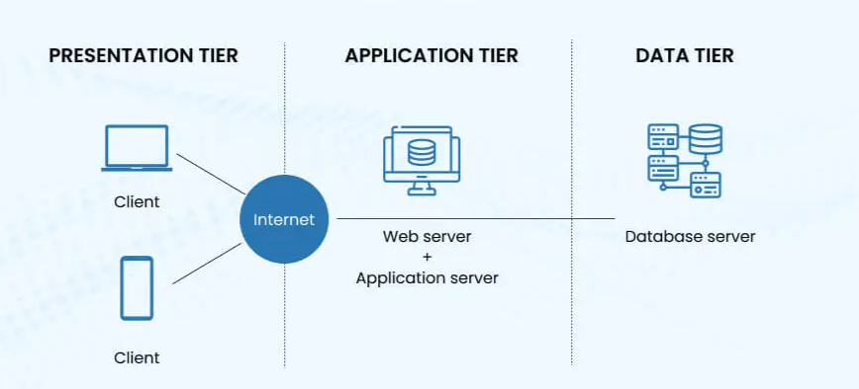
Figure: 3-Tier Web Application Architecture
The request first reaches a secure network edge, passes through a firewall and a load balancer, is handled by an application server, and then reads or writes data in a database. Every step generates a log entry sent to a monitoring system, and important data is backed up and, for critical services, copied to a separate disaster-recovery (DR) site in another location. If any single component in this chain is the firewall, the application server, or the database fails without a backup, the citizen's request fails too. This is exactly why redundancy is central to good data-center design.

2.3 Features of a Well-Established Data Center
A well-established data center is engineered so that the failure of any one component does not immediately interrupt the service. This principle is achieved mainly through redundancy, disciplined operations, continuous monitoring and tested disaster-recovery planning.
Feature | What It Means in Practice | Why it Matters
High availability | Redundant servers, network paths, power and cooling; planned maintenance is done without a full shutdown. | Minimizes service interruption for end users.
Power redundancy | UPS batteries plus generator backup, multiple PDUs, tested automatic transfer procedures. | Protects against power cuts and voltage fluctuations, which are still common in Nepal.
Cooling reliability | Redundant cooling units (commonly N+1), hot/cold aisle separation, temperature sensors. | Prevents thermal damage and equipment slowdown or shutdown.
Network redundancy | Multiple carriers/links, redundant switches, physically diverse fiber paths. | Stops a single network fault from taking every service offline.
Physical security | Controlled entry, CCTV, visitor logs, mantraps, restricted rack-level access. | Protects hardware and the sensitive data stored on it.
Cybersecurity | Firewalls, network segmentation, IDS/IPS, endpoint protection, vulnerability management. | Reduces the risk and impact of cyberattacks.
Backup & disaster recovery | Regular backups, off-site copies, data replication, periodic recovery drills. | Allows services to be restored after a fire, earthquake or major hardware failure.
Scalability | Reserved space, power and network capacity for future growth. | Let’s the facility grow with demand without a costly rebuild.
24×7 monitoring | Round-the-clock monitoring of servers, power, cooling, network and security, with a help desk. | Enables faults to be detected and fixed before they become outages.
Standards compliance | Certifications such as ISO/IEC 27001 (information security) and the ANSI/TIA-942 data-center design standard. | Provides an independently verified benchmark of quality and reliability.

Uptime Institute Tier Classification
Data-center availability is most benchmarked using the Uptime Institute's four-tier system. This system is important to understand because Nepal's own 2081 Directive uses it directly as a legal requirement for government data.
Tier | Description | Approx. Annual Availability
Tier I | Basic capacity; no redundancy; a single path for power and cooling. | ≈ 99.671%
Tier II | Redundant capacity components are added, but still a single distribution path. | ≈ 99.741%
Tier III | Concurrently maintainable — any planned maintenance can occur without shutting down IT equipment. | ≈ 99.982%
Tier IV | Fault tolerant — the facility can absorb an unplanned single-component failure with no service impact. | ≈ 99.995%

It is worth stressing to students that Tier certification only measures the physical design of the facility. True resilience depends equally on operational discipline regular disaster-recovery testing, careful patch management, well-trained facilities staff, and layered cybersecurity defence. A Tier IV building operated carelessly can still fail; a well-run Tier III building can, in practice, be extremely reliable.
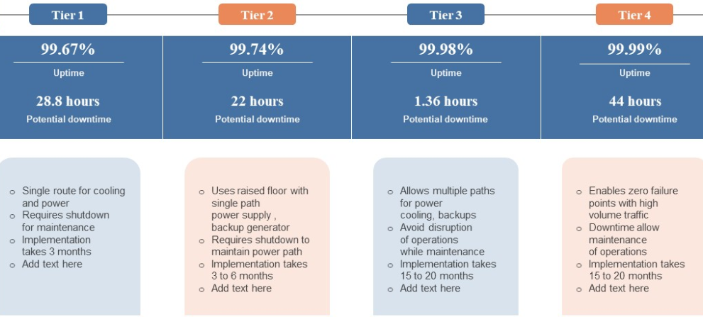
Figure: Run Time of Tiers

2.4 Equipment and Services Required in a Well-Defined Government Data Center
A government data center carries extra responsibility because it stores citizen data that, in many cases, cannot legally or practically be recreated. Nepal's Data Centre and Cloud Services Directive, 2081 formalizes this responsibility: providers must be listed with the Department of Information Technology, must conduct annual security audits, must submit a Tier rating certificate, and critically any data center that stores government data must be rated Tier III or above. Non-compliant or misused facilities can be delisted.

Recommended Equipment Checklist
Category | Essential Equipment
Compute | Rack/blade servers; virtualization cluster hosts; management servers.
Storage | Enterprise SSD/HDD arrays; SAN/NAS; backup storage; immutable/offline backup capability.
Networking | Redundant core/leaf switches; border routers; load balancers; optical transceivers; structured cabling.
Security hardware | Next-generation firewalls; IDS/IPS; VPN gateways; Web Application Firewall (WAF); Hardware Security Modules (HSM) for key management.
Power | Dual utility feeds where possible; modular UPS with redundant battery strings; diesel generators; automatic transfer switches; rack-level PDUs.
Cooling | Precision (CRAC/CRAH) cooling units with N+1 redundancy; hot/cold aisle containment; environmental sensors.
Physical protection | Biometric/card access control; CCTV; mantrap; racks and cages; visitor-management system.
Fire & safety | Early smoke detection (e.g., VESDA); clean-agent gas suppression; alarms; emergency lighting; leak detection.
Monitoring | DCIM software; SIEM platform; centralized logging; environmental and network monitoring with alerting.
Recovery | Automated backup appliances; off-site/DR replication servers; periodic recovery drills against defined Recovery Point Objectives (RPO).

Essential Government Data-Center Services
- Application hosting a secure environment for public portals, e-tax systems and administrative software, centralizing service delivery and improving uptime.
- Database management hosting relational and non-relational databases for civil registration, taxation and licensing with structured access and audit logging.
- Government cloud (G-Cloud) virtualized compute, storage and networking made available to public agencies without each agency having to buy its own hardware.
- Backup-as-a-Service and archiving automated incremental backups and long-term archival storage, protecting historical government data against ransomware, corruption or hardware loss.
- Cybersecurity management centralized DDoS mitigation, firewall management, Security Operations Centre (SOC) monitoring and vulnerability scanning.
- Disaster Recovery as a Service real-time or near-real-time database mirroring and failover hosting at a geographically distant site.
- Co-location secure rack or cage space made available for government systems that agencies operate themselves rather than as a managed service.

2.5 Data Centers in Nepal: Government and Private Sector
Nepal's data-center ecosystem is a mix of one primary government facility with its dedicated disaster-recovery site, and an expanding private commercial market that mainly serves banks, internet service providers, telecom operators and enterprises. The table below brings together the publicly documented facilities most consistently referenced in official and industry sources.

Facility | Owner / Operator | Type | Location | Notable Points
Integrated Data Management Center (formerly GIDC) | Department of Information Technology (DoIT) / National Information Technology Center | Government | Singha Durbar, Kathmandu | Nepal's central government hosting facility, built with support from the Government of Korea and handed over in 2009; hosts major government portals, colocation, virtualisation and e-mail hosting.
Disaster Recovery Office / Site | DoIT | Government | Hetauda | Dedicated off-site DR facility providing replication for critical government databases and continuity of government systems.
Ncell Integrated Data Centre | Ncell Axiata Limited | Private / Telecom | Nakkhu, Lalitpur | ANSI/TIA-942-C Rated-3 (Tier III) certified; roughly 99.98% design availability; offers colocation, cloud hosting and enterprise DR.
WorldLink Data Center | WorldLink Communications | Private / ISP | Chandragiri, Kathmandu | Approximately 3.5 MW power capacity with about 520 server racks; supports ISP operations and cloud services; has announced further expansion, including plans for province-level facilities.
DataHub Kathmandu Data Center | DataHub Nepal Pvt. Ltd. | Private / Commercial | Thapathali, Kathmandu | Commercial colocation center offering enterprise cloud, managed backup and hosting; ISO 27001 and PCI DSS aligned.
DataHub Butwal Data Center | DataHub Nepal Pvt. Ltd. | Private / Commercial | Tilottama, Butwal | Established as a primary/DR facility outside the Kathmandu valley, housed in an earthquake-resistant structure, improving Nepal's DR geography.
Nepal Electricity Authority Data Center | Nepal Electricity Authority | Government / Utility | Syuchatar, Kathmandu | Tier III rated; supports automation of electricity distribution systems.
Data World | Data World Nepal | Private / Commercial | Multiple strategic locations | Purpose-built, Tier III certified facility advertising redundant power, cooling and multiple connectivity routes.
Cloud Himalaya | Cloud Himalaya | Private / Commercial | Thapathali, Kathmandu | Tier III colocation and cloud services.
DataLaya Data Center | Dish Media Network / DataLaya | Private / Commercial | Bhaisepati, Lalitpur | Offers virtual private cloud (VPC), dedicated hosting and colocation to enterprise clients.
Dataspace | Dataspace Nepal | Private / Commercial | Kamaladi, Kathmandu | Carrier-neutral colocation facility.

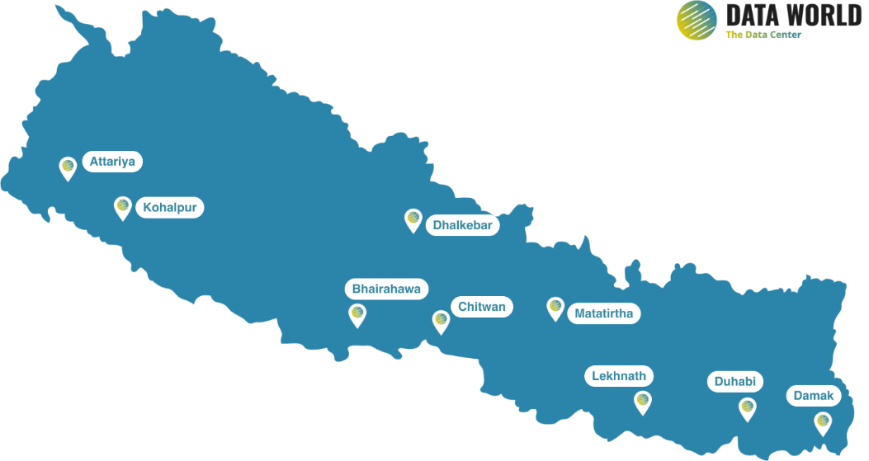
Figure: Location of Datacenter In Nepal
Two observations stand out from this table. First, the great majority of both government and private hosting capacity remains concentrated inside the Kathmandu Valley, which is a known seismic risk area; DataHub's Butwal facility and the government's Hetauda DR site are still the clearest examples of deliberate geographic diversification. Second, until February 2025 Nepal had no dedicated legal framework specifically governing data centers. The Data Centre and Cloud Services Directive, 2081, issued under the Electronic Transactions Act, 2063, changed this by introducing mandatory registration with DoIT, annual security audits, Tier certification, and a Tier III minimum standard for any facility hosting government data a first step toward treating data centers as regulated critical national infrastructure rather than ordinary commercial premises.

2.6 Importance of Data Centers in Nepal
- Foundation of e-governance every government portal, database and digital service must physically run somewhere; without a reliable data center, no digital government service can be reliable.
- Cost efficiency a shared government data center avoids every ministry duplicating its own power, cooling, security and technical staff.
- Data sovereignty hosting citizen data inside Nepal keeps it under Nepali jurisdiction and reduces dependence on foreign providers for sensitive national records.
- Business continuity with a tested DR site and regular backups, government and financial services can survive fire, earthquake or major hardware failure, which is especially important given Nepal's seismic exposure.
- Better performance for citizens hosting services locally reduces network latency and reduces spending on expensive international bandwidth.
- Support for the digital economy banks, telecom companies, fintech startups and software firms all depend on locally available, reliable hosting capacity to operate and grow.

2.7 Challenges of Data Centers in Nepal
- High capital cost: import dependency and tariffs on specialized power, cooling and networking equipment raise facility setup costs substantially compared with countries that manufacture this equipment domestically.
- Power quality and continuity: although national grid coverage has improved, voltage fluctuations and unplanned outages still require expensive UPS capacity and diesel fuel reserves.
- Geographic concentration: the clustering of major facilities inside the Kathmandu Valley leaves both public and private digital infrastructure exposed to a single large seismic event.
- Weak disaster-recovery testing: many smaller institutions lack active-active or even active-passive off-site replication because of cost and bandwidth constraints, and DR sites that are never tested cannot be assumed to work when needed.
- Shortage of specialized technical staff: Nepal faces a scarcity of certified data-center engineers, facilities managers and cloud architects, and skilled staff often migrate abroad.
- Persistent cybersecurity threats: public hosting infrastructure faces continuous port scanning, distributed denial-of-service (DDoS) attempts, website defacement and targeted phishing campaigns.

CHAPTER 3: PAYMENT INFRASTRUCTURE AND E-PAYMENT IN NEPAL

3.1 What Is Payment Infrastructure?
Payment infrastructure is the complete set of institutions, rules, networks, switches and settlement systems that allow money to move electronically from one party to another. It is useful to think of payment infrastructure in two layers. The wholesale layer settles large-value transactions, usually between banks, typically in real time and in central bank money in Nepal this is the Real Time Gross Settlement (RTGS) system operated by Nepal Rastra Bank. The retail layer handles everyday payments such as utility bills, shop purchases, salary transfers and remittances, and typically involve clearing houses, card networks, mobile wallets and QR systems.
A third essential concept is interoperability. If every bank and every wallet provider build a separate, closed network, then a customer of one wallet cannot easily pay a customer of a different wallet or a different bank, and the overall payment system remains fragmented. Shared, standardized national infrastructure a common switch, a common QR standard, a common card scheme is what allows different institutions to interoperate without every pair of institutions building a private connection with every other pair.

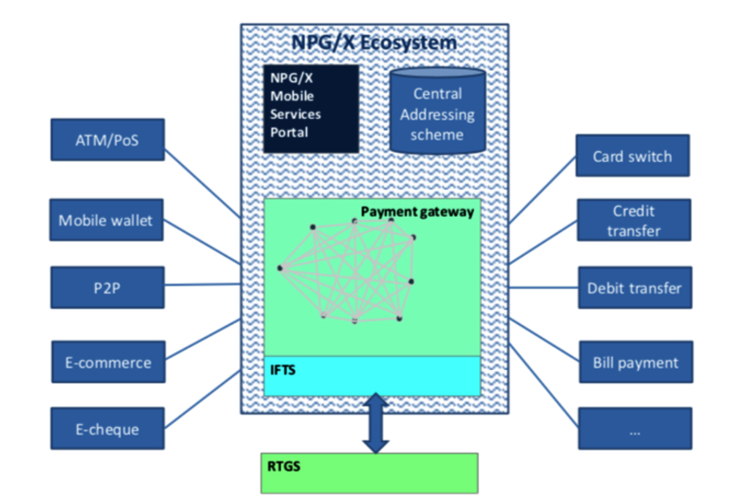

Figure: Nepal Payment System Simplified Version

3.2 Regulatory and Institutional Structure in Nepal
Nepal Rastra Bank (NRB) regulates and oversees the entire national payment system through its Payment Systems Department, under the authority of the Nepal Rastra Bank Act, 2002 and the Payment and Settlement Act, 2019. Institutions operating in this space are licensed under two broad categories. Payment System Operators (PSOs) run shared infrastructure and switches used by many participants Nepal Clearing House Limited (NCHL), Fonepay and Smart Choice Technologies are examples. Payment Service Providers (PSPs) serve customers directly this category includes commercial banks as well as non-bank wallet operators such as eSewa, Khalti and IME Pay. As of recent NRB reporting, Nepal had licensed 9 PSOs and more than 20 non-bank PSPs, in addition to banks licensed as PSPs.

3.3 Major Payment Systems and Platforms in Nepal
- RTGS (Real Time Gross Settlement) operated by NRB since 2019 for large-value, time-critical interbank transfers, settling each transaction individually and instantly rather than in batches.
- NCHL-ECC (Electronic Cheque Clearing) and NCHL-IPS (Interbank Payment System) run by Nepal Clearing House Limited; ECC clears cheques electronically, while IPS is a batch clearing house for smaller-value interbank transfers.
- National Payment Switch (NPS) shared national infrastructure developed through NCHL. Its Retail Payment Switch (RPS) has handled non-card retail transactions since November 2021, and the National Card Switch, running the domestic NEPALPAY card scheme, has operated since March 2025. Access is provided through the National Payments Interface (NPI).
- connectIPS lets customers pay directly from their bank accounts through a mobile app or web portal, without needing a separate wallet balance.
- NepalQR / NEPALPAY QR a standardised QR framework issued under NRB's NepalQR standard so that a single QR code can be scanned by customers of any participating bank or wallet, removing the need for merchants to display multiple, provider-specific QR codes.
- Mobile wallets eSewa, Khalti, IME Pay, Prabhu Pay and others, which are stored-value digital wallets operated by licensed non-bank PSPs.
- Fonepay one of the largest privately operated interoperable QR and interbank transfer networks, connecting many banks and wallets.

3.4 Current Status of E-Payment in Nepal
Digital payment adoption in Nepal has grown very rapidly over the past several years. According to Nepal Rastra Bank's payment-system indicators, the number of registered mobile-wallet users rose from under 9 million to roughly 27 million between 2021 and 2025, an increase of more than 200 percent. Mobile-banking customers reached approximately 27 to 28 million, and internet-banking users reached around 2.2 to 2.4 million. Growth has not been limited to registrations: transaction values across most instruments have also risen sharply.

Indicator | Approx. Mid-2024 | Approx. Mid-2025 | Approx. Change
Registered mobile wallet users | 23.5 million | 26.8 million | +14%
Mobile banking customers | 24.7 million | 27.7 million | +13%
Internet banking users | 1.9 million | 2.2 million | +16%
connectIPS registered users | 1.3 million | 1.4 million | +13%
Debit cards issued | 12.9 million | 13.7 million | +6%
Credit cards issued | 0.29 million | 0.32 million | +10%
RTGS participating institutions | 44 | 44 | Stable

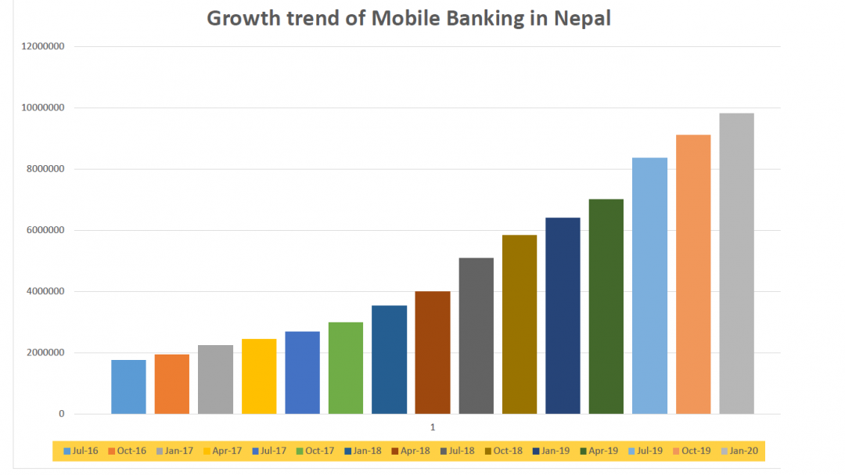
Figure: Growing Trend of Mobile Banking in Nepal

Growth has been strongest in QR-based payments, whose transaction volumes and values have roughly doubled within a single fiscal year in recent reporting, reflecting the low cost of QR acceptance for small merchants compared with card-based point-of-sale terminals. Supporting conditions have helped this growth: 4G network coverage has reached almost all local levels in the country, the average cost of mobile internet has fallen sharply over the past several years, and smartphone ownership has climbed to roughly three-quarters of the population.
However, the picture is not fully positive. World Bank Global Findex data cited in recent NRB reporting shows that only around 47 percent of Nepali account holders made or received a digital payment in 2024 noticeably lower than the comparable figures for India, Bangladesh and Pakistan. This gap between registration and active use is one of the most important findings of this report: Nepal has succeeded in getting people to open digital accounts but converting that access into habitual daily use remains unfinished work. Cross-border integration has also begun, with Nepali merchants now able to accept QR payments from India's UPI network among others, indicating an early but real step toward regional payment interoperability.

3.5 Comparison with India, South Korea and Bangladesh
The four countries considered here have each followed a different institutional and technical path toward digital payments and comparing them side by side is more useful for Nepal than trying to reduce each country's system to a single score.

Dimension | Nepal | India | South Korea | Bangladesh
Main retail rail | NepalQR, connectIPS, mobile/wallet banking, National Payment Switch | Unified Payments Interface (UPI) open, account-to-account, bank-agnostic | Credit/debit cards plus super-app wallets (KakaoPay, Naver Pay, Toss) | Mobile Financial Services bKash, Nagad, Rocket, plus Bangla QR
Institutional model | NRB regulation; NCHL as the main shared-infrastructure operator | RBI regulation; NPCI operates UPI as open public infrastructure | Central bank and commercial card/payment networks; market-led model | Bangladesh Bank regulation; agent-based mobile-money model
Approx. scale | ~27 million wallet users; QR and connectIPS transactions rising sharply year on year | Tens of billions of UPI transactions per month across 600+ banks | Very high card and mobile-payment penetration; smartphone ownership above 95% | Tens of millions of registered MFS accounts; wide agent network
Digital payment use by account owners (2024, approx.) | ~47% | ~54% | Near universal | ~78%
Key strength | Fast-growing, standardised, interoperable QR system | Massive scale, very low transaction cost, open access for fintech innovators | Mature infrastructure and seamless everyday user experience | Deep rural and unbanked reach through a large agent network
Key weakness | Usage still lags behind registration; limited rural depth | Some concentration of usage among a few dominant apps | Less directly transferable as a model for lower-income countries | Gap between the number of registered and genuinely active accounts
Main lesson for Nepal | — | Treat payment rails as open public infrastructure, not a private product, to unlock third-party innovation. | Focus on reliability, security and continuous technical modernisation of core infrastructure. | A strong agent network can extend digital payment reach into rural and low-income communities quickly.

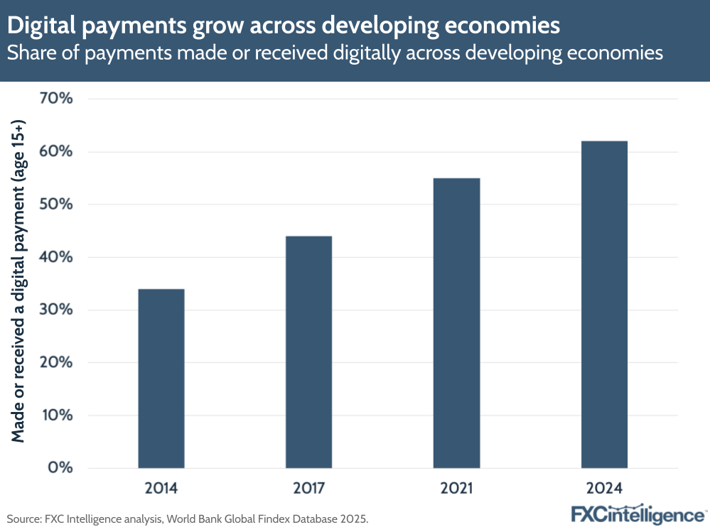
Figure: Digital Payment Grow Across Developing Economies

India
India's Unified Payments Interface (UPI), operated by the National Payments Corporation of India (NPCI), is widely regarded as the clearest example in the world of payment infrastructure being deliberately built and treated as reusable public infrastructure. UPI allows any participating bank or fintech application to move money between customer accounts instantly, twenty-four hours a day, using a common open standard. Because the underlying rail is shared, hundreds of competing consumer-facing applications have been able to launch on top of it at very low incremental cost. This is the single most important structural lesson for Nepal: building one common, open, well-governed national rail can do more for adoption than encouraging many separate, closed private systems.

South Korea
South Korea represents a mature, high-income digital-payment environment where card networks, bank transfers and large mobile 'super-app' wallets are deeply woven into daily commerce. Because Korea's high card and smartphone penetration developed under very different economic conditions than Nepal's, its specific consumer products are less directly transferable. The more useful lesson for Nepal is architectural discipline: Korea continuously upgrades its settlement messaging standards, throughput capacity and security controls, treating payment infrastructure as a utility that must be modernised on an ongoing basis rather than built once and left unchanged.

Bangladesh
Bangladesh demonstrates how mobile financial services combined with a large network of local cash-in/cash-out agents can extend digital payments deep into rural and low-income communities that lack easy access to a bank branch. Its national Bangla QR standard connects many banks, mobile-financial-service providers and payment-service providers under one interoperable acceptance mark for merchants. For Nepal, whose geography also includes many remote and hard-to-reach communities, Bangladesh's agent-based inclusion model is arguably more directly relevant than either India's or South Korea's.

3.6 Payment Infrastructure and Financial Inclusion
Digital payment infrastructure advances financial inclusion mainly by removing the geographic and time barriers of physical banking. In rural areas where bank branches are sparse, mobile banking and digital wallets allow households to send and receive money, pay utility bills and access basic financial products without travelling long distances. Low-cost, interoperable QR codes let micro-merchants and informal vendors accept digital payments without buying expensive point-of-sale hardware. Digitising government-to-person (G2P) transfers, such as social security payments, also reduces leakage and delay compared with cash disbursement.
However, account ownership and even wallet registration do not automatically translate into regular use. As already noted, roughly half of Nepali account holders did not make a single digital payment in 2024. Persistent barriers include entrenched cash habits, merchant resistance to transaction fees, fear of digital fraud, and intermittent network connectivity in hilly and remote terrain. Achieving deeper financial inclusion in Nepal will require pairing continued infrastructure expansion with sustained investment in digital literacy, merchant incentives and consumer-protection mechanisms infrastructure alone is a necessary but not sufficient condition.

3.7 Advantages, Challenges and Future Prospects

Advantages
- Convenience and speed payments can be made at any time without visiting a bank branch.
- Lower cash-handling costs for banks, businesses and government agencies.
- Greater transparency digital transaction records support tax compliance and reduce revenue leakage.
- Financial inclusion through wallets and rural agent networks.
- Lower cost of acceptance for small merchants, since interoperable QR needs no point-of-sale terminal rental and settles almost instantly.

Challenges
- Cybersecurity threats payment operators run systems that are attractive targets for data breaches and denial-of-service attacks.
- Fraud and financial crime identity theft, account takeover and social-engineering scams such as fake OTP requests.
- Weak internal controls at some providers inspections have found gaps such as missing disaster-recovery plans and incomplete KYC verification.
- Low digital literacy, particularly among older and rural users, which limits actual day-to-day usage even where access exists.
- Absence of a comprehensive personal data protection law in Nepal, which leaves consumer data rights less clearly defined than in India or Estonia.
- Uneven geographic coverage, with adoption still concentrated in urban areas and among younger, wealthier users.

Future Prospects
Nepal Rastra Bank has established a Digital Finance Innovation Hub, initiated a Fintech Strategy for digital financial services, and is preparing a regulatory sandbox to allow new payment products to be tested under supervision before wide release. NRB has also issued guidance on the use of artificial intelligence by licensed financial institutions and a framework for identifying systemically important payment systems that need enhanced oversight. Continued expansion of the National Payment Switch, deeper cross-border QR integration with neighbouring countries, and USSD-based payment options for citizens with basic feature phones all point toward a more inclusive and resilient payment system over the coming years.

CHAPTER 4: DIGITAL PUBLIC INFRASTRUCTURE (DPI)

4.1 Introduction to DPI
Digital Public Infrastructure (DPI) refers to a small number of foundational, reusable digital systems that are treated as public utilities, on which many different government and private services can be built. The idea deliberately mirrors physical infrastructure: a country does not build a separate road for every individual business; it builds one shared road network that everyone uses. In the same way, DPI argues that a government should not build a separate identity check, a separate payment mechanism and a separate document-verification process for every single service it offers. Instead, it should build these as shared layers once, to open and well-governed standards, and let every service tax filing, social benefits, business registration, healthcare reuse them.
What distinguishes DPI from an ordinary government IT system is that it is reusable, interoperable and typically accessed through published, standardised Application Programming Interfaces (APIs), rather than being a closed system built for one agency's exclusive use. The World Bank and UNDP both describe DPI in these terms: an ecosystem built on open standards, strong governance, privacy protection and participation from both public and private actors.

4.2 The Three-Layer DPI Model
DPI Layer | Core Question It Answers | Typical Building Blocks
Digital Identity | Who is this person or organisation? | National ID number, biometric enrolment, digital authentication, verifiable credentials.
Data Exchange | Can two trusted systems securely share the information they each already hold? | Secure APIs, a data-exchange bus/gateway, consent management, access logging and audit trails.
Digital Payments | Can value move safely and instantly between two parties? | Instant payment rails, national switches, standardised QR, account-to-account transfers, settlement systems.
A fourth element, consent management, is increasingly treated as essential rather than optional, because a data-exchange layer that lets agencies share citizen information without the citizen's knowledge or control creates serious privacy risks. India's Account Aggregator/DEPA framework and Estonia's access-logging model are two different but equally serious attempts to solve this consent problem, and both are discussed further below.

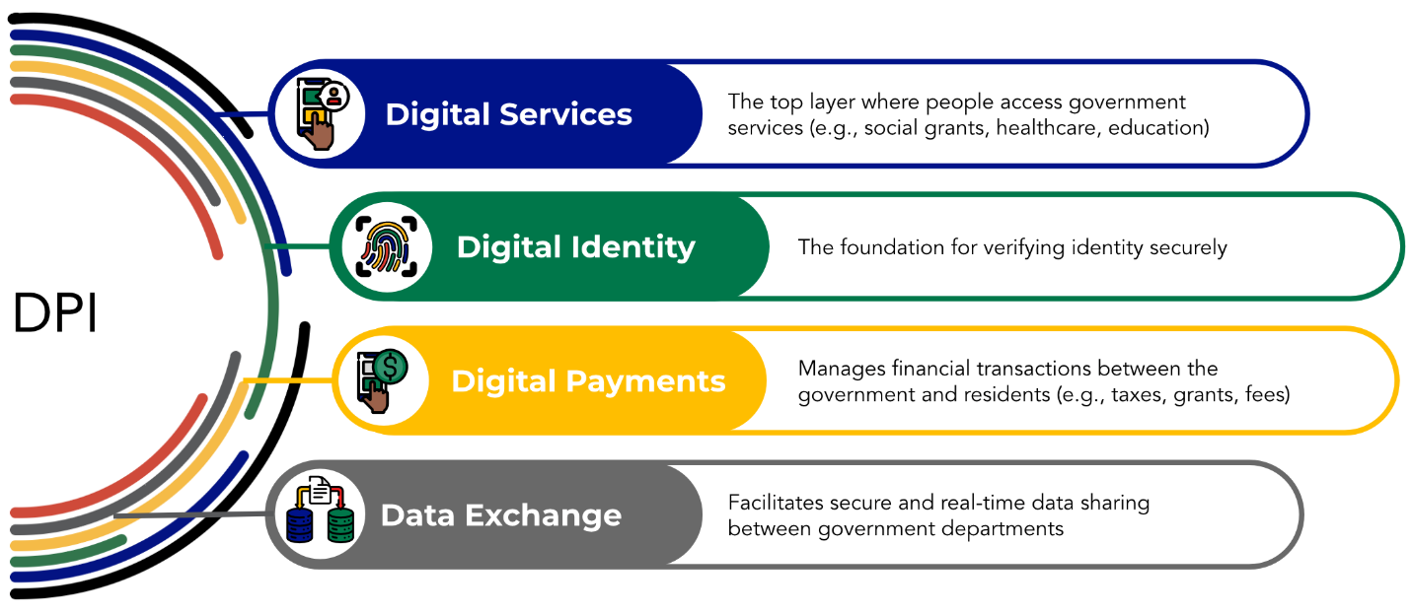
Figure: DIP Layer

Principles of Good DPI
- Interoperability systems communicate through common, published standards rather than proprietary formats.
- Security strong authentication, encryption, logging and continuous monitoring are built into the design from the start.
- Privacy only the minimum necessary information is shared, and only for a clearly defined and consented purpose.
- Scalability the infrastructure must support very large numbers of users and transactions without redesign.
- Inclusiveness citizens should not be excluded from digital services because of their device, location, disability or income level.
- Openness public infrastructure should avoid unnecessary vendor lock-in and favour open, reusable standards.
- Accountability clear rules must exist for access, correction of errors, dispute resolution and handling of misuse.

4.3 National ID and Digital Identity in Nepal
Nepal's national identity system is governed by the National Identity Card and Registration Act, 2076 (2019) and is implemented by the Department of National ID and Civil Registration (DoNIDCR) under the Ministry of Home Affairs. Every registered citizen receives a unique National Identity Number (NIN) together with a biometric smart card, commonly called the Rastriya Parichaya Patra, which stores a photograph, fingerprints and iris data on an embedded chip. Enrolment involves an online pre-enrolment step followed by in-person biometric capture at a District Administration Office.
The National ID is now required, or increasingly required, for opening a bank account, applying for an e-passport, enrolling in the Social Security Fund and registering a SIM card. A digital version of the identity is also available through the government's Nagarik App, which is particularly useful because it lets citizens use their identity for verification even before their physical card has been printed and delivered.
Two limitations are worth highlighting for a DPI assessment. First, enrolment in the NID programme has moved faster than the printing and physical distribution of cards, so a significant number of citizens hold a valid NIN without yet holding the physical card. Second, and more important from a DPI perspective, simply having a national identity database is not the same as having a national identity platform. The real value of digital identity as DPI comes only when other government and private systems can verify a person's identity electronically, in real time, through a standard interface rather than merely checking a physical card by eye. Nepal Rastra Bank has indicated that it is coordinating with DoNIDCR to implement electronic Know-Your-Customer (eKYC) verification, which shows that this integration work is under way but not yet complete.

4.4 Data Exchange Platform
A data-exchange platform, sometimes called an interoperability layer or a data-exchange bus, allows different government agencies to securely share verified information with one another. It is important to note that a well-designed data-exchange layer is not a single central database into which every agency's data is copied. Instead, each agency keeps ownership and control of its own authoritative records, and exposes only specific, approved pieces of information to other authorised systems through a controlled, logged interface. This distinction matters both for security a breach of one connected system does not automatically expose every other system's data and for institutional practicality, since agencies are generally reluctant to give up control of the data they are legally responsible for.
This is precisely the layer where Nepal currently has the largest gap. At present, most ministries and agencies run separate systems that cannot communicate with one another, which causes duplicated data collection, citizens repeatedly submitting documents the government itself already issued, and delays in cross-agency verification. Work has begun to close this gap. The government has announced a National Data Exchange Platform, and a roadmap study has been commissioned aligned with the Digital Nepal Framework 2.0 and Nepal's Sixteenth periodic development plan. Funding has also been arranged: under the Nepal Digital Transformation Project, supported jointly by the World Bank (approved February 2026) and the Asian Development Bank (March 2026), a meaningful share of the roughly USD 50 million project budget has been earmarked specifically for the national data-exchange platform, alongside allocations for land-administration digitalisation, digital-signature infrastructure and expansion of the Nagarik App.
Two cautions are important here. First, Nepal is a federal country with seven provinces, seventy-seven districts and 753 local levels, so any data-exchange design must be built to work across all three tiers of government, not just at the federal centre. Second, Nepal's own experience shows that past donor-funded digital projects have often been delayed by weak inter-agency coordination rather than by a lack of funding, which suggests that execution discipline not just budget will determine whether this platform succeeds on schedule.

4.5 Digital Payment Platforms as DPI
Payment is the DPI layer where Nepal is furthest along, building directly on the infrastructure described in Chapter 3. In DPI terms, the relevant components are the National Payment Switch and its Retail Payment Switch, the National Payments Interface as a shared access point, the standardised NepalQR mark, the domestic NEPALPAY card scheme, and connectIPS. These qualify as genuine DPI rather than merely a collection of separate private products because they are shared and interoperable, and are made available equally to banks, wallets, fintech companies and government agencies, rather than belonging exclusively to any single provider. Comparable systems elsewhere, such as India's UPI, Brazil's Pix and Singapore's PayNow, are now explicitly treated by their governments as strategic national infrastructure rather than ordinary commercial products, and Nepal's National Payment Switch is best understood as an early step in the same direction.

4.6 India's DPI: India Stack
India Stack is a set of open, layered APIs built over roughly the last fifteen years, generally described in four layers, summarised below.

Layer | Component | Function
Identity | Aadhaar | A biometric identity number used for authentication and electronic KYC; well over a billion numbers have been issued, giving it near-universal population coverage.
Payments | UPI (Unified Payments Interface) | Instant, account-to-account payments over open APIs, processing tens of billions of transactions per month across hundreds of participating banks.
Paperless | DigiLocker and eSign | Issuing, storing and digitally signing verified documents, letting citizens hold and present government-issued documents electronically.
Consent | Account Aggregator and DEPA | Lets individuals share their own financial data between institutions only with their explicit, revocable consent.

India's own National Data Governance framework and the country's Digital Personal Data Protection Act, 2023, add a legal layer on top of these technical layers. The single most important architectural lesson from India Stack is that by keeping identity, payments, documents and consent as separate but connectable layers rather than one monolithic system private companies and startups were able to build competing consumer applications on top of the same shared public rails, dramatically accelerating adoption without the government having to build every consumer-facing product itself.

4.7 Estonia's DPI: e-ID and X-Road
Estonia, a small country of roughly 1.3 million people, rebuilt much of its government around digital identity starting in the early 2000s and is widely regarded as the earliest complete real-world example of DPI.
- e-ID an electronic identity card issued since 2002 and held by nearly the entire population. It carries cryptographic certificates for authentication and digital signing, and an Estonian digital signature carries the same legal force as a handwritten one.
- X-Road (X-tee) a secure data-exchange layer connecting hundreds of public and private-sector databases. Crucially, X-Road is not a central database; each authority keeps its own system, and X-Road allows them to exchange data securely using strong mutual authentication, encryption and complete logging of every access. It reportedly handles well over two billion transactions a year.
- The once-only principle is because connected systems can query each other through X-Road, a citizen is generally required to give a given piece of information to the state only once. As a direct result, close to all Estonian public services are available online.
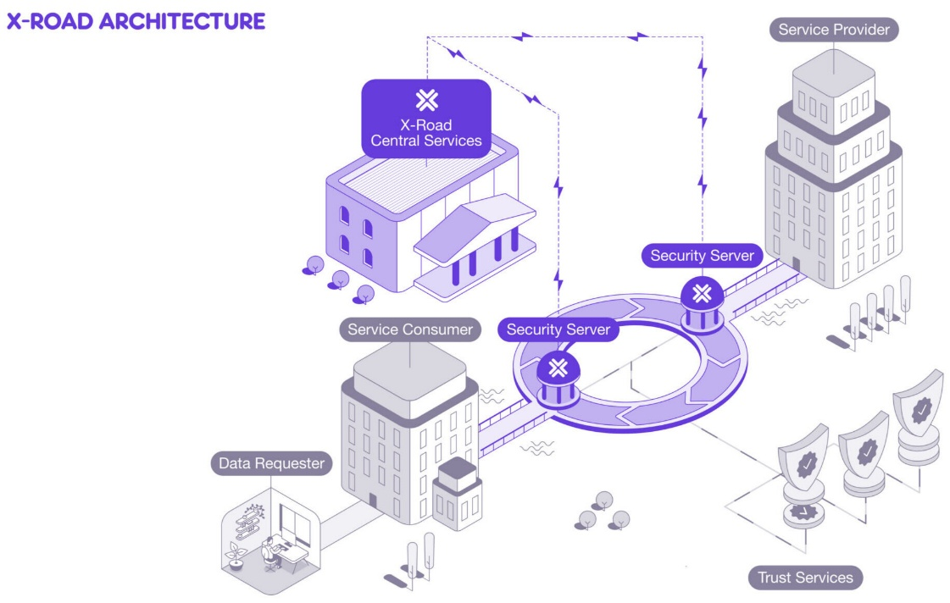
Figure: X-Road Architecture
The most instructive feature of Estonia's approach is deliberate decentralisation. Because data is never pooled into one giant central store, a breach of any single connected system does not automatically compromise every other system, and every single access is logged so that citizens can, in principle, see exactly who has looked at their data and why. In Estonia's design, trust is engineered into the architecture itself rather than added afterward as a policy statement.

4.8 Comparison of Nepal's DPI with India and Estonia
Component | Nepal | India | Estonia
Digital identity | National ID (NIN) with biometric smart card; digital identity available via Nagarik App; eKYC integration still being developed | Aadhaar well over a billion numbers issued, with mature, high-volume authentication APIs | e-ID issued since 2002, held by nearly the whole population, with full legal weight for digital signatures
Data exchange | National Data Exchange Platform announced and funded, but not yet operational; agencies remain largely siloed | Multiple national platforms and APIs DigiLocker, Account Aggregator with governance still being strengthened | X-Road a mature, decentralised exchange layer running continuously since the early 2000s
Payments | National Payment Switch, NepalQR, connectIPS, NEPALPAY | UPI at very large scale with fully open APIs | Deep integration of bank payments with e-ID, operating within the EU payment area
Consent / data protection | No comprehensive personal data protection law yet | Digital Personal Data Protection Act, 2023, plus the DEPA consent architecture | EU GDPR, plus full citizen-facing access logging through X-Road
Overall architecture | Payment layer relatively developed; identity layer partly developed; exchange layer still the main missing piece | Layered and open, explicitly designed for population-scale use | Decentralised, built around identity and consent from the very start
Governance | Responsibility spread across MoCIT, DoIT, DoNIDCR and NRB | Dedicated bodies for each layer, such as UIDAI (identity) and NPCI (payments) | A single dedicated body, the Information System Authority (RIA), with X-Road maintained by NIIS

Similarities
- All three countries treat digital identity as the foundational layer on which other digital services depend.
- All three aim to reduce repeated paperwork and repeated submission of the same documents to different agencies.
- All three rely on shared infrastructure that both government agencies and private-sector organisations can connect to.

Differences
- Estonia built its identity layer first and designed the rest of government around it; Nepal's payment layer has advanced ahead of both its identity and its data-exchange layers.
- Estonia's X-Road is deliberately decentralised, while India's Aadhaar relies on a large centralised database; Nepal has not yet made a comparable architectural choice for its own data-exchange platform.
- Both India and Estonia already have comprehensive data-protection legal frameworks; Nepal does not yet have one.
- India and Estonia each have a clearly dedicated institution responsible for each DPI layer; in Nepal, responsibility is currently spread across several separate agencies.

4.9 Nepal's Strengths and Areas for Improvement

Nepal's Strengths
- A standardised, interoperable QR payment system and a working national payment switch, which many countries at a similar income level still lack.
- Very fast growth in digital-payment usage, showing that citizens readily adopt these services once they are made available and affordable.
- An active, transparent central bank with a clear legal mandate that publishes detailed payment-system data openly.
- Rapidly improving digital foundations, including near-universal 4G coverage at the local level and steadily falling internet costs.
- The advantage of arriving later than India and Estonia, meaning Nepal can study and adapt already-proven models such as X-Road and India Stack instead of designing entirely from scratch.

Areas Where Nepal Can Improve
- Build and operationalise the national data-exchange layer this is the single largest gap. Nepal should adopt a proven open standard and design it from the outset to work across federal, provincial and local levels of government.
- Make the National ID electronically verifiable through a standard API, rather than simply distributing physical cards.
- Enact a data-protection and consent framework alongside the data-exchange layer, not after it is already built.
- Clarify institutional responsibility, giving each DPI layer a single, clearly accountable owning agency.
- Adopt common data and API standards early, since connecting already-built systems later is far more expensive than designing for interoperability from the start.
- Strengthen cybersecurity through regular audits and tested disaster-recovery drills as government systems become more interconnected.
- Close the usage gap by shifting policy focus from registration numbers to actual, active usage especially among women, rural residents and low-income users.

CHAPTER 5: COMPARATIVE ANALYSIS MATRIX
This chapter draws together the three pillars examined separately in Chapters 2 to 4 data centers, payment infrastructure and DPI into a single, consolidated comparison across Nepal and its four benchmark countries: India, Estonia, South Korea and Bangladesh.

5.1 Data Center Infrastructure Cross-Country Comparison
Country | Maturity of Data Center Market | Notable Characteristic
Nepal | Early / developing | One primary government facility (Singha Durbar) with a DR site in Hetauda; growing private colocation market concentrated mainly in Kathmandu, with limited geographic diversification (e.g., DataHub Butwal).
India | Mature / hyperscale | Large commercial cloud and colocation ecosystem across major metropolitan hubs, serving both global cloud providers and national public digital infrastructure.
Estonia | Mature, sovereignty-focused | Emphasises secure data management and international backup redundancy through 'data embassies' hosted abroad, ensuring continuity even during a domestic crisis.
South Korea | Mature / highly resilient | Highly resilient telecom and financial-sector hosting facilities built to strict fault-tolerant standards.
Bangladesh | Rapidly developing | Growing commercial data-center capacity to support an expanding digital economy and mobile-financial-services sector.

5.2 Payment Infrastructure Cross-Country Comparison
Country | Core Retail Rail | Interoperability | Relative Strength
Nepal | NepalQR, connectIPS, mobile banking, National Payment Switch | Improving through NPS/RPS and NPI | Fast growth from a low base; standardised QR
India | UPI | Very high — open rails, hundreds of banks/apps | Massive scale at very low transaction cost
Estonia | Bank transfers integrated with e-ID, within EU/SEPA | High within the EU payment area | Deep integration of payments with identity and trust services
South Korea | Cards plus mobile 'super-app' wallets | High; continuous technical modernisation (e.g., ISO 20022) | Mature, reliable, seamless user experience
Bangladesh | Mobile Financial Services (bKash, Nagad) plus Bangla QR | Improving via national QR and switch standardisation | Deep rural and unbanked reach via agent networks

5.3 Digital Identity Cross-Country Comparison
Country | Identity System | Coverage / Maturity
Nepal | National ID (NIN) with biometric smart card | Enrolment expanding rapidly; electronic verification (eKYC) still being integrated
India | Aadhaar | Well over a billion numbers issued; mature, high-volume authentication APIs
Estonia | e-ID | Held by nearly the entire population since 2002; legally binding digital signatures
South Korea | Resident registration plus advanced mobile/bank digital certificates | Mature, deeply integrated with both government and financial services
Bangladesh | National ID (NID) | Established and widely used for banking and civil-registration purposes

5.4 Data Exchange Platforms Cross-Country Comparison
Country | Model | Status
Nepal | National Data Exchange Platform (planned) | Announced and funded under the 2026 Digital Transformation Project; not yet operational
India | DigiLocker, Account Aggregator, API Setu | Operational at large scale; governance continuing to strengthen
Estonia | X-Road (X-tee) | Mature, decentralised, operational since the early 2000s
South Korea | Advanced public/private inter-agency systems | Mature and continuously modernised
Bangladesh | Evolving inter-agency data-sharing initiatives | Early / developing

5.5 Digital Payments as DPI Cross-Country Comparison
Country | Payment Platform as DPI | Public-Infrastructure Lesson
Nepal | National Payment Switch, RPS, NEPALPAY QR, connectIPS | Build one common domestic rail and enforce common standards across all participants
India | UPI | Treat payment infrastructure as reusable national infrastructure, open to private innovation
Estonia | Bank payments integrated with e-ID within the EU payment area | Connect digital identity and trust services directly with financial services
South Korea | Card and mobile-wallet ecosystem with continuous ISO 20022 modernisation | Maintain security, resilience and cross-border interoperability continuously
Bangladesh | Bangla QR connecting banks and mobile-financial-service providers | Standardise merchant acquiring to include informal micro-enterprises

5.6 Overall Cross-Country Comparison Matrix
Infrastructure Area | Nepal | India | Estonia | South Korea | Bangladesh
Digital Identity | Developing | Very large scale | Mature | Mature | Established
Digital Payments | Rapid growth | Global leader | Near-cashless | Mature | Strong MFS reach
Data Exchange | Planned / funded | Multi-platform | Federated / mature | Advanced | Evolving
e-Services / Portals | Digitising | Massive scale | ~99% online | Fully digitised | Expanding
Interoperability | Improving | High | Core principle | High | Improving
Digital Inclusion | Rural barriers remain | Large scale, rural gaps remain | High, near-universal | Universal | High via agents

5.7 Lessons Nepal Can Learn from Other Countries
- From India: adopt an open payment rail model (like UPI) that encourages private fintech innovation while enforcing common clearing and settlement standards.
- From Estonia: implement a federated data-exchange model (like X-Road) that connects agency databases securely without creating a single, vulnerable central repository.
- From South Korea: treat digital infrastructure as a dynamic utility that requires continuous upgrades to messaging standards, throughput and cybersecurity, not a one-time build.
- From Bangladesh: standardise merchant acquiring through a single interoperable QR mark to bring informal and micro-enterprises into the digital payment system.

CHAPTER 6: FINDINGS, CHALLENGES AND RECOMMENDATIONS

6.1 Major Findings
- Uneven structural growth: Nepal's three infrastructure pillars have developed at very different speeds. Payment infrastructure (NCHL, connectIPS, NepalQR) is the most mature of the three, data-center infrastructure is regulated but still concentrated and moderately developed, while government-wide data exchange has only just entered the implementation stage.
- Rising adoption with residual cash dependency: digital payments have reached significant scale among urban consumers and formal businesses, yet cash remains dominant for everyday retail purchases in much of the country, and only around 47 percent of account holders actively used a digital payment in 2024.
- A transitioning identity system: the National ID (NIN) programme is establishing a solid biometric foundation across public registries, but its real DPI value depends on completing electronic, API-based verification (eKYC) rather than relying on physical card inspection alone.
- An interoperability deficit that is now being directly addressed: historic fragmentation across ministry-level systems is the specific target of the 2026 World Bank/ADB-supported Digital Transformation Project, through its national data-exchange bus and digital-locker components.
- A physical and geographic resilience gap: the concentration of both public and private critical data-hosting assets inside the Kathmandu Valley leaves Nepal's digital services disproportionately exposed to a single seismic event.

6.2 Challenges Identified
- Geographic concentration of hosting assets within an earthquake-prone valley.
- Fragmented legacy government software systems that lack standard API connectors.
- Persisting digital divides in rural local levels caused by network drops and low digital literacy.
- Rising cybersecurity threats, including phishing, social-engineering scams and DDoS attacks against public hosting assets and payment operators.
- Absence of comprehensive data-privacy legislation and an independent supervisory authority for data protection.
- A shortage of certified local experts in data-center engineering, cloud architecture and cybersecurity.

6.3 Recommendations
Identified Bottleneck | Recommended Action | Expected Benefit
Concentration of hosting assets & disaster risk | Mandate active off-site disaster-recovery replication outside the Kathmandu Valley (e.g., Hetauda, Butwal) for all critical public and financial hosting assets, and test failover regularly. | Guarantees continuity of essential services during a regional physical disaster.
Data fragmentation and silos | Enforce mandatory compliance with a Government Enterprise Architecture and open API standards for all new government software procurement. | Eliminates repeated manual document verification and accelerates e-service delivery.
Merchant acquiring friction | Standardise merchant QR acquiring fees nationally and mandate full cross-wallet interoperability under the NepalQR/NEPALPAY framework. | Drives digital-payment acceptance among micro-merchants and rural vendors.
Cybersecurity exposure | Establish a dedicated, 24×7 Government Security Operations Centre (SOC) and mandate multi-factor authentication across all public-facing portals and payment systems. | Improves threat detection and protects public records and payment rails against breach.
Digital literacy and access divide | Deploy simplified, local-language user interfaces, assisted e-service counters at local (Palika) offices, and targeted rural digital-literacy campaigns. | Drives more inclusive adoption among elderly, rural and low-income populations.
Privacy and governance risk | Enact a dedicated personal data-protection law defining clear consent rules, citizen access to logs, and enforceable audit rights, before the national data-exchange platform goes fully live. | Builds public trust in digital identity and inter-agency data sharing.
Identity not yet a verification platform | Prioritise completing eKYC-style electronic verification APIs for the National ID, in coordination between DoNIDCR and NRB. | Turns the NID from a physical card into genuine reusable digital identity infrastructure.
Institutional fragmentation | Assign a single clearly accountable lead agency for each DPI layer (identity, exchange, payments), with a formal inter-agency coordination mechanism. | Reduces duplication of effort and speeds up delivery of the Digital Transformation Project.

6.4 Future Prospects
Nepal's digital infrastructure trajectory over the next several years looks genuinely promising, provided execution keeps pace with planning. Completing the 2026 Digital Transformation Project will deliver a secure government-wide data-exchange bus, a citizen digital locker and integrated social registries, materially streamlining e-governance service delivery. Expanding cross-border QR payment acceptance with neighbouring countries should lower friction for remittances, tourism spending and cross-border trade. Emerging technologies such as artificial intelligence can also be layered on top of a mature DPI foundation once it exists enabling automated document processing, localised voice-assisted public service portals, and real-time fraud detection within payment-clearing networks. None of these advanced applications, however, can be reliably built until the underlying identity, data-exchange and payment foundations described in this report are themselves complete, secure and trusted.

CHAPTER 7: CONCLUSION
This report has examined three interconnected foundations of e-governance in Nepal: data centers, payment infrastructure and Digital Public Infrastructure. Each foundation supports a different but essential function. Data centers provide the physical facilities, power redundancy and computing capacity needed to host government and financial records continuously and securely. Payment infrastructure enables the fast, low-cost transfer of monetary value between citizens, businesses, financial institutions and government. Digital Public Infrastructure connects these elements together linking digital identity, secure data exchange and payment rails into reusable, horizontal platforms that many different services can build upon, instead of every agency repeatedly building the same capability in isolation.
The evidence gathered across this study shows that Nepal has made real and measurable progress on each of these three pillars. The Integrated Data Management Center in Singha Durbar, together with its disaster-recovery site in Hetauda and a growing, increasingly regulated private data-center market, has strengthened the country's national hosting capacity. Central bank leadership and NCHL's clearing and switching platforms connectIPS, the Retail Payment Switch and NEPALPAY QR have driven rapid growth in mobile banking, digital wallets and QR-based payments over a short period. The expansion of National ID enrolment and the launch of the World Bank- and ADB-supported Digital Transformation Project mark a genuine, funded step toward integrated data exchange and citizen digital lockers.
At the same time, this report's comparison with India, Estonia, South Korea and Bangladesh makes clear that Nepal's greatest remaining gap is not technology in the abstract, but integration. Nepal currently has a reasonably developed payment layer, a partly developed identity layer, and a data-exchange layer that is funded and planned but not yet operational. A data center that is not connected to interoperable software, an identity system that cannot be verified electronically by other agencies, and a payment system that operates separately from the rest of government together deliver far less value than they would if they were properly joined up. The overall conclusion of this study is that Nepal has largely built the individual pieces of digital infrastructure but has not yet connected them into a single, coherent system.
Going forward, the next stage of e-governance in Nepal depends less on acquiring new technology and more on sustained work in four areas: completing and operationalising the national data-exchange platform across all three tiers of government; enacting a comprehensive data-protection and consent framework; strengthening physical and cyber resilience, including geographic diversification away from the Kathmandu Valley; and, above all, maintaining the consistent, disciplined project execution that has historically been Nepal's weakest link in digital government initiatives. If these priorities are pursued together, Nepal is well placed to move from having built strong individual components to operating a genuinely integrated, secure and inclusive digital public infrastructure.

REFERENCES
- Asian Development Bank. (2026, March 10). ADB supports Nepal's digital transformation toward high-impact services for citizens and businesses [Press release]. ADB.
- Bangladesh Bank. (2025). Payment systems overview and Bangla QR standard. Dhaka: Bangladesh Bank.
- Department of Information Technology (DoIT), Government of Nepal. (2025). Government Integrated Data Center (GIDC) mandate and infrastructure operations. Kathmandu: DoIT.
- e-Estonia Briefing Centre. (2025). X-Road – Interoperability services. Tallinn: e-Estonia.
- Government of Nepal, Ministry of Communication and Information Technology. (2025). Data Centre and Cloud Services (Operation and Management) Directive, 2081. Kathmandu: MoCIT.
- Government of Nepal. (2019). National Identity Card and Registration Act, 2076. Kathmandu: Ministry of Home Affairs.
- Information System Authority (RIA), Republic of Estonia. (2025). Data exchange layer X-tee. Tallinn: RIA.
- National Payments Corporation of India (NPCI). (2026). UPI product statistics. Mumbai: NPCI.
- Nepal Clearing House Limited. (2026). National Payment Switch, connectIPS and NEPALPAY [Corporate information]. Kathmandu: NCHL.
- Nepal Rastra Bank. (2019). Payment and Settlement Act, 2019. Kathmandu: NRB.
- Nepal Rastra Bank. (2026). Payment systems oversight report, FY 2024/25. Kathmandu: Payment Systems Department, NRB.
- Unique Identification Authority of India (UIDAI). (2026). Aadhaar dashboard and statistics. New Delhi: UIDAI.
- World Bank Group. (2026, February 9). Nepal: World Bank approves $50 million Digital Transformation Project [Press release]. Washington, DC: World Bank.
- World Bank Group. (2025). The Global Findex Database 2025. Washington, DC: World Bank.
- World Bank Group. (2026). Digital public infrastructure and services: Operational guidance framework. Washington, DC: World Bank.

