**Project on simulating an E-Commerce Website using C programming**

**__________________________________________**

**Team Members**

|  |  |  |
| --- | --- | --- |
| ***Sl. No.*** | ***Student Name*** | ***Roll Number*** |
| 1 | B Siddharth Prabhu | 200010003 |
| 2 | Patel Shahil Manishbhai | 200010039 |
| 3 | Rishita S Nambur | 200020036 |
| 4 | Krish Sosa | 200030030 |

**Problem Statement**

Write a C program to simulate an e-commerce website. The program should have the following modules:

(a) User login (Is the user a seller or consumer?)

(b) If seller: seller ID and username to be entered. Add items to the category.

(c) Display category and items with seller ID and price.

(d) Consumers can search an item, or select an item from the list displayed.

(e) Enter item and quantity with seller ID.

(f) Display total amount and complete purchase details.

**Design Steps**

1. ***int main()*** - The main code has the definition and declaration of functions. Each function implements the features mentioned in the problem statement. It will also display a welcome message “welcome to our e-commerce website” and then provide options like “existing seller”, “ customer ”, “new seller” after a certain amount of time delay.

2. ***void seller_login()*** - If the user chooses the “existing seller” option, this function gets called. The user is asked for details like username and seller ID. The function scans through a database containing all the seller details. If the username and seller ID are present/match, the function displays “logged in.” and is taken back to the main function [and then to the seller_choice() function]. If a match isn’t found, it displays “Invalid ID or Username.” and gives the user another try.

3. ***void seller_choice()*** - Here, the user is given options such as “Add items to your inventory”, “Display all items” and “Exit”. If the user picks option 1, seller_itemadd() function is called. If option 2 is picked, seller_display() is called.

4. ***void seller_itemadd()*** - The seller can pick a category to which they want to add their items and then fill in details like: Item ID, Name, Stock Quantity, Price and Features. If the item ID is taken, the seller is notified and is asked to pick another item ID. They can add multiple items in one go.

5. ***void seller_displayall()*** - This function displays everything the currently logged in seller has added to the item lists.

6. ***void seller_addaccount()*** - If the seller is new to the platform, they can create an account. The user is asked for a username and an ID of six digits. If the username or ID is taken, they are given another chance to add a new username and ID. This information is added and saved to the seller list and these details can be used by the seller to login next time.

7. ***void customer_choice()*** - This function allows the customer to choose between these options :- “Display all items”, “Display a category”, “Add item to cart”, “Check Cart” and “Exit”.

8. ***void customer_viewall()*** - Separate text files are maintained for each category. This function displays the contents of all the text files in the form of a table for the customer to view.

9. ***void customer_viewcat()*** - This function helps the customer in narrowing down the search by asking them to pick a category to view.

10. ***void customer_addtocart()*** - The customer can pick the item they wish to buy by entering the item ID and the quantity of the item they would like to buy. If the item ID entered is invalid, or if the quantity exceeds stock quantity, then the user is notified. This function allows the customer to choose multiple items.

11. ***void customer_checkcart()*** - This function allows the user to view all the items in their cart and is given an option to checkout or continue shopping.

12. ***void customer_checkout()*** - This function displays the final bill of purchase and asks the customer their name and payment method.

***Note:***

1. Every time the user enters an invalid option, the user is informed of it and is given another chance to enter their choice.

2. Details of all the customers (name, payment method, and total amount to be paid) are stored in the file “cdetails.txt” as a store transaction summary.

3. Coupons can be redeemed at checkout; info regarding this is located in the README.txt file.

4. For best performance, refrain from adding spaces in any string inputs.

**Role of team members**

|  |  |
| --- | --- |
| ***Student Name*** | ***Role*** |
| Siddharth | Implementing main code; functions 2, 5, 6; Documentation. |
| Shahil | Implementing functions 1, 4, 9; Report writing. |
| Rishita | Making code framework; Implementing functions 3, 7, 8, 10. |
| Krish | Implementing functions 11, 12; Report writing. |

**Results**

1. Initial display:

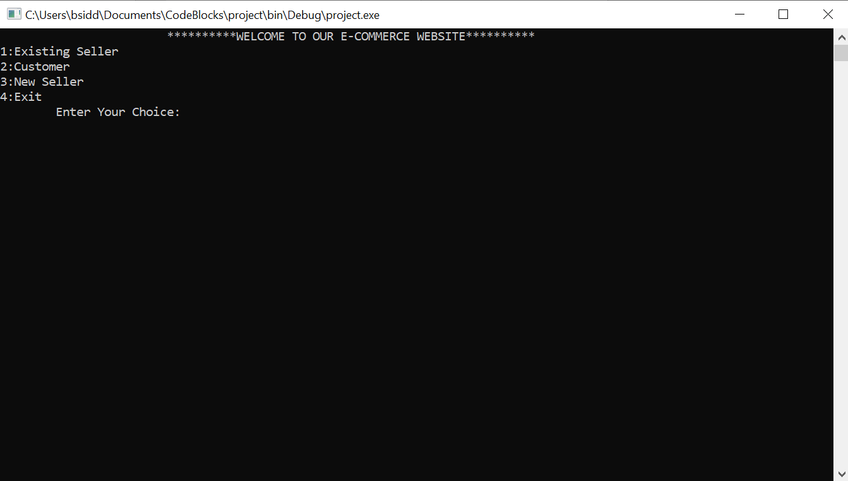

1. Login portal for an existing seller:

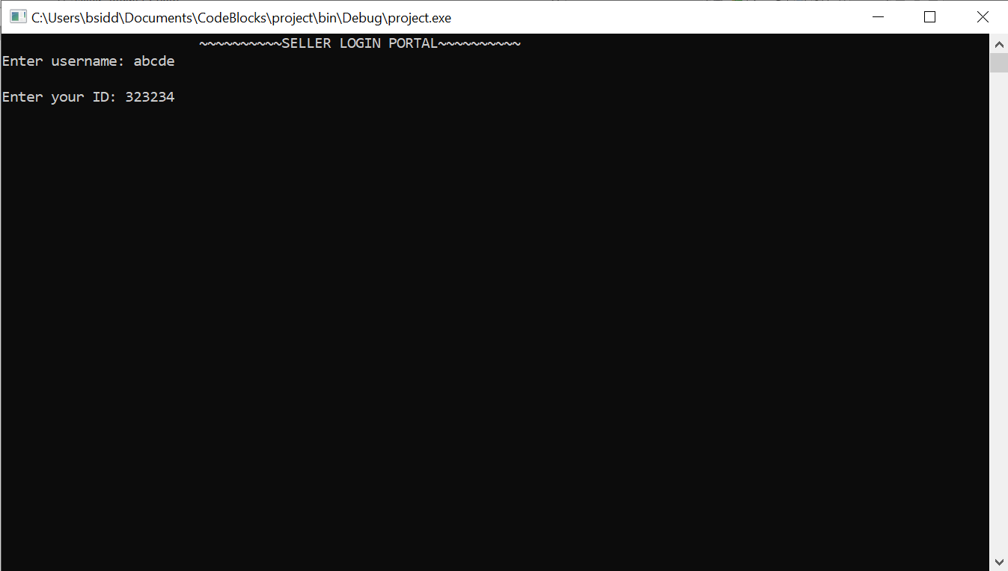

1. On adding an item to the inventory:

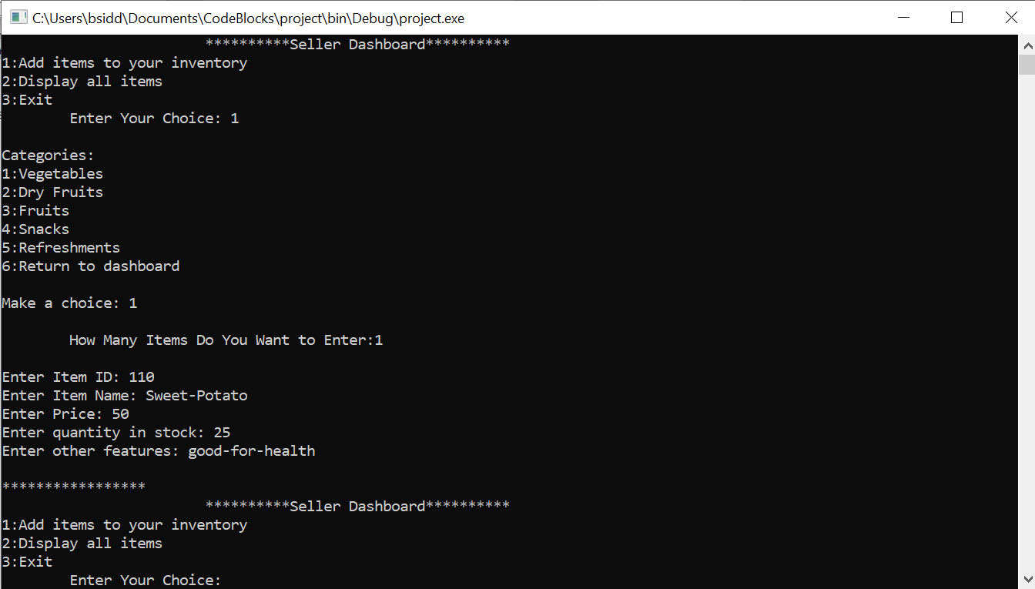

1. On displaying the seller’s inventory:

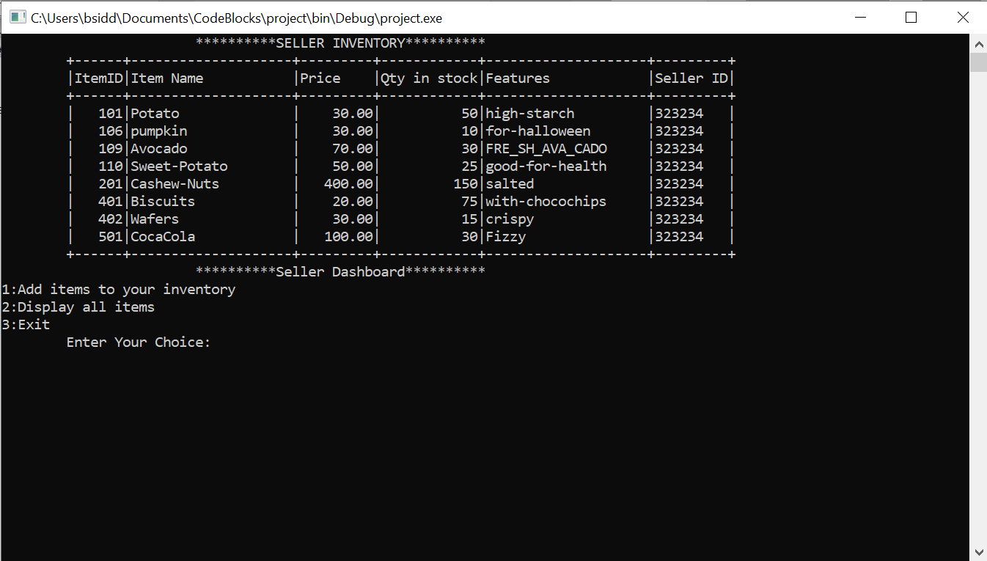

1. Choices for the customer:

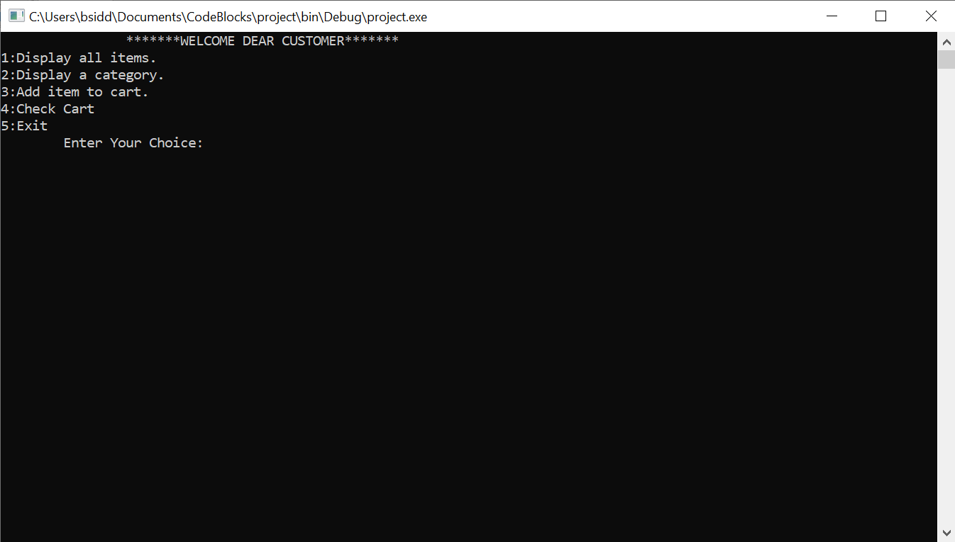

1. On displaying all items:

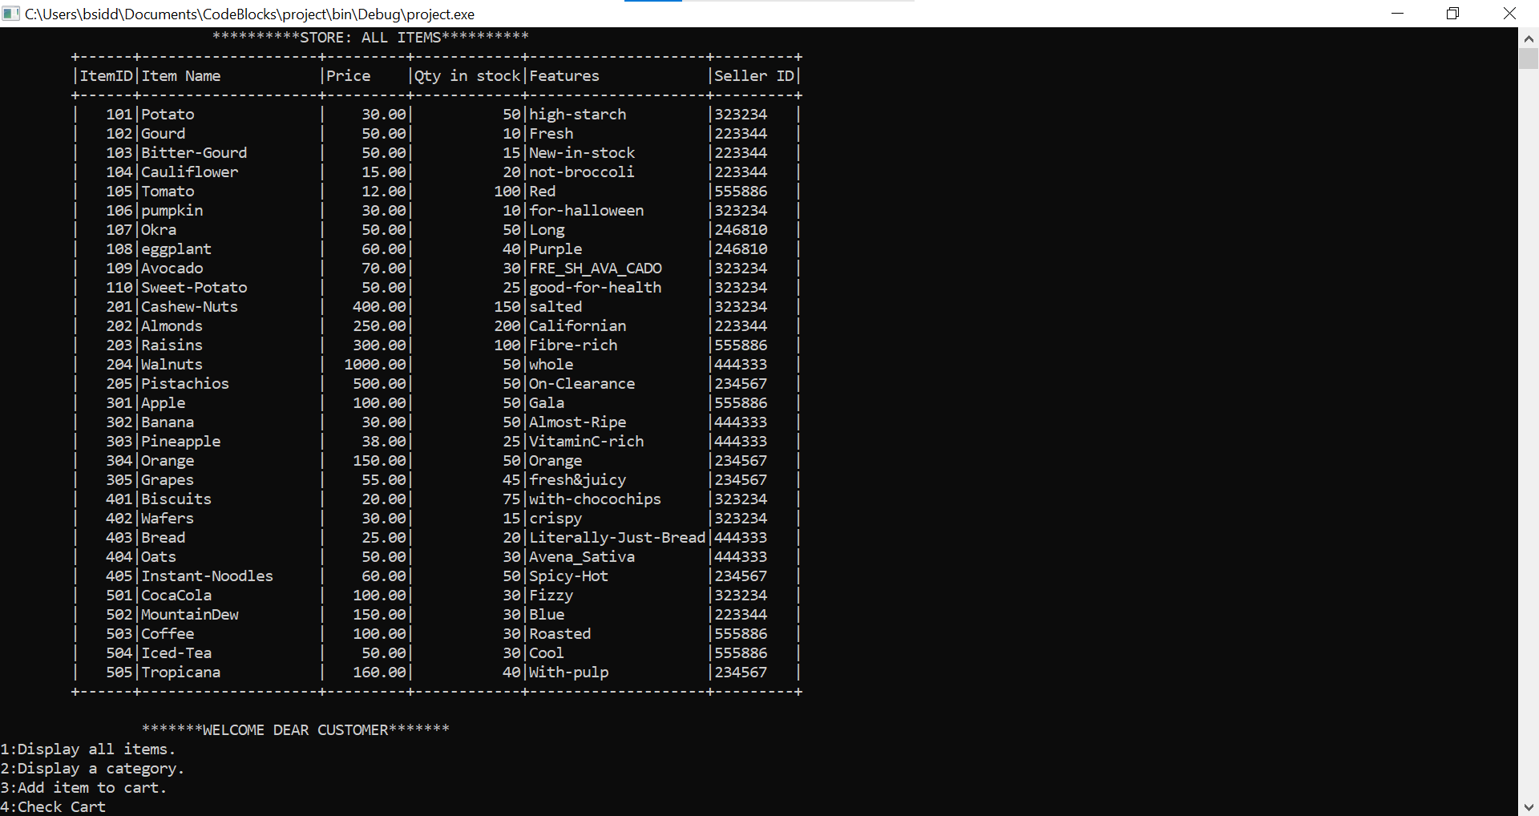

1. On displaying the items of a category:

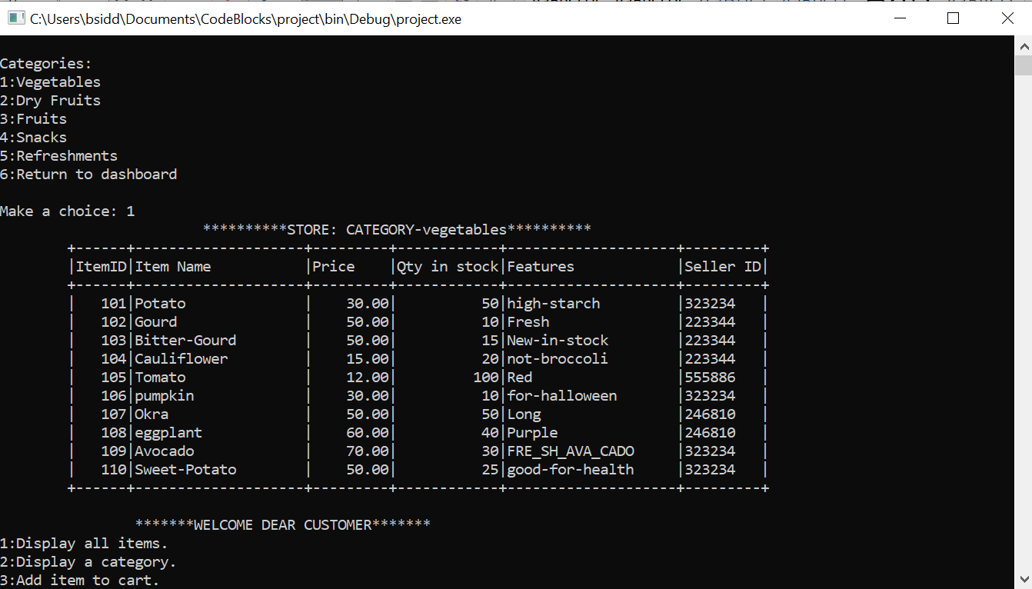

1. On adding items to the cart. (Screen not cleared so customer can refer to the category display):

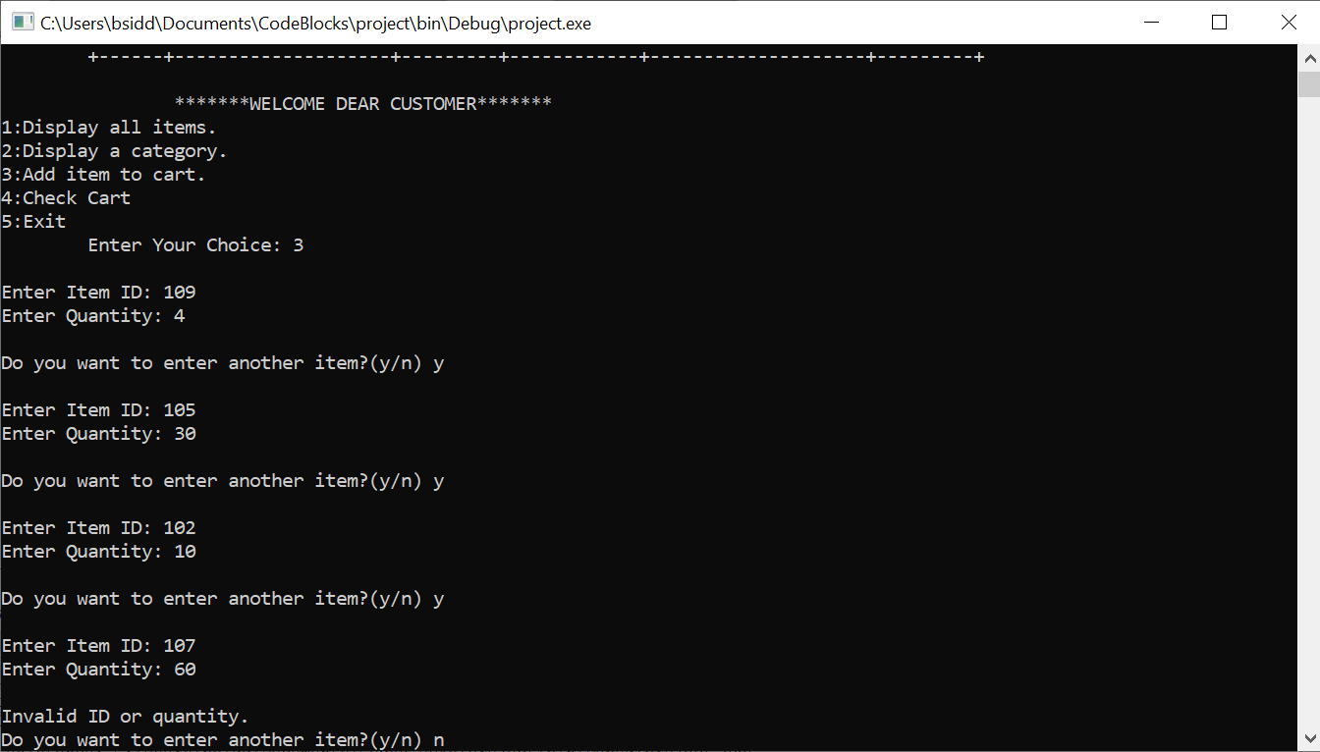

1. On displaying the cart:

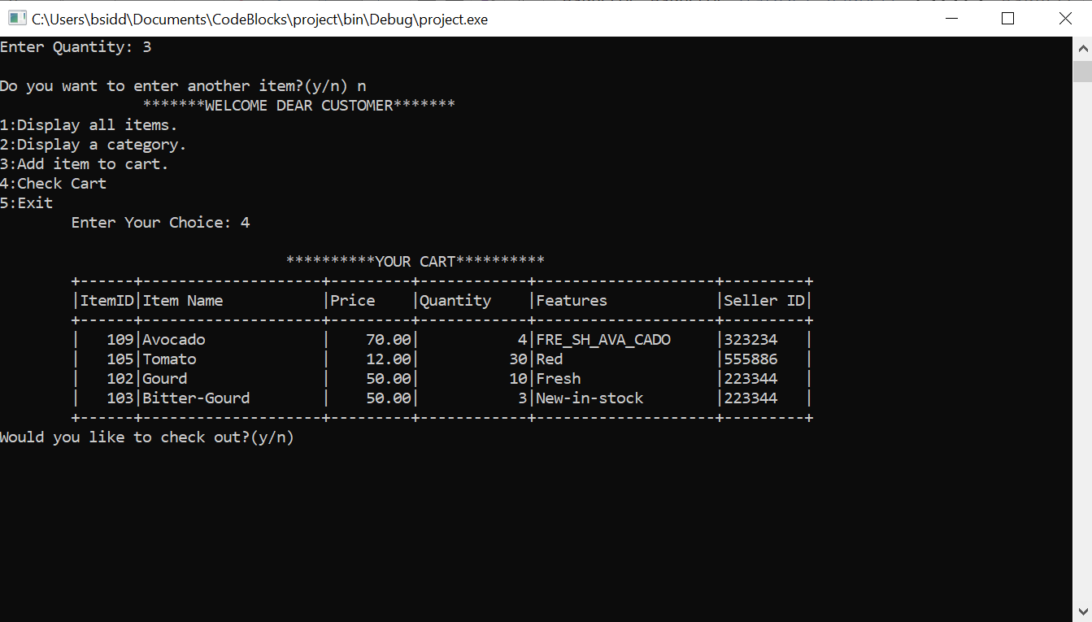

1. On checking out with the cart:

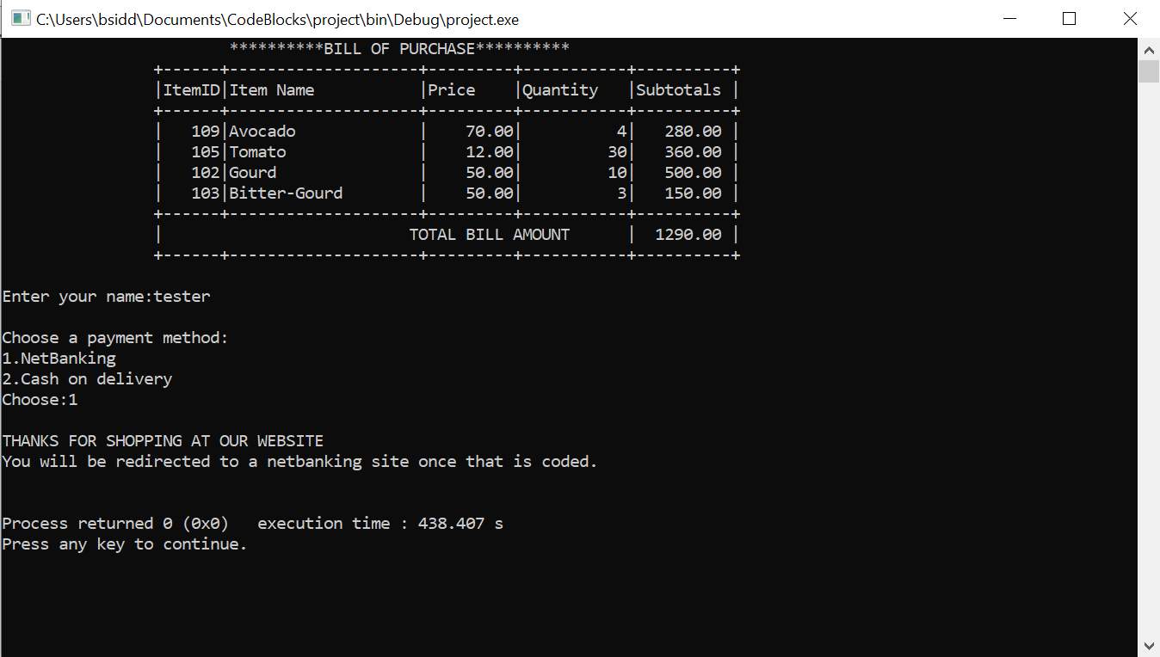

1. Registration of a new seller (log in after this is same as that of an existing seller):

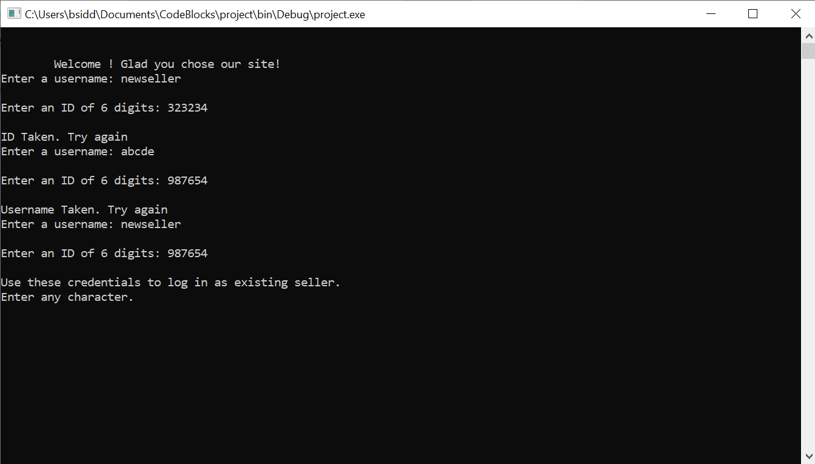

**References and Sources of info**

1. For concepts of records: [Data Structures Using C: CHAPTER 2: RECORDS, ARRAYS, AND POINTERS](http://orion.lcg.ufrj.br/Dr.Dobbs/books/book2/chap02.htm)
2. For info about files: <https://faculty.winthrop.edu/dannellys/csci325/>
3. Other concepts of structures and records from "The Spirit of C"(1998) by Mullish Cooper (Chapters 13, 14)

**___________________________________________**