Tagme3a (تجميعة) — Full MVP Plan
Production-grade mobile app for the Egyptian computer hardware market: EGP-denominated
custom PC builder, laptop recommendation engine, and live multi-merchant price tracker.

1. Monorepo layout
tagme3a/
├── app/ # (optional) or keep Flutter at root
├── backend/
│ ├── app/
│ │ ├── main.py
│ │ ├── core/ # config, security, db session, logging
│ │ ├── api/v1/ # routers (auth, products, builder, laptops, prices)
│ │ ├── models/ # SQLAlchemy 2.0 ORM
│ │ ├── schemas/ # Pydantic v2
│ │ ├── services/ # matcher, compatibility, recommender, pricing, text_gen
│ │ ├── scrapers/ # base.py + sigma.py, compumarts.py, nekhely.py
│ │ ├── workers/ # arq tasks + scheduler
│ │ └── data/ # seed data: cpus, gpus, sockets, compat matrix
│ ├── alembic/
│ ├── tests/
│ ├── pyproject.toml # uv/poetry, ruff, mypy, pytest
│ └── Dockerfile
├── docker-compose.yml # postgres(pgvector), redis, meilisearch, api, worker
├── .github/workflows/ # ci.yml (backend + flutter)
└── (existing Flutter files)
Flutter lib/ becomes feature-first:
lib/
├── main.dart
├── app.dart # MaterialApp.router, theme, locale
├── core/ # theme, network(dio), router, storage, i18n, utils
├── features/
│ ├── catalog/{data,domain,presentation}/
│ ├── builder/{data,domain,presentation}/
│ ├── laptops/{...}/
│ ├── prices/{...}/
│ ├── auth/{...}/
│ └── alerts/{...}/
└── shared/ # widgets, models shared across features

2. Backend architecture
Runtime: Python 3.12, FastAPI, Pydantic v2, SQLAlchemy 2.0 async, Alembic,
PostgreSQL 16 + pgvector, Redis, Meilisearch, arq (worker) + arq cron (scheduler).

Core domain models
Table | Purpose
users | auth, roles (user/admin/reviewer)
products | canonical product (brand, category, model, normalized specs JSONB, image, slug)
product_specs | typed spec rows (or JSONB) for compat checks
merchants | store metadata, scraper adapter key, base URL
offers | merchant ↔ product link, url, current price EGP, stock, last_seen_at, match_confidence
price_history | append-only (offer_id, price, in_stock, captured_at)
raw_snapshots | raw HTML/JSON per scrape (audit + reparse)
staging_listings | parsed-but-unnormalized rows pending match
components | CPU/GPU/board/RAM/PSU/case/cooler/storage compat attributes
builds | saved user builds (JSONB component ids, total, compatibility result)
laptop_profiles | scoring weights per use-case
alerts | user price-drop subscriptions
fx_rates | EGP reference rates + timestamps
resources | curated article/video/doc (type, url, youtube_id, language, AR/EN title/description, is_available)
combination_resources | resource ↔ combination_key (build parts / laptop pick), relevance, is_curated
build_resources | resource ↔ saved build
device_tokens | user ↔ FCM push tokens (platform)
interaction_events | append-only user events (view/save/click/outbound) for future ranking + content popularity

API surface (v1)
- POST /auth/register, POST /auth/login, POST /auth/refresh, GET /auth/me
- GET /products?q=&category=&min=&max=&merchant=&sort= (search via Meilisearch)
- GET /products/{id} (offers + price history + specs)
- GET /products/{id}/offers, GET /products/{id}/price-history
- POST /builder/validate (send component ids → compatibility report + total)
- POST /builder/optimize (budget + use-case → suggested builds)
- GET /laptops/recommend?use_case=&budget=
- POST /alerts, GET /alerts
- Admin: POST /admin/listings/{id}/match, GET /admin/review-queue, POST /admin/resources, POST /admin/combinations/{key}/resources
- Content: GET /combinations/{combination_key}/resources

Compatibility engine (services/compatibility.py)
Rule matrix seeded from data/:
- socket (CPU↔board)
- RAM type/DDR (CPU/board↔RAM)
- form factor (board↔case)
- max GPU length (GPU↔case)
- cooler height (cooler↔case)
- PSU wattage headroom (est. load ×1.25–1.3, connectors)
- M.2/SATA (storage↔board)
Output: {compatible: bool, issues: [{severity, code, message, components}]}.
OS/BIOS caveats surfaced as warnings.

Matching pipeline (services/matcher.py)
- Scrape → raw_snapshots
- Parse → staging_listings
- Normalize (brand/model/spec extraction, alias tables, rapidfuzz)
- Embed + pgvector nearest neighbor + rule gates
- Auto-link if confidence ≥ threshold; else → review queue
- Manual review promotes/rejects and feeds alias learning

Scrapers (scrapers/)
BaseScraper interface: fetch() -> raw, parse(raw) -> listings, key.
httpx + selectolax; Playwright fallback flag per merchant. Per-merchant throttling,
UA rotation, robots check, failure alerting (scraper "health" metric,
consecutive-failure threshold).

Jobs (arq cron)
- scrape_all (staggered per merchant)
- recompute_offers (ghost-inventory: no change/stale last_seen_at → mark unverified)
- fx_update
- price_drop_notify (query alerts, dispatch FCM)

3. Flutter app architecture
- State: Riverpod 3 (AsyncNotifier, providers per feature).
- Routing: go_router with deep links (/product/:slug, /build/:id).
- Network: dio + interceptors (auth refresh, retry, EGP error mapping); generated
typed client from OpenAPI (openapi_generator/retrofit).
- Models: freezed + json_serializable.
- Offline: drift (SQLite) cache for catalog + last prices; stale badge when offline.
- i18n: flutter_localizations + intl; AR (default, RTL) + EN; Cairo font;
NumberFormat.currency(symbol: 'ج.م'/'EGP', locale).
- Theme: Material 3, dark/light, seed color, Arabic-safe typography.
- Push: firebase_messaging for price-drop alerts.
- Images: cached_network_image with placeholders.
- Analytics/crash: Firebase Analytics + Sentry.

Screens (MVP)
Home (categories, deals) · Search/Browse · Product detail (offers table, price chart) ·
PC Builder (picker w/ live compat warnings + total) · Build results/optimizer ·
Laptop recommender · Alerts · Auth · Profile/Saved builds.

4. Milestones & deliverables

M0 — Foundation (repo + tooling)
- Restructure to monorepo, scaffold backend/, docker-compose (pg+pgvector, redis, meili).
- Backend config/session/logging, Alembic baseline, health endpoint, ruff/mypy/pytest, Dockerfile.
- Flutter: feature-first folders, Riverpod, go_router, theme, i18n/RTL, dio, lint, app shell.
- CI: backend lint+test, flutter analyze+test.
- Exit: docker compose up serves /health; app boots with AR RTL shell.

M1 — Catalog + Auth
- Models products/offers/price_history/merchants/users; migrations.
- Auth (JWT access/refresh, roles).
- Meilisearch indexing + search endpoints; product CRUD (admin).
- Flutter: search, browse, detail, auth flow.
- Exit: search a seeded catalog, open detail, log in.

M2 — Scraping MVP
- BaseScraper + Sigma and Compumarts adapters; raw→staging.
- arq worker + cron; price history; ghost-inventory marking.
- Admin review queue (basic).
- Exit: daily prices flowing for 2 merchants; history visible in app.

M3 — Normalization & Matcher
- Canonical schema hardening, alias tables, rapidfuzz + pgvector matching,
confidence thresholds, review UI.
- Exit: ≥90% auto-match on target merchants; low-confidence queued.

M4 — PC Builder
- Component data seed (CPU/GPU/board/RAM/PSU/case/cooler/storage + compat matrix).
- compatibility.py + /builder/validate; budget optimizer (/builder/optimize).
- Flutter builder UI with live compat warnings; saved builds.
- Exit: build a compatible PC within budget in-app.

M5 — Laptop Recommender
- Scoring weights per use-case (gaming/engineering/editing/3D/student) + budget tiers.
- /laptops/recommend + Flutter screen.
- Exit: recommendations ranked and explained.

M6 — Alerts & Release Polish
- FCM price-drop alerts end-to-end; offline cache/stale badges; analytics;
empty/error states; performance pass.
- Internal testing → Play Store internal track.
- Exit: installable build with alerts live.

5. Cross-cutting decisions locked
- API contract-first: FastAPI OpenAPI → generated Dart client (prevents model drift).
- Every price carries captured_at + source; UI never presents stale as live.
- Raw snapshots retained (audit / reparse after store HTML changes).
- One merchant = one adapter = one health metric (scrapers break often).
- Confidence-gated auto-matching + human review; legal review before scraping any store
and prefer commercial data agreements.

5a. AI-assisted AR/EN phrasing (single model use)
We will use a small online model (e.g. Gemini Flash free tier) only to rephrase English titles/facts into Arabic and English descriptions/labels for curated videos and articles. No model is used to discover or rank content.
- Provider-agnostic: backend/app/services/text_gen.py with adapters for hosted APIs; one method generate(context, lang, task="rephrase").
- Precompute + cache: generate once at curation (or via a batch job) and store in resources.title_ar, resources.description_ar, resources.description_en. Runtime calls are avoided.
- Strict guardrails: prompts always inject DB values; the model must not invent specs/prices/URLs.
- Graceful fallback: on failure, fall back to original title/templates — app never breaks.
- Scope: output-only, bilingual phrasing. No decision-making, no compatibility checks, no price logic.

5b. Curated videos/articles (no model for listing)
- Curated manually via admin (or seed script). Stored in resources + combination_resources (is_curated=true).
- Ordered on response: language priority (ar → en) → is_curated → relevance. Plain sorting; no model.
- Video → youtube_player_flutter inline; article → url_launcher external.
- Dead links are pruned via the YouTube API (videos.list) on a nightly schedule; no model.
- AR/EN labels/descriptions may be filled by the phrasing model (5a).

6. Key risks
Risk | Mitigation
Scraper breakage | adapter isolation, health alerts, raw snapshot reparse
Legal/ToS | review + merchant agreements; throttle/robots
EGP volatility & stale prices | timestamped prices, FX cache, stale badges
Matching accuracy | confidence gates + review queue + alias learning
Compat data completeness | dedicated seed dataset + tests, warnings not silent failures
Scope creep | phase gates above; MVP = M0–M6 only

7. Functional Requirements (FR)
Priority scale: M = Must (MVP), S = Should, C = Could, W = Won't (this release).

FR-1 — Authentication & Accounts
ID | Requirement | Priority
FR-1.1 | Register/login with email + password (JWT access + refresh) | M
FR-1.2 | Persistent session, silent token refresh | M
FR-1.3 | Role-based access: user / admin / reviewer | M
FR-1.4 | Password reset, logout, account deletion | S
FR-1.5 | Social login (Google) | C

FR-2 — Catalog & Search
ID | Requirement | Priority
FR-2.1 | Browse products by category (CPU, GPU, motherboard, RAM, PSU, case, cooler, storage, laptop, peripherals) | M
FR-2.2 | Full-text search with Arabic + English support | M
FR-2.3 | Filter by category, price range (EGP), merchant, brand, availability | M
FR-2.4 | Sort by price, popularity, recency, best offer | M
FR-2.5 | Product detail: images, specs, all merchant offers, price timeline | M
FR-2.6 | Show lowest current price + spread across merchants | M
FR-2.7 | Pagination / infinite scroll | M
FR-2.8 | Faceted search (socket, DDR type, VRAM size) | S

FR-3 — Price Tracking & Merchants
ID | Requirement | Priority
FR-3.1 | Scheduled scraping per merchant (adapter per store) | M
FR-3.2 | Store append-only price history with timestamps | M
FR-3.3 | Each offer links back to the merchant product URL | M
FR-3.4 | Ghost-inventory detection (stale price/stock) | M
FR-3.5 | Display "last verified" time and stale indicator | M
FR-3.6 | Price-drop notifications (push) | M
FR-3.7 | FX rate tracking (if USD-denominated sources) | S
FR-3.8 | Merchant health/failure dashboard (admin) | S

FR-4 — Product Normalization & Matching
ID | Requirement | Priority
FR-4.1 | Canonical product schema independent of merchant listing titles | M
FR-4.2 | Auto-match scraper listings to canonical products (fuzzy + vector) | M
FR-4.3 | Confidence scoring per match | M
FR-4.4 | Admin review queue for low-confidence matches | M
FR-4.5 | Manual promote/reject + alias learning | S
FR-4.6 | Raw snapshot retention for reparse | S

FR-5 — PC Builder
ID | Requirement | Priority
FR-5.1 | Select components per slot with live compatibility checks | M
FR-5.2 | Compatibility engine (socket, DDR, form factor, GPU length, cooler height, PSU wattage, storage) | M
FR-5.3 | Display per-issue severity (error/warning) | M
FR-5.4 | Running total in EGP using lowest available offers | M
FR-5.5 | Budget optimizer: suggest a compatible build within a budget + use case | M
FR-5.6 | Save / name / share builds | S
FR-5.7 | Estimate bottleneck / performance balance | C

FR-6 — Laptop Recommendation
ID | Requirement | Priority
FR-6.1 | Recommend laptops by use case + budget | M
FR-6.2 | Weighted scoring model per use case (gaming/engineering/editing/3D/student) | M
FR-6.3 | Explain ranking rationale | S
FR-6.4 | Compare 2–3 laptops side by side | C

FR-7 — Alerts & Notifications
ID | Requirement | Priority
FR-7.1 | Subscribe to price-drop alert for a product | M
FR-7.2 | Push delivery via FCM | M
FR-7.3 | Manage/manage-list alerts | M
FR-7.4 | Threshold or any-drop configuration | S

FR-8 — Admin & Operations
ID | Requirement | Priority
FR-8.1 | CRUD canonical products + compatibility data | M
FR-8.2 | Manage merchants + trigger manual scrape | M
FR-8.3 | Review queue actions | M
FR-8.4 | Audit log of price changes / matches | S

FR-9 — Localization & Presentation
ID | Requirement | Priority
FR-9.1 | Arabic (default, RTL) + English UI | M
FR-9.2 | EGP currency formatting (ar_EG / en_EG) | M
FR-9.3 | Dark + light theme | S
FR-9.4 | Offline browsing of cached catalog + last prices | S

8. Non-Functional Requirements (NFR)

NFR-1 — Performance
- API p95 latency < 300 ms for read endpoints (cached), < 800 ms uncached.
- Search results returned < 500 ms for p95.
- App cold start < 2.5 s on mid-range Android; 60 fps scrolling.
- Product detail renders < 1 s (with cached thumbnail).
- Scrape job completes within a defined window without blocking API.

NFR-2 — Scalability
- Support horizontal API scaling (stateless, shared Postgres/Redis).
- Handle 10k+ canonical products and 100k+ historical price rows in MVP without redesign.
- Scraping scales per-merchant (add adapter = new worker queue).
- Meilisearch/Redis independent of API availability.

NFR-3 — Reliability & Availability
- Target 99.5% API uptime (post-launch).
- Scraper failures never corrupt canonical data (staging isolation).
- Idempotent jobs; retries with backoff; dead-letter for failed tasks.
- Graceful degradation: search/catalog usable if scraper pipeline is down.

NFR-4 — Data Integrity
- Prices are append-only; never overwrite history.
- Every price carries source, captured_at, currency.
- Stale prices clearly marked; never presented as live.
- FK/constraint integrity enforced at DB level; migrations versioned (Alembic).

NFR-5 — Security
- Passwords hashed (bcrypt/argon2); JWT short-lived access + rotating refresh.
- TLS everywhere; secrets via env/secret manager (never in repo).
- Input validation via Pydantic; ORM parameterization (no raw SQL injection).
- Rate limiting on auth + public endpoints (Redis).
- Role-based authorization on all admin routes.
- No scraping of authenticated/paywalled content without authorization.

NFR-6 — Privacy & Legal/Compliance
- GDPR-style data handling: consent, export, delete account.
- Egypt PDPL-aligned data practices where applicable.
- Respect robots.txt, merchant ToS; prefer commercial data agreements.
- PII minimization; encrypted at rest where feasible.

NFR-7 — Usability & Localization
- Full RTL correctness (mirrored layouts, icons, charts).
- Arabic-safe typography (Cairo/Tajawal); no broken ligatures.
- Accessible tap targets, contrast (WCAG AA target), screen-reader labels.
- Clear empty / loading / error / offline states everywhere.

NFR-8 — Maintainability
- Typed API contract: FastAPI OpenAPI → generated Dart client.
- Feature-first Flutter structure; backend layered (api/services/models).
- Linting + formatting enforced (ruff/black, flutter analyze).
- ≥70% test coverage on compatibility + matcher + pricing logic.
- Documented compatibility rule set as versioned data, not hardcoded.

NFR-9 — Observability
- Structured logs (request id, user id, latency).
- Error tracking (Sentry) in backend + Flutter.
- Metrics: scrape success rate, match confidence distribution, p95 latency.
- Alerts on scraper consecutive failures and error-rate spikes.

NFR-10 — Portability & Deployment
- Containerized (Docker Compose local; reproducible builds).
- CI runs lint + tests for backend and app on every PR.
- Config via environment variables; no environment-specific code paths.
- Mobile targets: Android + iOS; responsive phone/tablet layouts.

NFR-11 — Cost & Resource Efficiency
- Aggressive caching (Redis + CDN for images) to limit DB load.
- Scraper politeness (throttling) to avoid IP bans and infra cost spikes.
- pgvector + Meilisearch chosen to avoid heavyweight external ML services in MVP.

Requirement traceability (sample)
Requirement | Milestone
FR-2, FR-9, NFR-8, NFR-10 | M0–M1
FR-3, FR-4, NFR-3, NFR-9 | M2–M3
FR-5, NFR-4 | M4
FR-6 | M5
FR-7, NFR-6, NFR-7 | M6

9. User Flows
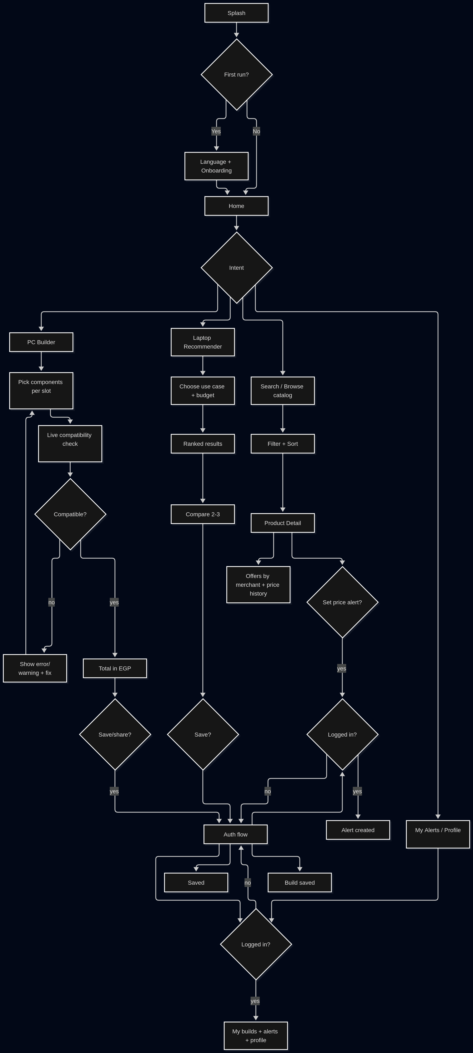
Personas: Guest, Registered user, Admin/Reviewer.

9.1 Onboarding & Entry
App launch
├─ First run ──► Splash → Language select (AR default / EN) → Onboarding (3 slides)
│ └─► Home (Guest mode)
└─ Returning ──► Splash → restore session (token)
├─ valid ──► Home (logged in)
└─ expired ──► silent refresh → Home
└─ refresh fails ──► Home (Guest) + "Sign in" prompt
Guest can browse, search, view prices, and use the builder; login required only to
save builds, set alerts, and sync.

9.2 Master flow (Mermaid)
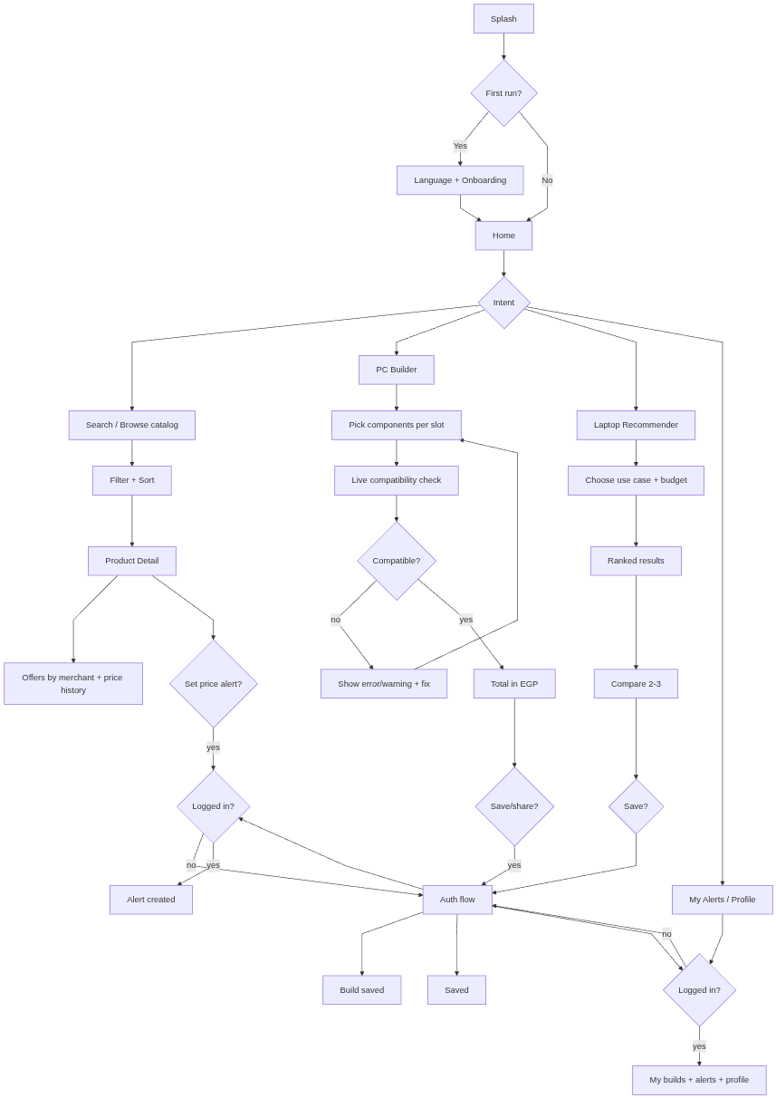

9.3 Detailed journeys
A. Guest → Buyer discovery (most common)
- Splash → lands on Home (no login wall).
- Home shows: categories, "best deals" (largest price drop), trending.
- Taps category or searches → Search/Browse list.
- Applies filters (price min/max, brand, merchant, availability) → results update.
- Taps a product → Product detail:
  - images, specs, offers table (merchant, price EGP, stock, last verified)
  - price history chart, lowest-price badge
  - stale/ghost badge if not recently verified
- Taps merchant offer → opens store URL in browser (url_launcher).
- Optional: taps "Alert me on price drop" → triggers Auth flow → alert created.
B. Auth flow (triggered by a gated action)
- Gated action (save build / set alert / profile) → Sign in / Register sheet.
- Register: email + password → validation → JWT issued.
- Login: credentials → access + refresh tokens stored securely.
- Returns to the original action with context preserved (deep-link return).
- Forgot password → email reset link (FR-1.4).
C. PC Builder (the core journey)
- From Home → Builder (may start from a preset budget build or blank).
- Selects slot (CPU → Motherboard → RAM → GPU → PSU → Case → Cooler → Storage).
- On each pick, compatibility engine runs:
  - 🔴 errors block progression (e.g., wrong socket, DDR mismatch)
  - 🟡 warnings allowed (e.g., PSU headroom low, BIOS update needed)
- Total EGP recomputes live using lowest in-stock offer per component.
- Taps "Optimize for my budget" → enters budget + use case → engine returns
suggested complete builds.
- Saves/named → Auth flow if guest → build persisted.
- Share build → generates a deep link (/build/:id).
D. Laptop Recommender
- Home → Laptops.
- Chooses use case (gaming / engineering / editing / 3D / student) + budget slider.
- Receives ranked list with rationale ("best GPU per EGP in budget").
- Optionally compares 2–3 side by side.
- Saves to profile (auth-gated) or sets a price alert.
E. Price-drop alert lifecycle (returning user)
- User previously set alert on a product.
- Scheduler/scraper captures new price → price_drop_notify job detects drop below rule.
- FCM push sent → tap opens Product detail deep link.
- User reviews offers → taps merchant link to buy.
- Manages alerts via My Alerts (list, edit threshold, delete).
F. Admin/Reviewer flow (back-office, not the mobile consumer app)
- Login (admin role) → Admin.
- Review queue: low-confidence scraper↔product matches.
- Promotes/rejects; alias learning improves future matching.
- Manages canonical products + compatibility dataset.
- Triggers manual scrape; views merchant health dashboard.

9.4 Flow edge cases / branches
Situation | Behavior
Offline | Show cached catalog + last prices with stale badge; block buy actions
No offers in stock | Product visible, marked "out of stock everywhere"; alert CTA emphasized
Scraper hasn't verified price recently | "Last verified 6 days ago" + ghost-inventory warning
Compatibility conflict | Hard errors with the specific conflicting components
Token expired mid-action | Silent refresh; if fails, re-auth then resume action
Search returns nothing | Suggest category browse + clear filters
Budget too low for any build | Show closest achievable build + required minimum

9.5 Screen map (navigation)
Splash → Home
Home ─┬─ Catalog ─┬─ Search/Browse → Product Detail
│ └─ Category → Product Detail
├─ Builder ─┬─ Component Picker → Compatibility Result → Build Summary
│ └─ Optimizer → Suggested Builds → Build Summary
├─ Laptops → Recommender → Compare → Detail
├─ Alerts (auth) → Alert Editor
└─ Profile (auth) ─┬─ Saved Builds → Build Detail (deep link /build/:id)
├─ Login/Register/Reset
└─ Settings (language, theme, notifications)

Suggested first executable step: M0 — restructure to monorepo, scaffold backend +
docker-compose, and set up Flutter feature-first foundation + CI.

