姓名：曾普新 | 专业：物联网工程 | 班级：20181191 | 学号：2018119157
科目：单片机原理及其应用 |  | 实验日期：2020/11/5
实验题目：LED闪烁及呼吸
【实验目的】
- 通过中断实现LED闪烁和呼吸效果的切换
- 呼吸效果通过PWM实现
- 闪烁通过来回切换电平实现

【实验内容】
1.实验设备
◆ 硬件：PC机一台
◆ STM32L系列板子
◆ 软件：XP/win7、8、8.1、10 系统，IAR 8.10 集成开发环境
2.实验内容和要求

【实验结果】
1.分析
1.设置管脚时钟
2.使能管脚
3.设置中断及中断响应
4.用PWM实现呼吸灯
2.核心代码：
/* USER CODE BEGIN Header */
/**
******************************************************************************
* @file : main.c
* @brief : Main program body
******************************************************************************
* @attention
*
* <h2><center>&copy; Copyright (c) 2021 STMicroelectronics.
* All rights reserved.</center></h2>
*
* This software component is licensed by ST under BSD 3-Clause license,
* the "License"; You may not use this file except in compliance with the
* License. You may obtain a copy of the License at:
* opensource.org/licenses/BSD-3-Clause
*
******************************************************************************
*/
/* USER CODE END Header */
/* Includes ------------------------------------------------------------------*/
#include "main.h"
#include "gpio.h"

/* Private includes ----------------------------------------------------------*/
/* USER CODE BEGIN Includes */

/* USER CODE END Includes */

/* Private typedef -----------------------------------------------------------*/
/* USER CODE BEGIN PTD */

/* USER CODE END PTD */

/* Private define ------------------------------------------------------------*/
/* USER CODE BEGIN PD */
/* USER CODE END PD */

/* Private macro -------------------------------------------------------------*/
/* USER CODE BEGIN PM */

/* USER CODE END PM */

/* Private variables ---------------------------------------------------------*/
enum s_Led_Mode_Value{
/*LED闪烁*/
twinkleMode = 0,
/*呼吸灯*/
breathMode = 1
} v_Led_Mode = twinkleMode;
/* USER CODE BEGIN PV */

/* USER CODE END PV */

/* Private function prototypes -----------------------------------------------*/
void SystemClock_Config(void);
/* USER CODE BEGIN PFP */
void delay_us(uint32_t us);
/* USER CODE END PFP */

/* Private user code ---------------------------------------------------------*/
/* USER CODE BEGIN 0 */

/* USER CODE END 0 */

/**
* @brief The application entry point.
* @retval int
*/
int main(void)
{

HAL_Init();

SystemClock_Config();

MX_GPIO_Init();

while (1)
{
/* USER CODE END WHILE */
/*LED灯亮灭切换*/
if(v_Led_Mode == twinkleMode){
HAL_GPIO_TogglePin(LED_GPIO_Port, LED_Pin);
HAL_Delay(500);
}
for(int timeCount = 0, changetime = -200; v_Led_Mode == breathMode;){
for(int timeCount2 = 0; timeCount2 < 10; timeCount2++){ //分10次亮灭，使得呼吸效果自然
HAL_GPIO_WritePin(LED_GPIO_Port, LED_Pin, GPIO_PIN_SET);
delay_us(timeCount/10);
HAL_GPIO_WritePin(LED_GPIO_Port, LED_Pin, GPIO_PIN_RESET);
delay_us(2000-timeCount/10);
}
if(timeCount>=20000||timeCount<=0){
changetime = -changetime;
}
timeCount+=changetime;
}
/* USER CODE BEGIN 3 */
}
/* USER CODE END 3 */
}

/**
* @brief System Clock Configuration
* @retval None
*/
//系统时钟初始化
void SystemClock_Config(void)
{
RCC_OscInitTypeDef RCC_OscInitStruct = {0};
RCC_ClkInitTypeDef RCC_ClkInitStruct = {0};

/** Initializes the RCC Oscillators according to the specified parameters
* in the RCC_OscInitTypeDef structure.
*/
RCC_OscInitStruct.OscillatorType = RCC_OSCILLATORTYPE_MSI;
RCC_OscInitStruct.MSIState = RCC_MSI_ON;
RCC_OscInitStruct.MSICalibrationValue = 0;
RCC_OscInitStruct.MSIClockRange = RCC_MSIRANGE_6;
RCC_OscInitStruct.PLL.PLLState = RCC_PLL_ON;
RCC_OscInitStruct.PLL.PLLSource = RCC_PLLSOURCE_MSI;
RCC_OscInitStruct.PLL.PLLM = 1;
RCC_OscInitStruct.PLL.PLLN = 40;
RCC_OscInitStruct.PLL.PLLP = RCC_PLLP_DIV7;
RCC_OscInitStruct.PLL.PLLQ = RCC_PLLQ_DIV2;
RCC_OscInitStruct.PLL.PLLR = RCC_PLLR_DIV2;
if (HAL_RCC_OscConfig(&RCC_OscInitStruct) != HAL_OK)
{
Error_Handler();
}
/** Initializes the CPU, AHB and APB buses clocks
*/
RCC_ClkInitStruct.ClockType = RCC_CLOCKTYPE_HCLK|RCC_CLOCKTYPE_SYSCLK
|RCC_CLOCKTYPE_PCLK1|RCC_CLOCKTYPE_PCLK2;
RCC_ClkInitStruct.SYSCLKSource = RCC_SYSCLKSOURCE_PLLCLK;
RCC_ClkInitStruct.AHBCLKDivider = RCC_SYSCLK_DIV1;
RCC_ClkInitStruct.APB1CLKDivider = RCC_HCLK_DIV1;
RCC_ClkInitStruct.APB2CLKDivider = RCC_HCLK_DIV1;

if (HAL_RCC_ClockConfig(&RCC_ClkInitStruct, FLASH_LATENCY_4) != HAL_OK)
{
Error_Handler();
}
/** Configure the main internal regulator output voltage
*/
if (HAL_PWREx_ControlVoltageScaling(PWR_REGULATOR_VOLTAGE_SCALE1) != HAL_OK)
{
Error_Handler();
}
}

/* USER CODE BEGIN 4 */
/*模式切换*/
void HAL_GPIO_EXTI_Callback(uint16_t GPIO_Pin)//外部中断回调函数
{
if(v_Led_Mode == twinkleMode){
v_Led_Mode = breathMode;
}else if(v_Led_Mode == breathMode){
v_Led_Mode = twinkleMode;
}
}
//微秒延时函数
void delay_us(uint32_t us)
{
uint32_t delay = (HAL_RCC_GetHCLKFreq() / 4000000 * us);
while (delay--)
{
;
}
}
/* USER CODE END 4 */

/**
* @brief This function is executed in case of error occurrence.
* @retval None
*/
void Error_Handler(void)
{
/* USER CODE BEGIN Error_Handler_Debug */
/* User can add his own implementation to report the HAL error return state */
__disable_irq();
while (1)
{
}
/* USER CODE END Error_Handler_Debug */
}

#ifdef USE_FULL_ASSERT
/**
* @brief Reports the name of the source file and the source line number
* where the assert_param error has occurred.
* @param file: pointer to the source file name
* @param line: assert_param error line source number
* @retval None
*/
void assert_failed(uint8_t *file, uint32_t line)
{
/* USER CODE BEGIN 6 */
/* User can add his own implementation to report the file name and line number,
ex: printf("Wrong parameters value: file %s on line %d\r\n", file, line) */
/* USER CODE END 6 */
}
#endif /* USE_FULL_ASSERT */

/************************ (C) COPYRIGHT STMicroelectronics *****END OF FILE****/
3.设计
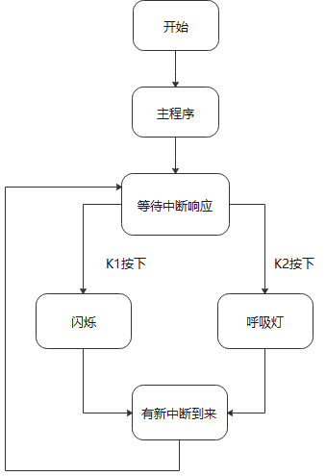
4.运行
（给出运行结果的照片和插入视频的链接）
照片：

视频链接：
【实验结论】（写结论，心得，和收获）
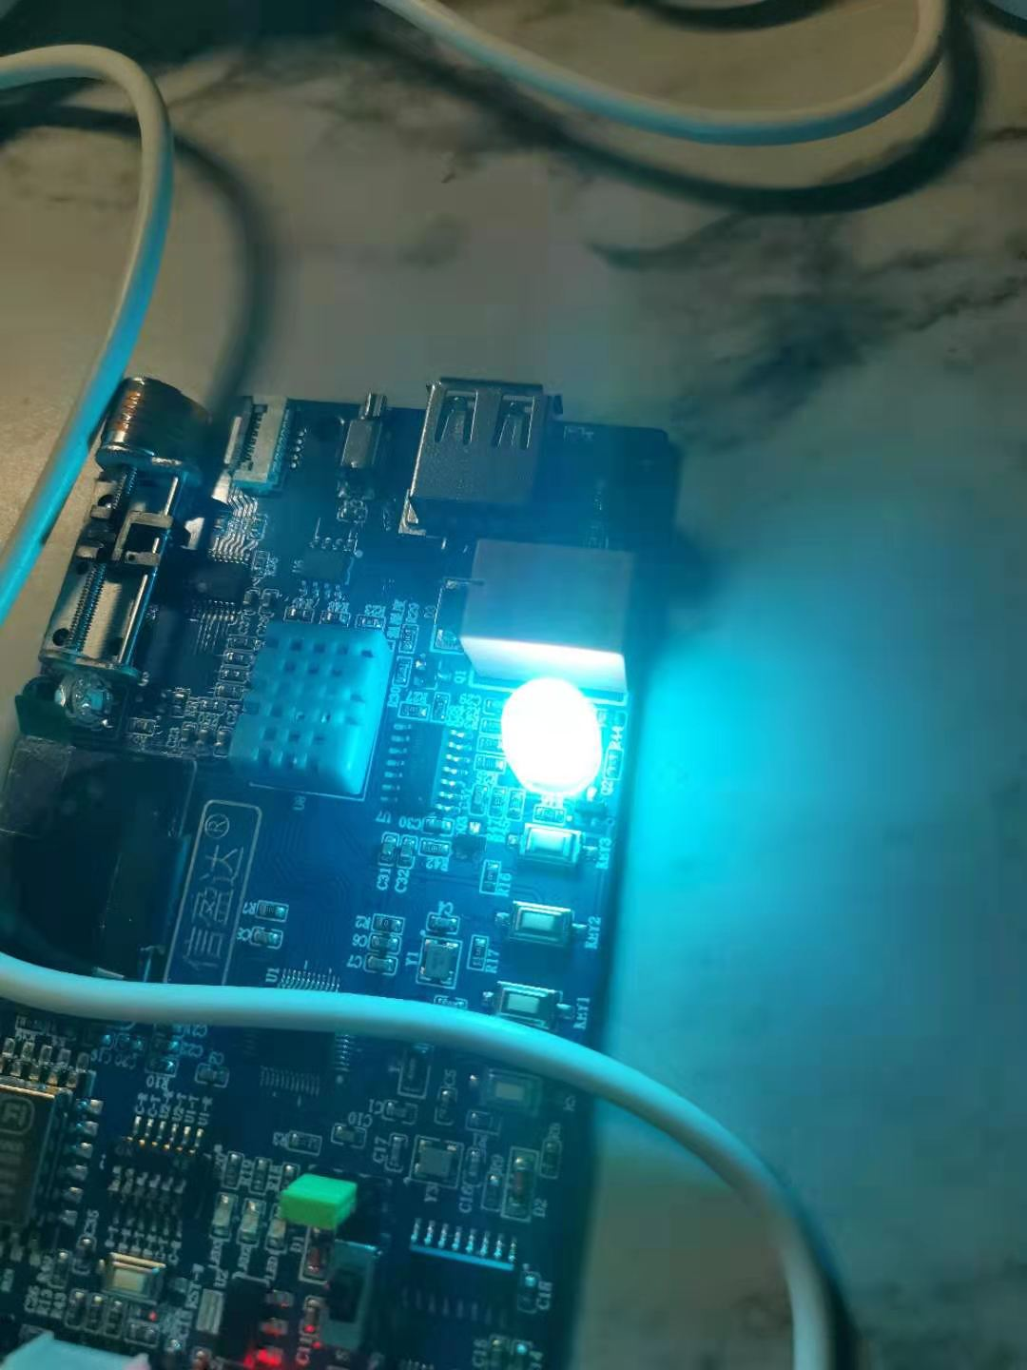

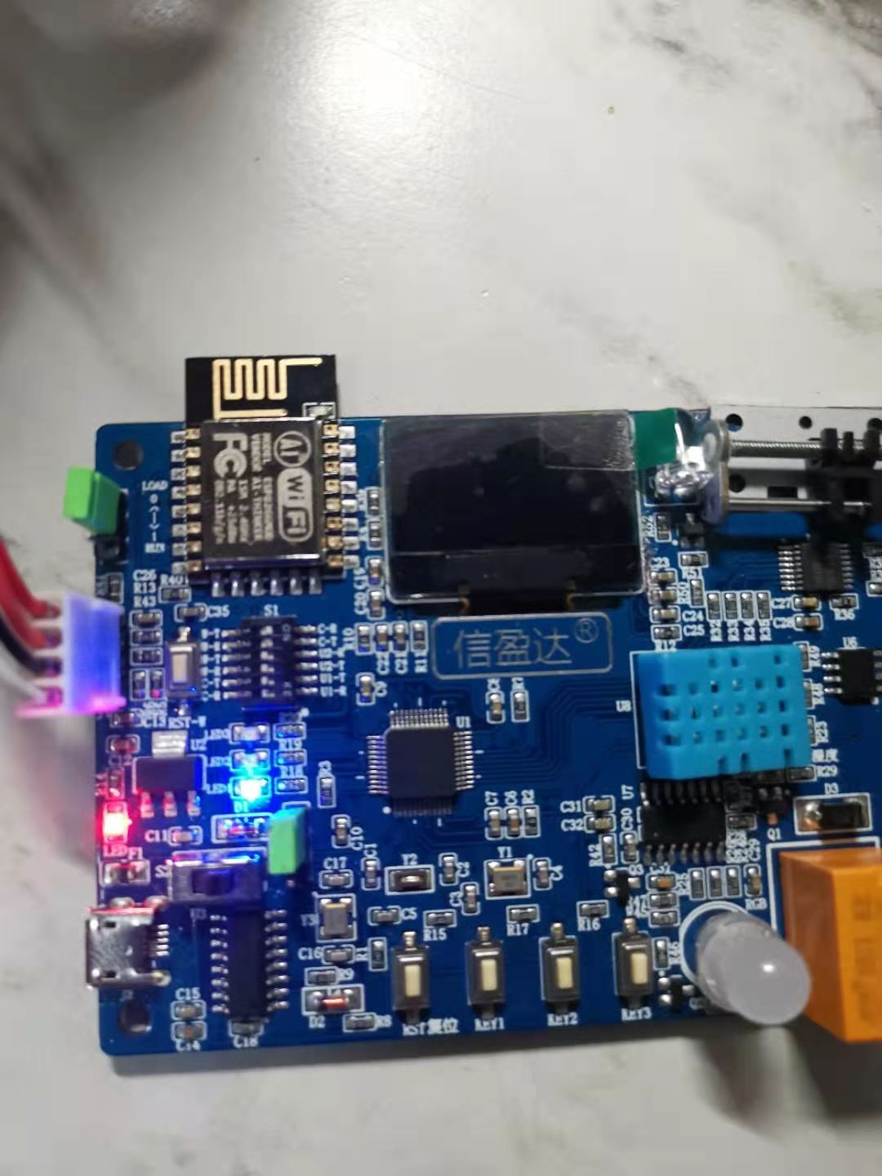

【教师评语和成绩】

成绩： 指导教师： 日期：

