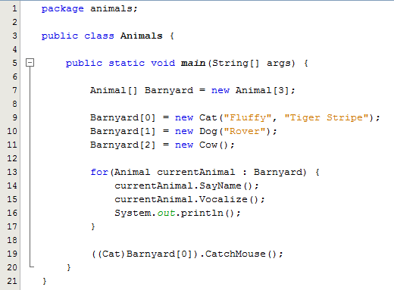
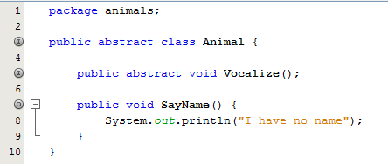
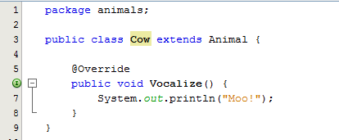
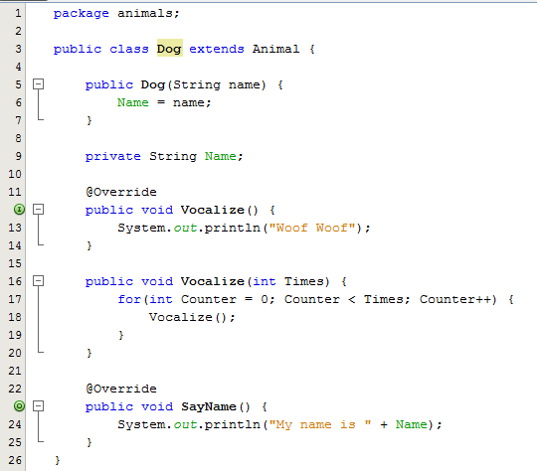
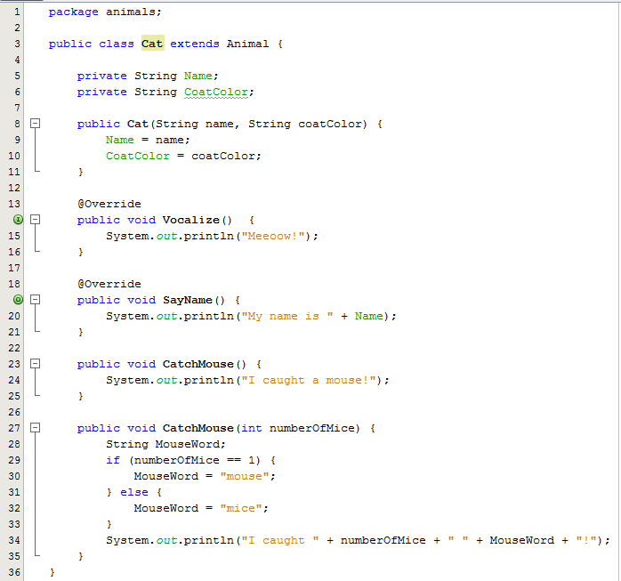
WL Robotics Java Lesson 2
- Base class Animal with only Vocalize and no abstracting

- Cat extends Animal

- Change Meow to Vocalize (Main winds up with error)

- Use Refactor to change Meow to Vocalize

- Add @Override directive

- Copy Dog from HelloWorld

- Dog extends Animal (do not change Bark to Vocalize)

- Use abstract to force Dog to implement Vocalize

- Create Cow class

- Implement SayName in Animal so that Cow doesn't have to

- Review variables (pointers) and types

- Barnyard array

- for loop

- Cast Animal to Cat

Additional Goals (to be accomplished by next week)

- Add a method to Cat that returns its CoatColor.
  - The method MUST NOT print the CoatColor to System.out - it must instead send the CoatColor back to the caller as a String. See the Add method in Lesson One's Dog class for an example to follow.
  - Add a line to Animals.Main that prints the cat's CoatColor to System.out similar to "The cat has a ___ coat".

- If you want an extra challenge, print the cat's name instead "The cat" (hint: you will have to add a method to the Cat class that returns the name)

- Add an abstract method to Animal named "DoATrick". Implement DoATrick in each of the sub-classes (which Java will force you to do anyway). You choose what each animal will do when DoATrick is called.

- Create a Goat class that inherits from (extends) Animal.

- You choose whether the Goat's name is required (like Cat or Dog) or is not required (like Cow)

- Implement Vocalize and DoATrick methods In Animals.Main:
- Add a Goat to the Barnyard array (hint: you'll have to increase the size of the array)

- Add a call to currentAnimal.DoATrick inside the for loop

Animals.java
Animal.java

Cow.java
Dog.java

Cat.java

