Whitney King

# P4: VGChartz Data Exploration in R by Whitney King

## Data Exploration in R

#### Dataset: VGChartsTop 10,000 Best Selling Video Games Globally

Data obtained on 5/22/2017

## Introduction

This data exploration will take an in depth look at data scraped from the VGChartz.com charts for regional and global video games sales (by millions of units). This data was obtained on 5/22/2017 using a Python3 script, and importing BeautifulSoup to parse out the HTML data.

After the dataset was scraped from the table on [VGChartz website](http://www.vgchartz.com/gamedb/), it was then limited to the top 10,000 rows, and formatted using a dataframe before being output to CSV for use in R. I've opted to format and color all charts, since they are easier for me to read that way.

The goal of this exploration will be to gain a general understanding of which features of video games are correlated to success in different regions around the globe and across time. It will also look at platforms, and how they're related to the ebb and flow of video games.

### Motivating Questions

* Which region has the most game units shipped?
* Is the popularity of video games still on the rise?
* Which game platform has been the most successful?

### Data Overview

The dataset is structured as follows:

* **Rank** *(num)*; Primary Key/Unique Identifier for each game in the list, ranked best-selling to worst-selling
* **Name** *(factor)*; Title of the video game
* **Platform** *(factor)*; Console/Platform game was released on
* **Year** *(num)*; Year game was released
* **Genre** *(factor)*; Genre/Category of the game title
* **Publisher** *(factor)*; Publisher of the video game
* **NA_Sales** *(num)*; Sales in millions of units in North America
* **EU_Sales** *(num)*; Sales in millions of units in Europe
* **JP_Sales** *(num)*; Sales in millions of units in Europe
* **Other_Sales** *(num)*; Sales in millions of units in other regions of the globe
* **Global_Sales** *(num)*; Total sales in units globally

Columns being generated are:

* **Decade** *(factor)*; Decade the game was released
* **Franchise** *(factor)*; Name of the franchise the game is from
* **Company_Name** *(factor)*; Company that built the game console the game was published on

### Limitations

Since this data was collected from VGChartz, it is not an authoritative list of all games ever released. Certain factors may prevent a game from landing on the VGChartz charts, however most highly publicized titles are in the dataset. This exploration is concerned with the top 10k bestselling games of all time, this list is pretty comprehensive and a good source to investigate.

Additionally, the counts are taken as sales figures (Global_Sales, NA_Sales, etc.), however this is a bit of a misnomer, since some games come free with other purchases, or are given away but still count towards a unit. Due to this factor, the numbers will mostly be talked about as units shipped instead of units sold, though it can be assumed most titles sold copies instead of gave them away.

## Univariate Plots Section

It will be important to understand a little bit about the data in this dataset prior to working with it.

## Name Platform Year   
## Need for Speed: Most Wanted: 11 PS2 :1465 Min. :1980   
## FIFA 14 : 9 DS : 991 1st Qu.:2002   
## LEGO Marvel Super Heroes : 9 PS3 : 967 Median :2007   
## Cars : 8 X360 : 935 Mean :2006   
## FIFA 15 : 8 Wii : 858 3rd Qu.:2010   
## FIFA Soccer 13 : 8 PS : 851 Max. :2020   
## (Other) :9947 (Other):3933 NA's :157   
## Genre Publisher NA_Sales   
## Action :2146 Electronic Arts :1145 Min. : 0.0000   
## Sports :1625 Activision : 758 1st Qu.: 0.1000   
## Misc :1013 Nintendo : 632 Median : 0.1900   
## Role-Playing: 930 Ubisoft : 624 Mean : 0.4304   
## Shooter : 869 THQ : 552 3rd Qu.: 0.4300   
## Racing : 788 Sony Computer Entertainment: 547 Max. :41.3600   
## (Other) :2629 (Other) :5742   
## EU_Sales JP_Sales Other_Sales Global_Sales   
## Min. : 0.0000 Min. : 0.0000 Min. : 0.0000 Min. : 0.1200   
## 1st Qu.: 0.0200 1st Qu.: 0.0000 1st Qu.: 0.0100 1st Qu.: 0.2100   
## Median : 0.0800 Median : 0.0000 Median : 0.0300 Median : 0.3900   
## Mean : 0.2412 Mean : 0.1207 Mean : 0.0791 Mean : 0.8714   
## 3rd Qu.: 0.2200 3rd Qu.: 0.0900 3rd Qu.: 0.0700 3rd Qu.: 0.8400   
## Max. :28.9600 Max. :10.2200 Max. :10.5700 Max. :82.5400   
##   
## Decade Franchise Console_Company  
## 00s :5471 Other :8212 Atari : 131   
## 10s :2920 LEGO : 146 Microsoft:1578   
## 20s : 1 FIFA : 114 Nintendo :3645   
## 80s : 199 Mario Brothers: 106 Other : 12   
## 90s :1252 Madden : 94 PC : 304   
## NA's: 157 Final Fantasy : 83 Sega : 136   
## (Other) :1245 Sony :4194

Descriptive Statistics for each column in the dataset, which shows some interesting breakdowns of the numbers at a glance. The dataset is made up of 13 columns, with 10,000 rows of data. Of the Top 10k games with the most units shipped, the minimum was 120,000 units, and the maximum was 82.54 million units globally.

### Numeric Values

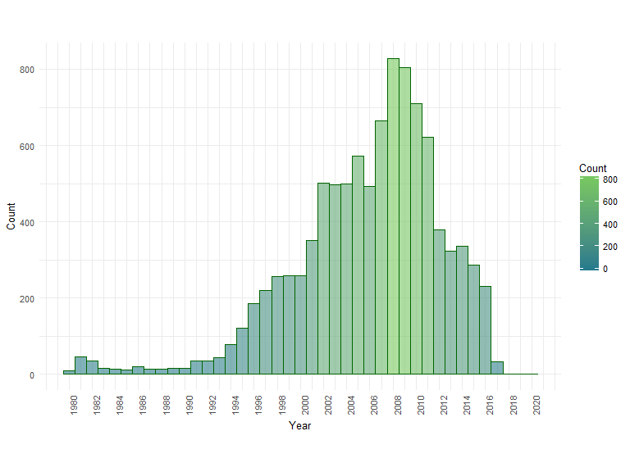

First worth noting is this chart does not include the 157 rows where NA was entered for the Year. It's interesting to see that the period from 2007 - 2011 was a peak time in games being released, with 2008 being the highest year overall with new 828 titles.

This could be due to a wide range of factors, and doesn't necessarily translate into high sales for all of the games that were released. The shape of the data is single-modal, with a rightward skew, showing an overall rise in the number of games released each year over time.

It's also worth noting that the data from 2017 forward is incomplete, as this data pull was done in May 2017, so it may be wise for some explorations to only look at full years counted (2016 or earlier). Next it will be interesting to look at a few categorical breakdowns of the data.

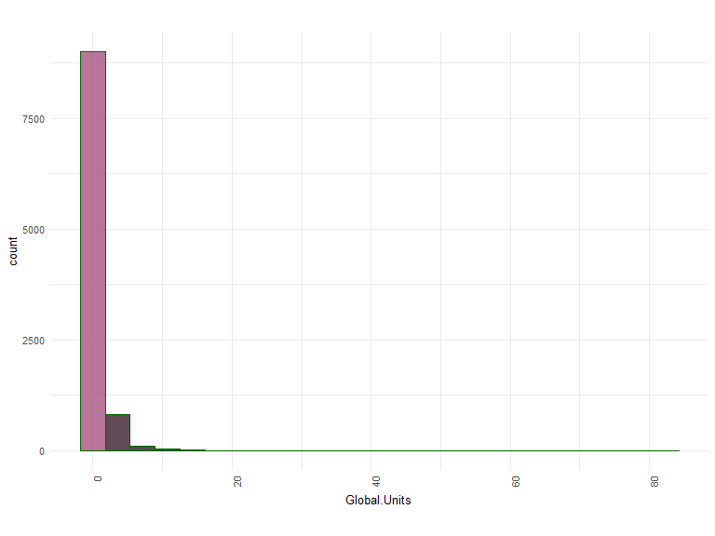

Breaking the global sales figures out in a histogram with 24 bins showing the number of games shipped for each range of values yields a very different histogram than the one for the Years column.

For global sales, there is an extreme leftward skew with a very tall first bar (8000 games that shipped 2 million copies or less), with an extremely long tail getting smaller and smaller as it goes to the right (very few games sell tens of millions of copies). This is interesting, but using a log scale on this plot would be more informative about the distribution of games selling less than a million copies.

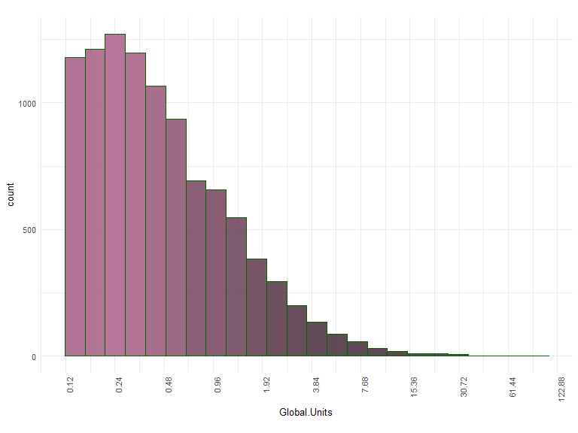

This is a much more expected distribution of data, with most games selling between 150k - 300k units. The distribution of global units shipped is single modal with a leftward skew, indicating most of the top games have shipped a couple hundred thousand units, with fewer and fewer games shipping millions of units.

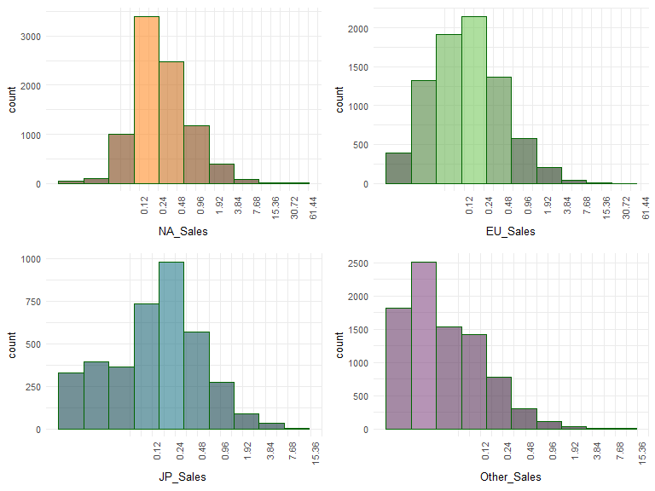

When the histogram is broken out by region, log10 no longer works well due to the large number of games in each region that didn't ship enough copies to register in the millions (or any at all), so to understand the long tail data, the dataset needed to be subset. There's a similar leftward skew in all regions, however there is more variation in where games land on the left side (which could be due to the large number of games that never shipped or didn't sell well in some regions).

What this shows is the curve of how games overall tend to ship in each region. It's apparent that globally it's very common for games to ship somewhere between 120k - 240k copies when they've made it into the top 10k bestselling games on VGChartz, however in the Other region, that many units would be considered a even larger success. In NA and EU, blockbuster titles have shipped tens of millions more units than what would be considered a blockbuster in JP and other regions.

### Categorical Values

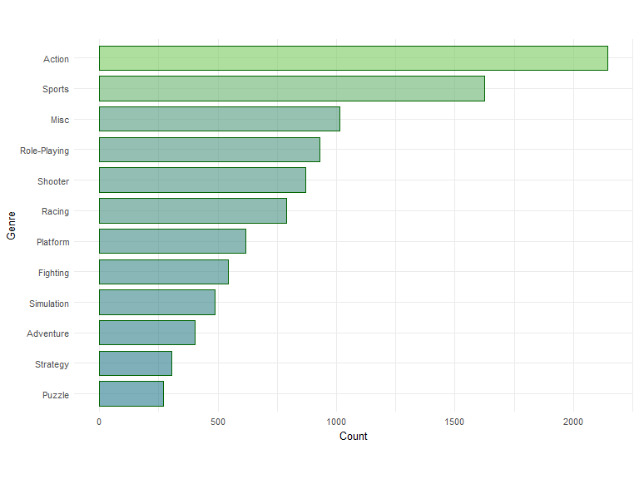

Somewhat unsurprisingly, Action is the most popular genre of games to release. Sports, is the next most popular genre, followed by Misc. Since 'Misc' isn't a very descriptive field, it will be worth digging into game titles that fall into this category to see if trends can be identified.

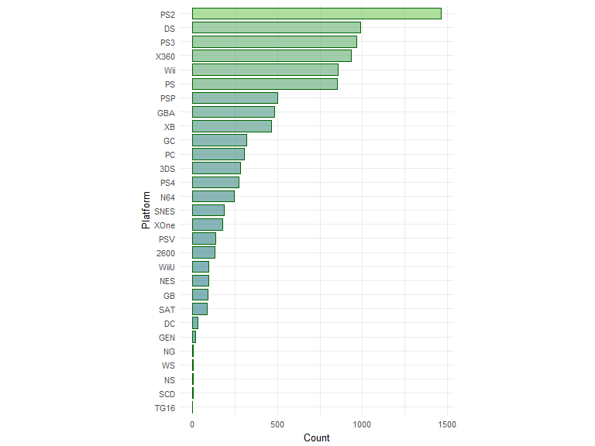

When the data is broken down by Platform, it starts becoming extremely varied. Just looking at the above bar chart, we can see that the most popular system for games titles tracked by VGChartz is the PlayStation 2 (PS2), which has almost half again as many titles published on it than next platform, Nintendo DS (DS). If we were to look at the other categorical variables in univariate plots, readability would be extremely compromised, so it will be more interesting to look at Console_Company and Franchise to group things together a little more.

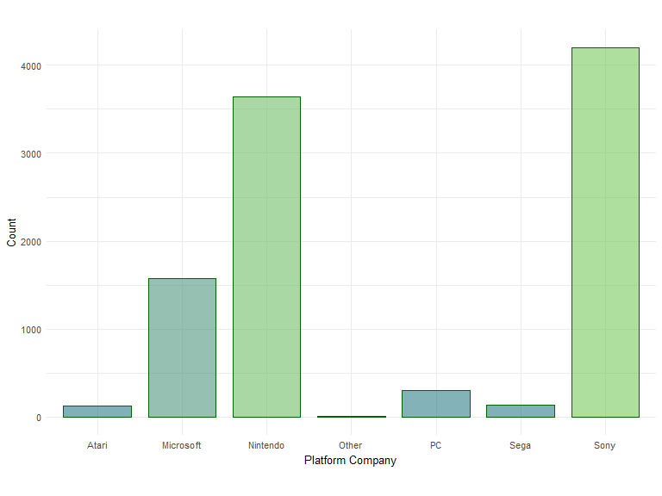

When it comes to titles published on a console, looking at just this plot, Sony is winning the console wars overall. However, there are other ways to examine the data.

## Publisher Count   
## Acclaim Entertainment : 1 Min. : 108   
## Activision : 1 1st Qu.: 141   
## Atari : 1 Median : 246   
## Capcom : 1 Mean : 370   
## Disney Interactive Studios: 1 3rd Qu.: 547   
## Eidos Interactive : 1 Max. :1145   
## (Other) :15

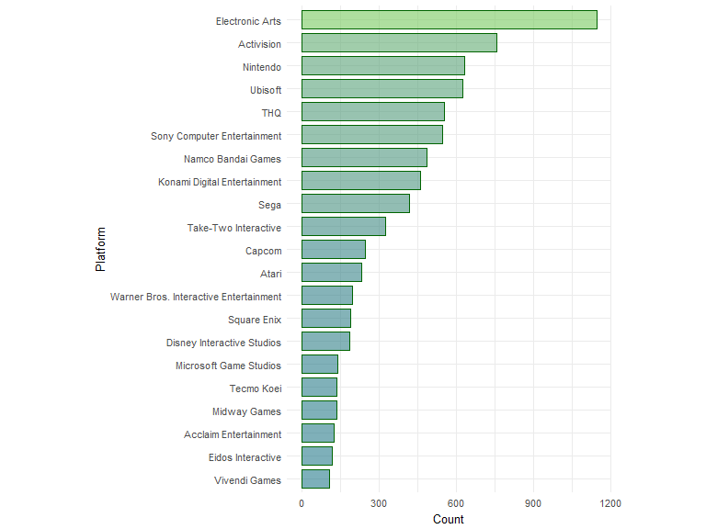

This summary gives us a more detailed view into the counts of games published for all publishers with more than 100 games on the market. These are the most prolific, and also the most recognizable, publishers in the industry, however publishing a lot of games is not an indication that those games shipped a large quantity.

Somewhat interesting (yet unsurprising) to see is that Electronic Arts, then Activision, then Nintendo are the top publishers by count. EA is notorious for shipping yearly games for their sports franchises, and all three companies are some of the largest and most well-known publishers.

## Name Count   
## Cars : 1 Min. : 7.000   
## FIFA 14 : 1 1st Qu.: 7.000   
## FIFA 15 : 1 Median : 7.000   
## FIFA Soccer 11 : 1 Mean : 7.577   
## FIFA Soccer 13 : 1 3rd Qu.: 8.000   
## Lego Batman 3: Beyond Gotham: 1 Max. :11.000   
## (Other) :20

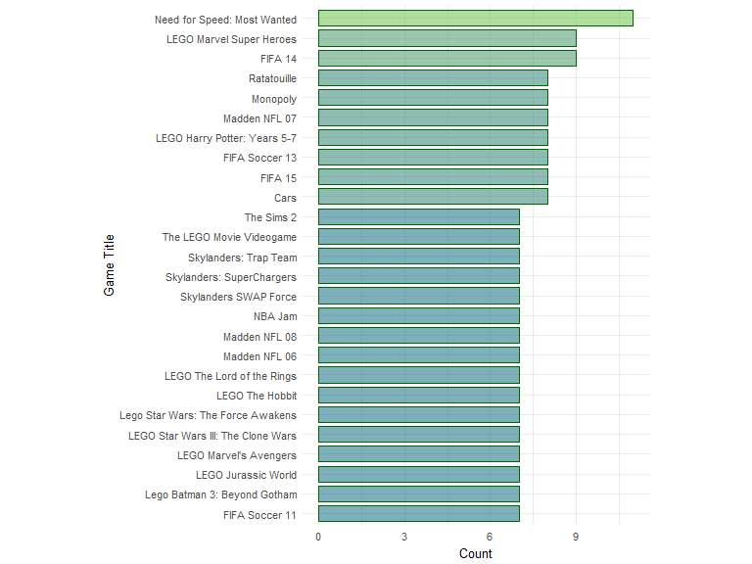

At first glance, this chart is blocky and less interesting than the previous ones, however when looking at the game titles themselves, there are some immediate observations. First, it becomes clear that if a game title is showing up more than once, it's been published on more than one platform.

This chart shows just how many of the most cross-published video games are LEGO related. Beyond that, there's some other noticeable patterns in the game titles. This is going to be a really interesting column to drill down into further, so we'll look at Franchise data. This could also lead to some scenarios where we might need to consider duplicated counting.

It should be noted that Franchise data has been limited to popular and frequently occurring titles.

## Franchise Count   
## Assassin's Creed: 1 Min. : 10.00   
## Batman : 1 1st Qu.: 24.00   
## Battlefield : 1 Median : 36.50   
## BioShock : 1 Mean : 44.70   
## Borderlands : 1 3rd Qu.: 54.25   
## Call of Duty : 1 Max. :146.00   
## (Other) :34

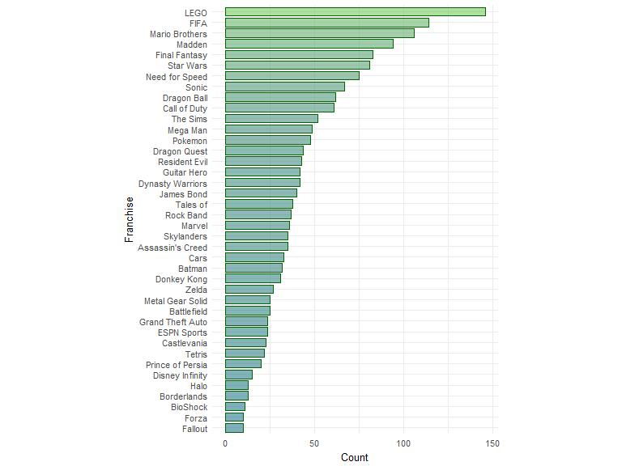

It's interesting to see which franchises have released the most games, however this data might be better viewed as a bivariate comparison of Franchise vs units shipped instead of a count of titles shipped, since titles can occur on more than one platform.

# Univariate Analysis

### What is the structure of your dataset?

## 'data.frame': 10000 obs. of 13 variables:  
## $ Name : Factor w/ 6838 levels "'98 Koshien",..: 6531 5524 3199 6533 4358 5758 3934 6529 3937 1541 ...  
## $ Platform : Factor w/ 29 levels "2600","3DS","DC",..: 24 10 24 24 5 5 4 24 24 10 ...  
## $ Year : num 2006 1985 2008 2009 1996 ...  
## $ Genre : Factor w/ 12 levels "Action","Adventure",..: 11 5 7 11 8 6 5 4 5 9 ...  
## $ Publisher : Factor w/ 338 levels "20th Century Fox Video Games",..: 207 207 207 207 207 207 207 207 207 207 ...  
## $ NA_Sales : num 41.4 29.1 15.7 15.6 11.3 ...  
## $ EU_Sales : num 28.96 3.58 12.84 10.94 8.89 ...  
## $ JP_Sales : num 3.77 6.81 3.8 3.29 10.22 ...  
## $ Other_Sales : num 8.45 0.77 3.29 2.95 1 0.58 2.88 2.84 2.25 0.47 ...  
## $ Global_Sales : num 82.5 40.2 35.6 32.8 31.4 ...  
## $ Decade : Factor w/ 5 levels "00s","10s","20s",..: 1 4 1 1 5 4 1 1 1 4 ...  
## $ Franchise : Factor w/ 41 levels "Assassin's Creed",..: 30 25 25 30 31 39 25 30 25 30 ...  
## $ Console_Company: Factor w/ 7 levels "Atari","Microsoft",..: 3 3 3 3 3 3 3 3 3 3 ...

Converting the data frame to a string shows a basic breakdown of how the data was ingested. The Year column is showing as a factor due to the 'N/A' values. It should be a continuous variable, so this will need to be taken into consideration as the analysis progresses.

There are 10,001 rows broken out across 13 variables. When broken down by year, the shape of the data is single-modal, with a rightward skew, showing an overall rise in the number of games released each year over time. Of the Top 10k games with the most units shipped, the minimum was 120,000 units, and the maximum was 82.54 million units globally.

### What is/are the main feature(s) of interest in your dataset?

VGChartz exists to track game sales in millions across global regions. The data consists of categorical columns, and the year column (independent variables), as well as numeric columns for sales in millions of units (Global Sales; dependent variable). When properly rearranged, the dependent variable can be drilled down by Region. All categorical columns contain data of interest and could affect the number of unit shipped regionally or globally.

### What other features in the dataset do you think will help support your investigation into your feature(s) of interest?

## NA.Units EU.Units JP.Units Other.Units Global.Units  
## NA.Units 1.0000000 0.7503898 0.4292556 0.6233701 0.9365152  
## EU.Units 0.7503898 1.0000000 0.4152400 0.7150651 0.8963314  
## JP.Units 0.4292556 0.4152400 1.0000000 0.2682371 0.5981830  
## Other.Units 0.6233701 0.7150651 0.2682371 1.0000000 0.7405071  
## Global.Units 0.9365152 0.8963314 0.5981830 0.7405071 1.0000000

Taking a look at correlation between games sales across regions could help predict if sales in one region based on another regions sales. This is more informative than just looking at global units shipped alone.

Additionally, the Name column is going to prove very interesting when looking at total sales, and cross comparing other columns. Using regexes to find titles that are part of popular series will be value in determining if a game should sell well.

### Did you create any new variables from existing variables in the dataset?

I created three new columns of data organizing the information that was in the dataset. One column for decade a game title was released (based on the Year column), one column for Series (based on frequently occurring game titles and popular franchises), and one column for Console_Company to better visualize the competition between the big three console makers.

Additionally, I've created new summarized datasets to view the information in different ways.

### Of the features you investigated, were there any unusual distributions?

There didn't appear to be any unusual distributions when broken out by year, though it was interesting to see that games published per year peaked in 2008, and hasn't continued to rise. This could be due to a lot of factors.

When examining the Global_Sales data in a histogram using log scale, there was a single-modal, leftward skewed distribution, which fell within expectations that most games don't ship more than a million units.

### Did you perform any operations on the data to tidy, adjust, or change the form of the data? If so, why did you do this?

This data was obtained on 5/22/2017 using a Python3 script, and importing BeautifulSoup to parse out the HTML data. After the dataset was scraped from the table on VGChartz website, it was then limited to the top 10,000 rows, and formatted using a data frame before being output to CSV for use in R. Since the games are ranked by units shipped, they can be ordered by Global_Sales, so Rank data isn't really important and was dropped. I also generated new columns based on data the existing dataset contained, since grouping the categorical data a bit more would allow for answering a wider variety of questions.

Aside from this, the data was left in it's original state, as it was downloaded in a tidy format. When working with the data in R, numerical values needed to be transformed into numeric, and categorical variables were transformed into factors.

# Bivariate Plots Section

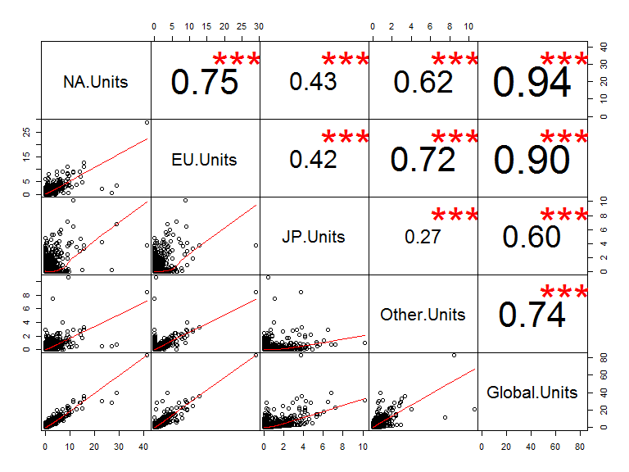

Taking a look at correlation between video game units shipped across regions could help predict sales in one region based on another regions units This correlation matrix compares numeric values from the dataset (aside from year). In general, if a game sells well in North America, this shows it does well in Europe, and globally. It will be interesting to see how the categorical values impact numerical ones in bivariate and multivariate exploration. We can see that most regions have at least strong or moderate positive correlation with each other, with a exception for JP/Other which have weak positive correlation.

## NA.Units EU.Units JP.Units Other.Units   
## Min. : 0.0000 Min. : 0.0000 Min. : 0.0000 Min. : 0.0000   
## 1st Qu.: 0.1000 1st Qu.: 0.0200 1st Qu.: 0.0000 1st Qu.: 0.0100   
## Median : 0.1900 Median : 0.0800 Median : 0.0000 Median : 0.0300   
## Mean : 0.4304 Mean : 0.2412 Mean : 0.1207 Mean : 0.0791   
## 3rd Qu.: 0.4300 3rd Qu.: 0.2200 3rd Qu.: 0.0900 3rd Qu.: 0.0700   
## Max. :41.3600 Max. :28.9600 Max. :10.2200 Max. :10.5700   
## Global.Units   
## Min. : 0.1200   
## 1st Qu.: 0.2100   
## Median : 0.3900   
## Mean : 0.8714   
## 3rd Qu.: 0.8400   
## Max. :82.5400

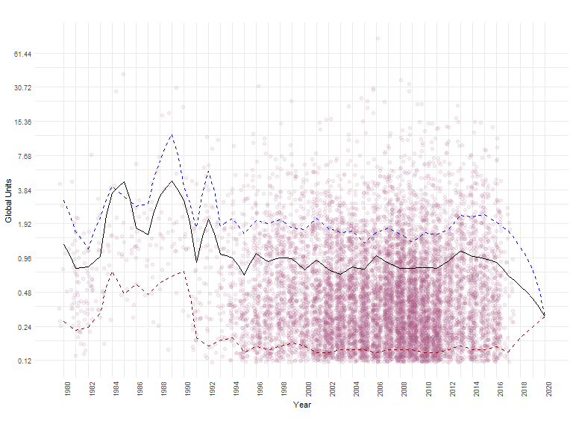

The jittered point plot showing number of units shipped per game per year shows some really interesting patterns. This plot was done with a log scale on the Y axis to better visualize the price breakdowns of the long tail global sales data. The black line shows the mean, the dotted blue is the 90th percent quantile, and the dotted red line is the 10% quantile.

Once the plot is generated, on the low end of the graph for games that shipped between 120k and 180k unit, there is some very obvious horizontal striping. This occurs because the way the data is tracked by VGCharts is a 2 decimal value representing millions. For games with only a couple hundred thousand units shipped, there are only so many levels to track these values with two decimal places.

We can see in the early years of video games, not nearly as many games were made, and of the ones that were made, most sold a lot of copies. This continued into the early 90's, when a lot more games started saturating the market. Since there is such a big difference in number of games made over the years, this would be interesting to visualize with averages.

Showing average global units shipped by year on an overlaid line plot gives a much clearer picture of the observations from the point plot, so I added a summary line by mean. There are two large spikes in 1985 and 1989 where the average units shipped per title was over 4 million. This is exceptionally high compared to the much more stable average over the last 20 years of about 750k - 1 million units per title through 2016. What if we look at these numbers split out by region?

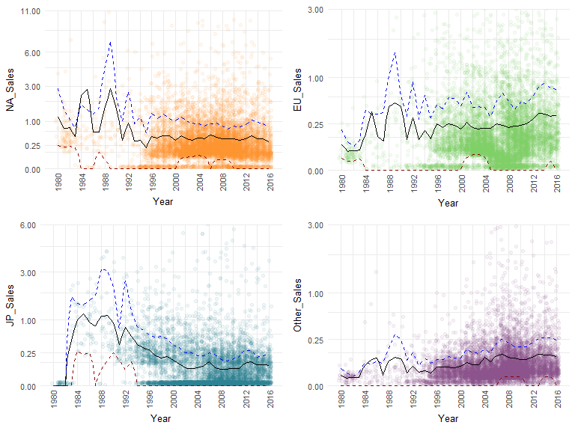

This plot takes the Global.Units scatter plots, and cleans it up by breaking it out regionally. The plots use sqrt instead of log10 so we can take into account zero units shipped in a region. These visualizations give a lot more information when broken out by region. Since regions are columns, each region has been plotted together on a grid area since they couldn't be easily faceted like a value. This problem was remedied for other plots, however this visualization ended up working for this, so I kept it as it is.

The plot for NA (North America, not N/A) ticks up to 11 million units, while the plots for EU and Other tick to 3 million, and the JP plot ticks to 6 million. For Japan, the low trend seems to make sense since it's only a single country, while it's somewhat surprising that places in Other (like the rest of Asia, and South America) don't generate more shipped units. Since these views are zoomed in, not all Y-axis outliers are visible, and only values from complete years (2016 or earlier) are shown.

In each region, we can still clearly see bumps around 1985 and 1989, so the great successes that shipped millions of units those years did so globally. Games represented by a dot above the 90th percentile line have done exceptionally well on the market in that region. Additionally, the solid stripe on the bottom of each region indicates games that shipped zero in that region, so perhaps they weren't released there, or didn't ship enough copies to be counted as millions.

For Japan, it's interesting to see that average units shipped has dropped and leveled out over time as the number of titles released increased (we see this pattern in NA, too). It also looks like there is a lot of games that didn't ship or do well there, as JP has the most defined bottom stripe. Maybe it really is impressive if something is big in Japan! For EU and Other regions, there has been a gradual increase is sales as the years go on, likely due in part to a slower market saturation in those areas.

For the last 20 years, it's been common for games to ship around 250k or more copies in NA and EU, while JP and Other each average about half of that.

## vgdata$Genre   
## n missing distinct   
## 10000 0 12   
##   
## Action (2146, 0.215), Adventure (402, 0.040), Fighting (545, 0.054), Misc  
## (1013, 0.101), Platform (618, 0.062), Puzzle (271, 0.027), Racing (788,  
## 0.079), Role-Playing (930, 0.093), Shooter (869, 0.087), Simulation (488,  
## 0.049), Sports (1625, 0.162), Strategy (305, 0.030)

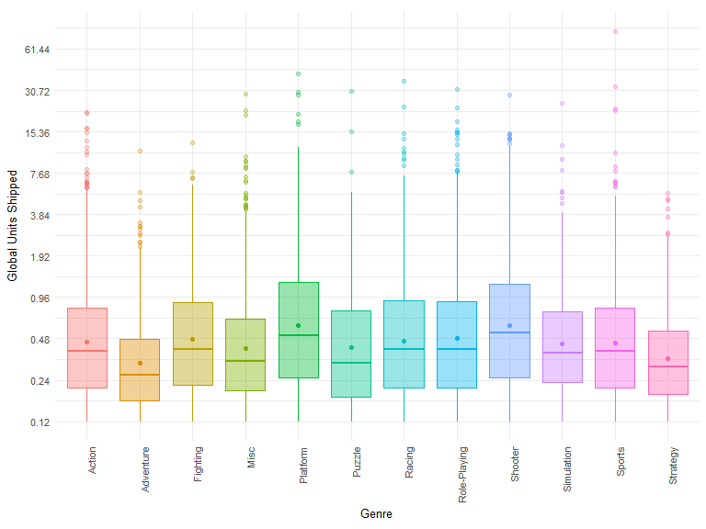

This boxplot shows the breakdown of units shipped by genre. The dot in the middle of each box is a scatterplot I've added to represent the mean, since the line of the box and whiskers shows median. This shows a lot of the same strengths we saw in the univariate plot for genre, though it's interesting to see that Sports has so many upper bounded outliers, and it's Platform games that have the highest upper quartile.

## vgdata$Platform   
## n missing distinct   
## 10000 0 29   
##   
## lowest : 2600 3DS DC DS GB , highest: WiiU WS X360 XB XOne

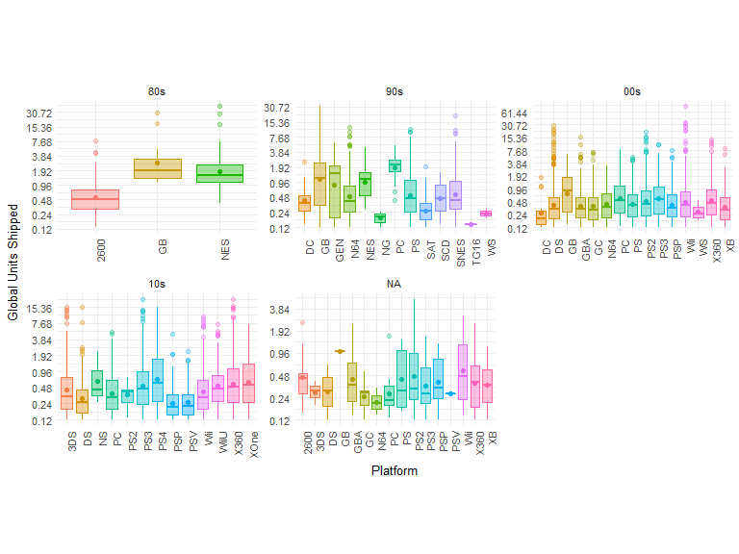

Looking at a boxplot broken down by platform gives a really cool view into some information about the successes of each platform. Faceting these plots by decades gives us a timeline of when different consoles were most popular, and for the 80s, 90s, 00s, and 10s you can see the generational changeovers for electronics as certain consoles were phased out and others were phased in.

Unfortunately, any games that didn't have a year land in the NA bin, but they are still worth looking at, as we can probably make some assumptions about which decades those NAs might have landed based on console generations.

## vgdata$Decade   
## n missing distinct   
## 9843 157 5   
##   
## Value 00s 10s 20s 80s 90s  
## Frequency 5471 2920 1 199 1252  
## Proportion 0.556 0.297 0.000 0.020 0.127

## vgdata$Console_Company   
## n missing distinct   
## 10000 0 7   
##   
## Value Atari Microsoft Nintendo Other PC Sega  
## Frequency 131 1578 3645 12 304 136  
## Proportion 0.013 0.158 0.364 0.001 0.030 0.014  
##   
## Value Sony  
## Frequency 4194  
## Proportion 0.419

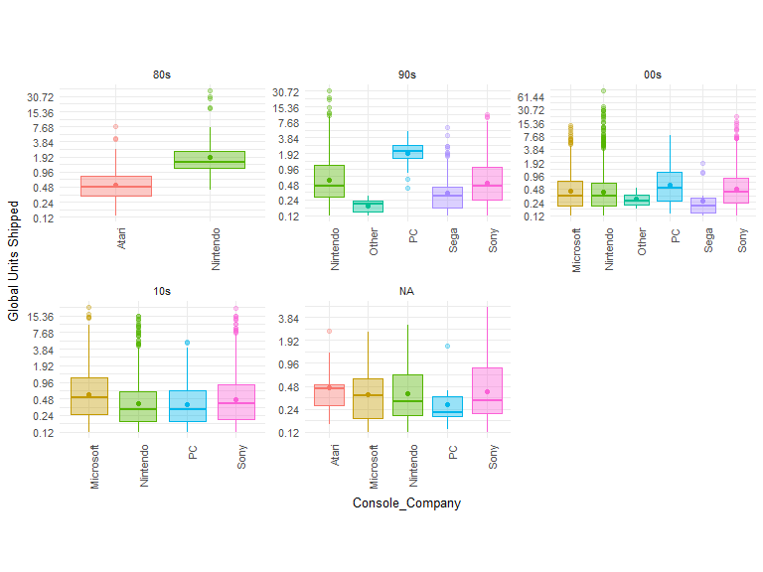

When the console companies are faceted by decade, immediately, you can see a trend related to the popularity of PC gaming over the years. As consoles have become popular, PCs which were once a booming platform have been steadily declining. However, these numbers aren't taking into consideration many free to play or subscription based PC games. As time has moved forward, many games for the PC have moved to subscriptions or in-app purchases instead of a one-time sale that would get counted as a unit shipped.

As far as the juggernaut console companies - Sony, Nintendo, and Microsoft, they've traded off how they edge out each other statistically as the decades have changed. Depending on how you evaluate the who is winning the console wars, will give you different answers to the question.

## vgdata$Franchise   
## n missing distinct   
## 10000 0 41   
##   
## lowest : Assassin's Creed Batman Battlefield BioShock Borderlands   
## highest: Star Wars Tales of Tetris The Sims Zelda

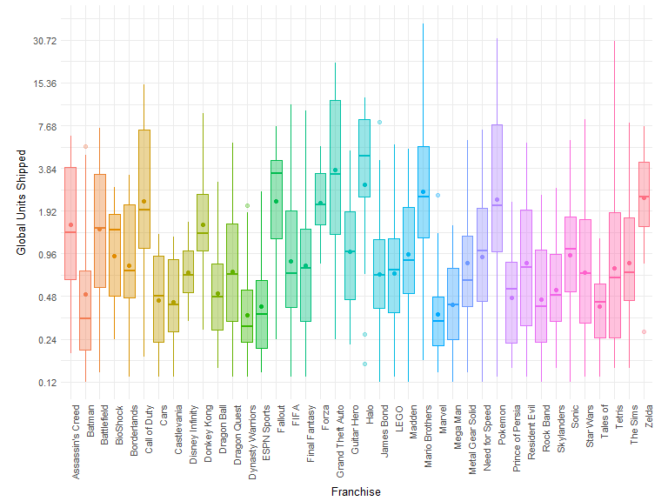

It's interesting to see the breakdown of sales globally for some of the most popular franchises in the world. It will be a good idea to explore this further regionally with multivariate exploration. When it comes to Halo, it may not have as many sales as other franchises, but it has far less variation in how well the games ship. This means, you can generally expect a game in the Halo franchise to be a success.

Another thing to take into consideration here is that some titles have downloadable content (DLC) that has made it to the charts. You see this in franchises like Halo and Fallout, so where it appears a game may not have done as well as others in a franchise, it could just be DLC... and if it's DLC, it's actually done really well to be on the chart at all.

## # A tibble: 6 x 27  
## Publisher NA.Sum NA.Mean NA.Median NA.Quant.90  
## <fctr> <dbl> <dbl> <dbl> <dbl>  
## 1 Tecmo Koei 11.99 0.08751825 0.06 0.184  
## 2 Vivendi Games 34.10 0.32476190 0.18 0.672  
## 3 Acclaim Entertainment 40.21 0.32168000 0.18 0.906  
## 4 Midway Games 42.09 0.31646617 0.20 0.658  
## 5 Eidos Interactive 45.12 0.38564103 0.20 0.930  
## 6 Disney Interactive Studios 69.28 0.37448649 0.27 0.754  
## # ... with 22 more variables: NA.Quant.10 <dbl>, EU.Sum <dbl>,  
## # EU.Mean <dbl>, EU.Median <dbl>, EU.Quant.90 <dbl>, EU.Quant.10 <dbl>,  
## # JP.Sum <dbl>, JP.Mean <dbl>, JP.Median <dbl>, JP.Quant.90 <dbl>,  
## # JP.Quant.10 <dbl>, Other.Sum <dbl>, Other.Mean <dbl>,  
## # Other.Median <dbl>, Other.Quant.90 <dbl>, Other.Quant.10 <dbl>,  
## # Global.Sum <dbl>, Global.Mean <dbl>, Global.Median <dbl>,  
## # Global.Quant.90 <dbl>, Global.Quant.10 <dbl>, Count <int>

## # A tibble: 6 x 27  
## Publisher NA.Sum NA.Mean NA.Median  
## <fctr> <dbl> <dbl> <dbl>  
## 1 Eidos Interactive 45.12 0.3856410 0.200  
## 2 Disney Interactive Studios 69.28 0.3744865 0.270  
## 3 Atari 95.94 0.4400917 0.225  
## 4 Warner Bros. Interactive Entertainment 76.04 0.4066310 0.250  
## 5 Square Enix 51.93 0.2762234 0.170  
## 6 Capcom 76.37 0.3129918 0.170  
## # ... with 23 more variables: NA.Quant.90 <dbl>, NA.Quant.10 <dbl>,  
## # EU.Sum <dbl>, EU.Mean <dbl>, EU.Median <dbl>, EU.Quant.90 <dbl>,  
## # EU.Quant.10 <dbl>, JP.Sum <dbl>, JP.Mean <dbl>, JP.Median <dbl>,  
## # JP.Quant.90 <dbl>, JP.Quant.10 <dbl>, Other.Sum <dbl>,  
## # Other.Mean <dbl>, Other.Median <dbl>, Other.Quant.90 <dbl>,  
## # Other.Quant.10 <dbl>, Global.Sum <dbl>, Global.Mean <dbl>,  
## # Global.Median <dbl>, Global.Quant.90 <dbl>, Global.Quant.10 <dbl>,  
## # Count <int>

When we compare top publishers (those that have published more than 100 games) by units shipped, we see a different story than we did breaking publishers down only by title count. Now we can see that Nintendo hops into the first spot for number of units shipped globally, while Electronic Arts falls to second place. I was curious if getting the list of top publishers from the top 5% of Publishers by units shipped would make a difference to what is considered the list of "top publishers". There are only 17 Publishers in the top 95% by units, whereas there are 21 in the top by titles. Aside from that, the list of the top 5% by units have all shipped 100 titles or more.

## vgdata$Publisher   
## n missing distinct   
## 10000 0 338   
##   
## lowest : 20th Century Fox Video Games 3DO 505 Games 989 Sports 989 Studios   
## highest: Xseed Games Yacht Club Games Zoo Digital Publishing Zoo Games Zushi Games

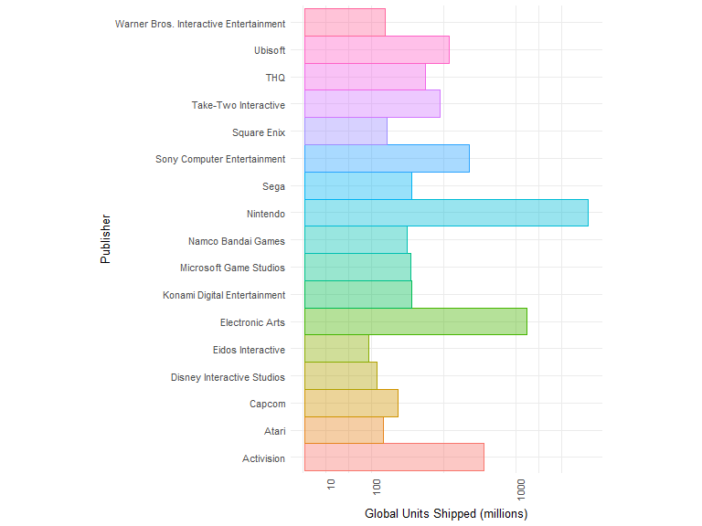

Nintendo is still on top when it comes to global units shipped. Their large amount of games published seems to translate into large amounts of those units shipped. I suspect that this is partially due to the global appeal of Nintendo. Following that, there aren't any surprises seeing Electronic Arts or Activision so successful.

## vgdata$Platform   
## n missing distinct   
## 10000 0 29   
##   
## lowest : 2600 3DS DC DS GB , highest: WiiU WS X360 XB XOne

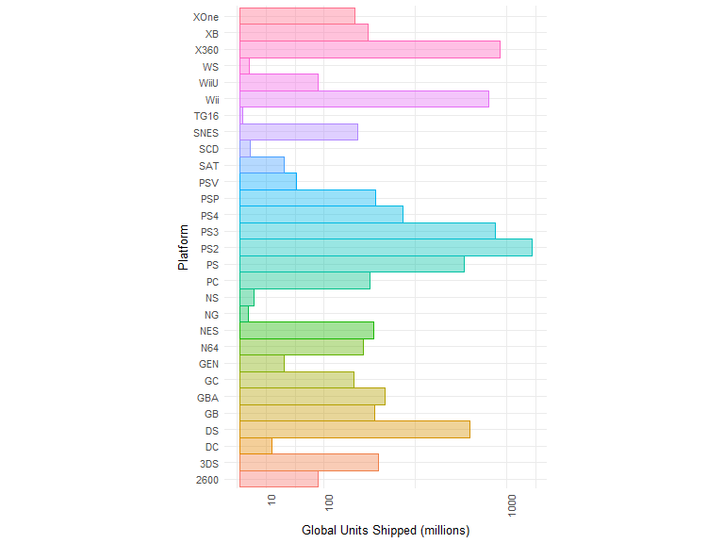

When we look at platform by units shipped, there's some irregular patterns that appear. This is mostly due to alphabetical ordering of the platform names. One thing that is interesting to see is NS (Nintendo Switch) is so low - that's likely more due to the fact it was very recently released, and not that it isn't gaining steam.

The TG16 was largely a flop, so it's surprising to see it even represented, though in the boxplot timeline that was created earlier, it seems it didn't really stick around on the market long.

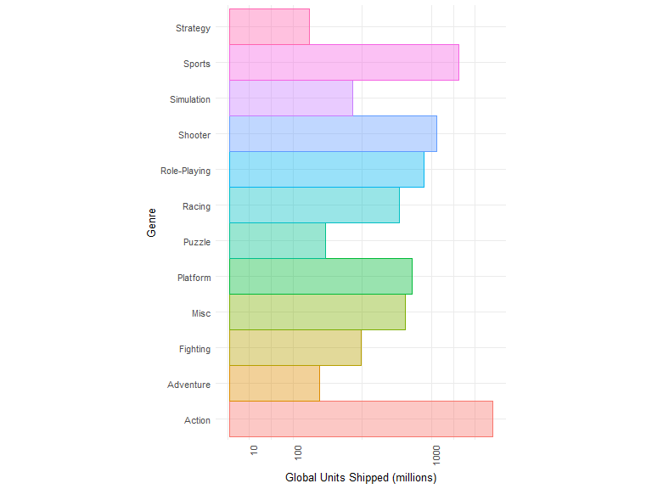

We see a very similar story when looking at genres by units shipped as we did when we looked at genres by count. Action has a wide lead, followed by Sports, and then Shooters. It's interesting to see Puzzle games aren't in last place anymore, but instead strategy, which is one of my favorite genres.

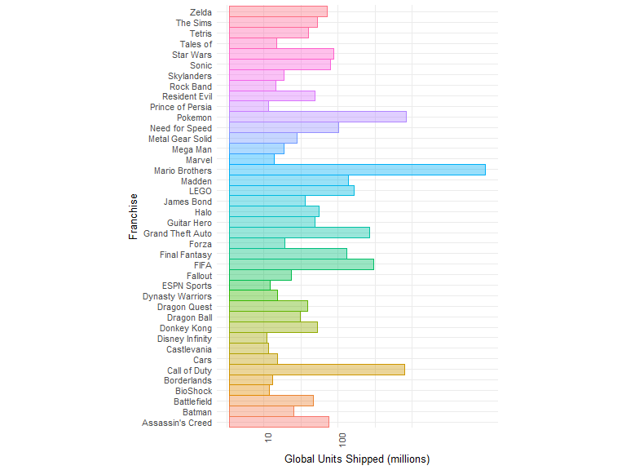

It's no surprise to see that games in the Mario Brothers franchise have sold so many copies. There's over 100 games across platforms in the franchise, and many have been wildly popular. Seeing as Nintendo was one of the big console makers in the 80s, drilling into the Mario Brothers games might reveal one of the big peaks in unit sales for 1985 or 1989.

## Name Platform Year Genre Publisher NA_Sales  
## 2 Super Mario Bros. NES 1985 Platform Nintendo 29.08  
## 3 Mario Kart Wii Wii 2008 Racing Nintendo 15.69  
## 7 New Super Mario Bros. DS 2006 Platform Nintendo 11.28  
## 9 New Super Mario Bros. Wii Wii 2009 Platform Nintendo 14.50  
## 12 Mario Kart DS DS 2005 Racing Nintendo 9.71  
## 19 Super Mario World SNES 1990 Platform Nintendo 12.78  
## EU_Sales JP_Sales Other_Sales Global_Sales Decade Franchise  
## 2 3.58 6.81 0.77 40.24 80s Mario Brothers  
## 3 12.84 3.80 3.29 35.62 00s Mario Brothers  
## 7 9.15 6.50 2.88 29.81 00s Mario Brothers  
## 9 6.95 4.70 2.25 28.40 00s Mario Brothers  
## 12 7.48 4.13 1.90 23.23 00s Mario Brothers  
## 19 3.75 3.54 0.55 20.61 90s Mario Brothers  
## Console_Company  
## 2 Nintendo  
## 3 Nintendo  
## 7 Nintendo  
## 9 Nintendo  
## 12 Nintendo  
## 19 Nintendo

The legendary game, Super Mario Bros. was released in 1989 and has shipped over 40 million units worldwide. That goes to show just how many people grew up playing that iconic game in the 90s. Perhaps it could even be correlated with the continued popularity of Nintendo (and Mario Brothers) to this day.

My favorite franchise is Fallout, and while this isn't one of the top franchises statistically, I'm interested in exploring the summary for that as well.

## Name Platform  
## 99 Fallout 4 PS4  
## 217 Fallout 3 X360  
## 252 Fallout 4 XOne  
## 301 Fallout: New Vegas X360  
## 313 Fallout 3 PS3  
## 450 Fallout: New Vegas PS3  
## 1403 Fallout 4 PC  
## 1745 Fallout: New Vegas PC  
## 2140 Fallout 3 PC  
## 7025 Fallout 3 Game Add-On Pack: Broken Steel and Point Lookout X360  
## Year Genre Publisher NA_Sales EU_Sales JP_Sales  
## 99 2015 Role-Playing Bethesda Softworks 2.64 3.50 0.25  
## 217 2008 Role-Playing Bethesda Softworks 3.41 0.99 0.09  
## 252 2015 Role-Playing Bethesda Softworks 2.69 1.38 0.02  
## 301 2010 Role-Playing Bethesda Softworks 2.66 1.03 0.04  
## 313 2008 Role-Playing Bethesda Softworks 2.16 1.13 0.07  
## 450 2010 Role-Playing Bethesda Softworks 1.53 1.03 0.10  
## 1403 2015 Role-Playing Bethesda Softworks 0.55 0.75 0.00  
## 1745 2010 Role-Playing Bethesda Softworks 0.59 0.45 0.00  
## 2140 2008 Role-Playing Bethesda Softworks 0.02 0.88 0.00  
## 7025 2009 Role-Playing Bethesda Softworks 0.16 0.06 0.00  
## Other_Sales Global_Sales Decade Franchise Console_Company  
## 99 1.20 7.59 10s Fallout Sony  
## 217 0.45 4.94 00s Fallout Microsoft  
## 252 0.41 4.49 10s Fallout Microsoft  
## 301 0.33 4.06 10s Fallout Microsoft  
## 313 0.59 3.96 00s Fallout Sony  
## 450 0.46 3.13 10s Fallout Sony  
## 1403 0.11 1.40 10s Fallout PC  
## 1745 0.14 1.17 10s Fallout PC  
## 2140 0.08 0.98 00s Fallout PC  
## 7025 0.02 0.24 00s Fallout Microsoft

## # A tibble: 4 x 7  
## Name Global.Sum  
## <fctr> <dbl>  
## 1 Fallout 3 Game Add-On Pack: Broken Steel and Point Lookout 0.24  
## 2 Fallout: New Vegas 8.36  
## 3 Fallout 3 9.88  
## 4 Fallout 4 13.48  
## # ... with 5 more variables: Global.Mean <dbl>, Global.Median <dbl>,  
## # Global.Quant.90 <dbl>, Global.Quant.10 <dbl>, Count <int>

Fallout is a cross-platform success, and it's now a little more apparent that cross platform launches can flub things up when trying to get an idea of how well a game has done overall, so this data might be better grouped by Name.

There's a lot of observations to be made from the box and bar charts, as well as the summary tables. In general, we can observe a lot of the same trends that we saw when looking at single variables. Games that had a larger number of titles tend to do well overall, and the same goes for publishers with a large number of titles produced. We can see similar trends when we look at games decade over decade (at least the full decades), that there was a boom in the 80s where relatively few games shipped a whole lot of copies. This has since leveled off, and continues to as the video game market has become saturated.

This section focused mostly on global unit numbers, since it will be good to see some of the regional breakdowns using multivariate plots.

## Name Platform Year Genre Publisher NA_Sales  
## 1 Wii Sports Wii 2006 Sports Nintendo 41.36  
## 2 Super Mario Bros. NES 1985 Platform Nintendo 29.08  
## 3 Mario Kart Wii Wii 2008 Racing Nintendo 15.69  
## 4 Wii Sports Resort Wii 2009 Sports Nintendo 15.61  
## 5 Pokemon Red/Pokemon Blue GB 1996 Role-Playing Nintendo 11.27  
## 6 Tetris GB 1989 Puzzle Nintendo 23.20  
## EU_Sales JP_Sales Other_Sales Global_Sales Decade Franchise  
## 1 28.96 3.77 8.45 82.54 00s Other  
## 2 3.58 6.81 0.77 40.24 80s Mario Brothers  
## 3 12.84 3.80 3.29 35.62 00s Mario Brothers  
## 4 10.94 3.29 2.95 32.79 00s Other  
## 5 8.89 10.22 1.00 31.37 90s Pokemon  
## 6 2.26 4.22 0.58 30.26 80s Tetris  
## Console_Company  
## 1 Nintendo  
## 2 Nintendo  
## 3 Nintendo  
## 4 Nintendo  
## 5 Nintendo  
## 6 Nintendo

If we take a look at games that have shipped in the 90th quantile globally, we can see the top game ever. In the top spot is *Wii Sports*, with over 82 million units shipped. This is an interesting data point, because Wii Sports came free with the purchase of a Wii console. This is an example where we can see a free game having inflated numbers because it was given away. That said, it was still an extremely popular game for people to play, so it's still an important achievement.

## Top.Pubs Percent  
## 1 Nintendo 0.22677323  
## 2 Electronic Arts 0.15284715  
## 3 Sony Computer Entertainment 0.08791209  
## 4 Activision 0.08191808  
## 5 Take-Two Interactive 0.05294705  
## 6 Ubisoft 0.05294705

With Nintendo and EA coming up again and again as a leader in titles shipped, I wanted to break the top publishers out by % of games published. This really puts into perspective just how much of a giant Nintendo is in the industry, not only making countless consoles, but also publishing over 22% of games on this list, with many titles that attain success globally. The next highest is Electronic Arts, with just over 15%. Seeing as the popularity of EA Sports games has come through loud and clear in this analysis, this isn't surprising. Just like with platforms, depending on how you slice the data with give you a different answer on who is 'better'.

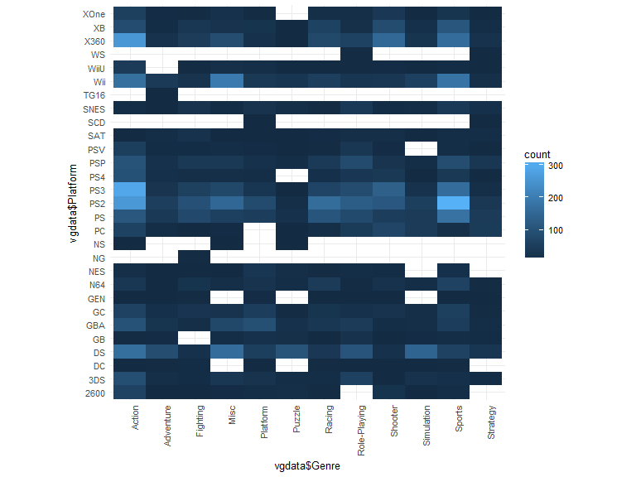

I wasn't sure how to compare these categorical variables properly at first, so with the suggestion to look into geom_bin2d, the above plot and the next one were made. We can see that the largest number of sports games have been made for PS2, and the largest number of action games for the PS3, followed by the PS2. Combined with the popularity of these types of games, this could certainly be used as an argument that Sony is winning the console wars.

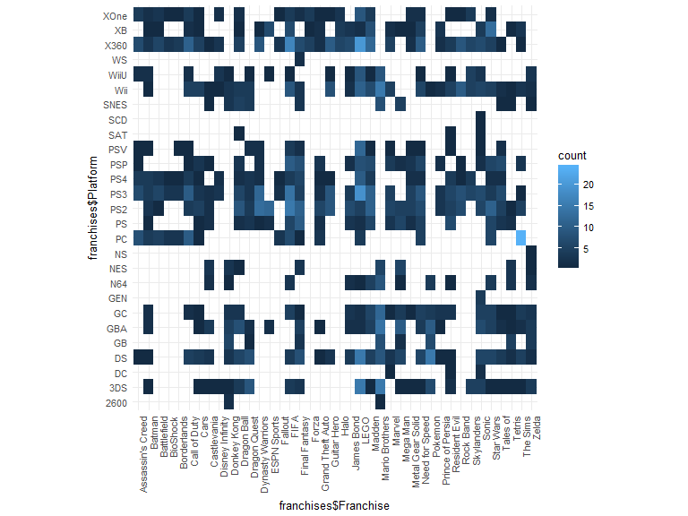

There's more interesting insights when looking at this plot showing count of franchises on platforms. It's clear The Sims have predominantly been PC games, whereas many other franchises haven't been published on the PC at all. The Sega Genesis was really only super famous for the Sonic games, and that is reflected here as well.

# Bivariate Analysis

### Talk about some of the relationships you observed in this part of the investigation. How did the feature(s) of interest vary with other features in the dataset?

To do this part of the analysis, I needed to reahape and summarize data in order to get a better understanding of the big picture. In general, if a publisher has released a lot of titles, then they usually have released a lot of copies of many of those titles.

Regionally, NA seems to drive the bulk of the volume, as success in units shipped in NA is extremely positively correlated with Global units. The same goes for the EU. Additionally, as the years go onward there is a trend downward from the 80's onward in number of units shipped per title, however it's mostly leveled out over the last decade.

When we compare top publishers (those that have published more than 100 games) by units shipped, we see a different story than we did breaking publishers down only by title count. Now we can see that Nintendo hops into the first spot for number of units shipped globally, while Electronic Arts falls to second place. I was curious if getting the list of top publishers from the top 5% of Publishers by units shipped would make a difference to what is considered the list of "top publishers". There are only 17 Publishers in the top 95% by units, whereas there are 21 in the top by titles. Aside from that, the list of the top 5% by units have all shipped 100 titles or more.

For the JP region, seeing the lower correlations was interesting, but it seems to coincide with the notorious reputation Japan has for being very loyal to games made by companies in Japan. Games popular in North America are generally not super successful there, and the scatterplot revealed a lot of games don't sell well enough to be denoted in the millions with two decimal places.

### Did you observe any interesting relationships between the other features (not the main feature(s) of interest)?

When it comes to game franchises, there is a huge amount in variance in the amount of success a game might achieve This makes a lot of sense, as some games do better than others, and some have been met with extremely poor sales even if they carry name recognition. Other observations were unsurprising, such as games that release on a lot of consoles being part of popular franchises, and having relatively successful sales. Drilling down into the Mario franchise revealed the source of some of the peaks in 1985 and 1989, which was no surprise considering how ubiquitous Super Mario Bros and Super Mario Land are.

Looking at a boxplot broken down by platform gives a really cool view into some information about the successes of each platform. Faceting these plots by decades gives us a timeline of when different consoles were most popular, and for the 80s, 90s, 00s, and 10s you can see the generational changeovers for electronics as certain consoles were phased out and others were phased in. Unfortunately, any games that didn't have a year land in the NA bin.

### What was the strongest relationship you found?

The strongest relationship that could be numerically measured was NA.Units with Global.Units with a .94 Pearson correlation, followed by EU.Units and Global.Units with a .9 Pearson correlation. The correlation between NA.Units and EU.Units was still extremely strong at .75.

# Multivariate Plots Section

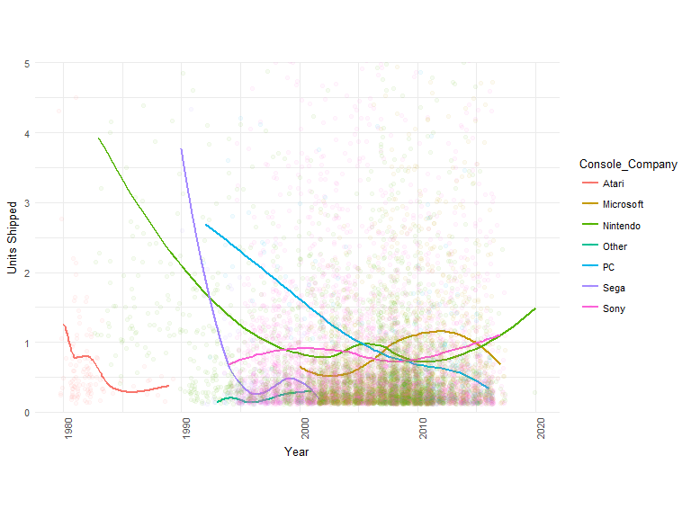

Looking at average units shipped globally by Console_Company reveals some really interesting chunks of data about the history of console makers. In 1992, PC gaming burst onto the scene with a passionate fan base that continued to drive up average sales per title into the mid-90s when the console wars really took off.

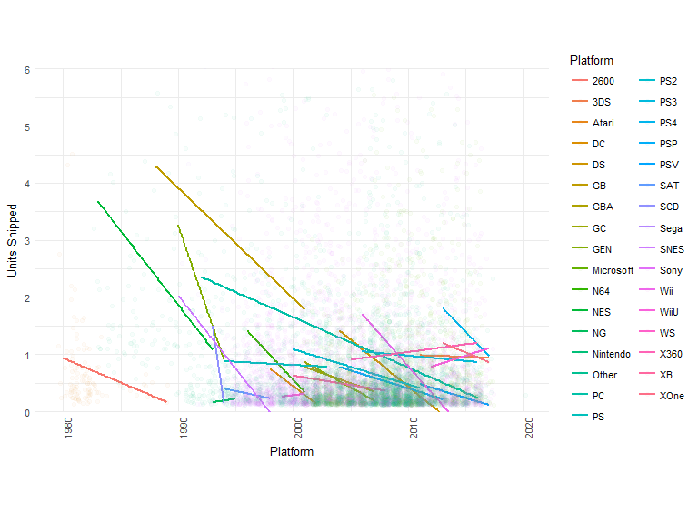

This plot split by platform is included because it really illustrates how much competition there was between consoles starting late 90s, which is what earned it the title of *the Console Wars*. That said, competition is still alive and well between the big three companies currently in the market, as well as PCs.

On average, the number of units shipped for each title on almost every console has continued to steadily decline over the years. This could be partially due to the sheer number of systems available compared to what there used to be. Perhaps it could be due to other factors not included in this dataset, such as rising costs to purchase games, or markets shifts towards subscription based, free-to-play, and pay-to-win games.

Seeing the overall decline in average number of units shipped per title begs several additional questions. Was there a video game bubble, and has it burst? Not only have average units shipped been decreasing in the last decade, as the first histogram shows, the number of games made each year has been decreasing. Or perhaps this is still a relatively young industry, and something more is going on here. As time goes forward, it's within reason to believe we could see further peaks and valleys in the trends of game sale based on the climate of the market in each region, especially seeing Sony as a whole has been steadily increasing their average units shipped over the last few years.

## Source: local data frame [6 x 3]  
## Groups: Year [6]  
##   
## Year Region Total.Units  
## <dbl> <fctr> <dbl>  
## 1 1980 Global.Units 11.38  
## 2 1981 Global.Units 35.77  
## 3 1982 Global.Units 28.86  
## 4 1983 Global.Units 16.79  
## 5 1984 Global.Units 50.36  
## 6 1985 Global.Units 53.89

## Source: local data frame [6 x 3]  
## Groups: Year [6]  
##   
## Year Region Total.Units  
## <dbl> <fctr> <dbl>  
## 1 2014 Global.Units 333.95  
## 2 2015 Global.Units 272.97  
## 3 2016 Global.Units 201.57  
## 4 2017 Global.Units 22.21  
## 5 2020 Global.Units 0.29  
## 6 NA Global.Units 93.74

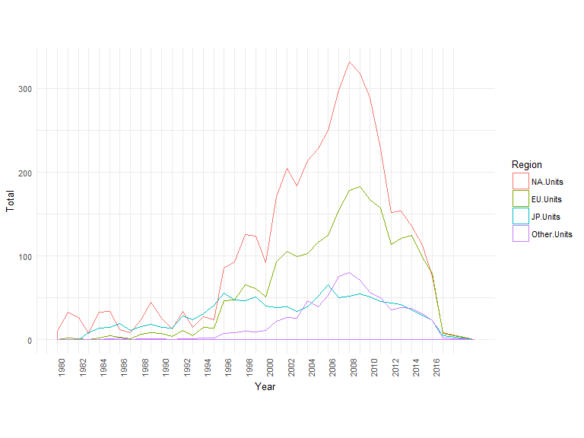

When I first identified the dependent variable (Global Sales, which with a properly arranged dataset can be broken out by Region), this plot showing global yearly units shipped, colored by region, was what I initially envisioned to tell the story of video game sales globally. In order to create this plot, the dataset needed to be significantly reshaped using melt, and also needed the sales data summarized.

What's really fascinating to see here is the steep trend upwards from 2005, peaking in 2008 and 2009, before dropping off in a downward trend. This shows that when there are spikes in game sales, the ripple effects are felt across regions, and the same goes for dips. During the big spike, games shipped to the Other region edged out Japan, however in the time since, JP and Other are on fairly even playing field. Another surprise was seeing the time period in the 90's where Japan sold the most units worldwide.

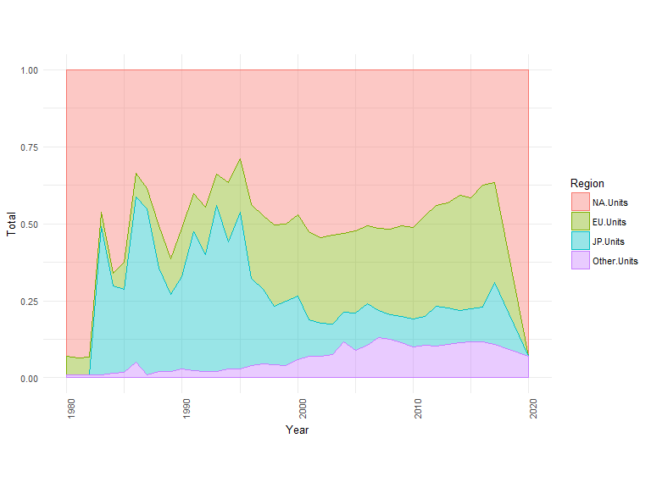

Since global units shipped is the sum of games shipped in each region, creating this plot showing each region as a proportion of the total gives a really good look at how much share each region held each year. It would seem that gaming hasn't necessarily gotten less popular in Japan over the years, just perhaps other regions have gained so much traction that Japan's share has decreased. This data set can't answer that for sure, but it's certainly something to speculate on.

## [1] "Top Games: 1985"

## Source: local data frame [6 x 7]  
## Groups: Name [6]  
##   
## Name Year NA.Sum EU.Sum JP.Sum Other.Sum  
## <fctr> <dbl> <dbl> <dbl> <dbl> <dbl>  
## 1 Super Mario Bros. 1985 29.08 3.58 6.81 0.77  
## 2 Kung Fu 1985 1.64 0.38 1.42 0.06  
## 3 Soccer 1985 0.18 0.23 1.53 0.02  
## 4 Ice Climber 1985 0.46 0.10 0.92 0.02  
## 5 Gyromite 1985 0.73 0.16 0.40 0.03  
## 6 Tag Team Match M.U.S.C.L.E. 1985 0.00 0.00 1.05 0.00  
## # ... with 1 more variables: Global.Sum <dbl>

## [1] "Top Games: 1989"

## Source: local data frame [6 x 7]  
## Groups: Name [6]  
##   
## Name Year NA.Sum EU.Sum JP.Sum Other.Sum  
## <fctr> <dbl> <dbl> <dbl> <dbl> <dbl>  
## 1 Tetris 1989 23.20 2.26 4.22 0.58  
## 2 Super Mario Land 1989 10.83 2.71 4.18 0.42  
## 3 Dr. Mario 1989 2.18 0.96 2.00 0.20  
## 4 Teenage Mutant Ninja Turtles 1989 3.38 0.44 0.31 0.04  
## 5 Golf 1989 0.83 0.33 0.92 0.04  
## 6 Tennis 1989 0.75 0.30 0.90 0.04  
## # ... with 1 more variables: Global.Sum <dbl>

## [1] "Top Games: 2008"

## Source: local data frame [6 x 7]  
## Groups: Name [6]  
##   
## Name Year NA.Sum EU.Sum JP.Sum Other.Sum  
## <fctr> <dbl> <dbl> <dbl> <dbl> <dbl>  
## 1 Mario Kart Wii 2008 15.69 12.84 3.80 3.29  
## 2 Grand Theft Auto IV 2008 11.58 7.57 0.58 2.72  
## 3 Call of Duty: World at War 2008 9.34 4.71 0.00 1.83  
## 4 Super Smash Bros. Brawl 2008 6.64 2.55 2.67 1.01  
## 5 Star Wars: The Force Unleashed 2008 5.28 2.86 0.01 1.87  
## 6 Guitar Hero: World Tour 2008 6.20 2.17 0.00 1.63  
## # ... with 1 more variables: Global.Sum <dbl>

## [1] "Top Games: 2009"

## Source: local data frame [6 x 7]  
## Groups: Name [6]  
##   
## Name Year NA.Sum EU.Sum JP.Sum  
## <fctr> <dbl> <dbl> <dbl> <dbl>  
## 1 Wii Sports Resort 2009 15.61 10.94 3.29  
## 2 New Super Mario Bros. Wii 2009 14.50 6.95 4.70  
## 3 Call of Duty: Modern Warfare 2 2009 13.52 8.05 0.46  
## 4 Wii Fit Plus 2009 9.01 8.49 2.53  
## 5 Pokemon HeartGold/Pokemon SoulSilver 2009 4.34 2.71 3.96  
## 6 Assassin's Creed II 2009 5.66 3.48 0.29  
## # ... with 2 more variables: Other.Sum <dbl>, Global.Sum <dbl>

## [1] "Top Franchise: 1985"

## Source: local data frame [1 x 7]  
## Groups: Franchise [1]  
##   
## Franchise Year NA.Sum EU.Sum JP.Sum Other.Sum Global.Sum  
## <fctr> <dbl> <dbl> <dbl> <dbl> <dbl> <dbl>  
## 1 Mario Brothers 1985 29.08 3.58 6.81 0.77 40.24

## [1] "Top Franchise: 1989"

## Source: local data frame [4 x 7]  
## Groups: Franchise [4]  
##   
## Franchise Year NA.Sum EU.Sum JP.Sum Other.Sum Global.Sum  
## <fctr> <dbl> <dbl> <dbl> <dbl> <dbl> <dbl>  
## 1 Tetris 1989 23.20 2.26 4.22 0.58 30.26  
## 2 Mario Brothers 1989 13.01 3.67 6.18 0.62 23.48  
## 3 Final Fantasy 1989 0.00 0.00 1.10 0.00 1.10  
## 4 Castlevania 1989 0.40 0.07 0.37 0.01 0.85

## [1] "Top Franchise: 2008"

## Source: local data frame [6 x 7]  
## Groups: Franchise [6]  
##   
## Franchise Year NA.Sum EU.Sum JP.Sum Other.Sum Global.Sum  
## <fctr> <dbl> <dbl> <dbl> <dbl> <dbl> <dbl>  
## 1 Mario Brothers 2008 18.80 15.29 4.53 3.98 42.60  
## 2 Grand Theft Auto 2008 11.58 7.57 0.58 2.72 22.43  
## 3 Guitar Hero 2008 12.51 4.17 0.01 2.63 19.31  
## 4 LEGO 2008 10.48 4.97 0.00 3.10 18.56  
## 5 Call of Duty 2008 9.95 4.89 0.00 2.77 17.59  
## 6 Star Wars 2008 7.10 3.27 0.01 2.07 12.48

## [1] "Top Franchise: 2009"

## Source: local data frame [6 x 7]  
## Groups: Franchise [6]  
##   
## Franchise Year NA.Sum EU.Sum JP.Sum Other.Sum Global.Sum  
## <fctr> <dbl> <dbl> <dbl> <dbl> <dbl> <dbl>  
## 1 Mario Brothers 2009 20.16 11.69 6.28 3.50 41.62  
## 2 Call of Duty 2009 14.82 8.50 0.46 3.14 26.90  
## 3 Pokemon 2009 4.91 3.14 4.40 0.88 13.33  
## 4 Assassin's Creed 2009 6.24 4.07 0.34 1.69 12.34  
## 5 FIFA 2009 1.96 6.16 0.07 2.47 10.65  
## 6 Guitar Hero 2009 5.16 3.53 0.00 1.67 10.37

To investigate the peaks that occurred in sales for 1985, 1989, 2008, and 2009, I created tables to show top games in those years, since the exploration up to this point had only revealed two of the major wave makers, Super Mario Bros., and Super Mario Land, which happened in 1985 and 1989 respectively. This was a really cool view of the data set, and put a lot of clarity on exactly what happened these years that made such a big impact.

Prior to this, it wasn't clear what made such a big impact in 1989, however that's now clearly Tetris, another absolutely ubiquitous game. It's no surprise it's shipped over 30 million copies. When examining Tetris more closely as a franchise on the franchise box plot, it's pretty clear that the original Tetris was a runaway success, while other Tetris branded games haven't done nearly as well.

2008 is an interesting year (which could arguably be the best year for games on record), because it wasn't any single game that made the spike. Seeing the list of games released to huge amounts of enthusiasm and acclaim (Mario Kart Wii, GTA IV, COD, Smash Brothers), it's no surprise the number of units shipped for this year was so high. We can make the same observations about the top games for 2009.

## Source: local data frame [6 x 4]  
## Groups: Franchise, Name [4]  
##   
## Franchise Name Year Global.Sales  
## <fctr> <fctr> <dbl> <dbl>  
## 1 Assassin's Creed Assassin's Creed 2007 10.36  
## 2 Assassin's Creed Assassin's Creed 2008 0.91  
## 3 Assassin's Creed Assassin's Creed II 2009 10.82  
## 4 Assassin's Creed Assassin's Creed II: Discovery 2009 0.28  
## 5 Assassin's Creed Assassin's Creed: Bloodlines 2009 1.24  
## 6 Assassin's Creed Assassin's Creed II 2010 0.55

## Source: local data frame [6 x 4]  
## Groups: Franchise, Name [6]  
##   
## Franchise Name Year Global.Sales  
## <fctr> <fctr> <dbl> <dbl>  
## 1 Zelda The Legend of Zelda: A Link Between Worlds 2013 3.20  
## 2 Zelda The Legend of Zelda: The Wind Waker 2013 1.92  
## 3 Zelda The Legend of Zelda: Majora's Mask 3D 2015 2.42  
## 4 Zelda The Legend of Zelda: Tri Force Heroes 2015 1.21  
## 5 Zelda The Legend of Zelda: Twilight Princess HD 2016 1.20  
## 6 Zelda The Legend of Zelda: Breath of the Wild 2017 3.26

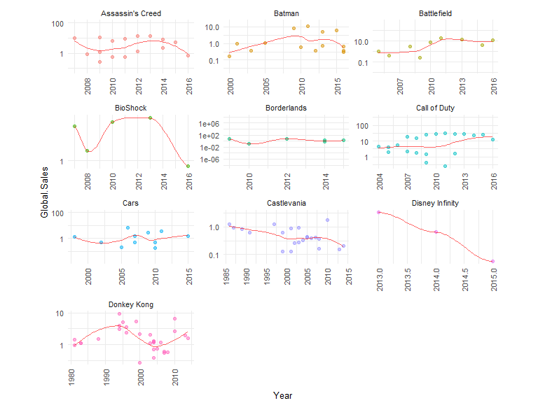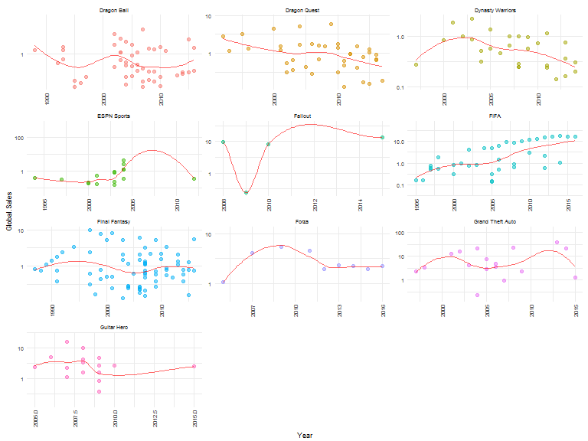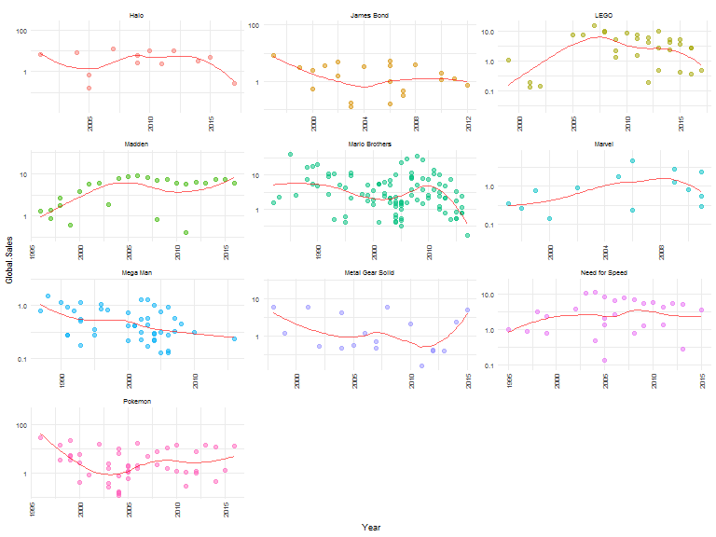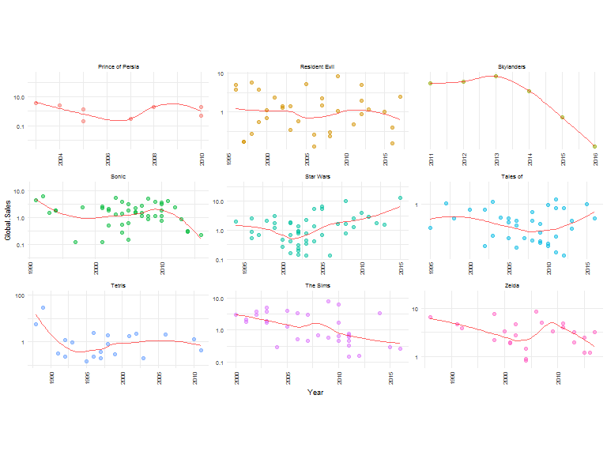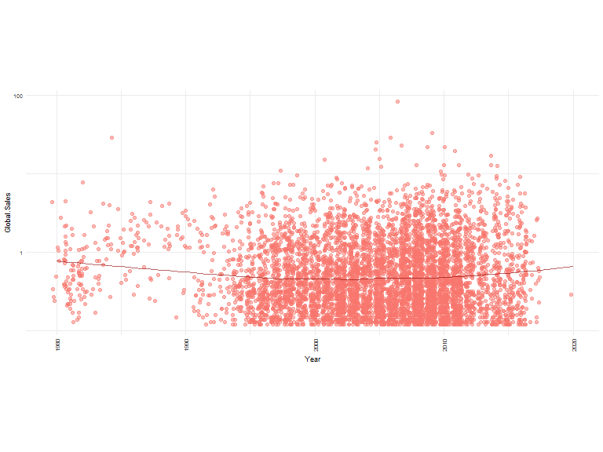

I wanted to take a look at all the games over time on a scatter plot, but when put all together on one plot it was really difficult to make any sense of since there weren't any defined patterns of note. Faceting by Franchise made these graphs really interesting (if not small, so I split the plots out), and you can see which Franchises have been the most prolific at which points in time. To better visualize how the franchise does as a whole, I added a mean line for average units shipped per year. This line helps visualize the general way game sales are trending for each franchise.

There is a lot of information here, and this is one of the plots I found myself having the most fun looking at, since it was really cool to see how different franchises have been doing as they release more games

# Multivariate Analysis

### Talk about some of the relationships you observed in this part of the investigation. Were there features that strengthened each other in terms of looking at your feature(s) of interest?

Once the games were broken out on a scatterplot of units shipped by Name and Franchise over year, it was easier to see patterns in the performance of different franchises. Notably, FIFA games continue to rise in number shipped, usually shipping well over 10 million units. There is a similar pattern in Madden, so it begins to become clear why EA is so gung-ho to keep churning out a new game for each league every year. Call of Duty is another franchise that is almost assured to sell over 10 million units if they put out a new game.

Most other franchises have released to various levels of success, and others like Skylanders and Disney Infinity might have been fads since their sales have steadily been decreasing.

### Were there any interesting or surprising interactions between features?

Looking at the global sales broken out by region, I was extremely surprised to see the giant drop off in game sales after 2009, since it hasn't recovered, however drilling into that further revealed that maybe it isn't so much a video game bubble that popped, but a few years where many publishers struck gold that caused a big increase in sales worldwide. As new AAA titles are released in the future (especially in the wildly popular franchises), I expect future years may also experience a boom in sales thanks to a few blockbuster hits.

# Final Plots and Summary

## Plot One

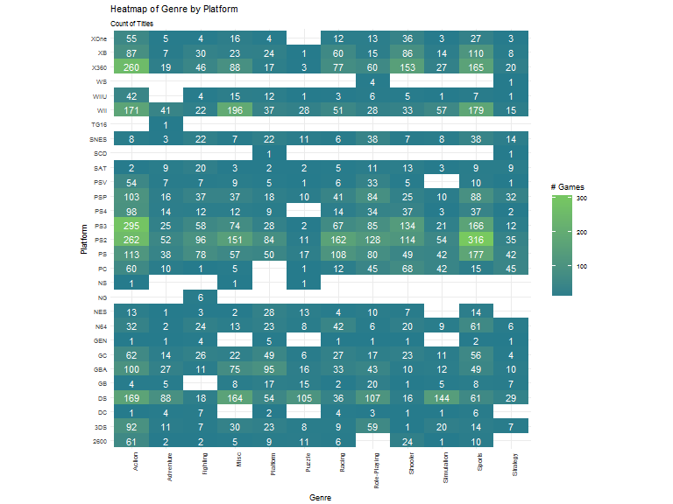

### Description

Heatmap plot made with bin2d that shows the count of games published in each genre on each platform. Blue squares are lower numbers published, while green squares are higher numbers of games. This provides an quick visualization that shows the popularity of PlayStation 2 and PlayStation 3 consoles across many genres. Additionally, this depicts the general popularity of Sports and Action games across platforms.

## Plot Two

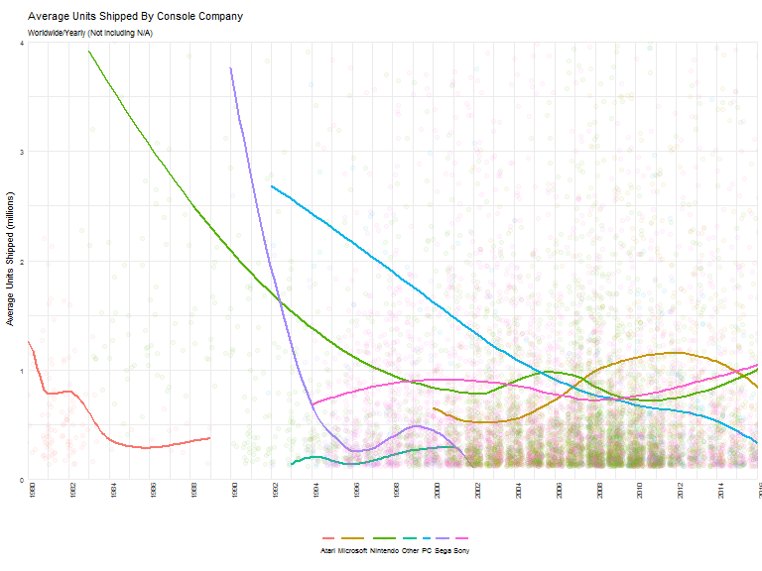

### Description

This smooth line plot shows the trend of global units shipped for games published by each console company. The method for smoothing used is 'loess', with standard error set to false. Games are plotted on a scatter plot to show where the data points are. Coordinates are transformed to show the averages of the entire data set, so not all points representing games are shown.

The plot is cut off at 2016, as to not show partial years as part of the trend. This shows an overall rise in average units shipped for Sony and Nintendo, while Microsoft and PCs have continued to have lowered average units shipped.

## Plot Three

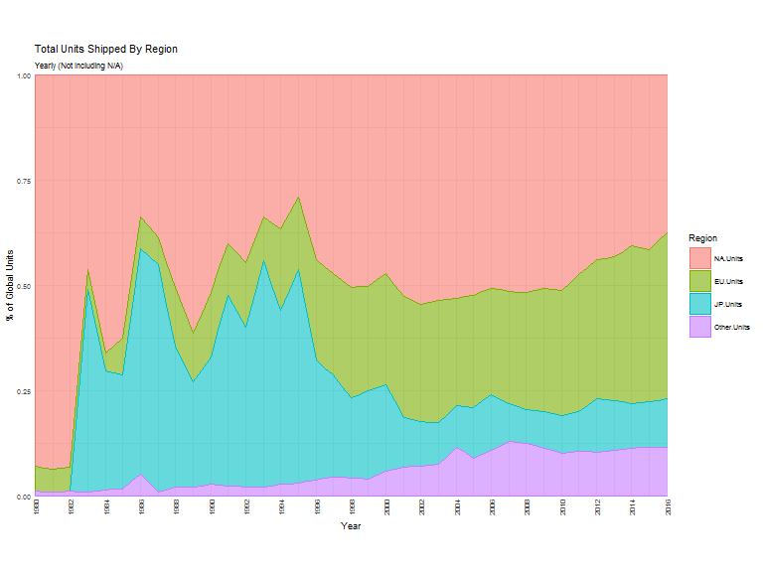

### Description

The Global units shipped numbers broken out by regions, in my opinion is one of the most interesting plots because of the scope of the story it tells. This plot was cleaned up to cut off at 2016, since it doesn't make sense to measure any years that are not complete in these numbers. It would seem that gaming hasn't necessarily gotten less popular in Japan over the years, just perhaps other regions have gained so much traction that Japan's share has decreased. This is a pattern that seems to have begun for North America as well, as the EU picks up steam in the gaming market and increases their overall share of the pie. On average, NA and EU regions make up about 75% of global units shipped, with EU gaining on NA as the years go on.

# Reflection

It has been really interesting starting with what I thought was a pretty shallow dataset as far as the amount of information about each game that it started with. All this said, once new columns were generated, and the data was reshaped, questions and exploration really began to flow freely. I've found myself most drawn to the Name/Franchise data, since drilling into that that was answering many of the questions that I'd come up with as I went through this exercise.

This set began with the 10k rows of top selling games, and then used extensive reshaping in order to explore the data in different ways, and be able to make different types of charts. While I conducted the exploration, I logged my thoughts and observations, along with relevant summaries along the way.

There was a clear boom in video game sales over a period of few years that could be observed after gaming really hit mainstream and became wildly popular. Most game sales are at this point trending downwards, though the dataset explored here isn't the best for being able to make conclusions about why that might be,

I've found it's tough to find a good stopping point, since every time I add a graph, it seems to open up a new wormhole of "what if I look at it this way instead" questions. I feel as though I've really just begun to scratch the surface of the exploration that could be done here, especially if I were to have created a linear model to try and predict how franchises will sell.

One of my biggest frustrations with organizing this dataset was figuring out franchises, as the last thing I wanted to do was insert dirty data into a tidy dataset. To do this part of the cleanup to the best of my abilities, I'd sorted the dataset by title, as well as global sum in order to best gauge which franchises were popular, or frequently occurring. From there, I selected the obvious ones to include, but left out may worthy franchises, opting for a large Other bucket. This made it so faceting the data on franchise would be feasible, and was nice for representing the most obvious franchises. However, it left the Other bucket large, which could end up catching heavy hitting games not tagged with a franchise.

As far as top consoles go, it's pretty decisive that it's either Nintendo or Sony at any given point in time. This is a disappointment for me, since I spent the early part of my career at Xbox, and my gaming platform of choice is a PC. It's okay for me to have a preference towards those platforms, but it would be very hard for me to argue that Microsoft was in any way winning the console wars with either Xbox or PCs (which aren't all Microsoft based anyways).