Memo

|  |  |
| --- | --- |
| To: | Sylvia Unwin |
| From: | Whitney King |
| Date: | November 21, 2014 |
| Re: | Assignment 8 |
|  |  |

The main difficulties on this assignment stemmed from not having any feedback or responses on the forum. Instructions all center on making calculations off of fiscal year, however, most of the results are then null or errors. If calendar year is used, it fixes the problem, but everything is designed around fiscal. There was no help or information on this problem provided on this last module, and it’s also affecting things in this module. Several students have posted for assistance, and we’ve all just resigned to do the best we can with it. With all the said, I think this week’s assignment turned out alright for the most part.

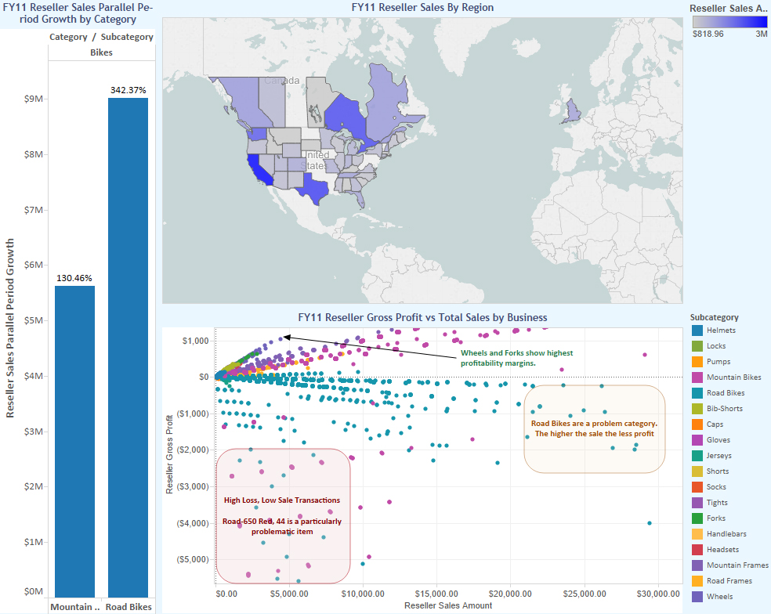

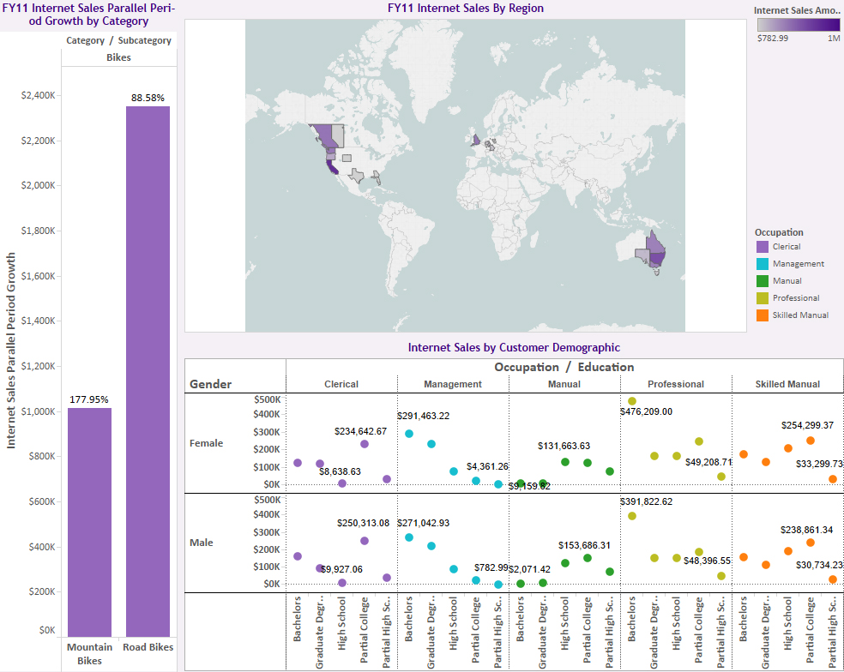

All answers to questions in this assignment also provided in the Tableau workbook in annotations and commentary where possible.

**Dashboard 1:** This is the Reseller Sales Dashboard. The assignment has requested one dashboard, however when putting both Internet Sales and Reseller Sales on a single dashboard, everything felt busy and unrelated other than total sales. For this reason, I wanted to look at the separately and get a really good understanding of the data so specialized actions can be taken to continue improving sales in the separate areas.

The map chart breaks down reseller sales by region, with a focus on State/Province for FY11. This is next to a vertical comparison of the Parallel Period Growth and Growth Percent. At the bottom, we look at gross profit versus product category to see which products are making us the most money and which products lose money. This was an extremely informative breakdown for me, with what feels like a lot of good information that we can work with to cut some products from the line or push sales of others.

**Dashboard 2:** This is the Internet Sales Dashboard. The map chart breaks down internet sales by region, with a focus on State/Province for FY11. This is next to a vertical comparison of the Parallel Period Growth and Growth Percent. At the bottom is a demographics breakdown of customers by gender, education and occupation so we can really do some specific targeting for potential new customers.

**Part II**

We are seeing the most gross profit and sales volume out of out of Brisbane, AUS... if you include East Brisbane, that profit almost doubles, so this is a great region where it is worth focusing more sales resources. Total Sales: $16,705 (12 items sold)

Our second most profitable city is Bellflower, California (though only marginally more so than East Brisbane). California overall seems to be extremely profitable, so it's another region to focus resources on growth. Total Sales: $14,122 (11 items sold)