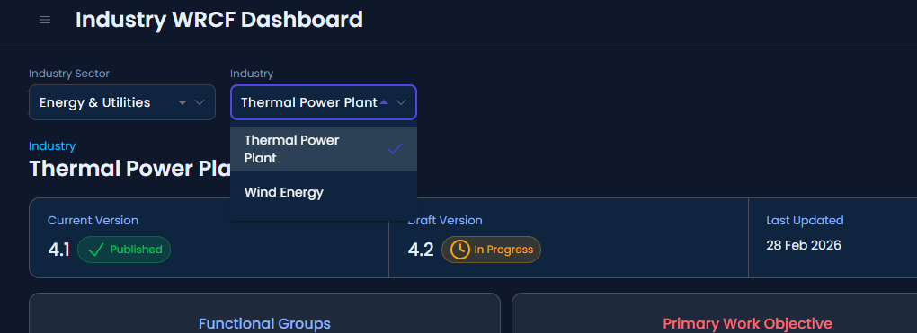
1
ii. In Industry Sector and Industry, two drop down arrow is showing in filter
`Dashboard`
- PDF: sector/industry sorted
- `DASH-E2E-004`, `005`, `006` → `pass`
XXX wrong from playwright test
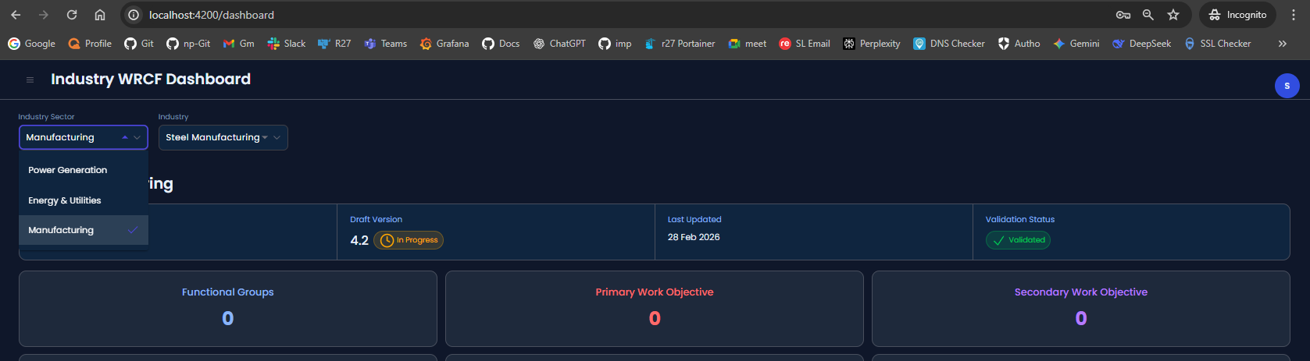
2
While loading page after login, it showing default filters selected but when
redirecting from any other page its some time not showing filter data
// did not understand
3
Manage Industry WRCF
ii. Should show Industry sector and industry in alphabetic sorted order
(ascending
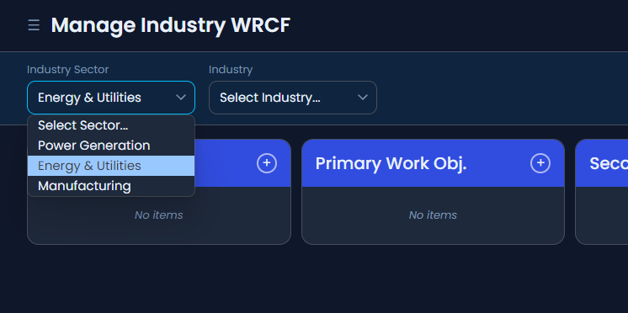
XXX wrong from playwright test
4
FG/PWO/SWO alphabetical/default first selected
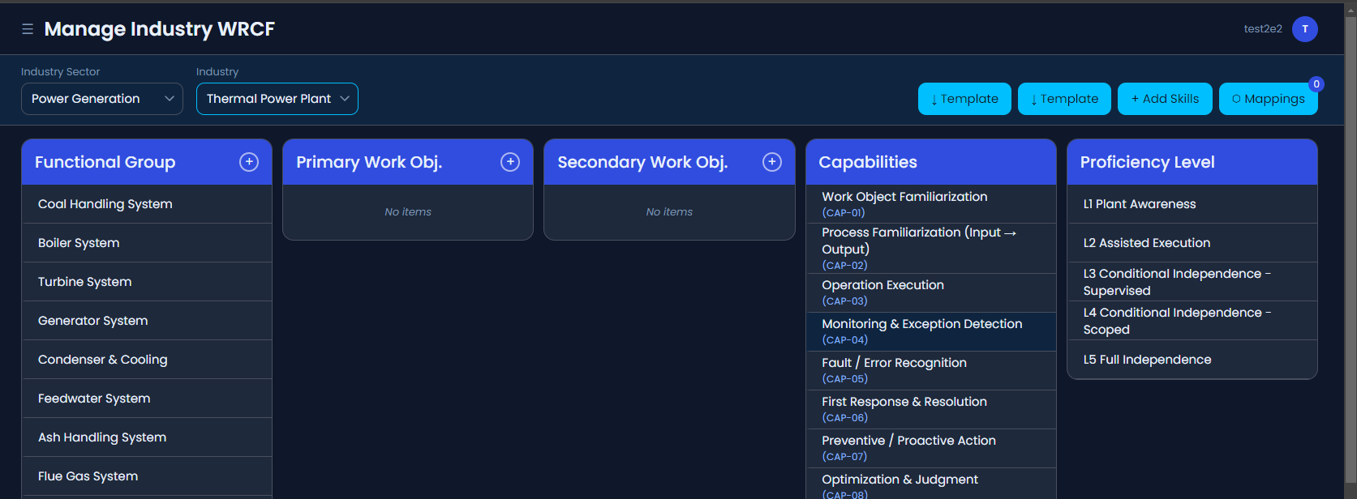
XXX wrong from playwright test
5:- - PDF: FG/PWO/SWO alphabetical/default first selected
- alphabetical FG: `MIWRCF-E2E-009` → `pass`
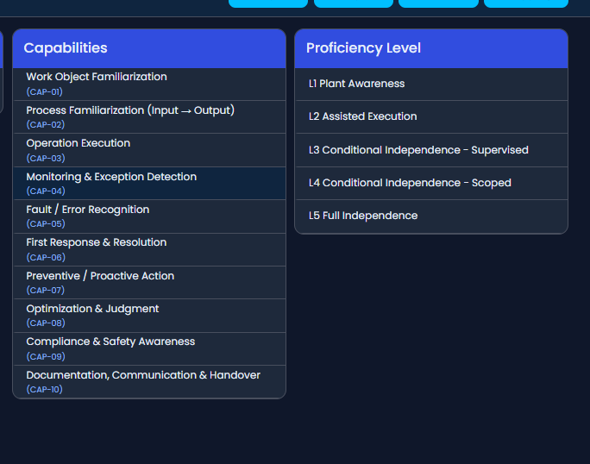
XXX wrong from playwright test
6
- PDF: capability/proficiency default view
- capabilities list/order: `MIWRCF-E2E-017` → `pass`
// did not understand
7:- `Primary Work Object`
- PDF: duplicate name not allowed
- `PWO-E2E-006`, `007`, `012` → `pass`
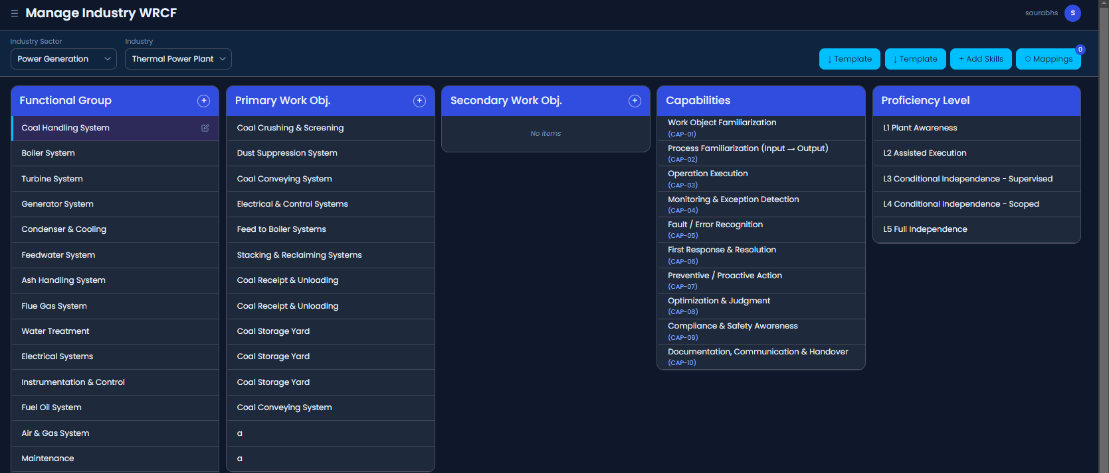
// wrong from playwright test
8:- `Secondary Work Object`
- PDF: duplicate name not allowed
- `SWO-E2E-006`, `007`, `012` → `pass`
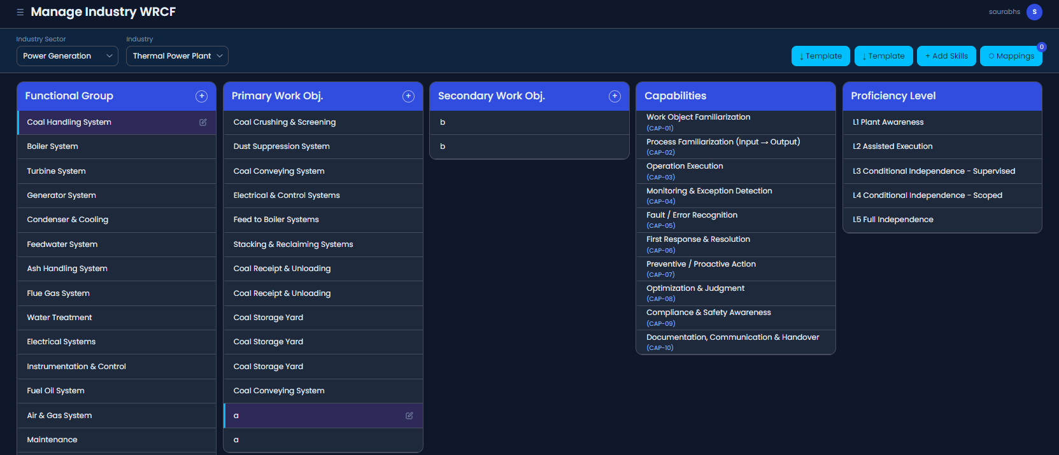
// wrong from playwright test
9: - PDF: popup inherits selected sector/industry/FG and shows accordion grouping
- `CIMAP-E2E-012`, `014`, `015`, `017` → `pass`
//working
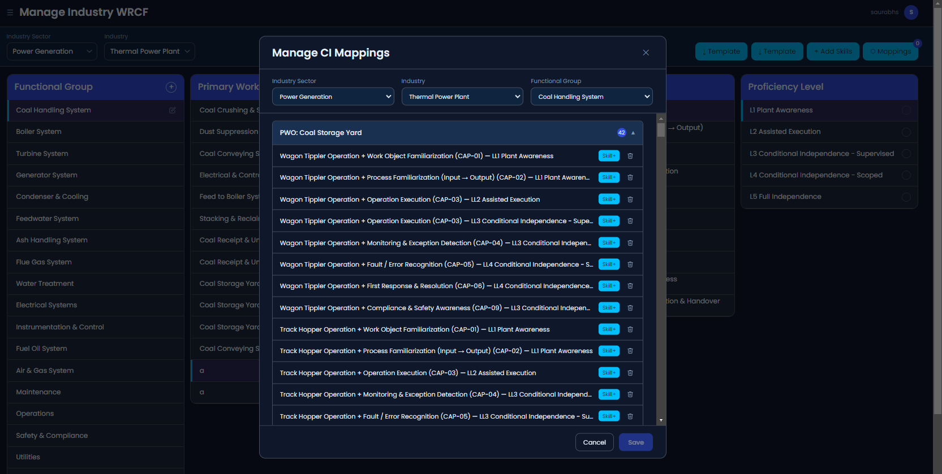
10:- `Manage WRCF Skills`
- PDF: Skills / Task / Control Point default first selection
- skills column resolves: `WSKILL-E2E-006` → `pass`
11:- - PDF: default selected filters from Manage WRCF / navigation
- `WSKILL-E2E-001`, `002` → `fail`
