**List of Abbreviations**

AJAX – Asynchronous JavaScript and XML

API – Application Programming Interface

BPM – Beats per Minute

EMI – Electromagnetic Interference

GPIO – General Purpose Input/Output

GPS – Global Positioning Satellite

HTTP – Hypertext Transfer Protocol

I2C – Inter-Integrated Circuit

IC – Integrated Circuit

IR – Infrared

NCAA – National Collegiate Athletic Association

PCB – Printed Circuit Board

SQL – Structured Query Language

TSDB – Time-Series Database

URL – Uniform Resource Locator

USB – Universal Serial Bus

USD – United States Dollar ($)

UWB – Ultra-Wideband

XML – Extensible Markup Language

1. **Evaluation**

This section describes, in detail, the testing procedures used to validate the operation of the Zotikon system. In order to limit system redesign, each subsystem was unit tested before integration into its higher-level module. Once the modules passed testing, the whole system was integrated and tested. Table 4-1 represents the technical design constraints originally listed in Section 2.1.

Table 4-1 Technical Design Constraints

|  |  |
| --- | --- |
| **Name** | **Description** |
| Transmission Range | The Zotikon system must be able to reliably transmit data to at least 70 meters in a noisy environment with radio interference with a success rate of at least 90 percent. |
| Max Beats per Minute (BPM) | The maximum beats per minute the athlete-worn device must be able to measure is 220 BPM with an accuracy of 1 BPM. |
| Simultaneous Users | The monitoring station must be able to receive data from 11 athlete-worn devices simultaneously. |
| Runtime | The athlete-worn device must be able to operate continuously for no less than 4 hours. |
| Body Temperature Measurable Range | The athlete-worn device must be able to measure temperatures in the range of 15℃ - 40℃ with 0.25℃ accuracy. |

The following sections explain the testing procedures used to verify that the approach, detailed in Section 3, meets the constraints listed.

* 1. **Test Certification – Heart Rate Sensor**

The heart rate sensor was unit tested in two steps. The first step was to verify proper operation of the analog circuitry that collected the heart rate and amplified that reading to a usable value. This test was carried out using the analog components and an oscilloscope to measure the waveform output. The output measured from the analog components is shown in Figure 4-1. While the team desired the waveform to utilize the majority of the operating voltage, the addition of more amplification began causing issues that could not be resolved in a timely manner. Due to the precision of the analog-to-digital converter (ADC), the output of 50mV was sufficient to distinguish the peaks in a heart rate.

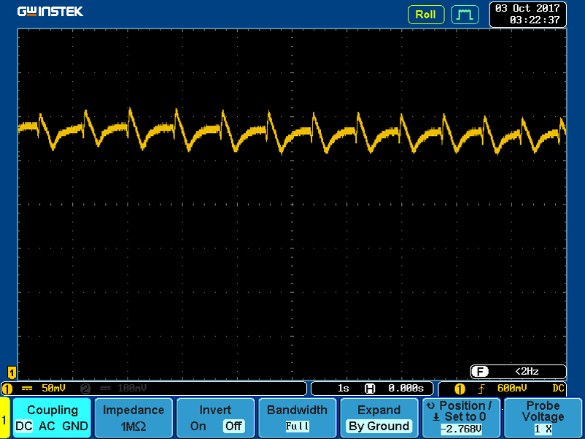

Figure 4-1 Heart Rate Analog Test

The next step was to verify proper operation of the ADC and the algorithm used to extract the beats per minute (BPM) measurement. This was accomplished by comparing the BPM output of the algorithm to another heart measurement device and verifying the time between peaks on the oscilloscope using cursor measurements. TODO (INSERT FIGURE) shows all three measurements in close accuracy to one another.

READER’S NOTE: The second test just discussed has not actually been performed yet.

* 1. **Test Certification – Temperature Sensor**

The temperature sensor unit test consisted of reading Inter-Integrated Circuit (I2C) messages from the sensor and translating the data into the correct format. This began with the Melexis MLX90615 that was selected in the approach section. However, after testing two sensors and testing each of those sensors against three different microcontrollers, the sensors never responded to read requests. The failed tests with the Melexis sensor are shown in Figure 4-2 and Figure 4-3. So, the Melexis sensor was replaced with a Maxim Integrated DS1631A temperature sensor, which met the design constraints using physical contact instead of infrared. The DS1631A testing proceeded without difficulty and provided the desired output shown in Figure 4-4. This measurement meets the design requirements and passes this unit test.

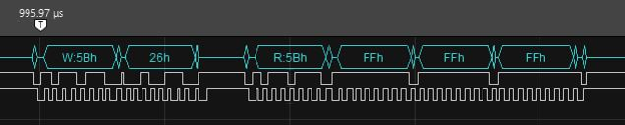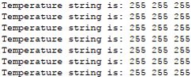

Figure 4-2 MLX90615 Failed I2C Messages

Figure 4-3 MLX90615 Failed Output

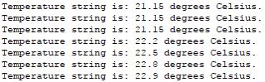

Figure 4-4 DS1631A Correct Output

* + 1. **Test Certification – Wireless Communications**

The wireless communications unit test was designed to verify the transmission range and reliability of Synapse devices in sporting arenas. To accomplish this test, the devices were operated for an extended period of time in the football stadium during the Mississippi State University vs. University of Massachusetts game. The test resulted in a 41% success rate at 75 meters. The design constraint specifies a success rate of 90% at 70 meters, which the devices fell short in meeting the success rate. The device was tested at various data rates which provided the necessary data to determine which rate was most successful. Based on this rate, the athlete-worn device maintains a buffer that is five times the size of the polling rate. Specifically for the Zotikon system, the devices are polled every one second by the monitoring station, so the athlete-worn device maintains a five second buffer of data. If a device fails to transmit the data requested, the monitoring station continues to provide the user with a stable graph because the data is buffered in the database. The chance of five sequential requests for data failing is less than 10%, which brings the success rate to over 90% as required. The results of the test are shown in TODO (INSERT FIGURE) and TODO (INSERT TABLE). The tests were conducted with the monitoring station stationary in Section 16 of the stadium. The portable devices were moved to three different places to test the range and connectivity. The first test, black line, demonstrated a high success rate at a distance of 46 meters. The second test, blue line, was conducted with extremely poor conditions due to the band moving along the path of transmission during the duration of the test. The third test, orange line, was conducted with one device next to the monitoring station and the other across the field in Section 7 of the stadium. This test demonstrated the devices ability to transmit the required distance. Combined with the buffering technique, the wireless devices meet the design constraints.

READER’S NOTE: We have another test scheduled for November 19th at the Humphrey Coliseum during a women’s basketball game and that data will also be included in this report.

Table 4-2 Wireless System Unit Test Data

|  |  |  |  |  |  |
| --- | --- | --- | --- | --- | --- |
| Test Case | Monitor Station Location | Device 1 Location | Device 2 Location | Max Distance (m) | Best Success Rate  (%) |
| 1 | Section 16 | Section 19 | Section 19 | 46 | 79.31 |
| 2 | Section 16 | Section 20 | Section 19 | 55 | 33.76 |
| 3 | Section16 | Section 7 | Section 16 | 70 | 41.42 |

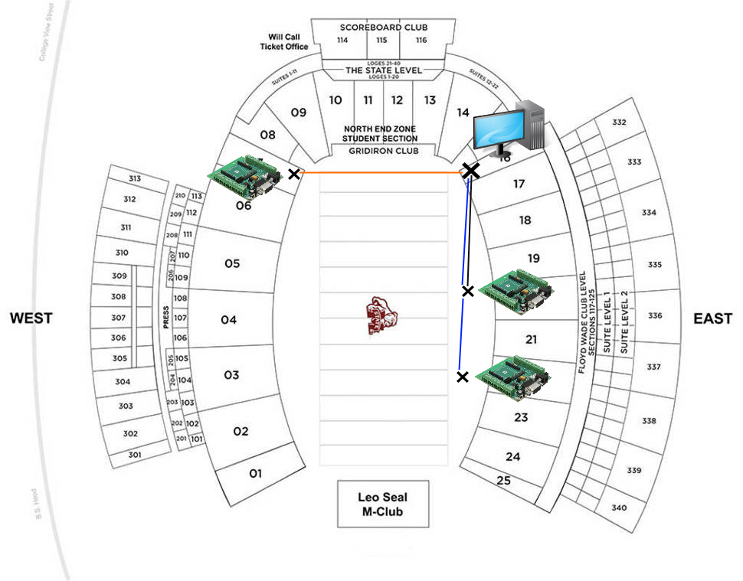

Figure 4-5 Wireless System Unit Test Device Locations

* 1. **Test Certification – Athlete-Worn Device**

TODO: Test it all working together and show we can collect data as necessary.

* 1. **Test Certification – Time-Series Database**

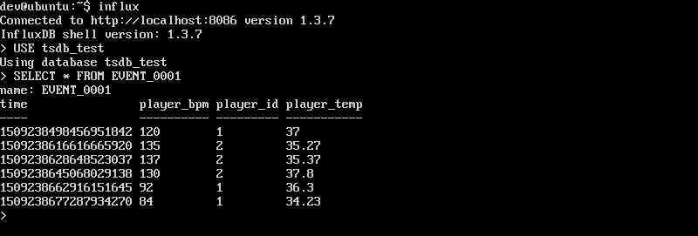The time-series database (TSDB) was tested by simulating a small event collecting vital signs from athletes. The heart rate and temperature values were successfully stored in the TSDB under a collection called ‘EVENT_0001’. The data points were also retrievable after being written, which is shown in Figure 4-5.

Figure 4-6 TSDB Successful Data Collection

READER’S NOTE: More stress testing will be performed on the database to ensure it can read/write at appropriate speeds to handle the input/output from the devices. We are waiting on the BeagleBone to arrive since its hardware will be the limiting factor in this test.

* 1. **Test Certification – Website**

TODO: this section will document the testing of the web server and website to ensure that the static and dynamic content can be accessed and updated within the time specifications.

* 1. **Test Certification – Zotikon System**

TODO: this will be a test of the entire Zotikon system being able to read values from the sensors, transmit them across the Synapse network, store them in the TSDB, and dynamically update them on the webpage.

1. **Summary and Future Work**

TODO: the project will be summarized and future improvements discussed here once we make more finalized progress.

1. **Acknowledgements**

The Zotikon team would like to thank Mr. Jay Allison, Director of Engineering in Smart Lighting Solutions at Synapse, for his support and donations to the development of this system.

1. **References**
2. NCAA.org - The Official Site of the NCAA. (2017). Student-Athletes. [online] Available at: http://www.ncaa.org/student-athletes [Accessed 5 Sep. 2017].
3. Bls.gov. (2017). Athletes and Sports Competitors : Occupational Outlook Handbook: : U.S. Bureau of Labor Statistics. [online] Available at: https://www.bls.gov/ooh/entertainment-and-sports/athletes-and-sports-competitors.htm#tab-6 [Accessed 5 Sep. 2017].
4. Team USA. (2017). Meet Team USA. [online] Available at: http://www.teamusa.org/road-to-rio-2016/team-usa/athletes [Accessed 5 Sep. 2017].
5. Polygraphia.ca - Polygraph Examination Service. (2011). The Polygraph History. [online] Available at: http://www.polygraphia.ca/polygraph_history.html [Accessed 31 Aug. 2017].
6. Polar.com. (2017). Innovations. [online] Available at: https://www.polar.com/us-en/about_polar/who_we_are/innovations
7. ["Syracuse vs. Connecticut - Game Recap - March 12, 2009 - ESPN", ESPN.com, 2009. [Online]. Available: http://www.espn.com/ncb/recap?gameId=290710041. [Accessed: 10- Sep- 2017].
8. B. McMurphy, "Commishes agree: NCAA football games too long", ESPN.com, 2017. [Online]. Available: http://www.espn.com/college-football/story/_/id/18421234/commissioners-college-football-coaches-seek-shorter-games-record-average-game-2016. [Accessed: 10- Sep- 2017].
9. Freitas Jr., R. (1999). Nanomedicine, Volume I: Basic Capabilities. [online] Nanomedicine.com. Available at: http://www.nanomedicine.com/NMI/8.4.1.1.htm [Accessed 11 Sep. 2017].
10. Bean, R. (2005). Facts about the skin :: Temperature of the human body. [online] Healthyheating.com. Available at: http://www.healthyheating.com/Definitions/facts_about_skin.htm#.WbYDZciGMkk [Accessed 11 Sep. 2017].
11. United States Soccer Federation, “United States Soccer Federation - Indoor Playing Rules”. [Online]. Available <http://www.ohsaa.org/sports/so/USSFIndoorSoccerRules.pdf> [Access 11 Sep. 2017].
12. CDC.gov, “Centers for Disease Control and Prevention.” [Online] Available at: <https://www.cdc.gov/physicalactivity/basics/measuring/heartrate.htm> [Accessed 9 Sep. 2017]
13. First In Architecture, “Average Male and Female Dimensions / Heights”. [Online]. Available: <http://www.firstinarchitecture.co.uk/average-male-and-female-dimensions/> [Accessed 11 Sep. 2017]
14. Altera.com. (2017). *Enhanced Temperature Device Support*. [online] Available at: https://www.altera.com/products/common/temperature/ind-temp.html [Accessed 11 Sep. 2017].
15. InfluxData. (2017). Time Series Database Explained | An Overview & Comparison of Top 15. [online] Available at: https://www.influxdata.com/time-series-database/ [Accessed 16 Sep. 2017].
16. Acreman, S. (2017). Top 10 Time Series Databases. [online] Outlyer Blog. Available at: https://blog.outlyer.com/top10-open-source-time-series-databases [Accessed 16 Sep. 2017].
17. Developer.synapse-wireless.com. (2017). Software Products - Developer Resources. [online] Available at: https://developer.synapse-wireless.com/software/index.html [Accessed 25 Sep. 2017].
18. Docs.influxdata.com. (2017). InfluxDB Documentation. [online] Available at: https://docs.influxdata.com/influxdb/v1.3/guides/writing_data/ [Accessed 19 Aug. 2017].
19. **Appendix: Product Specification**

