**Executive Summary**

Professional trainers for competitive athletes continually seek to improve athlete performance during training and competition by monitoring the essential performance indicators or a method to analyze performances post-exercise. Furthermore, competitive vital sign tracking devices operate on commonly used wireless communication protocols, which increases susceptibility to interference. Zotikon provides real-time monitoring of those indicators and presents them to trainers to allow for advanced, adaptive workouts and finely tuned recovery periods and, upon completion of the exercise, the information is available in common data formats for further analysis. Zotikon utilizes a novel mesh network protocol that increases reliability by reducing the necessary distance required to transmit, making it a superior product operating in facilities occupied by large crowds. Figure 1 shows an overview of the Zotikon system and how the individual subsystems function together.

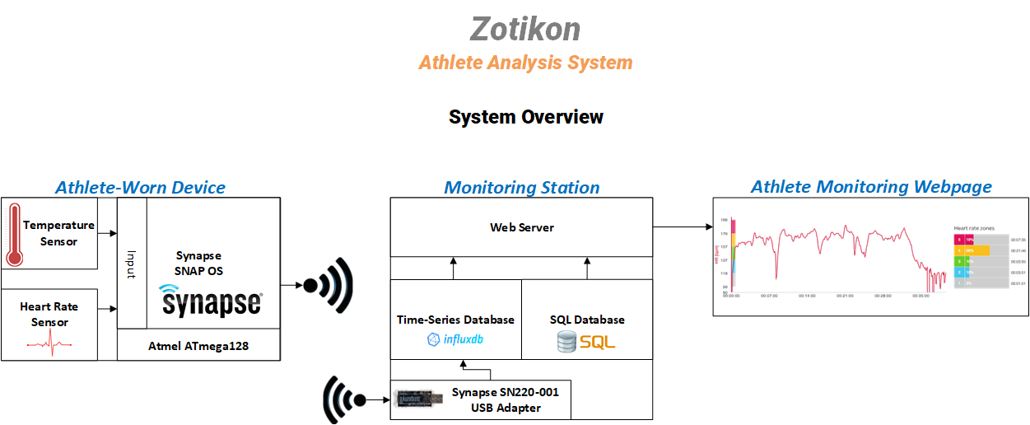

Figure 1 Zotikon System Overview

Due to the environment of sporting events and the amount of people that could be present, Zotikon must be able to accurately transmit heart rate and temperature data in high electromagnetic interference environments across the full length of the playing surface. Since athletes are active while wearing Zotikon devices, these devices need to be Ingress Protection 64 compliant to be resistant to sweat and dust. In order for athletes or trainers to increase their performance and recovery, Zotikon must provide a real-time graph of distinct players’ data along with storing it in a database for later analysis. In order for Zotikon to be competitive in its market, it needs to be cost effective, provide the players’ data accurately in real time, and display them in a user-friendly fashion.

The Zotikon system was designed to overcome wireless interference by using a radio that implements a mesh network to transmit messages through intermediary devices to reach the monitoring station. An electrocardiogram circuit and external temperature sensor transmit data to the microprocessor. The processor communicates the data to the monitoring station to provide the trainer access to real-time readings of heart rate and temperature for each athlete. This system is capable of continuous operation for at least four hours so that athletes can monitor their health for the duration of a game.

The Zotikon system provides a unique way to monitor athletic health. Other similar systems only connect between monitoring units and the base station while the Zotikon system utilizes a mesh network to allow intermediary connections through other monitoring units to reach the base station, extending the range of the system. Introducing Zotikon to the market would increase competition by granting consumers access to a cost-effective solution to athletic health monitoring.