**Task 1: Database and Tables Creation**

Q1: Create a database named inventory_management.



Q2: Create a products table with the following columns: product_id, product_name, category_id, supplier_id, quantity, price, and created_at.

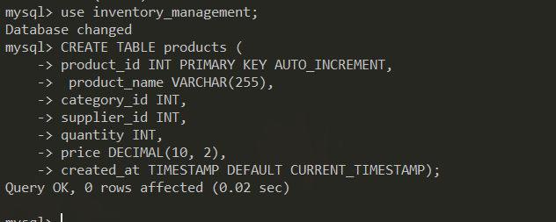

Q3: Create a categories table with the following columns: category_id and category_name.

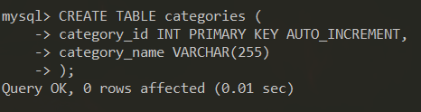

Q4: Create a suppliers table with the following columns: supplier_id, supplier_name, and contact_info.

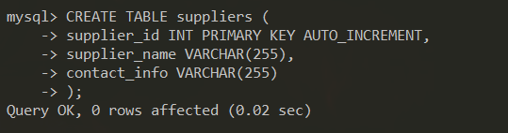

**Task 2: Data Insertion and Updating**

**Q1: Insert sample data into the** categories **table.**

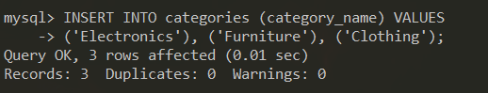

Q2: Insert sample data into the suppliers table.

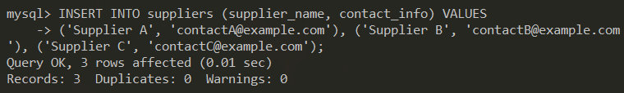

Q3: Insert sample data into the products table.

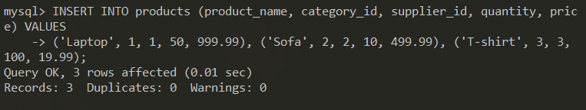

Q4: Update the quantity of the product with product_id 1 to 60

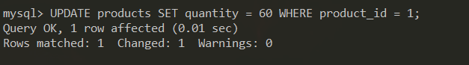

**Task 3: Joins**

Q1: Write a query to retrieve all products along with their category names and supplier names.

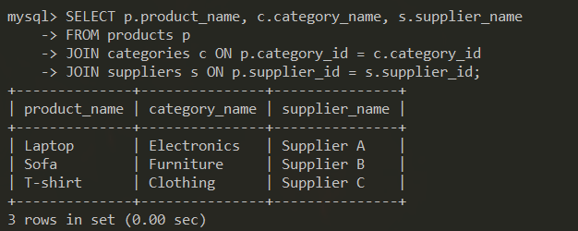

**Task 4: Indexes**

Q1: Create an index on the product_name column of the products table.

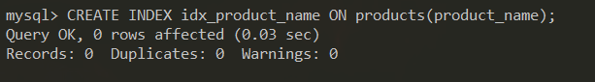

**Task 5: Views**

Q1: Create a view named product_details that displays product_name, category_name, supplier_name, quantity, and price.

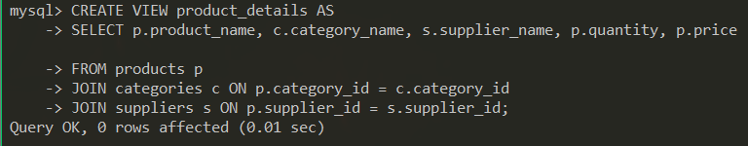

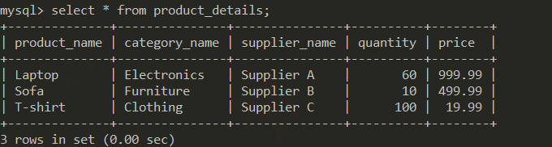

**Task 6: Transactions**

Q1: Write a transaction to update the quantity of a product and log the change in a product_log table. Create the product_log table first.

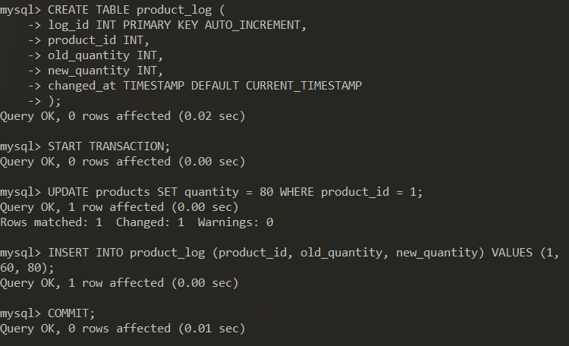

**Task 7: Triggers**

Q1: Create a trigger to automatically update the updated_at column of the products table whenever a row is updated.

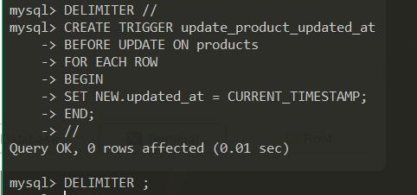

**Frontend Tasks**

**Task 8: HTML**

Q1: Create an HTML file named index.html that includes a form to add a new product.

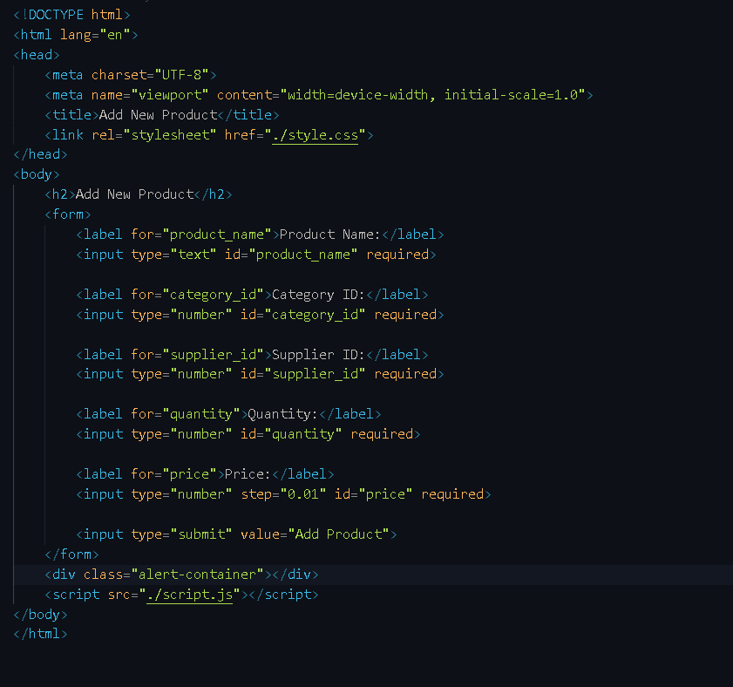

**Task 9: CSS**

Q1: Create a CSS file named styles.css to style the form created in the HTML file.

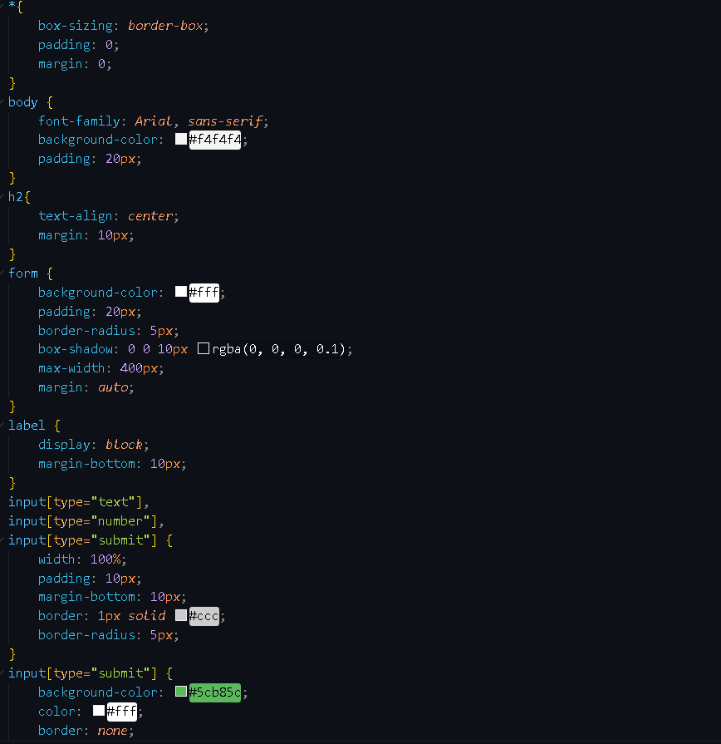

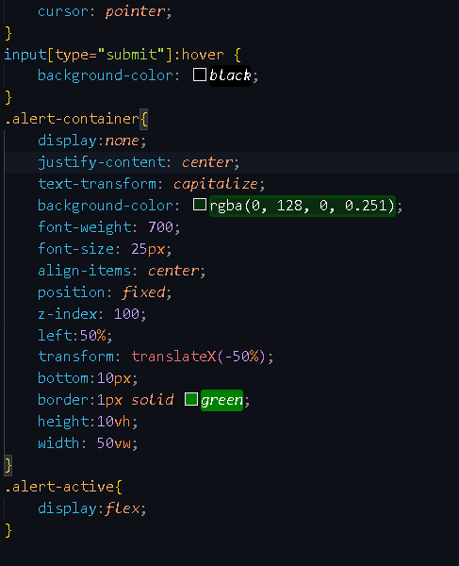

**Task 10: JavaScript**

Q1: Create a JavaScript file named script.js to handle the form submission and send the data to the server using AJAX.

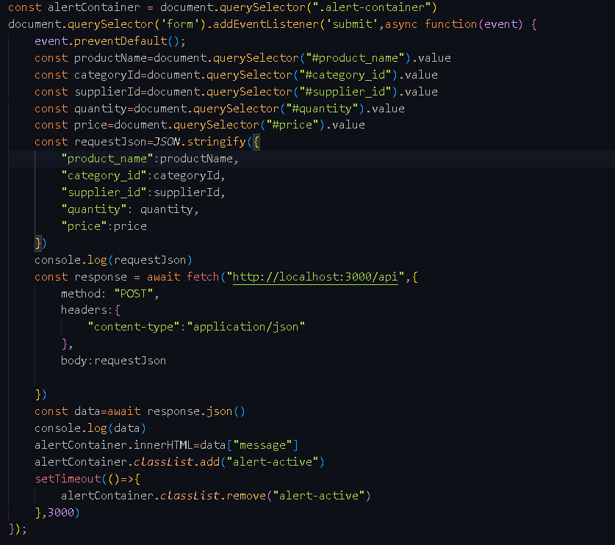

**Task 11: Backend (Integration)**

Q1: Write a backend script in your preferred language (e.g., PHP, Node.js) to handle the product addition request from the form.

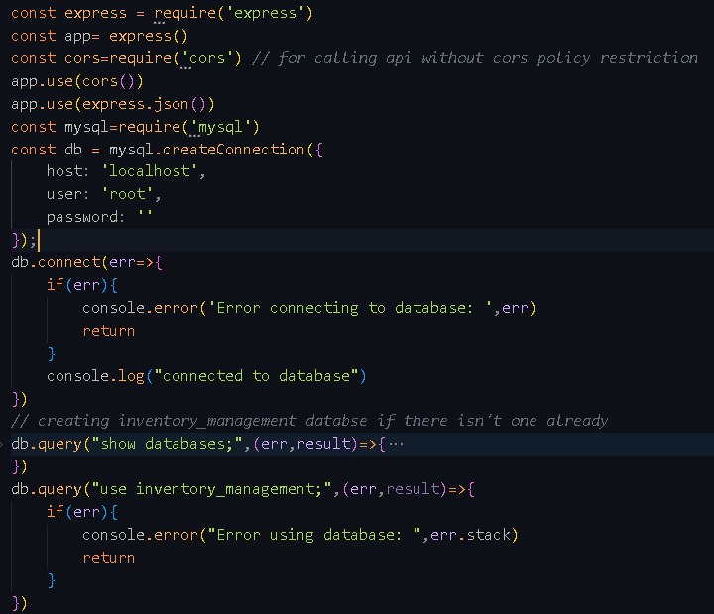

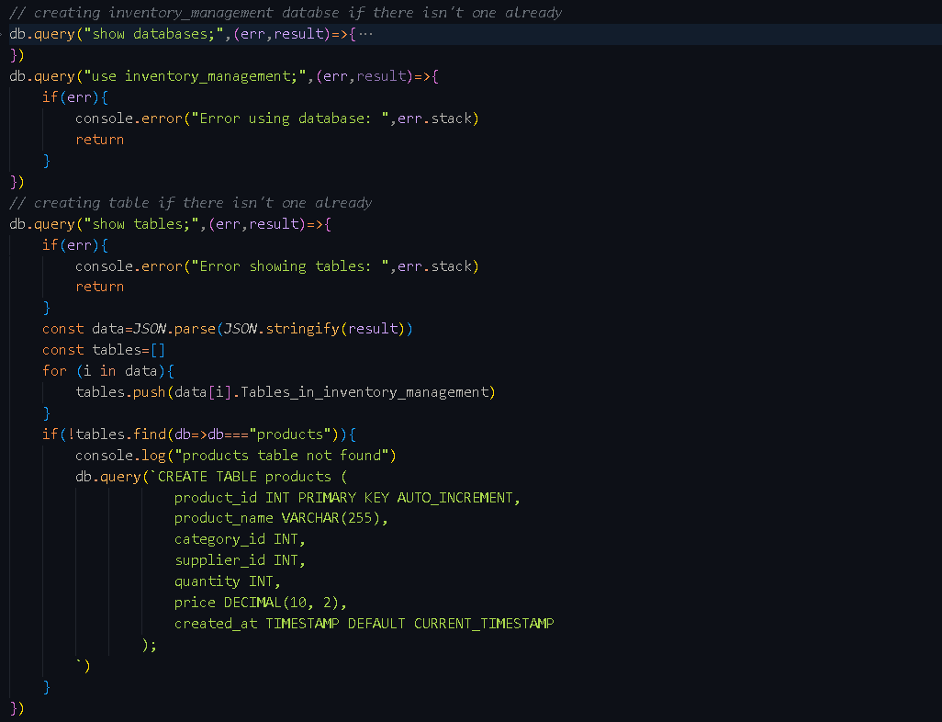

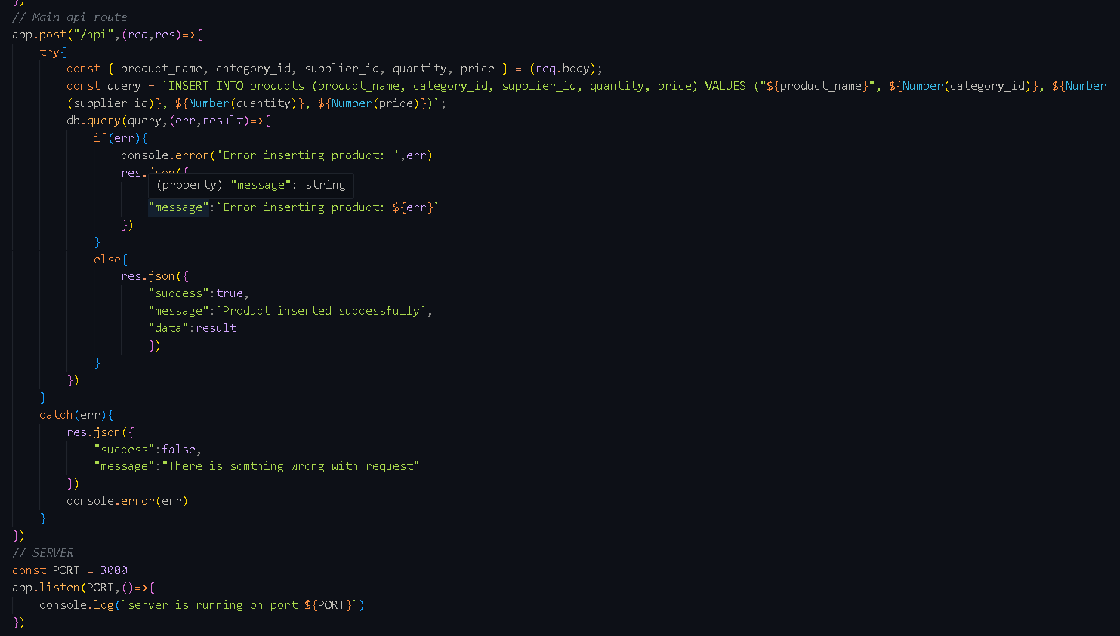

**Final Integration**

**Q1: Integrate the HTML, CSS, and JavaScript files into a single project directory.**

* Place index.html, styles.css, and script.js in the root directory.

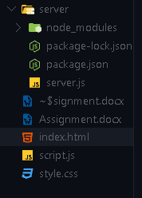

* Ensure the form in index.html uses the correct paths to link the CSS and JS files:



