**Workflow Editor for Precision Health**

**1. Instruction**

The Precision Health System is the system which will measure the state of health of individuals

and give appropriate suggestions before they suffering from potential diseases. The Workflow Editor for Precision Health is designed to define and execute the workflow and display the intermediate results. In addition, it will save the data in the database which is prepared for the further analysis.

**2. Files**

The root directory contains the source code directory of the Workflow Editor for Precision Health which is named as workflow and the archives of the other tools which need to be installed. For example, Python 3.6.2, MySQL 5.7.23. In addition, the database file, precision_health.sql, and a file for the package requirements, requirements.txt, are also included.

**3. Requirements**

There are several requirements for using the Workflow Editor for Precision Health. These requirements can be divided into 2 parts, the environment requirements, and the package requirements.

**3.1 Environment requirements**

In addition, Python 3.6.2 is used to develop the system, and the database employed in this system is MySQL 5.7.23, therefore, Python 3.6.2 and MySQL 5.7.23 are required.

**3.2 Packages requirements**

The packages requirements contain the packages which are adopted in this system. They are mainly Flask, which will build the website, PyMySQL, which will connect with the MySQL database, numpy, which will handle the data. All the packages which are demanded are list in the requirements.txt.

**4. Installation**

The Workflow Editor is designed to be implemented on the Ubuntu 16.04, therefore, the install methods which will be introduced is based on the Ubuntu 16.04.

**4.1 Install the environment requirements**

**4.1.1 Install Python 3.6.2**

The archive of Python 3.6.2 can be found in the root directory. The installation method is:

1. $ tar xf Python-3.6.2.tar.xz

2. $ cd Python-3.6.2

3. $ ./configure --prefix=/usr/local --enable-shared

4. $ make

5. $ make install

**4.1.2 Install MySQL database and import the database file**

**4.1.2.1 Install MySQL database**

There are two methods, one is based on the source code and the other one will download resources from the internet. And the archive of MySQL 5.7.23 can be found in the root directory.

* + - * 1. **The installation method based on the archive**

1. Extract the files which are compressed in the archive

1. $ tar –xvf mysql-server_5.7.23-1ubuntu16.04_amd64.deb-bundle.tar

2. Install the packages. As there is a dependency between these packages, these packages have to be installed one by one.

1. $ sudo apt-get install libaio1

2. $ sudo dpkg -i mysql-common_5.7.23-1ubuntu16.04_amd64.deb

3. $ sudo dpkg -i libmysqlclient20_5.7.23-1ubuntu16.04_amd64.deb

4. $ sudo dpkg -i libmysqlclient-dev_5.7.23-1ubuntu16.04_amd64.deb

5. $ sudo dpkg -i libmysqld-dev_5.7.23-1ubuntu16.04_amd64.deb

6. $ sudo dpkg -i mysql-community-client_5.7.23-1ubuntu16.04_amd64.deb

7. $ sudo dpkg -i mysql-client_5.7.23-1ubuntu16.04_amd64.deb

8. $ sudo apt-get –f install

9. $ sudo dpkg -i mysql-community-server_5.7.23-1ubuntu16.04_amd64.deb

10. $ sudo dpkg -i mysql-server_5.7.23-1ubuntu16.04_amd64.deb

**4.1.2.1.2 The installation method based on the APT tool which is provided by Ubuntu 16.04**

1. $ sudo apt-get install mysql-server

2. $ sudo apt install mysql-client

3. $ sudo apt install libmysqlclient-dev

**4.1.2.2 Import the database file**

After installing the MySQL server, the MySQL service is available. It can be used by the following command.

1. $ mysql –u (username) –p (your password)

Then, create the database in the MySQL database.

1. mysql>CREATE DATABASE precision_health

Finally, import the database file which can be found in the root directory. Open the terminal at the root directory and use the following command.

1. $ mysql –u (username) –p precision_health < precision_health.sql

**4.2 Install the packages requirements**

The package requirements are enumerated in the requirements.txt, and all the packages can be installed by using the following command.

1. $ pip install –r requirements.txt

**5. Run**

After installing the environment requirements and the package requirements, the Workflow Editor for Precision Health system can be executed. In the root directory, the workflow directory which contains the source code can be found. Change the directory into the workflow directory. The Workflow Editor for Precision Health system can be executed by using the following command.

1. $ python workflow.py

There are several parameters which can be set. These parameters are host, user, password, database_name and person_id. Host, user, password, and database_name indicate the host name, user name, password and database name which are required when connecting with the MySQL database. The default values are ‘localhost’ for host, ‘root’ for user, ‘123456’ for password and ‘precision_health’ for the database_name. The person_id is the identification of different users, the default value is ‘1’. To modify these parameters, the name of parameter and the value can be appended after the running command, and different parameters are separated by spaces. For example,

1. $ python workflow.py host=127.0.0.1 password=111111 person_id=2

Finally, filling the address bar of the browser by using 127.0.0.1:5000, the Workflow Editor for Precision Health is available. The webpage will be displayed as below.

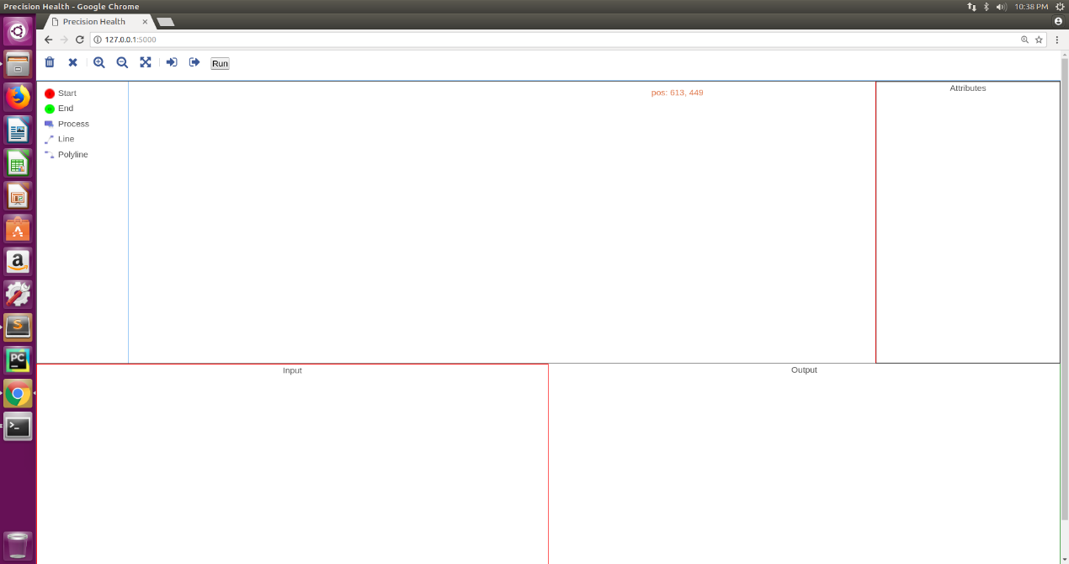

Figurer 1 The webpage of the Workflow Editor for Precision Health