Advanced Data Structures and
Algorithm Analysis

Laboratory Project1

Tries and AVL Trees
胡亮泽、徐雨豪、刘俊灏、毛晨炀
Date: 2013-11-20

contents

Chapter 1: Introduction 3

Chapter 2: Data Structure / Algorithm Specification 3

Chapter 3: Testing Results 7

Chapter 4: Analysis and Comments 12

Appendix: Source Code (if required) 16

References 16

Author List 39

Declaration 39

Signatures 39

Chapter 1: Introduction
In this problem, we are requested to compare the two structures that are AVL tree and tries tree. We should compare the performances of a sequence of insertions and search-deletions on these two structures. Insert and delete in different way. Strings will have different behaviors.
We use use the struct TrieNode and struct AvlNode to build the trees. And use the function insert and delete with the rotation to finish the aim. In deletion of Trie ,we use the lazy deletion as a matter of convenience .Use clock() to calculate the time cost.

Chapter 2: Data Structure / Algorithm Specification
2.1Data Structure
Struct TrieNode is to build the tries tree structure.
struct Trienode
{
int eow; /*end of word,1 represents the node is the end of a word*/
Tposition next[26];
};
The eow is useful for lazy deletion.

Struct AvlNode is to build the Avl tree structure.
struct AvlNode
{
char s[100];
Avltree left;
Avltree right;
int height;
};
Char s[] stores the string. AvlTree Left and Right are subtrees. Height counts the height of this node.

2.2Algorithm Specification
With these structures, we use the function insert, delete and rotate to finish the task.

2.3Algorithm Specification of AvlTree
Avltree Ainsert( char *s,Avltree T )/*Insertion*/
{
Compare to decide to insert in the left or right;
Update the Height;
If(Height(T->Right)-Height(T->Left)==2 or -2) choose to Rotate single or double and left or right with LL, LR, RR, RL;
}

AvlTree Adelete(char *s,Avltree T) /*deletion*/
{
Compare the string with node to find its position;
Rotate it to the leaf position;
Delete;
Update the height and free space;
}

Avlposition ingleRotateWithLeft(Avlposition ) LL

Avlposition SingleRotateWithRight(Avlposition ) RR

Avlposition DoubleRotateWithLeft(Avlposition ) LR

Avlposition DoubleRotateWithRight(Avlposition ) RL

int AHeight(AvlTree) /*calculate the height*/

int max( int ,int ) /*return the max value*/

Avltree Amakeempty( Avltree ) /*Initialize the tree*/

Avlposition Afind( char , Avltree ) /*Find the node*/

Avlposition Afindmin( Avltree )

Avlposition Afindmax( Avltree )

2.3Algorithm Specification of Trie
Ttree Tmakeempty( Ttree T )/*Initialize the tree*/

void Tinsert( char *s,Ttree T )/*Insertion */
{
Transform the word to a number.
Find the leaf to add the node of this string’s end;
initialize the new node’s pointer;
iterative until insert all char of the strings;
Update eow;
}

Tposition Tfind( char *s,Ttree T ) /*Find*/
{
Transform the word to a number.
Find the last word of the string;
If(eow is equal to 1)
Then find the string;
}

void Tdelete( char *s,Ttree T )/*Deletion*/
{
If NULL printf(error);
Find the string;
Lazy deletion the last word of the string;
}

int wordtonumber( char ) /*Transform the word to a number.*/

2.3Algorithm Specification of Main

int main()
{
Open a file to read the string for testing;
Insertion ,Find or Deletion to get the clock to calculate the time cost.
Repeat the procedure before for many results;
}

Chapter 3: Testing Results
*The unit of testing results is ‘SECONDS’
*Each testting loops for 100 times
*We define the maximum of ‘The number of strings ’ to be 10000
*We define the maximum of ‘The length of strings ’ to be 34
*We use VS2012 as the testing environment.
*Appendix: The program to create random strings
#include<stdio.h>
#include<stdlib.h>
#include<time.h>
int main(void)
{
char ch;
int i,j,k,d;
FILE *fp;
if((fp=fopen("1.txt","w"))==NULL){
printf("file open error!\n");
exit(0);
}
scanf("%d",&d);
srand((int)time(0));
for(i=0;i<d;i++){
k=rand()%8+1;
for(j=0;j<k;j++){
ch=rand()%26+'a';
if(ch!=EOF)fputc(ch,fp);
}
ch='\n';
if(ch!=EOF)fputc(ch,fp);
}
return 1;
}

*Appendix: The program to create random strings which contains k words.
#include<stdio.h>
#include<stdlib.h>
#include<time.h>
int main(void)
{
char ch;
int i,j,k;
FILE *fp;
if((fp=fopen("1.txt","w"))==NULL){
printf("file open error!\n");
exit(0);
}
scanf("%d",&k);
srand((int)time(0));
for(i=0;i<1000;i++){
for(j=0;j<k;j++){
ch=rand()%26+'a';
if(ch!=EOF)fputc(ch,fp);
}
ch='\n';
if(ch!=EOF)fputc(ch,fp);
}
return 1;
}

*Appendix: The program to make the random strings into increasing order and decreasing order.
#include <stdio.h>
#include <stdlib.h>
#include <string.h>

#define MAXLENGTH 100
#define MAXN 100000

char s[MAXN][MAXLENGTH];

int stringComparer(const void * a, const void * b){
return strcmp(s[*(int *)a], s[*(int *)b]);
}

int main(int argc, char const *argv[])
{
FILE *fin = fopen("1.txt", "r");
FILE *fout1 = fopen("2.txt", "w");
FILE *fout2 = fopen("3.txt", "w");

int list[MAXN];
int count = 0;
int i;

while(fscanf(fin, "%s", s[count]) == 1) // read from in.txt
count++;

for(i = 0; i < count; i++)
list[i] = i;

qsort(list, count, sizeof(int), stringComparer); // you can use your own sort algorithm e.g. qsort

for(i = 0; i < count; i++)
fprintf(fout1, "%s\n", s[list[i]]); // print to file "out.txt" in increasing order

for(i = count - 1; i >= 0; i--)
fprintf(fout2, "%s\n", s[list[i]]); // print to file "out.txt" in decreasing order

return 0;
}

A.Insert and delete in 1000 to 10000 nums of strings in therr order.
- Insert N strings in increasing order and delete them in the same order;
Num of Strings | Avl | Tries
1000 | 0.126 | 0.157
2000 | 0.255 | 0.318
3000 | 0.389 | 0.446
4000 | 0.529 | 0.590
5000 | 0.773 | 0.789
6000 | 0.807 | 0.894
7000 | 0.944 | 1.072
8000 | 1.073 | 1.200
9000 | 1.227 | 1.356
10000 | 1.378 | 1.560

(2)Insert N strings in increasing order and delete them in the reverse order
Num of Strings | Avl | Tries
1000 | 0.123 | 0.156
2000 | 0.252 | 0.300
3000 | 0.383 | 0.444
4000 | 0.531 | 0.598
5000 | 0.675 | 0.776
6000 | 0.788 | 0.902
7000 | 0.930 | 1.042
8000 | 1.069 | 1.205
9000 | 1.211 | 1.355
10000 | 1.351 | 1.520

(3)Insert N strings in random order and delete them in random order.
Num of Strings | Avl | Tries
1000 | 0.145 | 0.159
2000 | 0.301 | 0.309
3000 | 0.443 | 0.469
4000 | 0.608 | 0.617
5000 | 0.665 | 0.774
6000 | 0.918 | 0.921
7000 | 1.108 | 1.088
8000 | 1.287 | 1.273
9000 | 1.426 | 1.418
10000 | 1.603 | 1.629

B Insert and delete in 10 to 90 nums of letters in therr order. All num of strings are 1000.
(1)Insert N strings in increasing order and delete them in the same order;
Numbers of letters | Avl | Tries
10 | 0.133 | 0.350
20 | 0.156 | 0.743
30 | 0.176 | 1.138
40 | 0.200 | 1.541
50 | 0.223 | 1.925
60 | 0.241 | 2.579
70 | 0.258 | 3.006
80 | 0.283 | 3.587
90 | 0.303 | 4.073

(2)Insert N strings in increasing order and delete them in the reverse order
Numbers of letters | Avl | Tries
10 | 0.131 | 0.333
20 | 0.153 | 0.730
30 | 0.176 | 1.124
40 | 0.209 | 1.535
50 | 0.217 | 1.902
60 | 0.248 | 2.683
70 | 0.260 | 3.116
80 | 0.287 | 3.576
90 | 0.322 | 4.044

(3)Insert N strings in random order and delete them in random order.
Numbers of letters | Avl | Tries
10 | 0.152 | 0.340
20 | 0.178 | 0.739
30 | 0.191 | 1.138
40 | 0.220 | 1.568
50 | 0.236 | 1.941
60 | 0.262 | 2.367
70 | 0.273 | 2.738
80 | 0.298 | 3.242
90 | 0.329 | 3.860

Chapter 4: Analysis and Comments
Analysis
A.Insert and delete in 1000 to 10000 nums of strings in therr order.
(1)Insert N strings in increasing order and delete them in the same order;
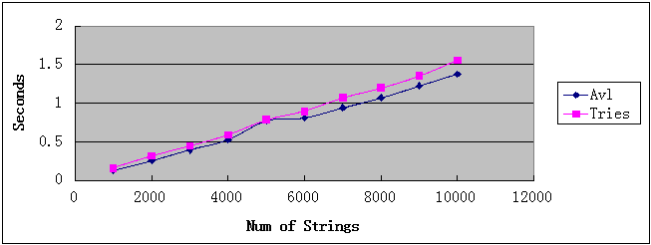

(2)Insert N strings in increasing order and delete them in the reverse order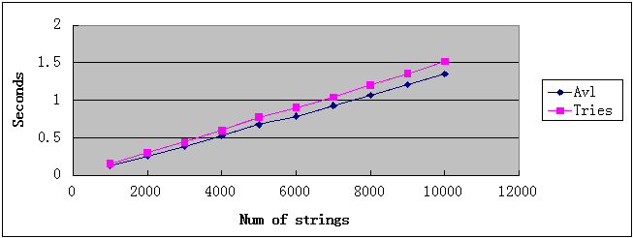

(3)Insert N strings in random order and delete them in random order.
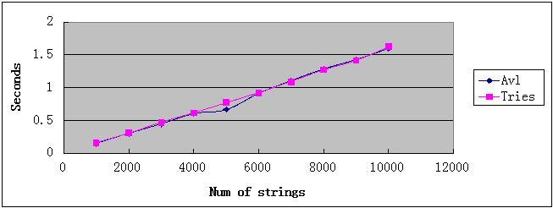
B Insert and delete in 10 to 90 nums of letters in therr order. All num of strings are 1000.
(1)Insert N strings in increasing order and delete them in the same order;
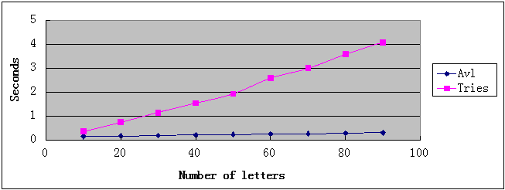

- Insert N strings in increasing order and delete them in the reverse order

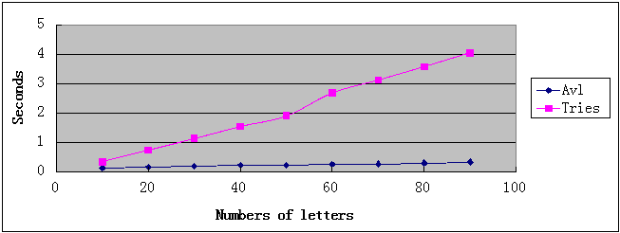
(3)Insert N strings in random order and delete them in random order.
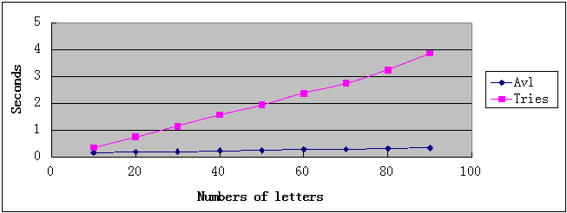

- The time complexities of inserting N strings in two trees is O(NlogN).
- The time complexities of inserting strings of length N (Tries) is O(N).
- the running times of AVL tree is faster than Tries in most cases.
- It is clear that the running times of AVL tree almost didn’t vary when the lengths of string vary.
- Through the project,we could find that both of AVL and Tries are excellent algorithms.AVL tree is very fast and has a very stable search time and suitable for a lot of cases.But AVL is not very easy to implement and Tries is suitable for some cases such as string is not very long .
- So facing with a problem , we would better have a serious thought and choose a good algorithm.

Comments
Our focus this time is on deletion of ALV tree and some operations of trie. For deletion of trie, during our discussion , two possible methods may be feasible .
The first one is lazy deletion , which are used by us this time. As we can see, it has the advantage of quick deletion with only a find operation and setting the variable edw value 0, and it can make further insertion easier if the first few letters of the new word have been inserted into the trie.
However, the space wasted by this method can be horrible because we can never delete a node of no use that has been inserted. One way to solve the problem is using a variable count to store the times of a node passed by words totally. Compare the space of the variable count, which is 2 BYTE , to the space of a node, it can save space theoretically. However , in practical use , only a few nodes may need to be deleted completely. Each time we renew the trie, we need to renew the count of the nodes and it can cost O(N). And the cost of some further insertion may be large, so it’s hard to determine whether this method works or not. So finally, we decided to use lazy deletion in consideration that it is easy .
Deletion of AVL tree consists of deletion of a leaf node and rotation, which saves the space while the time complexity is not very large.
Finally , during testing, we found that some strings generated randomly are the same. Most of them has the length of 1 or 2. It can hardly influence the testing results so we ignored this problem.
Our testing algorithm can test the running time of insertion, search, and deletion of both trie and AVL tree so we can find the relationship between time complexity and each factor.
Some other possible improvements . For example, we used a lot of arrays in our structure , so it can be improved by using list to save space with more time complexity. In practice works, we need to use array and list appropriately to balance time complexity and space complexity.
During our testing, we only insert all strings and delete them, so the result may be of much difference with that in practical use. Due to our bad programming skill, the routine can , of course , be improved by balance the complexity of algorithm and time complexity.

Appendix: Source Code (if required)

#include <stdio.h>

#include <stdlib.h>

#include <string.h>

#include <time.h>

#ifndef _AVLTREE_H/*AVL树声明*/

struct Avlnode;

typedef struct Avlnode *Avltree;

typedef struct Avlnode *Avlposition;

Avltree Amakeempty( Avltree T );

Avlposition Afind( char *s,Avltree T );

Avlposition Afindmin( Avltree T );

Avlposition Afindmax( Avltree T );

Avltree Ainsert( char *s, Avltree T );

Avltree Adelete( char *s, Avltree T );

Avlposition singlerotatewithleft( Avlposition k2 );

Avlposition singlerotatewithright( Avlposition k2 );

Avlposition doublerotatewithleft( Avlposition k3 );

Avlposition doublerotatewithright( Avlposition k3 );

int Aheight( Avltree T );

#endif /*_AVLTREE_H*/

#ifndef _TRIE_H/*字典树声明*/

struct Trienode;

typedef struct Trienode *Ttree;

typedef struct Trienode *Tposition;

Ttree Tmakeempty( Ttree T );

Tposition Tfind( char *s,Ttree T );

void Tinsert( char *s,Ttree T );

void Tdelete( char *s,Ttree T);

int wordtonumber( char ch );/*将字母转换成序号*/

int max( int a,int b );

#endif/*_TRIE_H*/

struct Trienode

{

int eow;/*end of word,0表示非词尾，1表示词尾*/

Tposition next[26];

};

struct Avlnode

{

char s[100];

Avltree left;

Avltree right;

int height;

};

Avltree Amakeempty( Avltree T ) /*清空树*/

{

if( T != NULL )

{

Amakeempty( T->left );

Amakeempty( T->right );

free( T );

}

return NULL;

}

Avlposition Afind( char *s, Avltree T )/*查找*/

{

if( T==NULL )

return NULL;

if( strcmp(s,T->s)<0 )

return Afind( s,T->left );

else if( strcmp(s,T->s)>0 )

return Afind( s,T->right );

else

return T;

}

Avlposition Afindmin( Avltree T )

{

if( T==NULL )

return NULL;

else if( T->left==NULL )

return T;

else return Afindmin( T->left );

}

Avlposition Afindmax( Avltree T )

{

if( T==NULL )

return NULL;

else if( T->right==NULL )

return T;

else return Afindmax( T->right );

}

Avltree Ainsert( char *s,Avltree T )/*插入*/

{

if( T==NULL )

{

T=( struct Avlnode * )malloc( sizeof( struct Avlnode ) );

if( T==NULL )

{

printf("Out of space!!!\n");

exit(0);

}

else

{

strcpy(T->s,s);

T->height=0;

T->left=T->right=NULL;

}

}

else if( strcmp( s,T->s )<0 )

{

T->left = Ainsert( s,T->left );

if( Aheight(T->left)-Aheight(T->right)==2 )

if( strcmp( s,T->left->s )<0 )

T=singlerotatewithleft( T );

else

T=doublerotatewithleft( T );

}

else if( strcmp( s,T->s )>0 )

{

T->right=Ainsert( s,T->right );

if( Aheight(T->right)-Aheight(T->left)==2 )

if( strcmp( s,T->right->s )>0 )

T=singlerotatewithright( T );

else

T=doublerotatewithright( T );

}

else /*说明要插入的内容已经存在，可以直接返回*/

{

return T;

}

T->height=max( Aheight( T->left ),Aheight( T->right) )+1;

return T;

}

Avltree Adelete( char *s,Avltree T )/*删除*/

{

Avlposition TmpCell;

if( T==NULL )

return NULL;

else

{

if( strcmp(s,T->s)<0 )

{

T->left=Adelete( s,T->left );

if( Aheight(T->right)-Aheight(T->left)==2 )

{

if( T->right->left )

T=doublerotatewithright( T );

else

T=singlerotatewithright( T );

}

}

else if( strcmp( s,T->s )>0 )

{

T->right=Adelete( s,T->right );

if( Aheight(T->left)-Aheight(T->right)==2 )

{

if( T->left->right )

T=doublerotatewithleft( T );

else

T=singlerotatewithleft( T );

}

}

else if ( T->left&&T->right )

{

TmpCell=Afindmin( T->right );

strcpy( T->s,TmpCell->s );

T->right=Adelete(T->s,T->right);

}

else

{

TmpCell=T;

if( T->left == NULL )

T = T->right;

else if( T->right==NULL )

T = T->left;

free( TmpCell );

}

if( T!=NULL )

T->height=max(Aheight(T->left),Aheight(T->right))+1;

}

return T;

}

Avlposition singlerotatewithleft( Avlposition k2 )/*左-左单旋转*/

{

Avlposition k1;

k1=k2->left;

k2->left=k1->right;

k1->right=k2;

k2->height=max( Aheight( k2->left ),Aheight( k2->right ) )+1;

k1->height=max( Aheight( k1->left ),k2->height )+1;

return k1;

}

Avlposition singlerotatewithright( Avlposition k1 )/*右-右单旋转*/

{

Avlposition k2;

k2=k1->right;

k1->right=k2->left;

k2->left=k1;

k1->height=max( Aheight( k1->left ),Aheight( k1->right ) )+1;

k2->height=max( Aheight( k2->right),k1->height )+1;

return k2;

}

Avlposition doublerotatewithleft( Avlposition k3 )/*左-右双旋转*/

{

k3->left=singlerotatewithright( k3->left );

return singlerotatewithleft( k3 );

}

Avlposition doublerotatewithright( Avlposition k3 )/*右-左双旋转*/

{

k3->right=singlerotatewithleft( k3->right );

return singlerotatewithright( k3 );

}

int max( int a,int b )/*求两者之间较大值*/

{

if( a>b )

return a;

else return b;

}

int Aheight( Avltree T )/*求AVL树节点高度，以处理子树为NULL情形*/

{

if( T==NULL )

return -1;

else

return T->height;

}

Ttree Tmakeempty( Ttree T )/*清空字典树*/

{

int i;

if( T!=NULL )

{

for(i=0;i<26;i++)

Tmakeempty( T->next[i] );

free( T );

}

return NULL;

}

void Tinsert( char *s,Ttree T )/*字典树插入*/

{

int i=0,n,j;

while( s[i] )

{

n=wordtonumber( s[i] );

if( T->next[n]==NULL )

{

T->next[n]=( struct Trienode * )malloc( sizeof( struct Trienode ) );

T=T->next[n];

if( T==NULL )

{

printf("Out of sapce!!!\n");

exit(0);

}

for( j=0;j<26;j++)

T->next[j]=NULL;

T->eow=0;

}

else

T=T->next[n];

i++;

}

T->eow=1;

}

Tposition Tfind( char *s,Ttree T )/*字典树查找*/

{

int i=0,n;

while( s[i] )

{

n=wordtonumber( s[i] );

if( T->next[n]==NULL )

return NULL;

else

{

T=T->next[n];

i++;

}

}

if( T->eow==1 )

return T;

else

return NULL;

}

void Tdelete( char *s,Ttree T )/*字典树删除*/

{

Tposition p;

p=Tfind( s,T );

if( p!=NULL )

p->eow=0;/*只删除最后一个字母的词尾标志即可*/

}

int wordtonumber( char ch )/*将字母转换成序号*/

{

if( ch>='a'&&ch<='z' )

return ch-'a';

else if( ch>='A'&&ch<='Z' )

return ch-'A';

else

{

printf("Illegal character!!!\n");

return -1;

}

}

int main()

{

clock_t start,end;

FILE *fp1 = fopen("1.txt", "r");

FILE *fp2 = fopen("2.txt", "r");

FILE *fp3 = fopen("3.txt", "r");

char str[100];

Avltree avl=NULL;

Ttree trie=NULL;

int i,j;

start=clock();

for(j=0;j<100;j++){

avl=Amakeempty(avl);

rewind(fp1);

while(!feof(fp1))

{

fscanf(fp1,"%s",&str);

avl=Ainsert(str,avl);

}

rewind(fp3);

while(!feof(fp3))

{

fscanf(fp3,"%s",&str);

avl=Adelete(str,avl);

}

}

end=clock();

printf("%f 随机插入随机删除AVL\n",(end-start)*1.0/CLK_TCK);

start=clock();

for(j=0;j<100;j++){

avl=Amakeempty(avl);

rewind(fp2);

while(!feof(fp2))

{

fscanf(fp2,"%s",&str);

avl=Ainsert(str,avl);

}

rewind(fp2);

while(!feof(fp2))

{

fscanf(fp2,"%s",&str);

avl=Adelete(str,avl);

}

}

end=clock();

printf("%f 顺序插入顺序删除AVL\n",(end-start)*1.0/CLK_TCK);

start=clock();

for(j=0;j<100;j++){

avl=Amakeempty(avl);

rewind(fp3);

while(!feof(fp3))

{

fscanf(fp3,"%s",&str);

avl=Ainsert(str,avl);

}

rewind(fp2);

while(!feof(fp2))

{

fscanf(fp2,"%s",&str);

avl=Adelete(str,avl);

}

}

end=clock();

printf("%f 顺序插入逆序删除AVL\n",(end-start)*1.0/CLK_TCK);

trie=(struct Trienode *)malloc(sizeof(struct Trienode));

for(i=0;i<26;i++)

trie->next[i]=NULL;

start=clock();

for(j=0;j<100;j++)

{

trie=Tmakeempty(trie);

trie=(struct Trienode *)malloc(sizeof(struct Trienode));

for(i=0;i<26;i++)

trie->next[i]=NULL;

rewind(fp1);

while(!feof(fp1))

{

fscanf(fp1,"%s",&str);

Tinsert(str,trie);

}

rewind(fp2);

while(!feof(fp2))

{

fscanf(fp2,"%s",&str);

Tdelete(str,trie);

}

}

end=clock();

printf("%f 随机插入随机删除字典树\n",(end-start)*1.0/CLK_TCK);

start=clock();

for(j=0;j<100;j++)

{

trie=Tmakeempty(trie);

trie=(struct Trienode *)malloc(sizeof(struct Trienode));

for(i=0;i<26;i++)

trie->next[i]=NULL;

rewind(fp2);

while(!feof(fp2))

{

fscanf(fp2,"%s",&str);

Tinsert(str,trie);

}

rewind(fp2);

while(!feof(fp2))

{

fscanf(fp2,"%s",&str);

Tdelete(str,trie);

}

}

end=clock();

printf("%f 顺序插入顺序删除字典树\n",(end-start)*1.0/CLK_TCK);

start=clock();

for(j=0;j<100;j++){

trie=Tmakeempty(trie);

trie=(struct Trienode *)malloc(sizeof(struct Trienode));

for(i=0;i<26;i++)

trie->next[i]=NULL;

rewind(fp2);

while(!feof(fp2))

{

fscanf(fp2,"%s",&str);

Tinsert(str,trie);

}

rewind(fp3);

while(!feof(fp3))

{

fscanf(fp3,"%s",&str);

Tdelete(str,trie);

}

}

end=clock();

printf("%f 顺序插入逆序删除字典树\n",(end-start)*1.0/CLK_TCK);

system("pause");

return 0;

}

References
[1]Mark Allen Weiss, “Data Structures and Algorithm Analysis in C”, China Machine Press, 2010.

Author List
Programmer:Liu Junhao & Mao Chenyang
Tester: Xu Yuhao & Mao Chenyang
Report Writer: Xu Yuhao
prepartion for ppt and presentation:Hu Liangze

Declaration
We hereby declare that all the work done in this project titled "Tries and AVL Trees" is of our independent effort as a group.

Signatures

