**JUAN MARTIN – FARUK ARIAS - Actividad 13/05/2025**

**1.) What are the differences between the following browsers? Make a concept map of advantages and disadvantages - Firefox - Brave - Edge - Google - Yahoo - AltaVista**

**1. Firefox**

* **Advantages:**
  + Privacy: Excellent in terms of personal data protection.
  + Open source: Open source and customizable.
  + Extensions: Large number of available extensions.
  + Performance: Good overall performance, with frequent updates.
* **Disadvantages:**
  + Resource consumption: Sometimes can use more RAM.
  + Compatibility: Less compatible with some websites compared to other browsers.

**2. Brave**

* **Advantages:**
  + Ad blocking: Blocks ads and trackers by default.
  + Privacy: Strong focus on privacy, with tools like HTTPS Everywhere integrated.
  + Performance: Faster due to ad blocking.
  + Rewards: Offers rewards for viewing ads (BAT).
* **Disadvantages:**
  + Compatibility: Some websites may not work properly because of ad blocking.
  + Lack of extensions: Although it supports extensions, the number is smaller than browsers like Firefox or Chrome.

**3. Microsoft Edge**

* **Advantages:**
  + Speed: Very fast, optimized for Windows.
  + Integration: Good integration with the Microsoft ecosystem (like Cortana and Office).
  + Performance: Lower resource consumption compared to other browsers.
  + Compatibility: Compatible with Chrome extensions.
* **Disadvantages:**
  + Privacy: Some criticism regarding personal data handling.
  + Microsoft dependency: For some users, it is too dependent on the Microsoft ecosystem.

**4. Google Chrome**

* **Advantages:**
  + Speed: Fast, with an optimized search engine.
  + Compatibility: Compatible with almost all websites.
  + Extensions: Wide variety of available extensions.
  + Synchronization: Syncs history, bookmarks, etc., with Google account.
* **Disadvantages:**
  + Privacy: A lot of user data is collected by Google.
  + Resource consumption: High RAM usage.
  + Google dependency: It is a platform dominated by Google, which may concern those who prefer independence.

**5. Yahoo**

* **Advantages:**
  + Search engine: One of the oldest search engines and known for its simplicity.
  + Email: Offers a widely used email service.
* **Disadvantages:**
  + Outdated: Lacks many innovative features.
  + Low market share: Its search engine is not as popular as Google’s.
  + Intrusive advertising: Sometimes annoying on its platform.

**6. AltaVista (Search engine, now discontinued)**

* **Advantages:**
  + Pioneer: Was one of the most popular search engines in the 1990s.
* **Disadvantages:**
  + Discontinued: Shut down in 2013.
  + Obsolescence: No longer relevant for current searches.

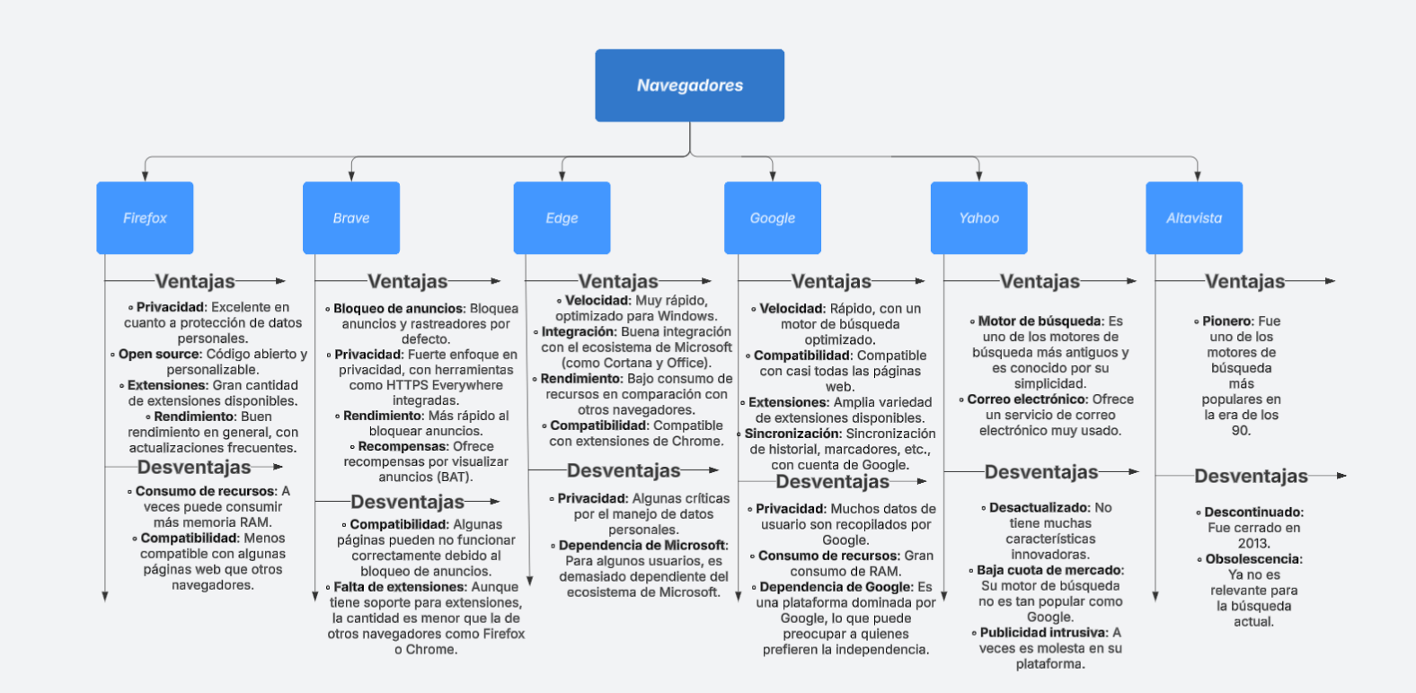

**2.) What is the difference between a page and a blog?**

The difference between a page and a blog mainly lies in their purpose and structure. Below are the key differences:

**Page**

* **Purpose:** A page on a website is generally static and contains fixed content. It is a section of the site that presents information that doesn’t change often, such as the homepage, contact page, about us, etc.
* **Structure:** Pages are more formal and usually part of the fixed site structure. They do not have user interactivity (although forms may exist, for example).
* **Updates:** They are not updated frequently. Their content remains stable over time.
* **Example:** A product or service page, the "About Us" section, the "Terms and Conditions" page, etc.

**Blog**

* **Purpose:** A blog is a section of a website used to publish more dynamic content such as articles, news, opinions, tutorials, among others. Blogs are designed to share new and relevant content continuously.
* **Structure:** Blogs are usually organized into entries or posts added chronologically, with the most recent at the top. They often allow interaction, such as user comments.
* **Updates:** Blogs are updated regularly with new content. They are ideal platforms to share articles, reflections, ideas, and keep users engaged with fresh posts.
* **Example:** A personal blog publishing recipes, tech tips, news on a particular topic, or a news site that constantly uploads new articles.

**Summary:**

* Pages: Fixed, stable, and not updated frequently.
* Blogs: Dynamic, frequently updated, and allow user interaction.

**3.) How many types of networks exist? Explain them.**

There are several types of networks according to different criteria, such as geographic scope, function, and technology. Here is a summary of the main types of networks and their characteristics:

**1. Networks by Geographic Scope**

* **LAN (Local Area Network):**
  + Definition: Local area network.
  + Scope: Connects devices within a limited geographic area such as a home, office, or building.
  + Characteristics: High data transmission speed, low cost, commonly uses technologies like Ethernet or Wi-Fi.
  + Example: Network inside an office.
* **WAN (Wide Area Network):**
  + Definition: Wide area network.
  + Scope: Covers larger geographic areas such as cities, countries, and even continents.
  + Characteristics: Uses telephone lines, satellites, submarine cables, and other media to connect different local networks.
  + Example: The internet is a WAN connecting millions of LANs.
* **MAN (Metropolitan Area Network):**
  + Definition: Metropolitan area network.
  + Scope: Extends over a city or metropolitan area.
  + Characteristics: Usually faster than a WAN and less costly than a LAN. Common in networks of universities or large corporations with multiple sites in the same city.
  + Example: Network connecting multiple branches of a company in the same city.
* **PAN (Personal Area Network):**
  + Definition: Personal area network.
  + Scope: Connects personal devices over short distances, usually within a few meters.
  + Characteristics: Used for connecting devices like phones, computers, printers, and other personal gadgets.
  + Example: Connecting a mobile phone to a smartwatch or a computer to a printer.

**2. Networks by Function**

* **Data Networks:**
  + Definition: Networks designed to transmit data from one place to another.
  + Characteristics: Fundamental for the internet, offices, and other digital communication services.
* **Telecommunications Networks:**
  + Definition: Networks used for transmitting voice and data through telephone lines.
  + Characteristics: Used for calls and data transmission via fixed or mobile lines.
* **Computer Networks:**
  + Definition: Networks formed by interconnected devices (computers, servers, routers) to share resources like internet, printers, and files.
  + Characteristics: Focused on information exchange between computing devices.

**3. Networks by Topology**

* **Bus Network:**
  + Definition: All devices are connected to a single cable (bus).
  + Advantages: Easy to install and cost-effective.
  + Disadvantages: If the bus (cable) fails, the entire network is affected.
* **Star Network:**
  + Definition: All devices are connected to a central point such as a hub or switch.
  + Advantages: Easy to manage and expand.
  + Disadvantages: If the central node fails, the whole network goes down.
* **Ring Network:**
  + Definition: Devices are connected in a circle or ring, each connecting to the next.
  + Advantages: Fast data transmission.
  + Disadvantages: If one device disconnects or fails, it may affect the entire network.
* **Mesh Network:**
  + Definition: Each device is connected to multiple others, creating multiple paths between them.
  + Advantages: High reliability since data can follow multiple routes.
  + Disadvantages: Expensive and complex to install.

**4. Networks by Technology**

* **Wireless Networks:**
  + Definition: Networks that do not require physical cables to connect devices, using radio waves or microwaves.
  + Characteristics: Use technologies such as Wi-Fi, Bluetooth, LTE, 5G, etc.
  + Example: Wi-Fi in a home or office.
* **Wired Networks:**
  + Definition: Networks that use physical cables like copper cables or fiber optics to transmit data.
  + Characteristics: Typically offer higher speed and reliability than wireless networks.
  + Example: Ethernet or fiber optic internet connections.

**Summary of Network Types:**

* By geographic scope: LAN, WAN, MAN, PAN.
* By function: Data networks, telecommunications networks, computer networks.
* By topology: Bus, star, ring, mesh.
* By technology: Wireless (Wi-Fi, Bluetooth, 5G), wired (Ethernet, fiber optic).

**4.) How many types of network topologies exist, and give an example for each?**

There are four main types of network topologies:

1. **Bus Topology**
   * **Description:** All devices are connected to a single central cable (bus).
   * **Example:** A small office network where all computers share one main cable for communication.
2. **Star Topology**
   * **Description:** All devices are connected to a central hub or switch.
   * **Example:** Most home Wi-Fi networks where devices connect to a central router.
3. **Ring Topology**
   * **Description:** Devices are connected in a circular chain, each connected to two other devices.
   * **Example:** Some office networks use token ring technology where data travels in one direction around the ring.
4. **Mesh Topology**
   * **Description:** Each device is connected to multiple other devices, creating multiple paths for data.
   * **Example:** The internet itself is an example of a large mesh network, where data can travel through many paths.