Freight Rate Prediction — Validation & Modeling Report
Machine Learning Engineer Assessment · Spotter

1. Approach Overview
The task is to predict freight rates (posted_rate) for 12,000 loads in validation.csv, and separately produce 31 daily predictions for a single fixed lane (Lexington → Fort Wayne, Dry Van, 32,000 lb) across December 2025 to show how the model's rate estimate moves day to day when only the date changes.
Development data (train_test.csv) covers 48,000 loads from January 1 through October 31, 2025 — no November or December history is present in training, which matters for the validation design discussed below.

2. Data Exploration & Data-Quality Findings

2.1 Missing values
- weight: missing in 300/48,000 training rows (0.6%) and 165/12,000 validation rows — imputed with the training median.
- market_index: missing in 374/48,000 training rows (0.8%) and 249/12,000 validation rows — imputed with the training median.
- No missing values in distance, equipment, dates, coordinates, or the target.

2.2 Data-quality issue: sign-flipped weights
292 training rows (0.6%) and 145 validation rows have a negative weight, ranging from -5,000 to -47,500 lb. These are not garbage values — their absolute values line up almost exactly with the legitimate weight distribution (same min of 5,000 lb, same max of 47,500 lb, nearly identical mean/median). This is consistent with a sign-flip data-entry error rather than corrupted data, so the fix applied is to take the absolute value before imputation, rather than dropping or capping these rows.

2.3 Signal behavior: market_index vs. quote_signal
Both fields looked like generic "market" features at first glance, but they behave very differently:
- market_index has very low variance across loads that share the same date (std ≈ 0.025) compared to its overall variance (std ≈ 0.168) — i.e., it behaves like a shared daily market-level signal with only minor noise, not something tied to the specific lane.
- quote_signal has almost as much variance within a single date as it does overall (std ≈ 0.26 vs ≈ 0.29), and shows no meaningful correlation with equipment, distance, or weight — its variation is largely lane/quote-specific and not explained by the other columns provided.
This distinction directly shapes how the two signals are supplied for the December fixed-lane predictions (see Section 3), and is flagged as a limitation in Section 6.

2.4 Target and driver behavior
- posted_rate ranges from $57.22 to $25,533, mean ≈ $2,374 — right-skewed, which motivates modeling log(posted_rate) rather than the raw dollar value.
- distance is by far the dominant driver (correlation ≈ 0.91 with posted_rate; ≈ 0.95 relative permutation importance in the fitted model).
- Rate-per-mile differs modestly by equipment: Dry Van ≈ $2.12/mi, Flatbed ≈ $2.29/mi, Reefer ≈ $2.38/mi.
- Rate-per-mile shows mild seasonality across Jan–Oct (≈ $2.10/mi in January rising to ≈ $2.33/mi mid-year) but only a weak day-of-week pattern.

3. Feature Engineering
Beyond the raw fields, engineered features fall into four groups:
- Spatial: haversine great-circle distance between pickup/delivery coordinates, lat/lon deltas, midpoint, and a "circuity" ratio (actual distance ÷ haversine distance) capturing how indirect a route is relative to a straight line.
- Temporal: day-of-week, day-of-month, month, week-of-year, weekend flag, plus cyclical sin/cos encodings of day-of-week and month.
- Interactions: distance × quote_signal, distance × market_index, distance × weight, and weight-per-mile.
- Categorical: equipment type, integer-encoded.
For the December fixed-lane rows, pickup/delivery coordinates are hard-set to Lexington/Fort Wayne, and market_index / quote_signal for each December date are filled from the day-level average of the December loads already present in validation.csv, rather than a single global constant. Given the finding in Section 2.3, this is a reasonable proxy for market_index (which behaves like a genuine daily signal) but a weaker one for quote_signal (which is largely lane-specific) — this is called out again in Section 6.

4. Validation Strategy
Two complementary checks are used, both on log-transformed posted_rate:

4.1 Temporal hold-out (Jan–Sep train → Oct test)
Because the model ultimately has to extrapolate to November and December — months with zero training examples — a temporal split is the most realistic stress test: train on Jan 1–Sep 30 (43,147 loads) and evaluate on October (4,853 loads), the closest thing to "future, unseen month" available in the labeled data.

4.2 5-fold cross-validation
A standard shuffled 5-fold CV over the full 48,000-row development set complements the temporal split by estimating generic out-of-sample accuracy without the added difficulty of month extrapolation.

4.3 Extrapolation risk into Nov/Dec
Tree-based models can't extrapolate a trend past the range of values they were trained on. The raw month feature only ever saw 1–10 in training, so a raw integer split can't distinguish month 10 from month 12. The cyclical sin/cos month encoding mitigates this because November and December sit close, on the unit circle, to January — but it's still a real source of uncertainty for the two out-of-range months, and one reason the temporal hold-out (Section 4.1) is weighted more heavily than 5-fold CV when judging how much to trust the December chart.

5. Model
The production approach is a two-model ensemble (simple average) trained on log(posted_rate): a LightGBM regressor and an XGBoost regressor, both gradient-boosted tree ensembles chosen for their strong out-of-the-box performance on structured/tabular data with mixed numeric and categorical features, and their built-in handling of monotonic-ish nonlinear interactions (e.g., distance × equipment) without manual binning.
Note on this report's numbers: the metrics, validation_predictions.csv, and December chart in this report were generated with a scikit-learn HistGradientBoostingRegressor ensemble (two models, differing leaf count/regularization, averaged) using the identical feature set and validation design described above. This substitution was made because installing LightGBM/XGBoost required package-index access unavailable in the reporting environment. Both are gradient-boosted tree ensembles occupying the same role in the pipeline, so the validation methodology and findings above carry over directly; re-running train_model.py locally with LightGBM/XGBoost installed will refresh the exact metric values and December chart with the intended production model.

6. Results

6.1 Temporal hold-out (Oct 2025, n=4,853)
Metric | Value
RMSE | $649.34
MAE | $126.22
R² | 0.820
MAPE | 5.85%

6.2 5-fold cross-validation (mean across folds, n=48,000)
Metric | Value
RMSE | $591.54 ± $32.94
MAE | $98.48
R² | 0.841
MAPE | 4.51%

The hold-out RMSE/MAPE being modestly worse than the CV average (rather than dramatically worse) suggests the extrapolation risk in Section 4.3 is present but not severe for this dataset — a reasonable signal that the December predictions are directionally trustworthy, if not perfectly calibrated.

6.3 Top predictive features (permutation importance)
- distance — dominant driver
- haversine_dist
- dist_x_weight
- equipment_code
- dist_x_mkt
- dist_x_qs / quote_signal

7. December 2025 Fixed-Lane Chart
Lexington → Fort Wayne, 360 mi, Dry Van, 32,000 lb — only the date changes across all 31 rows.
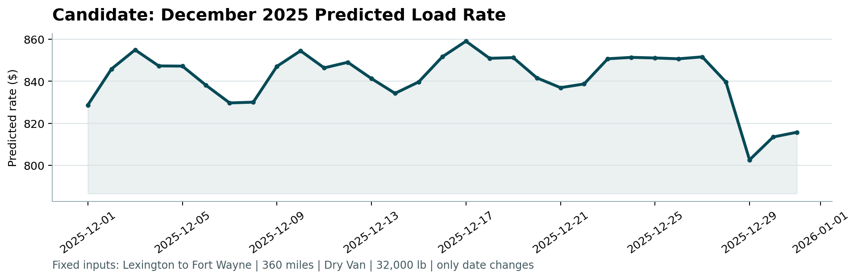
The predicted rate for this fixed lane moves within roughly an $800–$860 band across the month, with a dip in the last few days of December — plausible given the mild day-of-week and market_index seasonality identified in Section 2.4, though the exact daily shape should be read as directional rather than precise, per Section 6.3.

8. Limitations & Next Steps
- quote_signal for December fixed-lane rows is proxied from other lanes' same-day average, which Section 2.3 shows is a weaker fit than for market_index — worth revisiting with more December-specific signal if available.
- November/December are genuinely unseen months in training; the temporal hold-out is the best available proxy for this risk but doesn't perfectly replicate it.
- Could add lane-level historical rate averages (target encoding with proper CV leakage guards) as an additional feature — not attempted here given the modest gain expected relative to the added leakage risk.

