SFWRENG 3K04 – Software Development

Assignment 2

Part 1: Pacemaker Simulink

Gurleen Kaur Rahi (400377038)

Yash Bhatia (400362372)

Daniel Lupas (400396848)

Varunan Varathan (400375287)

Connor Usaty (400409624)

Table of Contents

1 Introduction 3

2 Variables 3

2.1 Measured Variables 3

2.2 Parameters Variables 3

2.3 Controlled Variables 6

2.4 Internal Variables 7

3 Modules 9

3.1 Pacemaker Modes 9

3.1.1 VOO/AOO/VOOR/AOOR 9

3.1.2 VVI/AAI/VVIR/AAIR 10

3.1.3 DOO/DOOR 12

3.1.4 SELECTING PARAMETERS 14

3.2 Rate Adaptivity 17

3.2.1 Description 17

3.2.2 Variables 17

3.2.3 Requirements 18

3.2.4 Anticipated Changes 18

3.3 Hardware Interface 18

3.3.1 PACING 18

3.3.2 SENSING 20

3.4 DCM Communication 21

3.4.1 In 21

3.4.2 Out 23

4 Design Decisions 26

4.1 Pacemaker Modes 26

4.1.1 VOO/AOO/VOOR/AOOR 27

4.1.2 AAI/VVI/AAIR/VVIR 27

4.2 Rate Adaptivity 28

4.3 Hardware Interface 29

4.3.1 Pacing 31

4.3.2 Sensing 31

4.4 DCM Communication 32

4.4.1 In 34

4.4.2 Out 35

5 Testing 35

5.1 VOO 35

5.2 AOO 36

5.3 VVI 36

5.4 AAI 38

5.5 DOO 40

5.6 AOOR 42

5.7 DOOR 43

5.8 VOOR 44

5.9 AAIR 45

**5.10 VVIR…………………………………………………………………………………………………………………48**

1. Introduction

An overview of the Simulink implementation of this Pacemaker Project, written with the end-user in mind, is found in this documentation. This documentation contains the working of ten sensing modes with the goal of creating a functional pacemaker that responds to its surroundings and operates in accordance with those responses. Depolarization of the ventricles or atria is what is meant by pacing. Sensing is the process of identifying chamber signals. Heart sensing and pacing are provided by the VVI, AAI, VVIR, and AAIR modes. The ventricles employ VVI and VVIR, whereas the atrium uses AAI and AAIR. These four modes operate on an inhibited basis, which means that when a specific activity occurs from the appropriate chamber, the pacemaker is turned off. Only the atrium and/or ventricle are pace (not sensed) by AOO, VOO, AOOR, VOOR, DOO, and DOOR.

While the AOO, VOO, AAI, VVI, and DOO modes pace regardless of the patient's activity, the AOOR, VOOR, AAIR, VVIR, and DOOR modes pace adaptively based on data from the onboard accelerometer.

1. Variables

*2.1 Measured Variables*

|  |  |  |  |
| --- | --- | --- | --- |
| **Name** | **Units/Type** | **Description** | **Range** |
| t | ms | Duration of last heartbeat | – |
| ATR_SIGNAL | Double | Atrial signal assessment on an ECG | 0 – 1 |
| VENT_SIGNAL | Double | Ventricle signal assessment on an ECG | 0 – 1 |
| ATR_CMP_DETECT | Boolean | Higher than threshold atrial signal voltage | {True, False} |
| VENT_CMP_DETECT | Boolean | Higher than threshold ventricular signal voltage | {True, False} |
| Accel | Double x 3 | Appropriate pacemaker Accel in g in local (a,b,c) | -4 – 4 |
| Receive | Uint8 x 17 | Buffer_Acceled UART | 0 – 255 |
| Buffer_Accel_status | Uint8 | shows the fullness of the UART Buffer_Accel | {0, 32} |

*2.2 Parameters Variables*

|  |  |  |  |
| --- | --- | --- | --- |
| **Name** | **Units/Type** | **Description** | **Range** |
| p_mode | int | Mode of operation in which pacemaker is working | {VOO,AOO,VVI,AAI, DOO, VOOR, AOOR, VVIR, AAIR, DOOR} |
| p_rateAdaptiveLowrateInterval | ppm | Lowest value of the heart rate that is allowed | 30 – 175 ± 8 ms |
| p_AV_delay | ms | Delay that is caused between ventricle and atrial signals | 70 – 300 ms ± 8 ms |
| p_atrialAmplitude | V | Pulse amplitude delivered to atrium | 0 – 5 ± 12% |
| p_ventricularAmplitude | V | Pulse amplitude delivered to ventricle | 0 – 5 ± 12% |
| p_atrial_sensitivity | V | Minimum voltage value that classifies an atrium signal as pulse | 0 – 5 ± 2% |
| p_ventricle_sensitivity | V | Minimum voltage value that classifies a ventricle signal as pulse | 0 – 5 ± 2% |
| p_atrialPulseWidth | ms | Pulse width of atrium | 1 – 30 ± 0.2 ms |
| p_ventricularPulseWidth | ms | Pulse width of ventricle | 1 – 30 ± 0.2 ms |
| p_vp_responseFactor | ms | Refractory time period of ventricle | 150–500 ± 8 ms |
| p_ap_responseFactor | ms | Refractory time period of atrium | 150–500 ± 8 ms |
| p_maximumSensorRate | ppm | Maximum rate of detection indicated by rate adaptivity | 50 – 175 ± 4 ppm |
| p_activityThreshold | – | Rate adaptivity's minimal activity level | {V-Low, Low, Med-Low, Med, Med-High, High, V-high} |
| p_lowrateLimit | s | Pacing rate's rising time from the lower rate limit to the maximum sensor rate | 10 – 50 ± 3 sec |
| p_response | – | shows reaction to activity levels over the cutoff | {True, False} |
| p_upperrateLimit | min | Maximum value of the pacing rate decrease that is allowed | 2 – 16 ± 30 sec |
| p_responseFactor | ms | Gives value of general refractory period rather than specific to its type | 150–500 ± 8 ms |
| p_rateAdaptive | - | Used in Rate Adaptativity | - |

## *2.3 Controlled Variables*

|  |  |  |  |
| --- | --- | --- | --- |
| **Name** | **Units/Type** | **Description** | **Range** |
| PACE_CHARGE_CTRL | Boolean | PWM attached to the primary capacitor | {True, False} |
| ATR_PACE_CTRL | Boolean | Atrium ring attached to the primary capacitor | {True, False} |
| VENT_PACE_CTRL | Boolean | Ventricle ring attached to the primary capacitor | {True, False} |
| ATR_GND_CTRL | Boolean | Atrium ring attached to the ground | {True, False} |
| VENT_GND_CTRL | Boolean | Ventricle ring connected to ground | {True, False} |
| AV_BLOCK | Boolean | Connected to the blocking capacitor are the atrium and ventricle tips | {True, False} |
| Z_ATR_CTRL | Boolean | Circuit with an impedance coupled to the atrium ring | {True, False} |
| Z_VENT_CTRL | Boolean | Circuit with an impedance coupled to the ventricle ring | {True, False} |
| PACING_REF_PWM | Percent | Percentage reference PWM needed for primary capacitor | 0–100 |
| ATR_CMP_REF_PWM | Percent | For the atrium signal comparator, use reference PWM. | 0–100 |
| VENT_CMP_REF_PWM | Percent | For the ventricle signal comparator, use reference PWM. | 0–100 |
| LEAD_SENSE_CIRCUIT | Boolean | Lead-connected sensing circuit | {True, False} |
| UART_BUFFER_ACCEL | Uint8 x 16 | UART escape Buffer_Accel | 0– 255 |
| s_paceStart | Boolean | Output will be paceStart regardless of Atrium or Ventricle | {True, False} |
| s_atrialPaceStart | Boolean | Commencement of atrial pulse | {True, False} |
| s_ventricularPaceStart | Boolean | Commencement of ventricular pulse | {True, False} |
| s_AOORState | Boolean | Commencement of AOOR state | {True, False} |
| s_AOOState | Boolean | Commencement of AOO state | {True, False} |
| s_VOORState | Boolean | Commencement of VOOR state | {True, False} |
| s_VOOState | Boolean | Commencement of VOO state | {True, False} |
| s_AAIRState | Boolean | Commencement of AAIR state | {True, False} |
| s_AAIState | Boolean | Commencement of AAI state | {True, False} |
| s_VVIRState | Boolean | Commencement of VVIR state | {True, False} |
| s_VVIState | Boolean | Commencement of VVI state | {True, False} |
| s_currentState | Boolean | Refers to the current state | 0-5 |
| s_offState | Boolean | States are turned off | {True, False} |

## *2.4 Internal Variables*

|  |  |  |  |
| --- | --- | --- | --- |
| **Name** | **Units/Type** | **Description** | **Range** |
| h_atrial_pulse_detect | Boolean | Pulse detection that happens in atrium | {True, False} |
| h_ventricle_pulse_detect | Boolean | Pulse detection that happens in ventricle | {True, False} |
| AOO_VOO_pace | Boolean | The pacing of either AOO or VOO start | {True, False} |
| AAI_VVI_pace | Boolean | The pacing of either AAI or VVI start | {True, False} |
| DOO_atrial_pace | Boolean | Heart rate is represented by DOO | {True, False} |
| DOO_ventricle_pace | Boolean | Ventricle pace is represented by DOO | {True, False} |
| DOO_AV_CHAMBER | Boolean | Indicates about the type of chamber that’s placed next | {True, False} |
| s_atrialPaceStart | Boolean | Atrium signal pacing gets signalled | {True, False} |
| s_ventricular_PaceStart | Boolean | Ventricle signal pacing gets signalled | {True, False} |
| AV_CHAMBER | Boolean | Indicates about the type of chamber that’s placed next | {A, V} |
| MODES_SENSOR_RATE_Range | ppm | Shows rate adaptivity in the range from minimum to maximum | p_rateAdaptiveLowrateInterval – p_maximumSensorRate |
| PACE_RATE_INC | ppm/sec | Increase in the pacing rate | 0 – 14.5 |
| PACE_RATE_DEC | ppm/sec | Decrease in the pacing rate | 0 – 1.3 |
| MODES_SENSOR_RATE | ppm | Indicates the sensor rate for different modes | p_rateAdaptiveLowrateInterval – p_maximumSensorRate |
| MODES_RATE_INC | ppm/sec | Increase in the modes rate | 0 – 14.5 |
| MODES_RATE_DEC | ppm/sec | Decrease in the modes rate | 0 – 1.3 |
| Buffer_Accel | double | Last 25 values of Accel | -4 – 4 |
| AV_Pulse_Detect | Boolean | Detecting the pulse generally and not for the type | {True, False} |
| CURR_PACE_RATE | ppm | Current pacing rate | 30 – 175 ppm |
| PEAK_TO_PEAK_SIG | double | Peak to peak of activity signal | 0 – 4 |
| Received_Code | uint8 | Last received Received_Code from DCM | 1– 5 |

# Modules

* 1. **Pacemaker Modes**

### **VOO/AOO/VOOR/AOOR**

#### Description

One chamber is paced at the specified rate in the VOO, AOO, VOOR, and AOOR modes. The different types of variables that were used for these four modes are listed in the table below.

#### Types of Variables

As seen below, we only used measured and internal variables. There were no Programmable Parameters and Controlled Variables used for these modes.

##### *3.1.1.2.1 Measured Variables*

|  |  |  |  |
| --- | --- | --- | --- |
| **Name** | **Units/Type** | **Description** | **Range** |
| t | ms | The duration of time period measured from the previous pulse. | – |

##### *Programmable Parameters*

There were no Programmable Parameters used for these modes.

##### *Controlled Variables*

|  |  |  |  |
| --- | --- | --- | --- |
| **Name** | **Units/Type** | **Description** | **Range** |
| s_AOORState | Boolean | Commencement of AOOR state | {True, False} |
| s_AOOState | Boolean | Commencement of AOO state | {True, False} |
| s_VOORState | Boolean | Commencement of VOOR state | {True, False} |
| s_VOOState | Boolean | Commencement of VOO state | {True, False} |

##### *Internal Variables*

|  |  |  |  |
| --- | --- | --- | --- |
| **Name** | **Units/Type** | **Description** | **Range** |
| AOO_VOO_pace | Boolean | Pacing for either AOO or VOO starts to happen | {True, False} |
| MODES_SENSOR_RATE | ppm | Indicates the sensor rate for different modes | p_rateAdaptiveLowrateInterval – p_maximumSensorRate |
| PACE_RATE_INC | ppm/sec | Increase in the pacing rate | 0 – 14.5 |
| PACE_RATE_DEC | ppm/sec | Decrease in the pacing rate | 0 – 1.3 |
| CURR_PACE_RATE | ppm | Current pacing rate | 30 – 175 ppm |

#### Requirements

|  |  |  |  |  |  |  |  |
| --- | --- | --- | --- | --- | --- | --- | --- |
| **Source** | **Case** | **Condition** | | **Activity** | **End Activity** | **Destination State** | **Start Activity** |
| START | N/A | N/A | | N/A | N/A | PACING_RATE | CURR_PACE_RATE = MODES_SENSOR_RATE |
| PACING_RATE | N/A | MODES_SENSOR_RATE > CURR_PACE_RATE | CURR_PACE_RATE + PACE_RATE_INC * t > MODES_SENSOR_RATE | CURR_PACE_RATE = MODES_SENSOR_RATE | N/A | RATE_UPDATED | AOO_VOO_pace = True |
| CURR_PACE_RATE + PACE_RATE_INC * t ≤ MODES_SENSOR_RATE | CURR_PACE_RATE += PACE_RATE_INC * t |
| MODES_SENSOR_RATE ≤ CURR_PACE_RATE | CURR_PACE_RATE – PACE_RATE_DEC * t < MODES_SENSOR_RATE | CURR_PACE_RATE = MODES_SENSOR_RATE |
| CURR_PACE_RATE – PACE_RATE_DEC * t ≥ MODES_SENSOR_RATE | CURR_PACE_RATE -= PACE_RATE_DEC * t |
| RATE_UPDATED | N/A | after(60/ CURR_PACE_RATE, sec) | | N/A | t = elapsed(sec) | PACING_RATE | on after(1, msec):  AOO_VOO_pace = False |

#### Anticipated Changes

A possible change that we can do is to combine the logic of these four modes with VVI/AAI/VVIR/AAIR modes to modify the behavior of detecting pulses.

### **VVI/AAI/VVIR/AAIR**

#### Description

In these four modes, pacing occurs in a chamber at a specified rate, however, they are inhibited by the sensed pulses in the same chamber.

#### Types of Variables

As seen below, we only used measured and internal variables. There were no Programmable Parameters and Controlled Variables used for these modes.

##### *Measured Variables*

|  |  |  |  |
| --- | --- | --- | --- |
| **Name** | **Units/Type** | **Description** | **Range** |
| t | ms | The duration of time period measured from the previous pulse. | – |

##### *Programmable Parameters*

There were no Programmable Parameters used for these modes.

##### *Controlled Variables*

|  |  |  |  |
| --- | --- | --- | --- |
| **Name** | **Units/Type** | **Description** | **Range** |
| s_AAIRState | Boolean | Commencement of AAIR state | {True, False} |
| s_AAIState | Boolean | Commencement of AAI state | {True, False} |
| s_VVIRState | Boolean | Commencement of VVIR state | {True, False} |
| s_VVIState | Boolean | Commencement of VVI state | {True, False} |

##### *Internal Variables*

|  |  |  |  |
| --- | --- | --- | --- |
| **Name** | **Units/Type** | **Description** | **Range** |
| AAI_VVI_pace | Boolean | The pacing of either AAI or VVI start | {True, False} |
| MODES_SENSOR_RATE | ppm | Indicates the sensor rate for different modes | p_rateAdaptiveLowrateInterval – p_maximumSensorRate |
| PACE_RATE_INC | ppm/sec | Increase in the pacing rate | 0 – 14.5 |
| PACE_RATE_DEC | ppm/sec | Decrease in the pacing rate | 0 – 1.3 |
| Buffer_Accel | double | Last 25 values of Accel | -4 – 4 |
| AV_Pulse_Detect | Boolean | Detecting the pulse generally and not for the type | {True, False} |
| P_RESPONSEFACTOR | ms | Gives value of general refractory period rather than specific to its type | 150–500 ± 8 ms |
| CURR_PACE_RATE | ppm | Current pacing rate | 30 – 175 ppm |

#### Requirements

|  |  |  |  |  |  |  |  |
| --- | --- | --- | --- | --- | --- | --- | --- |
| **Source** | **Condition** | | | **Condition Activities** | **Finished Activites** | **Destination State** | **Starting Activities** |
| START | N/A | | | N/A | N/A | HOLD | CURR_PACE_RATE = MODES_SENSOR_RATE |
| HOLD | AV_Pulse_Detect == 1 | | | N/A | t = elapsed(sec) | SENSING_UPDATE |  |
| after(60/CURR_PACE_RATE – 0.001P_RESPONSEFACTOR+ 0.001,sec) | | | N/A | t = elapsed(sec) | PACING_RATE |  |
| PACING_RATE | after(p_p_responseFactor, msec) | MODES_SENSOR_RATE > CURR_PACE_RATE | CURR_PACE_RATE + PACE_RATE_INC * t > MODES_SENSOR_RATE | CURR_PACE_RATE = MODES_SENSOR_RATE | t += elapsed(sec) | HOLD | AAI_VVI_pace = True  on after(1, msec)  AAI_VVI_pace = True |
| CURR_PACE_RATE + PACE_RATE_INC * t ≤ MODES_SENSOR_RATE | CURR_PACE_RATE += PACE_RATE_INC * t |
| MODES_SENSOR_RATE ≤ CURR_PACE_RATE | CURR_PACE_RATE – PACE_RATE_DEC * t < MODES_SENSOR_RATE | CURR_PACE_RATE = MODES_SENSOR_RATE |
| CURR_PACE_RATE – PACE_RATE_DEC * t ≥ MODES_SENSOR_RATE | CURR_PACE_RATE -= PACE_RATE_DEC * t |
| SENSING_UPDATE | N/A |

#### Possible Changes

For now, there are no possible changes that we can think of doing for these modes.

### **DOO/DOOR**

#### Description

In both of these modes, pacing occurs between both modes and there is a fixed amount of delay that occurs between the atria and ventricles.

#### Types of Variables

##### *Measured Variables*

|  |  |  |  |
| --- | --- | --- | --- |
| **Name** | **Units/Type** | **Description** | **Range** |
| t | ms | The duration of time period measured from the previous pulse. | – |

##### *Programmable Parameters*

|  |  |  |  |
| --- | --- | --- | --- |
| **Name** | **Units/Type** | **Description** | **Range** |
| p_AV_delay | ms | Delay that is caused between ventricle and atrial signals | 70 – 300 ms ± 8 ms |

##### *Controlled Variables*

There were no Controlled Variables used for these modes.

##### *Internal Variables*

|  |  |  |  |
| --- | --- | --- | --- |
| **Name** | **Units/Type** | **Description** | **Range** |
| DOO_atrial_pace | Boolean | Heart rate is represented by DOO | {True, False} |
| DOO_ventricle_pace | Boolean | Ventricle pace is represented by DOO | {True, False} |
| DOO_AV_CHAMBER | Boolean | Indicates about the type of chamber that’s placed next | {True, False} |
| MODES_SENSOR_RATE | ppm | Indicates the sensor rate for different modes | p_rateAdaptiveLowrateInterval – p_maximumSensorRate |
| PACE_RATE_INC | ppm/sec | Increase in the pacing rate | 0 – 14.5 |
| PACE_RATE_DEC | ppm/sec | Decrease in the pacing rate | 0 – 1.3 |
| CURR_PACE_RATE | ppm | Current pacing rate | 30 – 175 ppm |

#### Requirements

|  |  |  |  |  |  |  |  |
| --- | --- | --- | --- | --- | --- | --- | --- |
| **Source** | **Condition** | | | **Condition Activities** | **Finished Actions** | **Destination State** | **Starting Actions** |
| START | N/A | | | N/A | N/A | VENTRICLE_PACING | CURR_PACE_RATE = MODES_SENSOR_RATE |
| ATRIAL_PACING | after(p_av_delay,msec) | MODES_SENSOR_RATE > CURR_PACE_RATE | CURR_PACE_RATE + PACE_RATE_INC * t > MODES_SENSOR_RATE | CURR_PACE_RATE = MODES_SENSOR_RATE | t += elapsed(sec) | VENTRICLE_PACING | DOO_atrial_pace= True  on after(1, msec)  DOO_atrial_pace= True  DOO_AV_CHAMBER = V |
| CURR_PACE_RATE + PACE_RATE_INC * t ≤ MODES_SENSOR_RATE | CURR_PACE_RATE += PACE_RATE_INC * t |
| MODES_SENSOR_RATE ≤ CURR_PACE_RATE | CURR_PACE_RATE – PACE_RATE_DEC * t < MODES_SENSOR_RATE | CURR_PACE_RATE = MODES_SENSOR_RATE |
| CURR_PACE_RATE – PACE_RATE_DEC * t ≥ MODES_SENSOR_RATE | CURR_PACE_RATE -= PACE_RATE_DEC * t |
| VENTRICLE_PACING | after(60/CURR_PACE_RATE – p_av_delay/1000, sec) | | | N/A | t = elapsed(sec) | ATRIAL_PACING | DOO_ventricle_pace= True  on after(1, msec)  DOO_ventricle_pace= True  DOO_AV_CHAMBER = A |

#### Anticipated Changes

By adding detected signal states as needed, DOO/DOOR would serve as the foundation for expanding to the DXXX modes.

### **SELECTING PARAMETERS**

#### Description

To feed parameter information to the real mode logic, parameter selection parses it. The mode logic output is then routed to the appropriate signal outputs.

#### Types of Variables

##### *Measured Variables*

No measured variables were used when selecting parameters.

##### *Programmable Parameters*

|  |  |  |  |
| --- | --- | --- | --- |
| **Name** | **Units/Type** | **Description** | **Range** |
| p_mode | int | Mode of operation in which pacemaker is working | {VOO,AOO,VVI,AAI, DOO, VOOR, AOOR, VVIR, AAIR, DOOR} |
| p_rateAdaptiveLowrateInterval | ppm | Lowest value of the heart rate that is allowed | 30 – 175 ± 8 ms |
| p_AV_delay | ms | Delay that is caused between ventricle and atrial signals | 70 – 300 ms ± 8 ms |
| p_vp_responseFactor | ms | Refractory time period of ventricle | 150–500 ± 8 ms |
| p_ap_responseFactor | ms | Refractory time period of atrium | 150–500 ± 8 ms |

##### *Controlled Variables*

No Controlled Variables were used when selecting parameters.

##### *Internal Variables*

|  |  |  |  |
| --- | --- | --- | --- |
| **Name** | **Units/Type** | **Description** | **Range** |
| h_atrial_pulse_detect | Boolean | Pulse detection that happens in atrium | {True, False} |
| h_ventricle_pulse_detect | Boolean | Pulse detection that happens in ventricle | {True, False} |
| AOO_VOO_pace | Boolean | The pacing of either AOO or VOO start | {True, False} |
| AAI_VVI_pace | Boolean | The pacing of either AAI or VVI start | {True, False} |
| DOO_atrial_pace | Boolean | Heart rate is represented by DOO | {True, False} |
| DOO_ventricle_pace | Boolean | Ventricle pace is represented by DOO | {True, False} |
| DOO_AV_CHAMBER | Boolean | Indicates about the type of chamber that’s placed next | {True, False} |
| s_atrialPaceStart | Boolean | Atrium signal pacing gets signalled | {True, False} |
| s_ventricular_PaceStart | Boolean | Ventricle signal pacing gets signalled | {True, False} |
| AV_CHAMBER | Boolean | Indicates about the type of chamber that’s placed next | {A, V} |
| MODES_SENSOR_RATE_Range | ppm | Shows rate adaptivity in the range from minimum to maximum | p_rateAdaptiveLowrateInterval – p_maximumSensorRate |
| PACE_RATE_INC | ppm/sec | Increase in the pacing rate | 0 – 14.5 |
| PACE_RATE_DEC | ppm/sec | Decrease in the pacing rate | 0 – 1.3 |
| AV_Pulse_Detect | Boolean | Detecting the pulse generally and not for the type | {True, False} |
| P_RESPONSEFACTOR | ms | Gives value of general refractory period rather than specific to its type | 150–500 ± 8 ms |

#### Requirements

|  |  |  |  |  |  |  |  |  |
| --- | --- | --- | --- | --- | --- | --- | --- | --- |
| **Modes** | **MODES_SENSOR_RATE** | **PACE_RATE_INC** | **PACE_RATE_DEC** | **AV_Pulse_Detect** | **P_RESPONSEFACTOR** | **S_atrialPaceStart** | **S_ventricular_PaceStart** | **AV_CHAMBER** |
| AOO | p_rateAdaptiveLowrateInterval | 0 | 0 | X | X | AOO_VOO_pace | 0 | Atr |
| VOO | X | X | 0 | AOO_VOO_pace | Vent |
| AAI | h_atrial_pulse_detect_Pulse_Detect | p_ap_responseFactor | AAI_VVI_pace | 0 | Atr |
| VVI | h_ventricle_pulse_detect_Pulse_Detect | p_vp_responseFactor | 0 | AAI_VVI_pace | Vent |
| DOO | X | X | DOO_S_atrialPaceStart | DOO_S_ventricular_PaceStart | DOO_AV_CHAMBER |
| AOOR | MODES_SENSOR_RATE | PACE_RATE_INC | PACE_RATE_DEC | X | X | AOO_VOO_pace | 0 | Atr |
| VOOR | X | X | 0 | AOO_VOO_pace | Vent |
| AAIR | h_atrial_pulse_detect_Pulse_Detect | p_ap_responseFactor | AAI_VVI_pace | 0 | Atr |
| VVIR | h_ventricle_pulse_detect_Pulse_Detect | p_vp_responseFactor | 0 | AAI_VVI_pace | Vent |
| DOOR | X | X | DOO_S_atrialPaceStart | DOO_S_ventricular_PaceStart | DOO_AV_CHAMBER |

#### Anticipated Changes

Increase in number of modes would eventually increase the number of programmable parameters so as to accommodate for input and output signals.

## **Rate Adaptivity**

### *Description*

Based on the activity detected by the on-board accelerometer, the rate adaptivity module provides the appropriate pace. In accordance with the rate adaptivity factors, it also determines the pace at which changes.

### *Types of Variables*

#### Measured Variables

|  |  |  |  |
| --- | --- | --- | --- |
| **Name** | **Units/Type** | **Description** | **Range** |
| Accel | Double x 3 | Appropriate pacemaker Accel in g in local (a,b,c) | -4 – 4 |

#### Progammable Parameters

|  |  |  |  |
| --- | --- | --- | --- |
| **Name** | **Units/Type** | **Description** | **Range** |
| p_rateAdaptiveLowrateInterval | ppm | Lowest value of the heart rate that is allowed | 30 – 175 ± 8 ms |
| p_maximumSensorRate | ppm | Maximum rate of detection indicated by rate adaptivity | 50 – 175 ± 4 ppm |
| p_activityThreshold | – | Rate adaptivity's minimal activity level | {V-Low, Low, Med-Low, Med, Med-High, High, V-high} |
| p_lowrateLimit | s | Pacing rate's rising time from the lower rate limit to the maximum sensor rate | 10 – 50 ± 3 sec |
| p_response | – | shows reaction to activity levels over the cutoff | {True, False} |
| p_upperrateLimit | min | Maximum value of the pacing rate decrease that is allowed | 2 – 16 ± 30 sec |

#### Controlled Variables

There are no Controlled Variables for Rate Adaptativity.

#### Internal Variables

|  |  |  |  |
| --- | --- | --- | --- |
| **Name** | **Units/Type** | **Description** | **Range** |
| PACE_RATE_INC | ppm/sec | Increase in the pacing rate | 0 – 14.5 |
| PACE_RATE_DEC | ppm/sec | Decrease in the pacing rate | 0 – 1.3 |
| MODES_SENSOR_RATE | ppm | Indicates the sensor rate for different modes | p_rateAdaptiveLowrateInterval – p_maximumSensorRate |
| Buffer_Accel | double | Last 25 values of Accel | -4 – 4 |
| PEAK_TO_PEAK_SIG | double | Peak to peak of activity signal | 0 – 4 |

### *Requirements*

|  |  |
| --- | --- |
| **Variable** | **Value** |
| PEAK_TO_PEAK_SIG | max(Buffer_Accel) – min(Buffer_Accel) |
| PACE_RATE_INC | (p_maximumSensorRate– p_rateAdaptiveLowrateInterval) / p_lowrateLimit |
| PACE_RATE_DEC | (p_maximumSensorRate – p_rateAdaptiveLowrateInterval) / (60 * p_upperrateLimit) |
| Overdriving_Action | 4 * p_response * (p_PEAK_TO_PEAK_SIG – p_activityThreshold) |
| MODES_SENSOR_RATE | min(p_maximumSensorRate, max(p_rateAdaptiveLowrateInterval, Overdriving_Action)) |

### *Possible Changes*

Change in the design for rate adaptivity requires modifying this document a lot as all the previous requirements will be changed.

## **Hardware Interface**

### **Pacing**

#### Description

In addition to controlling which level to charge the pacing capacitor at and which chamber to pace, the pacing module also keeps an eye on the pace start and AV choose lines.

#### Types of Variables

##### *Measured Variables*

There were no measured variables used in this section.

##### *Programmable Parameters*

|  |  |  |  |
| --- | --- | --- | --- |
| **Name** | **Units/Type** | **Description** | **Range** |
| p_atrialAmplitude | V | Pulse amplitude delivered to atrium | 0 – 5 ± 12% |
| p_ventricularAmplitude | V | Pulse amplitude delivered to ventricle | 0 – 5 ± 12% |
| p_atrialPulseWidth | ms | Pulse width of atrium | 1 – 30 ± 0.2 ms |
| p_ventricularPulseWidth | ms | Pulse width of ventricle | 1 – 30 ± 0.2 ms |

##### *Controlled Variables*

|  |  |  |  |
| --- | --- | --- | --- |
| **Name** | **Units/Type** | **Description** | **Range** |
| PACE_CHARGE_CTRL | Boolean | PWM attached to the primary capacitor | {True, False} |
| ATR_PACE_CTRL | Boolean | Atrium ring attached to the primary capacitor | {True, False} |
| VENT_PACE_CTRL | Boolean | Ventricle ring attached to the primary capacitor | {True, False} |
| ATR_GND_CTRL | Boolean | Atrium ring attached to the ground | {True, False} |
| VENT_GND_CTRL | Boolean | Ventricle ring connected to ground | {True, False} |
| AV_BLOCK | Boolean | Connected to the blocking capacitor are the atrium and ventricle tips | {True, False} |
| Z_ATR_CTRL | Boolean | Circuit with an impedance coupled to the atrium ring | {True, False} |
| Z_VENT_CTRL | Boolean | Circuit with an impedance coupled to the ventricle ring | {True, False} |
| PACING_REF_PWM | Percent | Percentage reference PWM needed for primary capacitor | 0–100 |

##### *Internal Variables*

|  |  |  |  |
| --- | --- | --- | --- |
| **Name** | **Units/Type** | **Description** | **Range** |
| s_atrialPaceStart | Boolean | Commencement of atrial pulse | {True, False} |
| s_ventricular_PaceStart | Boolean | Commencement of ventricular pulse | {True, False} |
| AV_CHAMBER | Boolean | Indicates about the type of chamber that’s placed next | {A, V} |

#### Requirements

|  |  |  |  |  |  |  |
| --- | --- | --- | --- | --- | --- | --- |
| **Source** | **Case** | **Condition** | **Condition Activities** | **Finished Activities** | **Destination State** | **Starting Activities** |
| START | N/A | N/A | N/A | N/A | Y_c22Charged | VENT_GND_CTRL=False  Z_VENT_CTRL=False  Z_ATR_CTRL=False  ATR_GND_CTRL=False |
| Y_c22Charged | N/A | s_ventricular_PaceStart == False AND  s_atrialPaceStart == False | N/A | N/A | Buffer_Accel | VENT_PACE_CTRL=False  ATR_PACE_CTRL=False  PACE_CHARGE_CTRL=True  AV_BLOCK_CTRL=True |
| Buffer_Accel | N/A | s_atrialPaceStart == True | N/A | N/A | Y_atriumPaced | N/A |
| s_ventricular_PaceStart == True | N/A | N/A | Y_ventriclePaced | N/A |
| y_atriumPaced | N/A | after(p_atrialPulseWidth) | N/A | N/A | Discharge_21_Atr | PACE_CHARGE_CTRL=False  VENT_PACE_CTRL=False  VENT_GND_CTRL=False  ATR_GND_CTRL=False  ATR_PACE_CTRL=True |
| Y_initialDischarge | N/A | N/A | N/A | N/A | Y_c22Charged | ATR_PACE_CTRL=False  ATR_GND_CTRL=True |
| Y_ventriclePaced | N/A | after(p_ventricularPulseWidth) | N/A | N/A | Discharge_21 | PACE_CHARGE_CTRL=False  ATR_PACE_CTRL=False  ATR_GND_CTRL=False  VENT_GND_CTRL=False  VENT_PACE_CTRL=True |
| Y_initialDischarge | N/A | N/A | N/A | N/A | Y_c22Charged | VENT_PACE_CTRL=False;  VENT_GND_CTRL=True; |

#### Possible Changes

Some modifications in configuration will occur when any change in hardware will be made.

### **Sensing**

### *Description*

When natural cardiac pulses are recognized, the sensor module analyzes the signal, sets the values of the reference capacitors, and outputs pulses.

### *Types of Variables*

##### *Measured Variables*

|  |  |  |  |
| --- | --- | --- | --- |
| **Name** | **Units/Type** | **Description** | **Range** |
| ATR_CMP_DETECT | Boolean | Higher than threshold atrial signal voltage | {True, False} |
| VENT_CMP_DETECT | Boolean | Higher than threshold ventricular signal voltage | {True, False} |

##### *Programmable Parameters*

|  |  |  |  |
| --- | --- | --- | --- |
| **Name** | **Units/Type** | **Description** | **Range** |
| p_atrial_sensitivity | V | Minimum voltage value that classifies an atrium signal as pulse | 0 – 5 ± 2% |
| p_ventricle_sensitivity | V | Minimum voltage value that classifies a ventricle signal as pulse | 0 – 5 ± 2% |

##### *Controlled Variables*

|  |  |  |  |
| --- | --- | --- | --- |
| **Name** | **Units/Type** | **Description** | **Range** |
| ATR_CMP_REF_PWM | Percent | For the atrium signal comparator, use reference PWM. | 0–100 |
| VENT_CMP_REF_PWM | Percent | For the ventricle signal comparator, use reference PWM. | 0–100 |
| LEAD_SENSE_CIRCUIT | Boolean | Lead-connected sensing circuit | {True, False} |

##### *Internal Variables*

|  |  |  |  |
| --- | --- | --- | --- |
| **Name** | **Units/Type** | **Description** | **Range** |
| h_atrial_pulse_detect | Boolean | Pulse detection that happens in atrium | {True, False} |
| h_ventricle_pulse_detect | Boolean | Pulse detection that happens in ventricle | {True, False} |

#### Requirements

|  |  |
| --- | --- |
| **Variable** | **Value** |
| h_atrial_pulse_detect | ATR_CMP_DETECT |
| h_ventricle_pulse_detect | VENT_CMP_DETECT |
| ATR_CMP_REF_PWM | p_atrial_sensitivity / (5 V) * 100 % |
| VENT_CMP_REF_PWM | p_ventricle_sensitivity / (5 V) * 100 % |
| LEAD_SENSE_CIRCUIT | 1 |

#### Possible Changes

Configuration will have to be modified if the any change is made in the hardware design.

## **DCM Communication**

### **Data Input**

#### Description

In order to update the pertinent variables on the pacemaker, the communication-Data Input module watches the UART Receive signal for messages from the DCM.

#### Types of Variables

##### *Measured Variables*

|  |  |  |  |
| --- | --- | --- | --- |
| **Name** | **Units/Type** | **Description** | **Range** |
| Receive | Uint8 x 17 | Buffer_Acceled UART | 0 – 255 |
| Buffer_Accel_Buffer_Accel_status | Uint8 | shows the fullness of the UART Buffer_Accel | {0, 32} |

##### *Programmable Parameters*

|  |  |  |  |
| --- | --- | --- | --- |
| **Name** | **Units/Type** | **Description** | **Range** |
| p_mode | int | Mode of operation in which pacemaker is working | {VOO,AOO,VVI,AAI, DOO, VOOR, AOOR, VVIR, AAIR, DOOR} |
| p_rateAdaptiveLowrateInterval | ppm | Lowest value of the heart rate that is allowed | 30 – 175 ± 8 ms |
| p_AV_delay | ms | Delay that is caused between ventricle and atrial signals | 70 – 300 ms ± 8 ms |
| p_atrialAmplitude | V | Pulse amplitude delivered to atrium | 0 – 5 ± 12% |
| p_ventricularAmplitude | V | Pulse amplitude delivered to ventricle | 0 – 5 ± 12% |
| p_atrial_sensitivity | V | Minimum voltage value that classifies an atrium signal as pulse | 0 – 5 ± 2% |
| p_ventricle_sensitivity | V | Minimum voltage value that classifies a ventricle signal as pulse | 0 – 5 ± 2% |
| p_atrialPulseWidth | ms | Pulse width of atrium | 1 – 30 ± 0.2 ms |
| p_ventricularPulseWidth | ms | Pulse width of ventricle | 1 – 30 ± 0.2 ms |
| p_vp_responseFactor | ms | Refractory time period of ventricle | 150–500 ± 8 ms |
| p_ap_responseFactor | ms | Refractory time period of atrium | 150–500 ± 8 ms |
| p_maximumSensorRate | ppm | Maximum rate of detection indicated by rate adaptivity | 50 – 175 ± 4 ppm |
| p_activityThreshold | – | Rate adaptivity's minimal activity level | {V-Low, Low, Med-Low, Med, Med-High, High, V-high} |
| p_lowrateLimit | s | Pacing rate's rising time from the lower rate limit to the maximum sensor rate | 10 – 50 ± 3 sec |
| p_response | – | shows reaction to activity levels over the cutoff | {True, False} |
| p_upperrateLimit | min | Maximum value of the pacing rate decrease that is allowed | 2 – 16 ± 30 sec |

##### *Controlled Variables*

There were no controlled variables used in this section.

##### *Internal Variables*

|  |  |  |  |
| --- | --- | --- | --- |
| **Name** | **Units/Type** | **Description** | **Range** |
| Received_Code | uint8 | Last received Received_Code from DCM | ­1– 5 |

#### Requirements

|  |  |  |  |
| --- | --- | --- | --- |
| **Buffer_Accel_status** | **Receive(1)** | **Parameters** | **Received_Code** |
| 0 | 1 | Receive(2:17) | Receive(1) |
| X | no change |
| 32 | X | no change | X |

#### Possible Changes

Reconfiguration will be required if any change in the hardware is made as the requirements would be different.

### **Data Output**

#### Description

To transmit the pacemaker's serial number, echo parameter data, or atrial/ventricular signal data to the DCM, the communications-Data output module regulates the UART UART_BUFFER_ACCEL signal.

#### Variables

##### *Measured Variables*

|  |  |  |  |
| --- | --- | --- | --- |
| **Name** | **Units/Type** | **Description** | **Range** |
| ATR_SIGNAL | Double | Atrial signal assessment on an ECG | 0 – 1 |
| VENT_SIGNAL | Double | Ventricle signal assessment on an ECG | 0 – 1 |

##### *Programmable Parameters*

|  |  |  |  |
| --- | --- | --- | --- |
| **Name** | **Units/Type** | **Description** | **Range** |
| p_mode | int | Mode of operation in which pacemaker is working | {VOO,AOO,VVI,AAI, DOO, VOOR, AOOR, VVIR, AAIR, DOOR} |
| p_rateAdaptiveLowrateInterval | ppm | Lowest value of the heart rate that is allowed | 30 – 175 ± 8 ms |
| p_AV_delay | ms | Delay that is caused between ventricle and atrial signals | 70 – 300 ms ± 8 ms |
| p_atrialAmplitude | V | Pulse amplitude delivered to atrium | 0 – 5 ± 12% |
| p_ventricularAmplitude | V | Pulse amplitude delivered to ventricle | 0 – 5 ± 12% |
| p_atrial_sensitivity | V | Minimum voltage value that classifies an atrium signal as pulse | 0 – 5 ± 2% |
| p_ventricle_sensitivity | V | Minimum voltage value that classifies a ventricle signal as pulse | 0 – 5 ± 2% |
| p_atrialPulseWidth | ms | Pulse width of atrium | 1 – 30 ± 0.2 ms |
| p_ventricularPulseWidth | ms | Pulse width of ventricle | 1 – 30 ± 0.2 ms |
| p_vp_responseFactor | ms | Refractory time period of ventricle | 150–500 ± 8 ms |
| p_ap_responseFactor | ms | Refractory time period of atrium | 150–500 ± 8 ms |
| p_maximumSensorRate | ppm | Maximum rate of detection indicated by rate adaptivity | 50 – 175 ± 4 ppm |
| p_activityThreshold | – | Rate adaptivity's minimal activity level | {V-Low, Low, Med-Low, Med, Med-High, High, V-high} |
| p_lowrateLimit | sec | Pacing rate's rising time from the lower rate limit to the maximum sensor rate | 10 – 50 ± 3 sec |
| p_response | – | shows reaction to activity levels over the cutoff | {True, False} |
| p_upperrateLimit | min | Maximum value of the pacing rate decrease that is allowed | 2 – 16 ± 30 sec |

##### *Controlled Variables*

|  |  |  |  |
| --- | --- | --- | --- |
| **Name** | **Units/Type** | **Description** | **Range** |
| UART_BUFFER_ACCEL | Uint8 x 16 | UART escape Buffer_Accel | 0– 255 |

##### *Internal Variables*

|  |  |  |  |
| --- | --- | --- | --- |
| **Name** | **Units/Type** | **Description** | **Range** |
| Received_Code | uint8 | Last received Received_Code from DCM | 1– 5 |

#### Requirements

|  |  |
| --- | --- |
| **Received_Code** | **UART_BUFFER_ACCEL** |
| 0 | Serial Digit |
| 1 | X |
| 2 | Parameters |
| 3 | [ATR_SIGNAL, 0] |
| 4 | [VENT_SIGNAL, 0] |
| 5 | [ATR_SIGNAL, VENT_SIGNAL] |

#### Possible Changes

Reconfiguration will be required if any change in the hardware is made as the requirements would be different.

# Design Decisions

## 4.1 Pacemaker Modes

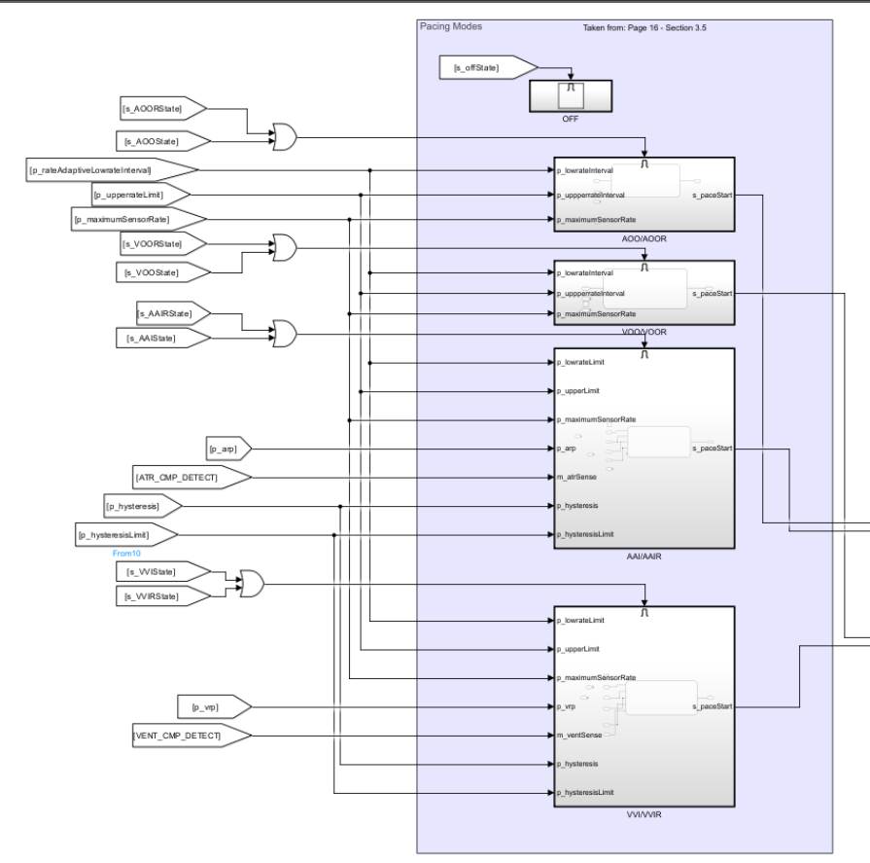

Figure 1: Pacing Modes Subsystem

The pacemaker's primary logic is contained in three Stateflow charts, which mostly interact with abstracted variables to successfully accomplish hardware concealing. For AOO, VOO, AOOR, and VOOR modes, there is a single Stateflow chart; for AAI, VVI, AAIR, and VVIR modes, but only one is active at any given moment. With the exception of input and output signal routing (which is managed by 4.1.4 Parameter Selection), all of the grouped modes are implemented in essentially the same way. Because Received_Code is reduced, sharing Stateflow charts facilitates improved maintainability.

In every mode, when pacing, the current pacing rate is adjusted at the appropriate rate based on the duration of the previous waiting interval if the rate reported by the sensor differs from the current pacing rate. It is assumed that the rate of change is linear in time. The higher rate limit was determined to have no purpose in these modes and was therefore omitted from this design as maximum sensor rate is defined as being independently programmable from the upper rate limit. On the appropriate out signal, a 1 ms pulse indicates that pacing should start. The hardware interface is informed of the expected level of the next pacing by the AV choose signal.

### AOO/VOO/AOOR/VOOR

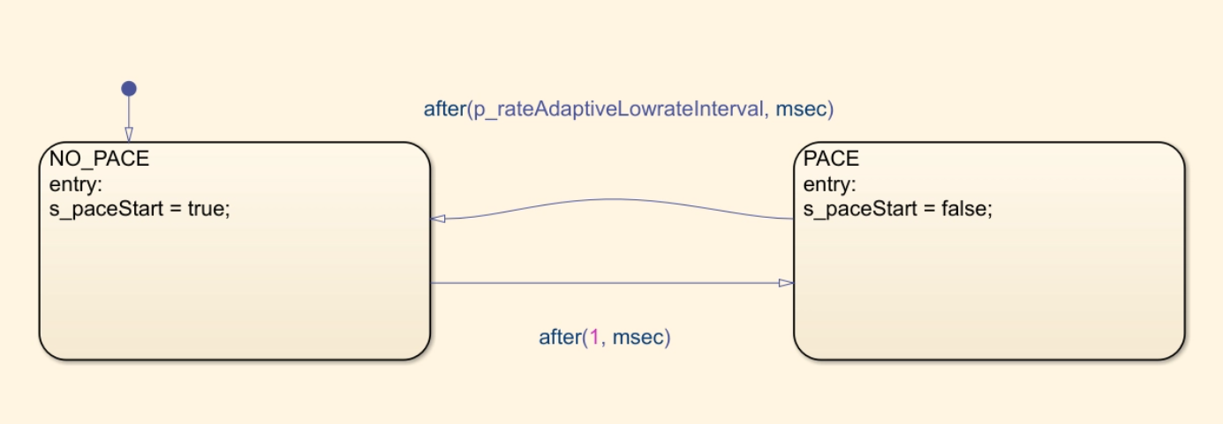

Figure 2: AOO/VOO/AOOR/VOOR Stateflow chart

Since they don't need to sense the heart, the AOO, VOO, AOOR, and VOOR modes just alternate between pacing and non-pacing states.

### AAI/VVI/AAIR/VVIR

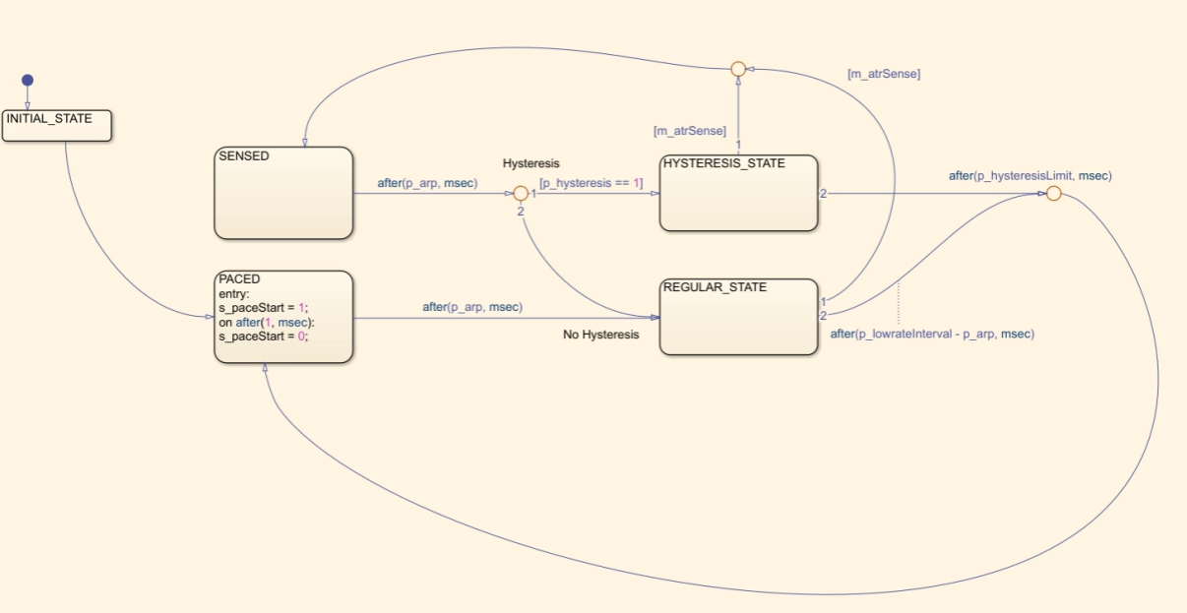

Figure 3: AAI/VVI/AAIR/VVIR Stateflow chart

The XOO modes' structure is comparable to that of the AAI, VVI, AAIR, and VVIR modes. Additionally, if a spontaneous pulse is detected after the refractory period (during which spontaneous pulses are ineffective), it is possible to avoid the pacing condition. To make sure the pacemaker does not pace excessively if the heart is beating at precisely the present pacing rate on its own, an extra millisecond is added to the wait period.

## Rate Adaptivity

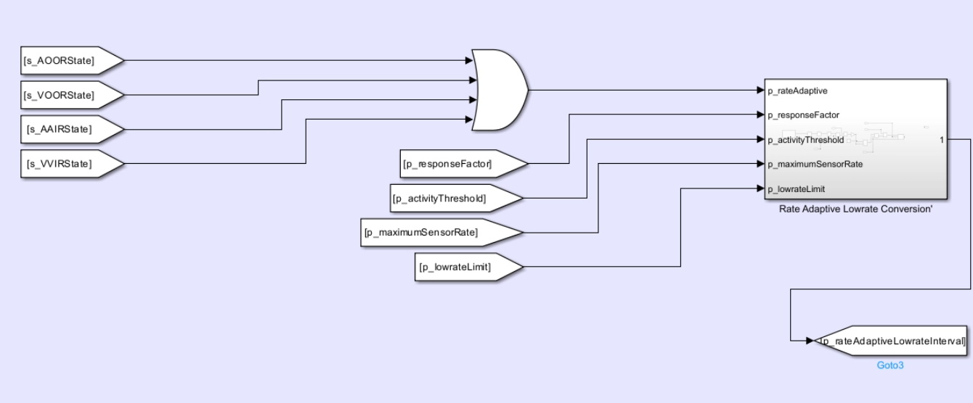

Figure 5a: Rate Adaptivity System

Figure 5b: Rate Adaptivity Subsystem

A_x, a_y, and a_z are the appropriate Accels in the local x, y, and z axes, respectively, and the activity level is intep_responseFactorreted as the peak-to-peak amplitude of the entire accelerometer signal, or √(a_x^2+a_y^2+a_z^2). By taking 25 second samples of the accelerometer's signal and deducting the minimum from the maximum of the Buffer_Accel, one may determine the amplitude. It is assumed that the relationship between the sensor-indicated rate and the amount that the activity level exceeds the activity threshold is linear. The activity level can be freely adjusted between 0 and 4 units by experiment. The seven activity levels were therefore mapped to 0.5 and 3.5, respectively, with V-Low and V-High being equally dispersed throughout that range. The slope of the response level (in ppm/activity unit) when activity surpasses the threshold is therefore equal to the response factor multiplied by 4. The indicated rate from the sensor is then compared to both the maximum and lower rate limits; if it exceeds the maximum or falls short of the former, it is adjusted to the correct value.

It is expected that the pace of increase and decline in pace rate is linear in time. For comprehensive equations, see 4.2.3.

## Hardware Interface

Figure 6a: Hardware Interface subsystem

Figure 6b: Hardware Interface Input Variables

Figure 6c: Hardware Interface Ouput Pins

The pacemaker's IN and OUT variables are abstracted by the hardware interface as a response factor, making it simple to transfer the pacemaker's primary functionality to any hardware device. This guarantees that the logic describing how the chosen instructions should be carried out on the hardware would be the only modifications that are required. In order to output 1 ms pulses when atrial/ventricular signals surpass their respective sensitivities, the hardware interface only has to accept 1 ms pulsed pace atrium/ventricle signals and an atrial-ventricular level selector signal.

### Pacing

Figure 7: Pacing Stateflow chart

When a pulse is detected on the S_atrialPaceStart or S_ventricular_PaceStart lines, the pacing module detects it and waits in a Buffer_Accel state. Then, it sets the relevant flags to pace the heart. Flags are set to start charging the pacing capacitor again and discharging the blocking capacitor after a delay equal to the pulse width. As a precaution against looping caused by a non-deasserted pacing signal pulse, the Buffer_Accel state is used.

### Sensing

Figure 8: Sensing Subsystem

To identify natural pulses, the sensing module routes the flags to the variables h_atrial_pulse_detect and h_ventricular_pulse_detect, and sets the proper PWMs for the atrial and ventricular reference capacitors.

## DCM Communication

Figure 9a: Communications Subsytems

Figure 9b: Communications Subsytems for DCM Communication

For all external communication, the DCM Communication module is responsible. Like the hardware interface, it interacts with the particular IN and OUT variables while presenting abstracted variables to the system. This design selected UART communication.

### In

Figure 10: Communications In Stateflow chart

When the Buffer_Accel_status indicates that it is full, the In module reads the Receive Buffer_Accel and, according on the Received_Code received, either updates the parameter data or transmits data to the DCM.

### Out

Figure 11: Communications Out Stateflow chart

Only upon receiving a Received_Code of a number between 1 and 16 (both inclusive) does the out module become active. As described in 4.4.2.3, data is transmitted via UART.

# Testing

## AOO

Chamber paced: Atrium

Chamber sensed: N/A

Response to Sensing: N/A

**Test Cases:**

1. Natural Atrium: **OFF |** Natural Ventricle: **OFF**

Only one test case—in which the ventricle and atrium are both nonfunctional—can show that our pacemaker is functioning correctly in AOO mode because we are not sensing any chambers.

*Graph representing artificial pulse from HeartView*

## VOO

Chamber paced: Ventricle

Chamber sensed: N/A

Response to Sensing: N/A

**Test Cases:**

1. Natural Atrium: **OFF |** Natural Ventricle: **OFF**

Only one test case—in which the ventricle and atrium are both nonfunctional—can show that our pacemaker is functioning correctly in VOO mode as well because we are not sensing any chambers.

*Graph representing artificial pulse from HeartView*

## AAI

Chamber paced: Atrium

Chamber sensed: Atrium

Response to Sensing: Inhibited

**Test Cases:**

1. Natural Atrium: **ON**, Pulse Width: **1ms** |Natural Ventricle: **OFF** | Heart Rate: **30bpm**

Because the heart beats every 2000 milliseconds and the pacemaker is designed to maintain a heart rate of 60 beats per minute, which is a pulse after every 1000 milliseconds, the pacemaker is expected to create a pulse at very low heat rate and low pulse width. The graph below illustrates how our pacemaker fills the gap by sending a pulse every 1000 ms.

*Graph representing natural and artificial pulse from HeartView*

1. Natural Atrium: **ON**, Pulse Width: **10ms** |Natural Ventricle: **OFF** | Heart Rate: **30bpm**

The pacemaker is expected to generate a pulse when the pulse width is increased to 10 ms while maintaining the same heart rate. This is because there is a gap of more than 1000 ms between two consecutive pulses. The graph below illustrates how our pacemaker accomplishes the same thing by supplying the pulse needed to fill the gap in time.

*Graph representing natural and artificial pulse from HeartView*

1. Natural Atrium: **ON**, Pulse Width: **1ms** |Natural Ventricle: **OFF** | Heart Rate: **50bpm**

A pacemaker is intended to produce an artificial pulse when our heart rate is slightly below the natural rate but the pulse width is insufficient to achieve the natural rate, which is 60 beats per minute or one pulse every 1000 milliseconds.

It is evident from the graph below that our pacemaker compensates for the delay.

*Graph representing natural and artificial pulse from HeartView*

1. Natural Atrium: **ON**, Pulse Width: **10ms** |Natural Ventricle: **OFF** | Heart Rate: **50bpm**

A pacemaker should not produce an artificial pulse when the heart rate is below normal but the pulse width is sufficient to fill the gap. Our pacemaker isn't giving our heart an extra pulse, as the graph below illustrates.

*Graph representing natural pulse from HeartView*

## VVI

Chamber paced: Ventricle

Chamber sensed: Ventricle

Response to Sensing: Inhibited

**Test Cases:**

1. Natural Atrium: **OFF** |Natural Ventricle: **ON**, Pulse Width: **1ms** | Heart Rate: **30bpm**

The pacemaker's pulse should be generated frequently enough to sustain a normal heart rate even at very low heart rates.

The graph below shows that our pacemaker generates artificial pulses when it has been more than 1000 milliseconds since the last pulse, which aids in sustaining a normal heart rate of 60 beats per minute or a pulse every 1000 milliseconds.

*Graph representing natural and artificial pulse from HeartView*

1. Natural Atrium: **OFF** |Natural Ventricle: **ON**, Pulse Width: **10ms** | Heart Rate: **30bpm**

High pulse width cannot fill the void left by a low heart rate; therefore, a pacemaker is needed to ensure that the heart is beating properly. It is evident from the graph below that our pacemaker keeps the heart operating normally by giving it artificial pulses.

*Graph representing natural and artificial pulse from HeartView*

1. Natural Atrium: **OFF** |Natural Ventricle: **ON**, Pulse Width: **1ms** | Heart Rate: **50bpm**

A pacemaker is supposed to activate and start sending pulses to the heart when the heart is beating somewhat slower than usual but the pulse width is not wide enough to make up for the difference. We may observe from the graph below that our pacemaker performs as planned.

*Graph representing natural and artificial pulse from HeartView*

1. Natural Atrium: **OFF** |Natural Ventricle: **ON**, Pulse Width: **10ms** | Heart Rate: **58bpm**

A pacemaker shouldn't be used when the patient's heart rate is slightly below normal and their pulse width is sufficient to close the gap.

The graph below shows that our pacemaker is not causing the heart to beat artificially.

*Graph representing natural pulse from HeartView*

## DOO

Chamber paced: Atrium and Ventricle

Chamber sensed: N/A

Response to Sensing: N/A

Rate Modulation

Heartview signals: Natural Atrium: **OFF |** Natural Ventricle: **OFF**

DCM signals:

Only one test case—in which the ventricle and atrium are both nonfunctional—can show that our pacemaker is functioning correctly in DOO mode as well because we are not sensing any chambers.

*Graph representing artificial pulse from HeartView*

With a 150 ms AV delay and a 60 ppm LRL, pace the ventricle and atrium.

**Result**: Passed

## AOOR

Chamber paced: Atrium

Chamber sensed: N/A

Response to Sensing: N/A

Rate Modulation

Heartview signals: Natural Atrium: **OFF |** Natural Ventricle: **OFF**

1. **No Activity sensed**

Pace to Atrium with an LRL of 60 ppm if no activity is detected above the threshold.

1. **Activity sensed**

Increase LRL within a 10-second response time and a 2-minute recuperation time after detecting Activity above Threshold.

**Result**: Passed

## VOOR

Chamber paced: Ventricle

Chamber sensed: N/A

Response to Sensing: N/A

Rate Modulation

Heartview signals: Natural Atrium: **OFF |** Natural Ventricle: **OFF**

1. **No Activity sensed**

Pace to Ventricle with an LRL of 60 ppm if no activity is detected above the threshold.

1. **Activity Sensed**

Increase LRL after 10 seconds of detecting Activity above Threshold and within 2 minutes of recovering from it.

**Result**: Passed

## DOOR

Chamber paced: Atrium and Ventricle

Chamber sensed: N/A

Response to Sensing: N/A

Rate Modulation

Heartview signals: Natural Atrium: **OFF |** Natural Ventricle: **OFF**

1. **No Activity sensed**

Pace to the ventricle and atrium with an LRL of 60 ppm and an AV delay of 70 ms if no activity is detected above the threshold.

1. **Activity sensed**

Within ten seconds of the activity being detected above the threshold, raise the LRL; allow two minutes for recuperation.

**Result:** Passed

## AAIR

Chamber paced: Atrium

Chamber sensed: Atrium

Response to Sensing: Inhibited

Rate Modulation

**Test Cases:**

1. **No activity**

Heartview signals: Natural Atrium: **On |** PW: 1ms | Heart rate: 30Bpm

DCM signals:

The pacemaker's job is to fill the gap in heart rate while we are in AAIR mode, with no activity, and when the heart rate is lower than normal. Our pacemaker functions in the same way, as seen by the graph below.

*Graph representing artificial and natural pulse from HeartView*

1. **Physical activity**

Heartview signals: Natural Atrium: **On |** PW: 1ms | Heart rate: 30Bpm

DCM signals:

Compared to normal, our pacemaker beats more frequently while we are physically active.

*Graph representing artificial and natural pulse from HeartView*

1. **No activity**

Heartview signals: Natural Atrium: **On |** PW: 1ms | Heart rate: 60Bpm

DCM signals:

A pacemaker is not meant to provide an extra pulse while the heart is beating naturally and there is no physical activity. The graph below makes it evident that our pacemaker functions in the same way.

*Graph representing artificial and natural pulse from HeartView*

1. **Physical activity**

Heartview signals: Natural Atrium: **On |** PW: 1ms | Heart rate: 60Bpm

DCM signals:

The purpose of a pacemaker is to add a second pulse to account for physical activity when the patient's heart is beating regularly. The graph below makes it evident that our pacemaker functions the same way.

*Graph representing artificial and natural pulse from HeartView*

## VVIR

Chamber paced: Ventricle

Chamber sensed: Ventricle

Response to Sensing: Inhibited

Rate Modulation

**Test Cases:**

1. **No activity**

Heartview signals: Natural Ventricle: **On |** PW: 1ms | Heart rate: 30Bpm

DCM signals:

The pacemaker's job is to provide a pulse to fill the gap when it is in the VVIR mode, there is no activity, and the heart rate is lower than normal. The graph below shows that our pacemaker functions in the same way.

*Graph representing artificial and natural pulse from HeartView*

1. **Physical activity**

Heartview signals: Natural Ventricle: **On |** PW: 1ms | Heart rate: 30Bpm

DCM signals:

Our pacemaker beats more frequently during physical activity than it does during rest.

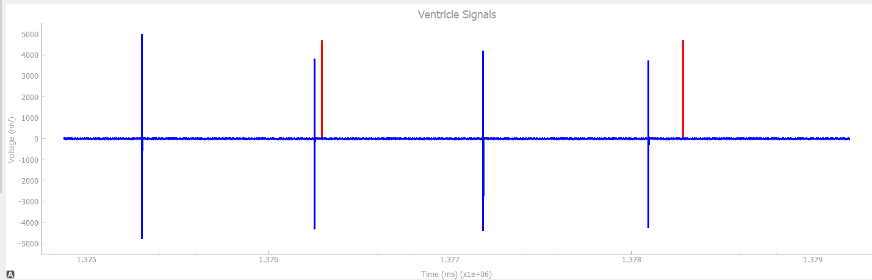

*Graph representing artificial and natural pulse from HeartView*

1. **No activity**

Heartview signals: Natural Ventricle: **On |** PW: 1ms | Heart rate: 60Bpm

DCM signals:

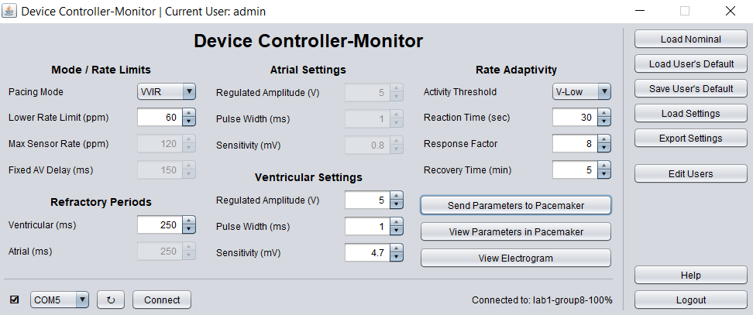

A pacemaker is not meant to provide an extra pulse while the heart is beating naturally and there is no physical activity. The graph below makes it evident that our pacemaker functions in the same way.

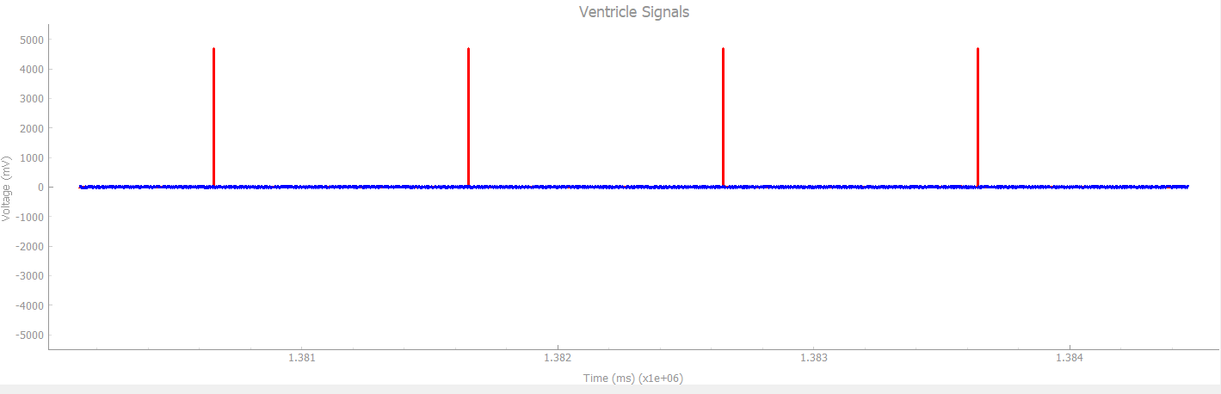

*Graph representing artificial and natural pulse from HeartView*