Machine Learning Experiment 0: Data Preprocessing and Visualization with NumPy, Pandas, and Matplotlib
Experiment Title: Student Performance Analysis Using Data Preprocessing and Visualization Libraries
Date: February 2026
Objective: To gain hands-on experience with Python libraries for ML data preprocessing and visualization techniques.

1. Dataset Source
Dataset Name: Student Performance Dataset
File Name: student_performance.csv
License: Educational Dataset
File Size: Variable

2. Dataset Description
The Student Performance dataset contains academic and behavioral metrics for students, designed to predict and analyze academic performance. This dataset is used for practicing data preprocessing, statistical analysis, and visualization techniques.

Dataset Overview:
- Target Purpose: Predictive analysis of student performance
- Data Types: Mix of numerical features
- Primary Focus: Hours studied, attendance, assignments, exam scores

Features Description:
- Hours_Studied (numerical): Number of hours dedicated to studying
- Attendance (numerical): Attendance percentage in class
- Assignment_Score (numerical): Score obtained on assignments
- Midterm_Score (numerical): Score obtained in midterm examination
- Final_Score (numerical): Score obtained in final examination (Target variable for analysis)
import pandas as pd
import numpy as np
import matplotlib.pyplot as plt
import seaborn as sns
import warnings
warnings.filterwarnings('ignore')
%matplotlib inline
sns.set_style('whitegrid')
# Load the student performance dataset
try:
df = pd.read_csv('student_performance.csv')
print("Dataset loaded successfully!")
except FileNotFoundError:
print("Dataset file 'student_performance.csv' not found.")
print("Please ensure the file is in the same directory as this notebook.")
df = None
Dataset loaded successfully!
if df is not None:
print("Dataset Shape:", df.shape)
print("\n" + "="*80)
print("First Few Rows:")
print(df.head())
print("\n" + "="*80)
print("Data Types:")
print(df.dtypes)
print("\n" + "="*80)
print("Missing Values:")
print(df.isnull().sum())
print("\n" + "="*80)
print("Statistical Summary:")
print(df.describe())
Dataset Shape: (20, 5)
================================================================================
First Few Rows:
Hours_Studied Attendance Assignment_Score Midterm_Score Final_Score
0 1 60 55 50 52
1 2 65 58 55 57
2 3 70 60 58 60
3 4 75 65 62 64
4 5 80 68 65 68
================================================================================
Data Types:
Hours_Studied int64
Attendance int64
Assignment_Score int64
Midterm_Score int64
Final_Score int64
dtype: object
================================================================================
Missing Values:
Hours_Studied 0
Attendance 0
Assignment_Score 0
Midterm_Score 0
Final_Score 0
dtype: int64
================================================================================
Statistical Summary:
Hours_Studied Attendance Assignment_Score Midterm_Score Final_Score
count 20.000000 20.000000 20.000000 20.000000 20.000000
mean 5.650000 80.150000 69.750000 65.750000 68.950000
std 2.621269 10.524533 9.025549 8.005755 8.941182
min 1.000000 60.000000 55.000000 50.000000 52.000000
25% 3.750000 71.500000 61.500000 59.500000 62.250000
50% 6.000000 81.000000 70.500000 67.500000 70.500000
75% 8.000000 88.500000 76.500000 71.250000 75.500000
max 10.000000 95.000000 85.000000 78.000000 83.000000
if df is not None:
# 1. Load Final_Score as NumPy array
final_scores = df['Final_Score'].to_numpy()
print("Final Scores:", final_scores)
print("\n" + "="*80)
Final Scores: [52 57 60 64 68 71 74 77 79 83 63 70 75 56 69 73 80 58 72 78]
================================================================================
if df is not None:
# 3. Perform Min-Max normalization
min_val = np.min(final_scores)
max_val = np.max(final_scores)
normalized_scores = (final_scores - min_val) / (max_val - min_val)
print("Normalized Scores:", normalized_scores)
Normalized Scores: [0. 0.16129032 0.25806452 0.38709677 0.51612903 0.61290323
0.70967742 0.80645161 0.87096774 1. 0.35483871 0.58064516
0.74193548 0.12903226 0.5483871 0.67741935 0.90322581 0.19354839
0.64516129 0.83870968]
if df is not None:
# 2. Compute mean, median, and standard deviation
mean_score = np.mean(final_scores)
median_score = np.median(final_scores)
std_score = np.std(final_scores)
print(f"Mean: {mean_score:.2f}, Median: {median_score:.2f}, Standard Deviation: {std_score:.2f}")
print("="*80)
Mean: 68.95, Median: 70.50, Standard Deviation: 8.71
================================================================================

5. Exercise 2: Pandas Data Handling
if df is not None:
# 1. Check shape, columns, and missing values
print("Shape of the dataset:", df.shape)
print("Columns:", list(df.columns))
print("Missing values per column:")
print(df.isnull().sum())
print("="*80)
Shape of the dataset: (20, 5)
Columns: ['Hours_Studied', 'Attendance', 'Assignment_Score', 'Midterm_Score', 'Final_Score']
Missing values per column:
Hours_Studied 0
Attendance 0
Assignment_Score 0
Midterm_Score 0
Final_Score 0
dtype: int64
================================================================================
if df is not None:
# 2. Create Performance label based on Final_Score
# Categorize: Low (<60), Medium (60-80), High (>80)
df_copy = df.copy()
df_copy['Performance'] = pd.cut(df_copy['Final_Score'], bins=[0, 60, 80, 100], labels=['Low', 'Medium', 'High'])
print("First 5 rows with Performance label:")
print(df_copy.head())
print("\n" + "="*80)
print("Performance Distribution:")
print(df_copy['Performance'].value_counts())
First 5 rows with Performance label:
Hours_Studied Attendance Assignment_Score Midterm_Score Final_Score \
0 1 60 55 50 52
1 2 65 58 55 57
2 3 70 60 58 60
3 4 75 65 62 64
4 5 80 68 65 68
Performance
0 Low
1 Low
2 Low
3 Medium
4 Medium
================================================================================
Performance Distribution:
Performance
Medium 14
Low 5
High 1
Name: count, dtype: int64

6. Exercise 3: Matplotlib Visualization
if df is not None:
# 1. Line plot: Hours_Studied vs Final_Score
plt.figure(figsize=(8, 5))
plt.plot(df['Hours_Studied'], df['Final_Score'], marker='o')
plt.xlabel('Hours Studied')
plt.ylabel('Final Score')
plt.title('Hours Studied vs Final Score')
plt.grid(True)
plt.show()
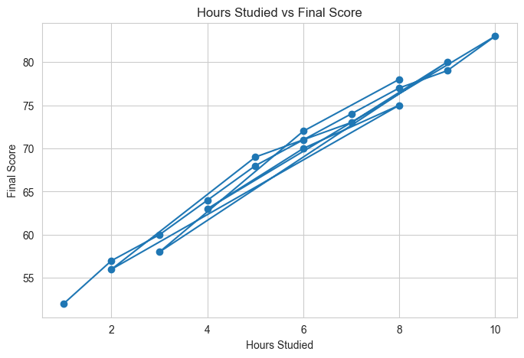
if df is not None:
# 2. Histogram of Final_Score
plt.figure(figsize=(8, 5))
plt.hist(df['Final_Score'], bins=10, edgecolor='black')
plt.xlabel('Final Score')
plt.ylabel('Frequency')
plt.title('Histogram of Final Score')
plt.show()
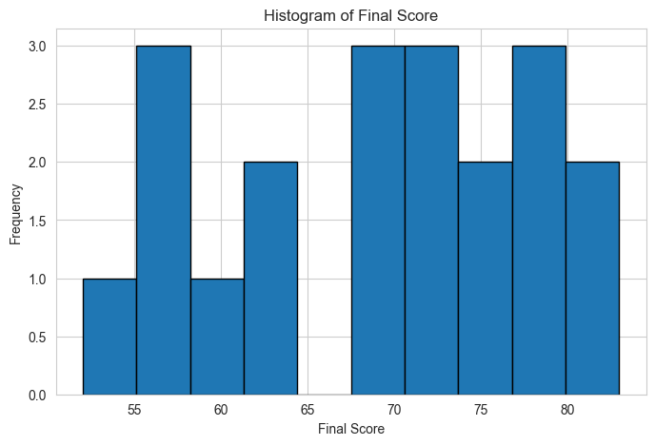
## 7. Exercise 4: Seaborn Visualization

Exercise 4: Seaborn Visualization
if df is not None:
# 1. Scatter plot using seaborn
plt.figure(figsize=(8, 5))
sns.scatterplot(data=df, x='Hours_Studied', y='Final_Score')
plt.title('Scatter Plot: Hours Studied vs Final Score')
plt.show()
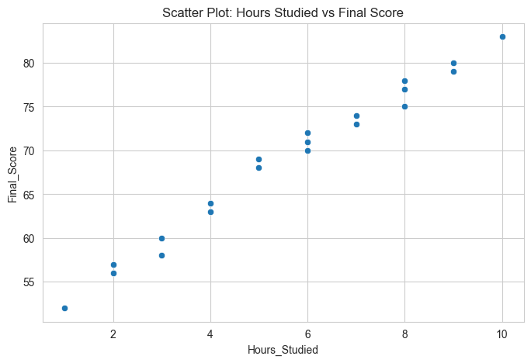
if df is not None:
# 2. Heatmap for correlation analysis
plt.figure(figsize=(8, 6))
corr = df.select_dtypes(include=[np.number]).corr()
sns.heatmap(corr, annot=True, cmap='coolwarm', fmt='.2f')
plt.title('Correlation Heatmap')
plt.show()
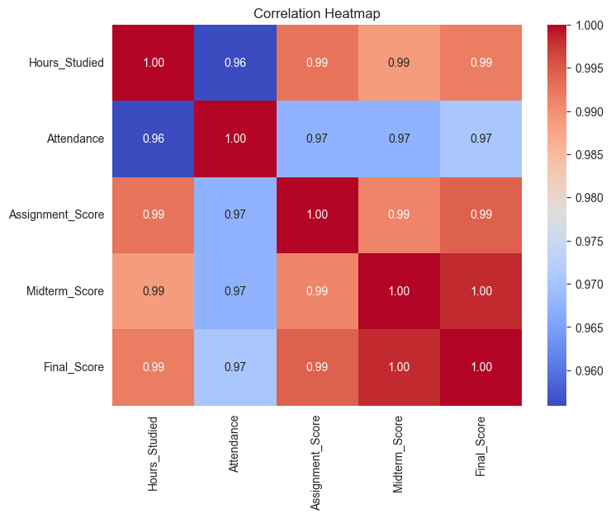
# 2. Heatmap for correlation analysis
plt.figure(figsize=(8, 6))
corr = df.select_dtypes(include=[np.number]).corr() # Only numeric columns
sns.heatmap(corr, annot=True, cmap='coolwarm', fmt='.2f')
plt.title('Correlation Heatmap')
plt.show()
if df is not None:
# 3. Boxplot for categorical analysis
df_copy = df.copy()
df_copy['Performance'] = pd.cut(df_copy['Final_Score'], bins=[0, 60, 80, 100], labels=['Low', 'Medium', 'High'])
plt.figure(figsize=(8, 5))
sns.boxplot(data=df_copy, x='Performance', y='Final_Score')
plt.title('Boxplot: Performance vs Final Score')
plt.show()
