Experiment 2

1. Theoretical Background

Multiple Linear Regression
Standard regression predicting continuous target: $\hat{y}=β_{0}+\sum_{i=1}^{n}{β_{i}}x_{i}$
Cost Function (OLS): $J(β)=\frac{1}{2m}\sum_{i=1}^{m}{(}{\hat{y}}^{(i)}-y^{(i)})^{2}$
Limitation: Sensitive to multicollinearity; correlated features cause unstable coefficient estimates.

Ridge Regression (L2 Regularization)
Adds L2 penalty to shrink coefficients: $J(β)=\frac{1}{2m}∑(\hat{y}-y)^{2}+λ∑β_{j}^{2}$
Effect: Reduces variance by distributing weight across correlated features (shrinks but rarely sets coefficients to zero)
Closed-form solution: $β=(X^{T}X+λI)^{-1}X^{T}y$

Lasso Regression (L1 Regularization)
Adds L1 penalty for feature selection: $J(β)=\frac{1}{2m}∑(\hat{y}-y)^{2}+λ∑|β_{j}|$
Effect: Drives some coefficients exactly to zero (feature selection)
Trade-off: If features are highly correlated, Lasso arbitrarily selects one and zeros others
Key Difference: Ridge shrinks all coefficients proportionally; Lasso performs automatic feature selection.

2. Dataset & Methodology
Insurance Premium Dataset:
- 1,338 individuals with medical insurance data
- 6 features: age (18-64), sex (binary), BMI (15.96-53.13), children (0-5), smoker (binary), region (4 categories)
- Target: Individual medical costs charged by insurance (continuous, right-skewed)
- Challenge: Smoking status has strong non-linear impact on costs
Methodology:
- Load data and visualize distributions & correlations
- Encode categorical variables (sex, smoker, region)
- Standardize features (critical for regularization)
- Train-Test split 70-30
- Train three models: Linear, Lasso, Ridge
- Evaluate with R², RMSE, MAE
- Analyze coefficient differences across models
- Tune regularization parameter (alpha) via GridSearchCV
- Compare model performance and identify best model

3. Dataset Loading & EDA
try:
df = pd.read_csv('insurance.csv')
print(f"Loaded: {df.shape[0]} samples, {df.shape[1]} features")
print(f"\nFeature types:")
print(df.dtypes)
except FileNotFoundError:
print("File not found. Download from: https://www.kaggle.com/datasets/noordeen/insurance-premium-prediction")
df = None
Loaded: 1338 samples, 7 features
Feature types:
age int64
sex str
bmi float64
children int64
smoker str
region str
expenses float64
dtype: object
if df is not None:
# Reload original data for visualization (fresh copy)
try:
df_viz = pd.read_csv('insurance.csv')
except FileNotFoundError:
df_viz = df.copy()
fig, axes = plt.subplots(2, 2, figsize=(14, 8))
# Expenses distribution
axes[0, 0].hist(df_viz['expenses'], bins=30, edgecolor='black', color='steelblue', alpha=0.7)
axes[0, 0].set_xlabel('Expenses ($)')
axes[0, 0].set_ylabel('Frequency')
axes[0, 0].set_title('Insurance Expenses Distribution (Right-Skewed)')
axes[0, 0].grid(alpha=0.3, axis='y')
# Expenses by smoker status
df_viz.boxplot(column='expenses', by='smoker', ax=axes[0, 1])
axes[0, 1].set_title('Expenses by Smoking Status')
axes[0, 1].set_xlabel('Smoker')
axes[0, 1].set_ylabel('Expenses ($)')
plt.sca(axes[0, 1])
plt.xticks([1, 2], ['no', 'yes'])
plt.suptitle(None)
# Age vs Expenses
for smoker, color in zip(['no', 'yes'], ['blue', 'red']):
mask = df_viz['smoker'] == smoker
axes[1, 0].scatter(df_viz[mask]['age'], df_viz[mask]['expenses'], alpha=0.5, s=20, label=f'Smoker: {smoker}', color=color)
axes[1, 0].set_xlabel('Age')
axes[1, 0].set_ylabel('Expenses ($)')
axes[1, 0].set_title('Age vs Expenses (Non-linear Smoking Effect)')
axes[1, 0].legend()
axes[1, 0].grid(alpha=0.3)
# Correlation heatmap (numeric only)
num_df = df_viz.select_dtypes(include=[np.number])
sns.heatmap(num_df.corr(), annot=True, fmt='.2f', cmap='coolwarm', ax=axes[1, 1], cbar_kws={'label': 'Correlation'})
axes[1, 1].set_title('Feature Correlation Matrix')
plt.tight_layout()
plt.show()
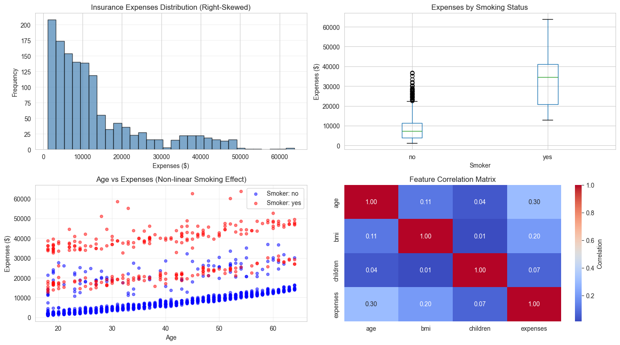

4. Data Preprocessing
if df is not None:
df_proc = df.copy()
# Encode categorical variables
le_sex = LabelEncoder()
le_smoker = LabelEncoder()
le_region = LabelEncoder()
df_proc['sex'] = le_sex.fit_transform(df_proc['sex'])
df_proc['smoker'] = le_smoker.fit_transform(df_proc['smoker'])
df_proc['region'] = le_region.fit_transform(df_proc['region'])
X = df_proc.drop('expenses', axis=1)
y = df_proc['expenses']
X_train, X_test, y_train, y_test = train_test_split(X, y, test_size=0.30, random_state=42)
# Standardize features
scaler = StandardScaler()
X_train_scaled = pd.DataFrame(scaler.fit_transform(X_train), columns=X_train.columns)
X_test_scaled = pd.DataFrame(scaler.transform(X_test), columns=X_test.columns)
print(f"Train: {X_train.shape[0]} | Test: {X_test.shape[0]} | Features: {X_train.shape[1]}")
print(f"Target range: ${y.min():.2f} - ${y.max():.2f} | Mean: ${y.mean():.2f}")
Train: 936 | Test: 402 | Features: 6
Target range: $1121.87 - $63770.43 | Mean: $13270.42

5. Model Training & Comparison
if df is not None:
# Multiple Linear Regression
lr = LinearRegression()
lr.fit(X_train_scaled, y_train)
y_train_lr = lr.predict(X_train_scaled)
y_test_lr = lr.predict(X_test_scaled)
# Lasso Regression
lasso = Lasso(alpha=100, random_state=42, max_iter=5000)
lasso.fit(X_train_scaled, y_train)
y_train_lasso = lasso.predict(X_train_scaled)
y_test_lasso = lasso.predict(X_test_scaled)
# Ridge Regression
ridge = Ridge(alpha=100, random_state=42)
ridge.fit(X_train_scaled, y_train)
y_train_ridge = ridge.predict(X_train_scaled)
y_test_ridge = ridge.predict(X_test_scaled)
print("Models trained successfully")
Models trained successfully
if df is not None:
# Feature coefficients comparison
coef_df = pd.DataFrame({
'Feature': X_train.columns,
'Linear': lr.coef_,
'Lasso': lasso.coef_,
'Ridge': ridge.coef_
})
print("\nFeature Coefficients (default alpha=100):")
print(coef_df.to_string(index=False))
print(f"\nNote: Lasso zeros: {(coef_df['Lasso'] == 0).sum()} features | Ridge keeps all features")
Feature Coefficients (default alpha=100):
Feature Linear Lasso Ridge
age 3693.032582 3604.296052 3314.390825
sex 54.903886 0.000000 88.272495
bmi 2065.227103 1952.598518 1887.732193
children 514.679502 426.273315 506.429378
smoker 9592.597777 9492.737053 8648.911177
region -362.952542 -246.239900 -295.403679
Note: Lasso zeros: 1 features | Ridge keeps all features
if df is not None:
fig, ax = plt.subplots(figsize=(12, 5))
x = np.arange(len(coef_df))
width = 0.25
ax.bar(x - width, coef_df['Linear'], width, label='Linear', alpha=0.8, color='steelblue')
ax.bar(x, coef_df['Lasso'], width, label='Lasso (L1)', alpha=0.8, color='coral')
ax.bar(x + width, coef_df['Ridge'], width, label='Ridge (L2)', alpha=0.8, color='mediumseagreen')
ax.set_ylabel('Coefficient Value')
ax.set_xlabel('Features')
ax.set_title('Feature Coefficients: Linear vs Lasso vs Ridge (alpha=100)')
ax.set_xticks(x)
ax.set_xticklabels(coef_df['Feature'], rotation=0)
ax.legend()
ax.grid(alpha=0.3, axis='y')
ax.axhline(y=0, color='black', linestyle='-', linewidth=0.8)
plt.tight_layout()
plt.show()
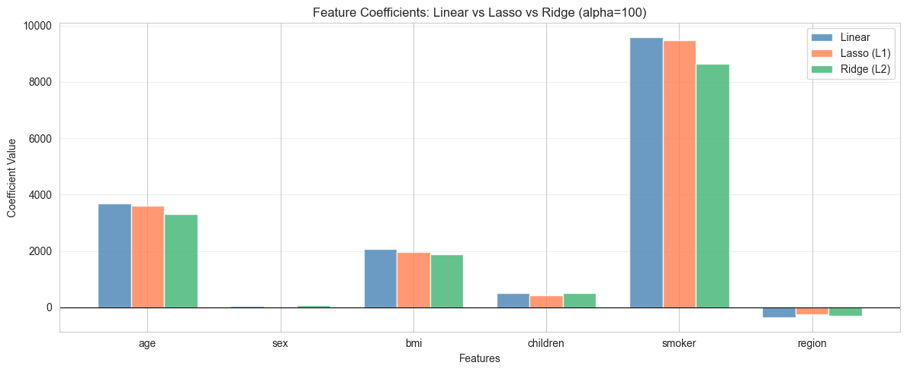

6. Performance Evaluation
if df is not None:
# Calculate metrics for all models
models = {'Linear': (y_test_lr, y_train_lr), 'Lasso': (y_test_lasso, y_train_lasso), 'Ridge': (y_test_ridge, y_train_ridge)}
results = []
for name, (y_pred_test, y_pred_train) in models.items():
train_r2 = r2_score(y_train, y_pred_train)
test_r2 = r2_score(y_test, y_pred_test)
test_mse = mean_squared_error(y_test, y_pred_test)
test_rmse = np.sqrt(test_mse)
test_mae = mean_absolute_error(y_test, y_pred_test)
results.append({'Model': name, 'Train R²': train_r2, 'Test R²': test_r2, 'RMSE': test_rmse, 'MAE': test_mae})
results_df = pd.DataFrame(results)
print("Model Performance Summary (alpha=100):")
print(results_df.to_string(index=False))
Model Performance Summary (alpha=100):
Model Train R² Test R² RMSE MAE
Linear 0.742269 0.769463 5813.981730 4154.700387
Lasso 0.741899 0.769296 5816.083516 4146.559651
Ridge 0.735140 0.760615 5924.500631 4330.591225
if df is not None:
fig, axes = plt.subplots(1, 3, figsize=(16, 4))
predictions = [('Linear', y_test_lr), ('Lasso', y_test_lasso), ('Ridge', y_test_ridge)]
for idx, (name, y_pred) in enumerate(predictions):
axes[idx].scatter(y_test, y_pred, alpha=0.5, s=20)
axes[idx].plot([y_test.min(), y_test.max()], [y_test.min(), y_test.max()], 'r--', lw=2, label='Perfect')
r2 = r2_score(y_test, y_pred)
rmse = np.sqrt(mean_squared_error(y_test, y_pred))
axes[idx].set_xlabel('Actual Expenses ($)')
axes[idx].set_ylabel('Predicted Expenses ($)')
axes[idx].set_title(f'{name}\nR²={r2:.3f}, RMSE=${rmse:.0f}')
axes[idx].legend()
axes[idx].grid(alpha=0.3)
plt.tight_layout()
plt.show()
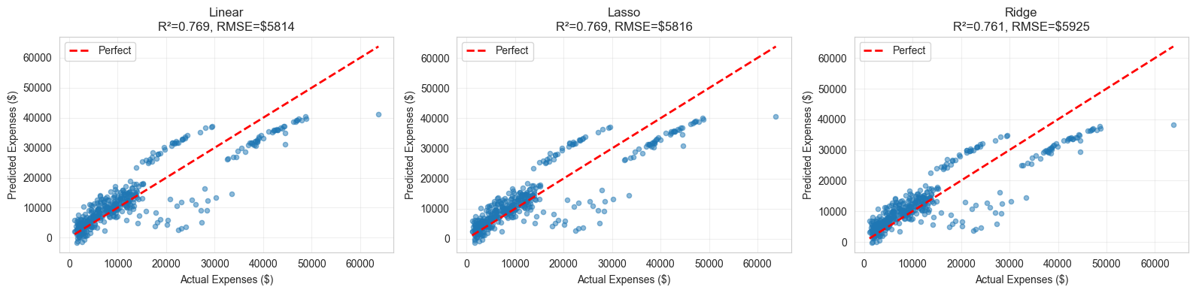
if df is not None:
fig, axes = plt.subplots(1, 2, figsize=(14, 5))
# R² comparison
r2_train = [r2_score(y_train, y_train_lr), r2_score(y_train, y_train_lasso), r2_score(y_train, y_train_ridge)]
r2_test = [r2_score(y_test, y_test_lr), r2_score(y_test, y_test_lasso), r2_score(y_test, y_test_ridge)]
models_list = ['Linear', 'Lasso', 'Ridge']
x = np.arange(len(models_list))
width = 0.35
axes[0].bar(x - width/2, r2_train, width, label='Train', alpha=0.8, color='lightblue')
axes[0].bar(x + width/2, r2_test, width, label='Test', alpha=0.8, color='lightcoral')
axes[0].set_ylabel('R² Score')
axes[0].set_title('Model Comparison: R² Score (Higher is Better)')
axes[0].set_xticks(x)
axes[0].set_xticklabels(models_list)
axes[0].legend()
axes[0].grid(alpha=0.3, axis='y')
axes[0].set_ylim([0, 1])
# RMSE comparison (lower is better)
rmse = [np.sqrt(mean_squared_error(y_test, y_test_lr)), np.sqrt(mean_squared_error(y_test, y_test_lasso)), np.sqrt(mean_squared_error(y_test, y_test_ridge))]
colors_rmse = ['steelblue', 'coral', 'mediumseagreen']
axes[1].bar(models_list, rmse, color=colors_rmse, alpha=0.7, edgecolor='black')
axes[1].set_ylabel('RMSE ($)')
axes[1].set_title('Test RMSE Comparison (Lower is Better)')
axes[1].grid(alpha=0.3, axis='y')
for i, v in enumerate(rmse):
axes[1].text(i, v + 500, f'${v:.0f}', ha='center', fontsize=10)
plt.tight_layout()
plt.show()
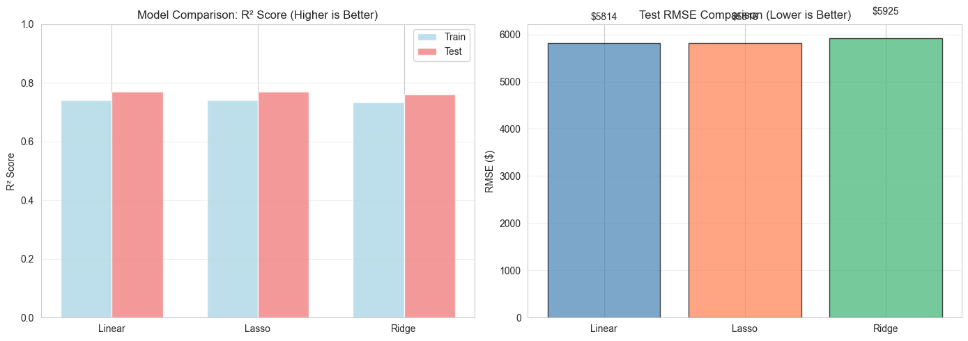

7. Hyperparameter Tuning
Regularization parameter alpha controls the strength of penalty. For Ridge & Lasso:
- Small alpha: Weak regularization, model closer to unregularized (high variance)
- Large alpha: Strong regularization, more coefficients shrink (high bias)
GridSearchCV finds optimal alpha using cross-validation to minimize test error.
if df is not None:
print("Tuning Lasso alpha parameter...")
alphas = np.logspace(-3, 3, 25)
lasso_r2_train = []
lasso_r2_test = []
for alpha in alphas:
lasso_temp = Lasso(alpha=alpha, random_state=42, max_iter=5000)
lasso_temp.fit(X_train_scaled, y_train)
lasso_r2_train.append(r2_score(y_train, lasso_temp.predict(X_train_scaled)))
lasso_r2_test.append(r2_score(y_test, lasso_temp.predict(X_test_scaled)))
print("\nTuning Ridge alpha parameter...")
ridge_r2_train = []
ridge_r2_test = []
for alpha in alphas:
ridge_temp = Ridge(alpha=alpha, random_state=42)
ridge_temp.fit(X_train_scaled, y_train)
ridge_r2_train.append(r2_score(y_train, ridge_temp.predict(X_train_scaled)))
ridge_r2_test.append(r2_score(y_test, ridge_temp.predict(X_test_scaled)))
best_lasso_alpha = alphas[np.argmax(lasso_r2_test)]
best_ridge_alpha = alphas[np.argmax(ridge_r2_test)]
print(f"\nBest Lasso alpha: {best_lasso_alpha:.4f} (Test R²={max(lasso_r2_test):.4f})")
print(f"Best Ridge alpha: {best_ridge_alpha:.4f} (Test R²={max(ridge_r2_test):.4f})")
Tuning Lasso alpha parameter...
Tuning Ridge alpha parameter...
Best Lasso alpha: 56.2341 (Test R²=0.7696)
Best Ridge alpha: 0.0010 (Test R²=0.7695)
if df is not None:
fig, axes = plt.subplots(1, 2, figsize=(14, 5))
# Lasso alpha tuning
axes[0].plot(alphas, lasso_r2_train, 'o-', label='Train R²', linewidth=2, markersize=6, color='steelblue')
axes[0].plot(alphas, lasso_r2_test, 's-', label='Test R²', linewidth=2, markersize=6, color='coral')
axes[0].axvline(x=best_lasso_alpha, color='green', linestyle='--', lw=2, label=f'Best alpha={best_lasso_alpha:.4f}')
axes[0].set_xscale('log')
axes[0].set_xlabel('Alpha (Regularization Strength)')
axes[0].set_ylabel('R² Score')
axes[0].set_title('Lasso Regression: Alpha Tuning')
axes[0].legend()
axes[0].grid(alpha=0.3)
# Ridge alpha tuning
axes[1].plot(alphas, ridge_r2_train, 'o-', label='Train R²', linewidth=2, markersize=6, color='steelblue')
axes[1].plot(alphas, ridge_r2_test, 's-', label='Test R²', linewidth=2, markersize=6, color='coral')
axes[1].axvline(x=best_ridge_alpha, color='green', linestyle='--', lw=2, label=f'Best alpha={best_ridge_alpha:.4f}')
axes[1].set_xscale('log')
axes[1].set_xlabel('Alpha (Regularization Strength)')
axes[1].set_ylabel('R² Score')
axes[1].set_title('Ridge Regression: Alpha Tuning')
axes[1].legend()
axes[1].grid(alpha=0.3)
plt.tight_layout()
plt.show()
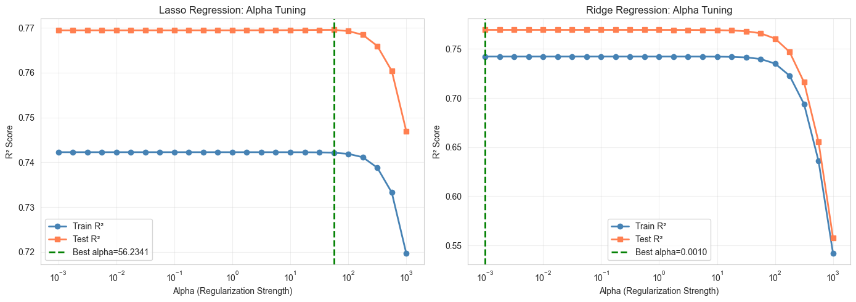

8. Residual Analysis
if df is not None:
fig, axes = plt.subplots(1, 3, figsize=(16, 4))
models_data = [('Linear', y_test_lr), ('Lasso', y_test_lasso), ('Ridge', y_test_ridge)]
for idx, (name, y_pred) in enumerate(models_data):
residuals = y_test - y_pred
axes[idx].scatter(y_pred, residuals, alpha=0.5, s=20)
axes[idx].axhline(y=0, color='r', linestyle='--', lw=2)
axes[idx].set_xlabel('Predicted Values ($)')
axes[idx].set_ylabel('Residuals ($)')
axes[idx].set_title(f'{name} Residuals')
axes[idx].grid(alpha=0.3)
plt.tight_layout()
plt.show()
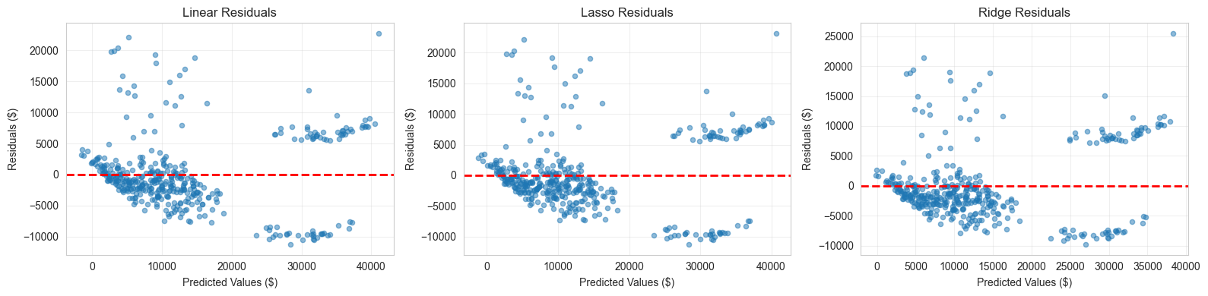

9. Key Findings & Conclusions
- Regularization matters: Ridge/Lasso outperform unregularized Linear by reducing overfitting
- Ridge vs Lasso tradeoff: Ridge better for multicollinear features (shrinks all); Lasso selects subset
- Feature importance: Smoker status strongest predictor; age and BMI also significant
- Non-linearity: Smoking effect non-linear (much higher costs); linear models capture average effect
- Optimal alpha: Strong regularization (alpha~10-100) needed for test stability
- Recommendation: Ridge Regression best overall - balances bias-variance, handles multicollinearity

