**THE NETHERLANDS**



(N E D E R L A N D)

**COMMUNICATION**

Concerning[1](1):

- approval granted

- ~~approval extended~~

- ~~approval refused~~

- ~~approval withdrawn~~

- ~~production definitely discontinued~~

of a type of safety glazing material pursuant to Regulation number 43.

|  |  |  |  |
| --- | --- | --- | --- |
| **Approval number: {{approval_no}}** | | | |
| Approval mark | | | |
| ***II***    **{{simple_no}}** | | | |
| 1. | Class of safety glazing material | : | Ordinary laminated-glass windscreen |
| 2. | Description of the type of glazing: please refer to appendices 1, 2, 3, 4, 5, 6, 7, 8, 9, 10, 11 and 12 (1), and in the case of windscreens, the list conforming to appendix 13 | : | Please refer to Appendix 3 and Appendix 13. |
| 3. | Trade names or marks | : | {{trade_names}}{% for image in trade_marks %}{{image}}{% if not loop.last %};{% endif %}{% endfor %} |
| 4. | Manufacturer’s name and address | : | {{company_name}} |
| 5. | If applicable, name and address of manufacturer’s representative | : | not applicable |
| 6. | Submitted for approval on | : | {{approval_date}} |
| 7. | Technical service responsible for conducting approval tests | : | TÜV NORD Mobilität GmbH & Co. KG (HQ)  IFM-Institut für Fahrzeugtechnik und Mobilität  Schönscheidtstrasse 28, 45307 Essen  Germany |
| 8. | Date of report issued by that service | : | {{report_date}} |
| 9. | Number or report issued by that service | : | {{report_no}} |
| 10. | Approval is | : | granted/~~refused/extended/withdrawn~~ (1) |
| 11. | Reason(s) for extension of approval | : | Not applicable |
| 12. | Remarks | : | --- |
| 13. | Place | : | Zoetermeer |
| 14. | Date | : |  |
| 15. | Signature | : |  |
| 16. | The list of documents filed with the administrative service which has granted approval and available on request is annexed to this communication. | | |

**APPENDIX 3**

# Laminated-glass windscreens

(Principal and secondary characteristics as defined in annex 6, 8 or 9 to Regulation number 43)

|  |  |  |  |
| --- | --- | --- | --- |
| **Principal characteristics:** | |  |  |
|  | Number of layers of glass | : | {{glass_layers}} |
|  | Number of layers of interlayer | : | {{interlayer_layers}} |
|  | Nominal thickness of the windscreen | : | {{windscreen_thick}} |
|  | Nominal thickness of interlayer(s) | : | {{interlayer_thick}} |
|  | Special treatment of glass | : | {{glass_treatment}} |
|  | Nature and type of interlayer(s) | : | {{interlayer_type}} |
|  | Nature and type of plastics coating(s) | : | {{coating_type}} |
|  | Nominal thickness of plastic coating(s) | : | {{coating_thick}} |
| **Secondary characteristics:** | |  |  |
|  | Nature of the material (plate, float, sheet glass) | : | {{material_nature}} |
|  | Colouring of glass | : | {% if glass_color_choice == "tinted_struck" %}(colourless/~~tinted~~){% elif glass_color_choice == "colourless_struck" %}(~~colourless~~/tinted){% elif glass_color_choice == "both_visible" %}(colourless/tinted){% endif %}(1) |
|  | Colouring of plastics coating(s) | : | {{coating_color}} |
|  | Colouring of interlayer | : | ({% if interlayer_total %}total{% else %}~~total~~{% endif %}/{% if interlayer_partial %}partial{% else %}~~partial~~{% endif %}) {% if not interlayer_colourless and (interlayer_total or interlayer_partial) %}tinted{% else %}~~tinted~~{% endif %}/{% if interlayer_colourless %}colourless{% else %}~~colourless~~{% endif %} |
|  | Conductors incorporated | : | {% if conductors_choice == "yes_struck" %}~~yes~~/no{% elif conductors_choice == "no_struck" %}yes/~~no~~{% elif conductors_choice == "both_visible" %}yes/no{% endif %}(1) |
|  | Opaque obscuration incorporated | : | {% if opaque_obscure_choice == "yes_struck" %}~~yes~~/no{% elif opaque_obscure_choice == "no_struck" %}yes/~~no~~{% elif opaque_obscure_choice == "both_visible" %}yes/no{% endif %} |
| Remarks:  … | | | |
| Documents attached: list of windscreens (see appendix 13) | | | |

{% for vehicle in vehicles %}

**APPENDIX 13**

**Contents of the list of windscreens** (1)

For each of the windscreens covered by this approval, at least the following particulars  
shall be provided:

|  |  |  |  |
| --- | --- | --- | --- |
|  | Vehicle manufacturer | : | {{vehicle.veh_mfr}} |
|  | Type of vehicle | : | {{ vehicle.veh_type}} |
|  | Vehicle category | : | {{ vehicle.veh_cat}} |
|  | Developed area (F) | : | {{ vehicle.dev_area}} |
|  | Height of segment (h) | : | {{ vehicle.seg_height}} |
|  | Curvature (r) | : | {{ vehicle.curv_radius}} |
|  | Installation angle (α) | : | {{ vehicle.inst_angle}} |
|  | Seat-back angle (β) | : | {{ vehicle.seat_angle}} |
|  | R-point co-ordinates (A, B, C) relative to the centre of the upper edge of the windscreen | : | {{ vehicle.rpoint_coords}} |
|  | Description of the commercially available specific device mentioned in annex 3, paragraph 4.9.2. (if applicable) | : | {{ vehicle.dev_desc}} |

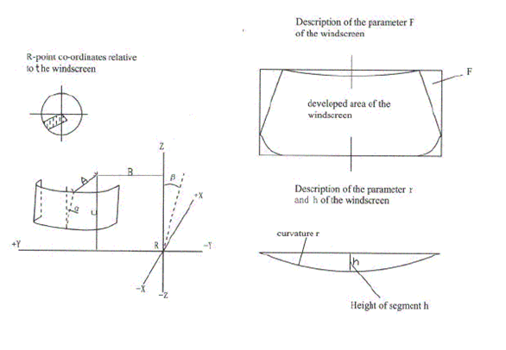

————————————

(1) These particulars shall be attached to appendices 1, 2 (if applicable) 3 and 5 to this annex.{% if not loop.last %}{% endif %}{% endfor %}

1. (1) Strike out what does not apply.