**TECHNICAL DESCRIPTION**

**(LAMINATED-GLASS WINDSCREENS)**

|  |  |  |  |  |  |  |  |
| --- | --- | --- | --- | --- | --- | --- | --- |
| Approval No.: | **{{approval_no}}** |  | | |  | |  |
|  | | | | | |  | |
| Information folder number: | | | | | | {{information_folder_no}} | |
|  | | | | | | | |
| Class of safety-glass pane | | | : | {{safety_class}} | | | |
|  | | |  |  | | | |
| Description of glass pane | | | : | {{pane_desc}} | | | |
|  | | |  |  | | | |
| Trade name | | | : | {{trade_names}}{% for image in trade_marks %}{{image}} {% endfor %} | | | |
|  | | |  |  | | | |
| Name and address of manufacturer | | | : | {{company_name}} {{company_address}} | | | |
|  | | |  |  | | | |
| Principal characteristics | | |  |  | | | |
| Number of layers of glass | | | : | {{glass_layers}} | | | |
| Number of layers of interlayer | | | : | {{interlayer_layers}} | | | |
| Nominal thickness of the windscreen | | | : | {{windscreen_thick}} | | | |
| Nominal thickness of interlayer(s) | | | : | {{interlayer_thick}} | | | |
| Special treatment of glass | | | : | {{glass_treatment}} | | | |
| Nature and type of interlayer(s) | | | : | {{interlayer_type}} | | | |
| Nature and type of plastics coating(s) | | | : | {{coating_type}} | | | |
| Nominal thickness of plastic coating(s) | | | : | {{coating_thick}} | | | |
|  | | |  |  | | | |
| Secondary characteristics | | |  |  | | | |
| Nature of the material (plate, float, sheet glass) | | | : | {{material_nature}} | | | |
| Colouring of glass (colourless/tinted) | | | : | {% if glass_color_choice == "tinted_struck" %}(colourless/~~tinted~~){% elif glass_color_choice == "colourless_struck" %}(~~colourless~~/tinted){% elif glass_color_choice == "both_visible" %}(colourless/tinted){% endif %} | | | |
| Colouring of plastics coating(s) | | | : | {{coating_color}} | | | |
| Colouring of interlayer (total/partial) | | | : | ({% if interlayer_total %}total{% else %}~~total~~{% endif %}/{% if interlayer_partial %}partial{% else %}~~partial~~{% endif %}) {% if not interlayer_colourless and (interlayer_total or interlayer_partial) %}tinted{% else %}~~tinted~~{% endif %}/{% if interlayer_colourless %}colourless{% else %}~~colourless~~{% endif %} | | | |
| Conductors incorporated (yes/no) | | | : | {% if conductors_choice == "yes_struck" %}~~yes~~/no{% elif conductors_choice == "no_struck" %}yes/~~no~~{% elif conductors_choice == "both_visible" %}yes/no{% endif %} | | | |
| Opaque obscuration incorporated (yes/no) | | | : | {% if opaque_obscure_choice == "yes_struck" %}~~yes~~/no{% elif opaque_obscure_choice == "no_struck" %}yes/~~no~~{% elif opaque_obscure_choice == "both_visible" %}yes/no{% endif %} | | | |
|  | | |  |  | | | |
| Remarks | | | : | {{remarks}} | | | |
|  | | |  |  | | | |

_____________________________________________________________________________

Documents attached: list of windscreens (see appendix 13).

{% for vehicle in vehicles %}

Annex 1 - Appendix 13

**CONTENTS OF THE LIST OF WINDSCREENS** 1/

|  |  |  |  |
| --- | --- | --- | --- |
| Information folder number: | | | {{information_folder_no}} |
|  | | | |
| For each of the windscreens covered by this approval, at least the following particulars shall be provided: | | | |
| Vehicle manufacturer | : | {{vehicle.veh_mfr}} | |
| Type of vehicle | : | {{vehicle.veh_type}} | |
| Vehicle category | : | {{vehicle.veh_cat}} | |
| Developed area (F) | : | {{vehicle.dev_area}} | |
| Height of segment (h) | : | {{vehicle.seg_height}} | |
| Curvature (r) | : | {{vehicle.curv_radius}} | |
| Installation angle (α) | : | {{vehicle.inst_angle}} | |
| Seat-back angle (β) | : | {{vehicle.seat_angle}} | |
| R-point coordinates (A, B, C) relative to the centre of the upper edge of the windscreen. | : | {{vehicle.rpoint_coords}} | |
| Description of the commercially available specific device mentioned in annex 3, paragraph 4.9.2. (if applicable) | : | {{vehicle.dev_desc}} | |

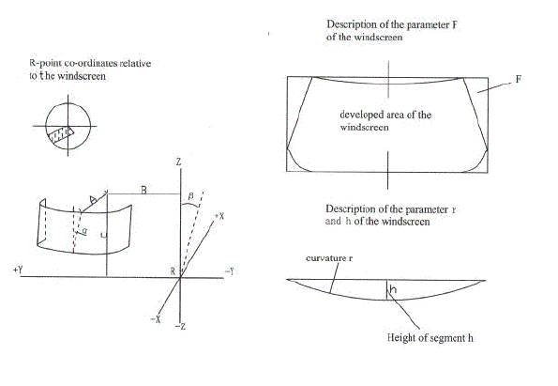

{% if not loop.last %}

{% endif %}{% endfor %}