**Abstract –** In this project we have created multiple recommendation systems to replicate and improve the recommendation engine present in streaming service Crunchyroll.

1. **Introduction**

This project report presents the research and development efforts of our team regarding the data mining and recommendation techniques utilized by Crunchyroll. The motivation behind this project is the potential for recommendation systems to further enhance user engagement and experience on the platform.

The main goals of this project were to analyze the applications of pre-calculated vs. on demand recommendations, especially with large datasets. Additionally, the application of static vs machine learning style recommender algorithms and user satisfiability.

This team currently has personal interest regarding Crunchyroll user experience, as members of the team utilize the streaming service and have noticed less than desirable recommendations. The team was hoping to understand the current process of recommendation and develop recommendation algorithms that would enhance user experience on the Crunchyroll platform.

Sourcing current and comprehensive datasets was the major initial hurdle to overcome regarding the development of recommendation algorithms. Furthermore, not every user rates shows they watch, and the lack of user watch habits means recommendations are purely based upon ratings which may not be as comprehensive as possible.

This team has concluded that utilizing a combination of static and machine learning algorithms will provide consistent recommendations that can be calculated while the user is not utilizing the streaming service. Moreover, the adaptation of multiple algorithms into different sections of the platform allows users to explore new content without issues with potential overspecialization and popularity bias.

1. **Data Mining Task**

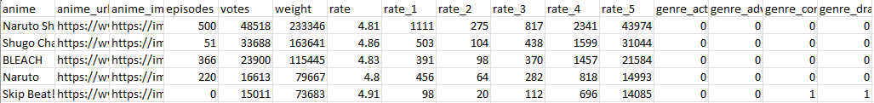Our input data is extremely vast and consists of data regarding show catalogs, user profiles, and individual ratings. Each type of data allows for the recommendation engine to take different traditional approaches (item-item and user-user) when calculating preferences.

*Figure 1: Show catalog with ratings and genre vectors*

*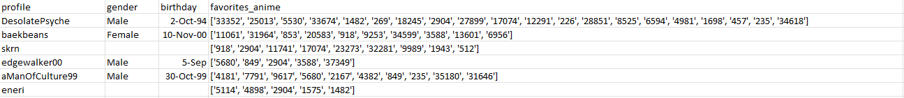Figure 2: Individual user profiles with basic identifiers and favorite shows.*

Our output showcases individual recommendations, similar shows, and different approaches to standard popularity trends as well as algorithmic runtime and RMSE.

**

*Figure 3: Artistic representation output on Crunchyroll platform for profile DesolatePsyche*

*Figure 4: TensorFlow recommendation with epoch runtime and success rate*

We wanted to explore the following fields: What is the ROI for implanting an assortment of recommendation algorithms? What styles of recommendation provide high user satisfiability? Do machine learning algorithms provide a time or satisfiability advantage to their static counterparts?

Beyond the challenges involved with implementing machine learning algorithms, our biggest challenge for these tasks was measuring our success. As previously mentioned, a lack of data on user habits makes our recommendations purely rating based. What’s more developing metrics to compare and improve algorithms proved to be a challenge, especially with the size scope of this project.

1. **Technical Approach**
2. **Evaluation Methodology**

The collection of our datasets was all directly sourced from Kaggle. Gathering these sources was simple, however, some datasets utilize the zstd standard or are ~500mb large. This meant developing between the members of the team took additional start time as each developer had to separately download the dataset as the hosting site used, GitHub, includes a 100mb file size limit. We were able to verify the integrity of the data being used as it was sourced from Crunchyroll directly or reliable third-party site MyAnimeList and had been used for other projects.

The evaluation of success involved two main metrics. RMSE (root mean square error) and training or calculation time. RMSE is automatically calculated by the machine learning libraries and provides a measurement of performance for unknown training data. Additionally, because multiple machine learning algorithms were implemented this metric can be used to compare effectiveness and determine a relative weight when presenting a final set for the user. This choice can provide a potential conversion for users to understand why they may be recommended certain shows. The measurement of time is an obvious and helpful tool for measurement. When dealing with large datasets it is important to understand the computational and time cost involved with generating recommendations. Additionally, as the team was exploring potential on-demand solutions, understanding time complexity makes sure users don’t experience delays improving satisfaction.

1. **Results and Discussion**
2. **Lessons Learned**

This project has provided beneficial insight into the scope and investment opportunities companies make for developing services. Without parallel computing and powerful servers calculating even a sample would take multiple hours for isolated algorithms. On top of that, this project scope only covers the second half necessary for recommendation engines. The major technical hurdle occurs when developing user habits (time spent watching a show, % of show watched, etc.).

If this team had more resources: time, computing power, and access to user habits, the ability to explore and make machine learning algorithms to develop a basis for recommendations would prove invaluable.

1. **Acknowledgements**

We would like to express our sincere gratitude to everyone who contributed to the successful completion of this project.

Firstly, we would like to thank the team at Crunchyroll for providing us insight into their recommendation algorithms and technical resources, which were crucial to the development of our own recommendation engine.

Additionally, we would like to thank Filipefilardi who worked tirelessly to collect and partition the below data, which provided the basis for this entire project.

<https://www.kaggle.com/datasets/filipefilardi/crunchyroll-anime-ratings>

Finally, a special thank you to Marlesson who provided and gathered vital review data from third party site MyAnimeList. In addition, the collection of other available review data to crossreference.

<https://www.kaggle.com/datasets/marlesson/myanimelist-dataset-animes-profiles-reviews>