**Purpose:**

This analysis and visualisation are aiming to investigate whether there is difference between the pre- and post- pineapple juice (PJ) administration on participant’s cT1, Iron and PDFF values.

**Methods:**

In total 80 cases were collected (40 cases pre-PJ administration, 40 cases post-PJ administration). Each case underwent MRCP and Liver LMS image acquisition. The liver images were then processed with auto-segmentation, and multi-parametric quantification with LMS Discover. Among the 40 cases, the analysis of 10 cases were incomplete (some lack cT1 and Iron values) and therefore were excluded from further analysis. From the 30 LMS reports, the cT1, Iron and PDFF median values and interquartile range values were organised into a dataset to proceed with data visualisation, descriptive statistics, and paired t-test.

**Results:**

Please see Appendix 1 for a complete table of data used for analysis.

Figure.1 and Figure.2 show the individual cT1 values pre-PJ and post-PJ respectively. The green shaded areas indicate the reference interval from 95% confidence interval on cT1 distribution in healthy subjects with BMI < 25 kg/m. The error bars indicate the standard deviation of cT1 value among this population of 30 cases. 4 out of 30 pre-PJ cases (subject 2, 3, 6, 8) showed cT1 value beyond the healthy reference interval. 6 out of 30 post-PJ cases (subject 2, 3, 6, 8, 19, 27) showed cT1 value beyond the healthy reference interval.

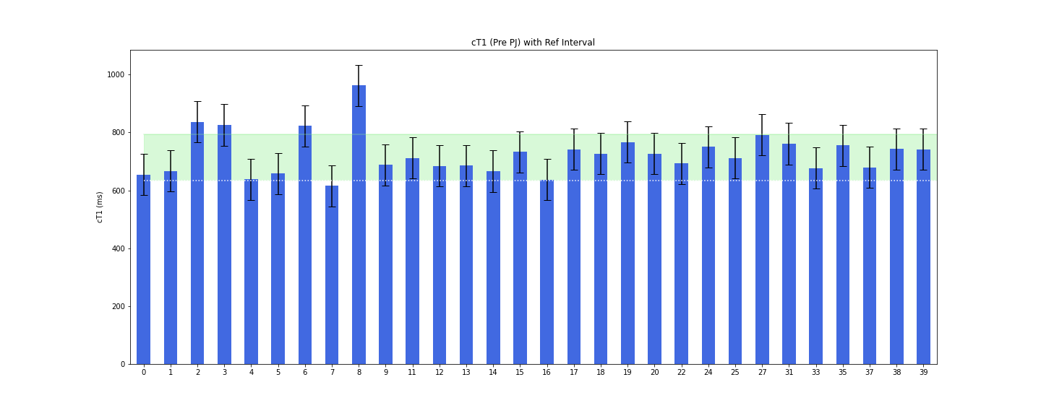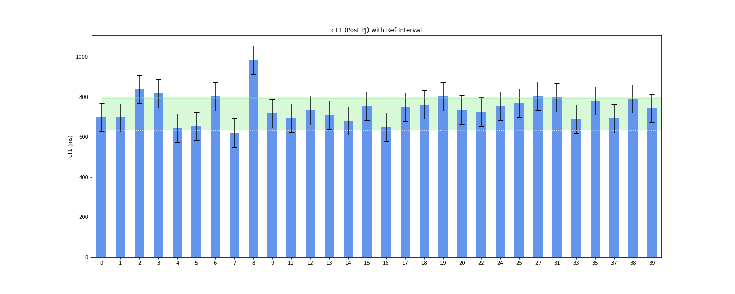

Figure.3 and Figure.4 show the individual iron concentrations pre-PJ and post-PJ respectively. The green shaded area means the healthy range of Iron concentration in the liver is below 1.8 mg/g (< 1,8 mg/g dry liver). At both time points, one case (subject 16) showed beyond normal Iron concentration.

Figure.5 and Figure.6 show the individual PDFF percentage pre-PJ and post-PJ respectively. The green shaded area means the healthy range of PDFF concentration in the liver is below 5.6 %. 4 out of 30 pre-PJ cases (subject 1, 8, 27, 38) showed PDFF concentrations higher than normal range. 3 out of 30 post-PJ cases (subject 8, 27, 38) showed PDFF concentrations higher than normal range.

Further analysis aims to visualise if the values are different across the 2 timepoints. Figure.7 shows the difference between post-PJ and pre-PJ for each biomarkers. The bar above 0 shows the positive outcome after the subtraction: (post-PJ) - (pre-PJ) and vice versa. Figure.8 shows the trend of the biomarkers change after PJ administration. The red line indicates the median of the changes. Figure.9 is the scatter plots with the x axis being pre PJ and y axis being post PJ values. From these graphs, it seemed that there is a positive change in the cT1, small to no change in the Iron values, Graphical user interface
and a slight decrease in the PDFF value post PJ administration.

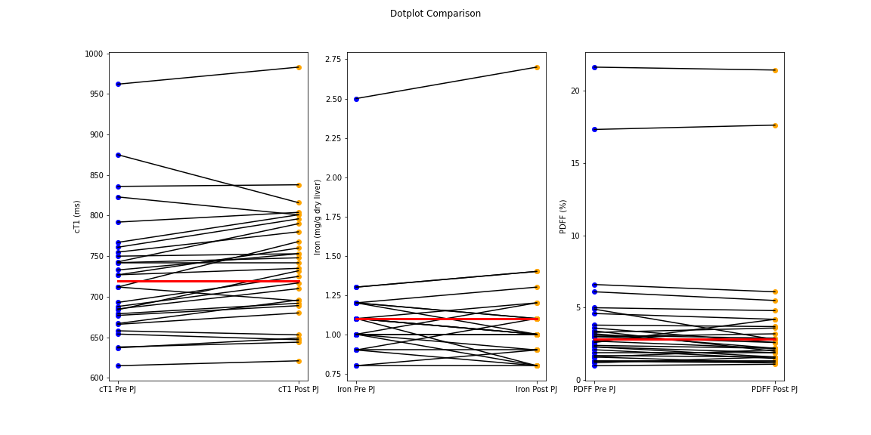

Further analysis is to judge whether paired t-test will be suitable. By confirming from the box plot, histogram and Shapiro Wilk signed-rank Test, we conclude that the distribution of the dataset is not guassian diistribution. Therefore a Wilcoxon signed-rank test should be used.

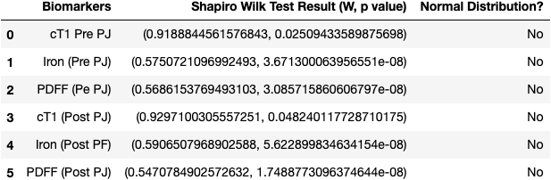

We further conducted Wilcoxon signed-rank Test to see if the difference of the median of each of the biomarkers between timepoints is statistically significant. Assuming that a p value < 0.05 is considered significant, the changes of cT1 and PDFF values post pineapple juice administration are statistically significant.

Strictly speaking because the cT1 datasets failed Shapiro Wilk test, therefore the samples were not normally distributed. However, given the fact that the histogram and box plot showed near normal distributions, we use paired sample T test to see if cT1 (Pre PJ) and cT1 (Post PJ) are significantly different. The following T test result and descriptive statistics allow us to report that cT1 (Post PJ) is greater than the cT1 (Pre PJ) with statistical confidence. The mean values are 740.6 ms (Post PJ) and 725.0 ms (Pre PJ). (Paired T test; t = -4.9, df = 29, p = 0.00003)





Bland Altman plots is used to evaluate the agreement among the 2 measurements on the same sample and thus will be useful to tell if there are measurement related errors. It can be systematic errors and/or relative errors. Although with the current dataset we have, we don’t have 2 measurements at each timepoint. However, in order to interpret Bland Altman results, let’s make an assumption: there is **NO** pineapple juice administered. Therefore, the y axis corresponds to 2 measurements.

In the cT1 Bland Altman plot, there seems to be no measurement errors, hence the differences in cT1 value can be concluded to the effect of pineapple juice.

In the Iron Bland Altman plot, there seems to be no measurement errors. With previous tests, we had concluded that the differences of Iron between each timepoint is not significant.

In the PDFF Bland Altman plot, the distribution of the differences seems to tilt toward the positive side hence there might be systematic errors in the measurement. Further repeatability experiment is needed to disseminate whether the differences of PDFF values between both timepoints is a result of measurement error or effect of pineapple juice.

Appendix 1

|  |  |  |  |  |  |  |  |  |  |  |  |  |  |  |  |  |  |  |  |  |  |  |  |  |  |  |  |
| --- | --- | --- | --- | --- | --- | --- | --- | --- | --- | --- | --- | --- | --- | --- | --- | --- | --- | --- | --- | --- | --- | --- | --- | --- | --- | --- | --- |
|  | Record Id | Portal ID LMS0 (pre PJ) | LMS0 (pre PJ) | Portal ID LMS1 (post PJ) | LMS1 (post PJ) | cT1 (Pre PJ) | Iron (Pre PJ) | PDFF (Pre PJ) | cT1 (Post PJ) | Iron (Post PJ) | PDFF (Post PJ) | cT1 Q1 (Pre PJ) | cT1 Q3 (Pre PJ) | Iron Q1 (Pre PJ) | Iron Q3 (Pre PJ) | PDFF Q1 (Pre PJ) | PDFF Q3 (Pre PJ) | cT1 Q1 (Post PJ) | cT1 Q3 (Post PJ) | Iron Q1 (Post PJ) | Iron Q3 (Post PJ) | PDFF Q1 (Post PJ) | PDFF Q3 (Post PJ) | cT1 Ref Int Lower | cT1 Ref Int Upper | Iron Ref Int | PDFF Ref Int |
| 0 | EXP010_002 | 11947 | EXP010vhobplp | 9827 | EXP010kfnnfem | 654 | 1.1 | 4.9 | 698 | 1.2 | 4.8 | 626 | 695 | 1.1 | 1.2 | 3.9 | 5.9 | 668 | 735 | 1.1 | 1.2 | 3.8 | 5.9 | 633 | 794 | 1.8 | 5.6 |
| 1 | EXP010_003 | 9625 | EXP010vetygxw | 9623 | EXP010nzjwutv | 667 | 1.1 | 6.1 | 696 | 1 | 5.5 | 643 | 701 | 1.1 | 1.2 | 4.7 | 7.5 | 640 | 696 | 1 | 1.1 | 4.1 | 7 | 633 | 794 | 1.8 | 5.6 |
| 2 | EXP010_004 | 9834 | EXP010vkcrjqc | 9830 | EXP010ooxyfwn | 836 | 1 | 1.9 | 838 | 0.8 | 1.9 | 808 | 881 | 1 | 1.1 | 1.1 | 2.8 | 810 | 881 | 0.8 | 0.8 | 1.1 | 2.7 | 633 | 794 | 1.8 | 5.6 |
| 3 | EXP010_005 | 9818 | EXP010vpitawu | 9816 | EXP010otlxkrz | 826 | 1 | 1.2 | 816 | 1 | 1.6 | 793 | 785 | 0.9 | 1.1 | 0.1 | 2.4 | 786 | 867 | 0.9 | 1 | 0.4 | 3.1 | 633 | 794 | 1.8 | 5.6 |
| 4 | EXP010_006 | 9843 | EXP010vuvdody | 9840 | EXP010ochlmjx | 638 | 1.1 | 3.6 | 644 | 1.1 | 2.6 | 614 | 675 | 1 | 1.2 | 2.4 | 4.8 | 616 | 678 | 1.1 | 1.2 | 1.6 | 3.8 | 633 | 794 | 1.8 | 5.6 |
| 5 | EXP010_007 | 9820 | EXP010woaclvx | 9814 | EXP010ogwfklv | 658 | 1.1 | 1.3 | 653 | 1.1 | 1.3 | 633 | 699 | 1 | 1.1 | 0 | 2.8 | 632 | 688 | 1 | 1.1 | 0 | 2.7 | 633 | 794 | 1.8 | 5.6 |
| 6 | EXP010_008 | 9618 | EXP010wktzdls | 9616 | EXP010olbctkw | 823 | 0.9 | 1.6 | 801 | 0.8 | 2.1 | 780 | 861 | 0.9 | 1 | 0.9 | 2.4 | 764 | 842 | 0.8 | 0.9 | 1.3 | 3.1 | 633 | 794 | 1.8 | 5.6 |
| 7 | EXP010_009 | 9819 | EXP010waxoiey | 9815 | EXP010opqcxxj | 615 | 1.3 | 1.7 | 621 | 1.4 | 1.6 | 597 | 652 | 1.2 | 1.3 | 0.2 | 3.1 | 600 | 656 | 1.3 | 1.5 | 0 | 3.1 | 633 | 794 | 1.8 | 5.6 |
| 8 | EXP010_011 | 9962 | EXP010wlnocav | 9958 | EXP010oyklrkq | 962 | 1.3 | 21.6 | 983 | 1.4 | 21.4 | 883 | 1034 | 1.3 | 1.4 | 20 | 23 | 917 | 1045 | 1.3 | 1.4 | 19.8 | 22.6 | 633 | 794 | 1.8 | 5.6 |
| 9 | EXP010_012 | 9973 | EXP010wrtonqh | 9971 | EXP010pzugyag | 688 | 1 | 3.4 | 717 | 1 | 2 | 664 | 722 | 1 | 1 | 1.5 | 5.3 | 692 | 749 | 1 | 1 | 0.9 | 3.3 | 633 | 794 | 1.8 | 5.6 |
| 11 | EXP010_014 | 9964 | EXP010xresjqh | 9959 | EXP010pbukhnp | 712 | 1 | 3.1 | 695 | 1 | 2.9 | 683 | 753 | 0.9 | 1.2 | 1.9 | 4.5 | 668 | 732 | 1 | 1.1 | 1.9 | 4.2 | 633 | 794 | 1.8 | 5.6 |
| 12 | EXP010_015 | 9965 | EXP010xukgukr | 9960 | EXP010pgarsgq | 684 | 1 | 2.6 | 732 | 1.2 | 4.2 | 660 | 719 | 1 | 1.1 | 1.5 | 3.8 | 700 | 770 | 1 | 1.3 | 2.6 | 5.7 | 633 | 794 | 1.8 | 5.6 |
| 13 | EXP010_016 | 9938 | EXP010xcidtzf | 9932 | EXP010pkplxry | 685 | 1.1 | 2.3 | 710 | 1 | 1.9 | 662 | 722 | 1 | 1.1 | 0.6 | 4.4 | 684 | 753 | 0.9 | 1 | 0.4 | 3.8 | 633 | 794 | 1.8 | 5.6 |
| 14 | EXP010_017 | 9939 | EXP010xhwjezc | 9933 | EXP010ppzojig | 666 | 1.2 | 1 | 680 | 1.1 | 1.1 | 646 | 699 | 1.2 | 1.3 | 0 | 2.2 | 661 | 711 | 1.1 | 1.1 | 0 | 2.4 | 633 | 794 | 1.8 | 5.6 |
| 15 | EXP010_018 | 9940 | EXP010xnqqfxi | 9945 | EXP010ptkyvkf | 733 | 1.1 | 1.3 | 753 | 1.1 | 1.2 | 710 | 766 | 1.1 | 1.2 | 0.1 | 2.7 | 732 | 785 | 1.1 | 1.1 | 0 | 2.7 | 633 | 794 | 1.8 | 5.6 |
| 16 | EXP010_019 | 10166 | EXP010xsnkfaa | 10164 | EXP010pyrnfmw | 637 | 2.5 | 4.6 | 649 | 2.7 | 4.2 | 604 | 711 | 2.3 | 2.7 | 3.2 | 6 | 614 | 723 | 2.2 | 2.9 | 2.7 | 5.8 | 633 | 794 | 1.8 | 5.6 |
| 17 | EXP010_020 | 10181 | EXP010xyhlgie | 10178 | EXP010qgnaouz | 742 | 1 | 3.8 | 748 | 0.9 | 3.7 | 717 | 777 | 0.9 | 1 | 2.6 | 4.9 | 723 | 783 | 0.8 | 0.9 | 2.7 | 4.8 | 633 | 794 | 1.8 | 5.6 |
| 18 | EXP010_021 | 10183 | EXP010yfiqjin | 10180 | EXP010qwltdhh | 727 | 1 | 2.7 | 760 | 1 | 2.2 | 701 | 762 | 0.8 | 1.1 | 1.7 | 3.7 | 734 | 798 | 0.9 | 1.1 | 1.3 | 3.4 | 633 | 794 | 1.8 | 5.6 |
| 19 | EXP010_022 | 10170 | EXP010ytmdrax | 10165 | EXP010qbcnicl | 767 | 0.8 | 3.3 | 801 | 0.8 | 3.6 | 735 | 801 | 0.7 | 0.8 | 0.9 | 5.1 | 760 | 836 | 0.7 | 0.8 | 2.1 | 5.1 | 633 | 794 | 1.8 | 5.6 |
| 20 | EXP010_023 | 10141 | EXP010yeubkrf | 10136 | EXP010qfsrhca | 727 | 0.9 | 2.4 | 735 | 0.9 | 2.2 | 700 | 767 | 0.9 | 1 | 1.1 | 3.9 | 711 | 778 | 0.9 | 1 | 0.8 | 3.7 | 633 | 794 | 1.8 | 5.6 |
| 22 | EXP010_025 | 10156 | EXP010ypjqucg | 10150 | EXP010qopnvaq | 693 | 1.1 | 5 | 725 | 1.1 | 4.8 | 667 | 725 | 1.1 | 1.2 | 3.5 | 6.6 | 701 | 762 | 1 | 1.2 | 3.4 | 6.4 | 633 | 794 | 1.8 | 5.6 |
| 24 | EXP010_027 | 10674 | EXP010yztnezr | 10672 | EXP010qxmbkpu | 750 | 0.8 | 2.1 | 753 | 0.9 | 1.5 | 716 | 806 | 0.8 | 0.8 | 1.1 | 3.2 | 721 | 807 | 0.8 | 0.9 | 0.4 | 2.6 | 633 | 794 | 1.8 | 5.6 |
| 25 | EXP010_028 | 11392 | EXP010zcimduw | 11382 | EXP010rjzcqfv | 712 | 1.2 | 3 | 768 | 1 | 2.6 | 680 | 759 | 1.1 | 1.2 | 2.1 | 4.2 | 737 | 816 | 1 | 1.1 | 1.8 | 3.4 | 633 | 794 | 1.8 | 5.6 |
| 27 | EXP010_030 | 10723 | EXP010zgntdcr | 10726 | EXP010raztyee | 792 | 1.2 | 17.3 | 804 | 1.3 | 17.6 | 759 | 836 | 1.2 | 1.3 | 15 | 19 | 770 | 847 | 1.2 | 1.3 | 15.1 | 19.4 | 633 | 794 | 1.8 | 5.6 |
| 31 | EXP010_035 | 10681 | EXP010yljbbzh | 10680 | EXP010rxcfdnn | 761 | 1.1 | 3.2 | 796 | 0.8 | 2.2 | 735 | 795 | 1 | 1.1 | 2 | 4.5 | 769 | 837 | 0.8 | 0.9 | 1.4 | 3 | 633 | 794 | 1.8 | 5.6 |
| 33 | EXP010_037 | 11350 | EXP010izqbipr | 11359 | EXP010satrxbp | 677 | 1.2 | 1.3 | 689 | 1.1 | 1.3 | 656 | 711 | 1.1 | 1.2 | 0 | 2.9 | 667 | 720 | 1.1 | 1.2 | 0.1 | 2.6 | 633 | 794 | 1.8 | 5.6 |
| 35 | EXP010_039 | 11385 | EXP010swffxwu | 11384 | EXP010sfjpmad | 755 | 1 | 2.3 | 780 | 1 | 1.6 | 726 | 792 | 0.9 | 1.1 | 1.3 | 3.3 | 750 | 820 | 0.9 | 1.2 | 0.8 | 2.5 | 633 | 794 | 1.8 | 5.6 |
| 37 | EXP010_041 | 11387 | EXP010vhntqjp | 11377 | EXP010nqgjyrz | 679 | 0.9 | 3 | 692 | 1.1 | 3.2 | 654 | 713 | 0.9 | 1 | 2 | 4.2 | 670 | 729 | 1 | 1.1 | 2.2 | 4.2 | 633 | 794 | 1.8 | 5.6 |
| 38 | EXP010_042 | 11454 | EXP010wgamgxp | 11354 | EXP010oufxzps | 743 | 1.1 | 6.6 | 790 | 1 | 6.1 | 717 | 778 | 1 | 1.1 | 5 | 8 | 733 | 790 | 1 | 1.1 | 4.5 | 7.7 | 633 | 794 | 1.8 | 5.6 |
| 39 | EXP010_043 | 11364 | EXP010zwbadsj | 11358 | EXP010roecjcc | 742 | 1 | 1.6 | 742 | 1 | 1.2 | 714 | 785 | 0.9 | 1 | 0 | 4.4 | 715 | 782 | 1 | 1.1 | 0 | 4 | 633 | 794 | 1.8 | 5.6 |