Basic analysis

Let us see how prices had been chaning from 13-17.

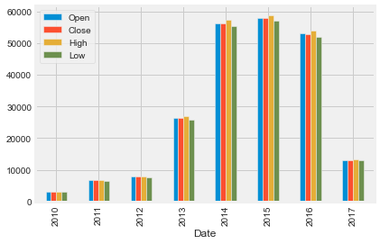

We may assume that 2014-2016 were very succesful period for Tesla because at tha time Elon Musk dreamed of Mars colonisation, whereas Tesla Model X and Model 3 were realesed.

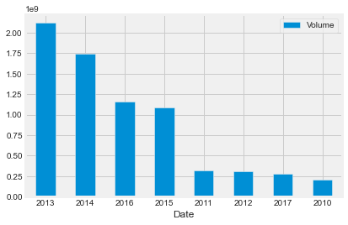

However, volume of traded securities show that people began intersted in Tesla in 2013 and Tesla therefore realesed many secutiries.

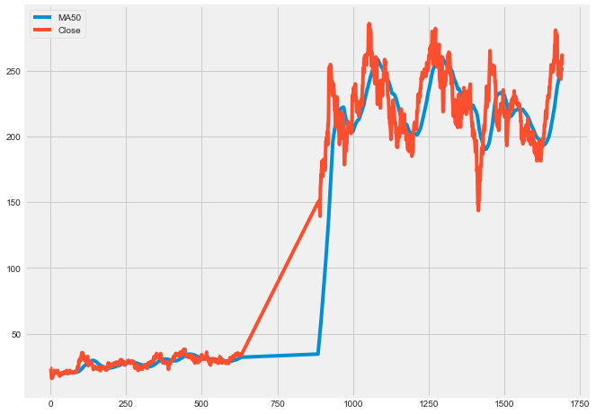

Now, let us look how close price looks in comparison with moving average. We build formula: where A-average in period, n- amount of periods.

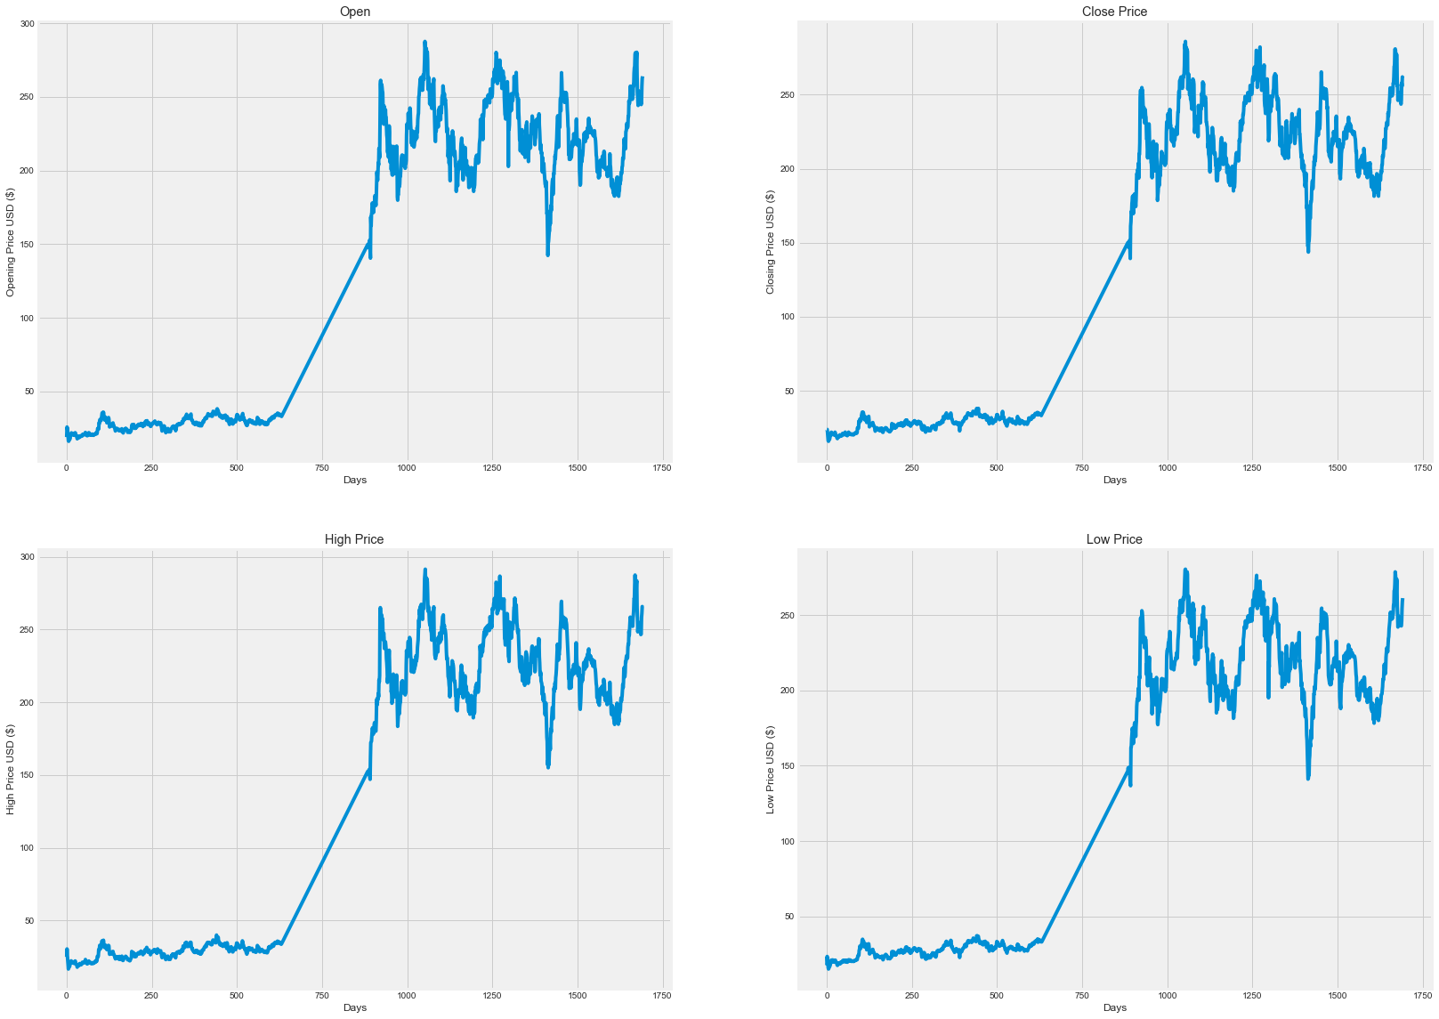

For more clarificaiton, I also added a simple time series of Tesla’s stock price which calculated in days for its more detailed volatility.

Monte Carlo Simulation

To undestand Method of Monte Carlo let us imagine a square with random lenght L, and points are changing from 0 to L in it. Therefore, we now can generate a random sample with 2 numbers . Hence, we get . Repeating this procedure many times we will have a greater amount of point fillings our square. The final number of points in the square will therefore characterise the area of the square. Or, suppose we share a room with a friend. The left side is yours, the right side is his. We draw a line on the floor to mark them, but you think it should be moved more to the right and so you start quarreling. You do not have a measuring tape (and besides, since the room is not a rectangle it's hard to measure), and we want to know if the division of the room is fair. What do we do? Therefore, in order to apply Monte Carlo Simulation, we throw the bouncy ball against a wall (really hard, so that it bounces against the floor and walls multiple times) and see where it ends up. We do this a lot of times and each times you note whether the ball ends up on our side or his side. If we keep doing this, and the room is divided fairly, the balls should land in each side of the room about the same time.

To perfom Monte Carlo Simulation, I used Yahoo Finance and integrated it into my analysis.

Now, time to build our simulation on the stock. Initally, we are going to build a simple model with a random value generator:

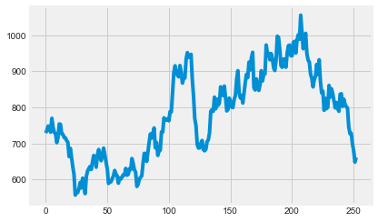

However, If I randomly choose values from 0 to 10000 with n-250- trading days-1 to close the year with a good profit.

Our model: , where where Pt is stock price today and Pt-1 is stock price yesterday, e- expected return or our random values, U is drift (or constant) SE is standard error.

We get:

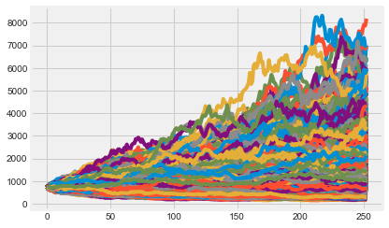

So, what this pictures tell us?

We see in this graph, that there is a possible realisation after the already realised path of the prices. Now we can go further for better prediction tools. Consequently, we should use logarithmic returns:

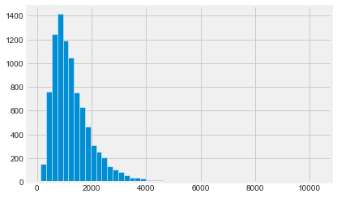

It can be interpreted as there is no seasonality, yet no any trend, just a general price changes with estimated future price of around 1284, while 10% chance that price will 535 and 10% that it will peak up to 2250 (calculations were made in Python).

Conclusion

The main question for a potential investor is should he invest into it?

Tesla used to be a company with the largest market cap in the car industry whereas they implemented many innovations into their automobiles. However, we also need to be really careful as it can be a bubble that may exploit if Tesla will make some crucial mistake in their management/engineering. Moreover, reading the news we already know that the industry and its factory are not really good in comparison with Germans for example. So, we probably cannot predict prices fluctuations in short/even medium terms, but for people who are looking for a long-term investment Tesla might take a little place in their portfolio because Tesla brank has become widely known worldwide and a personality of Elon Musk plays one of the most vital.

Note, this analysis might be very inaccurate and I kindly suggest to think rationally before investing into something.