On the computer to generate the Jar archieve for the Matlab code:

1. Run the Matlab Compiler by typing deploytool to Matlab command line and select Library Compiler.

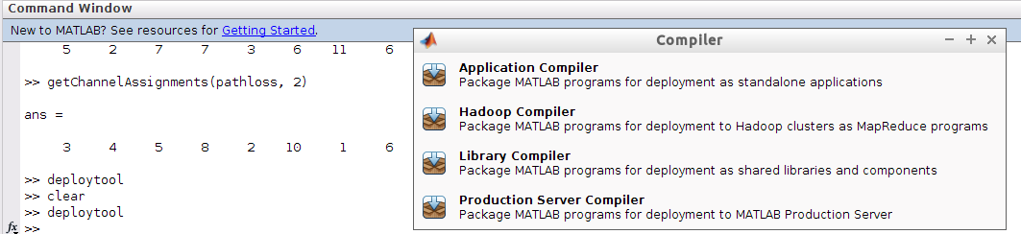
2. In the compiler window, select Java Package as Type.

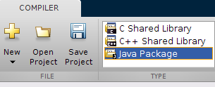

3. Click the plus sign next to the Exported Functions section, and select the file getChannelAssignments.m

4. Fill in the Library Information as you see fit. In this section, the most importance part is the Class Name. This will be the name of the class that needs to be instantiated in Java code. Change the default value of “Class1” to a more suitable name, e.g. Wi5.

5. Save the project.

6. Click the Package button to create the jar file.

7. Go to the folder “for_redistribution_files_only” in the output file and copy the generated jar file in order to deploy on another computer.

On the computer that is to run the generated Jar archieve:

1. Download and install Matlab Compiler Runtime (MCR) from https://www.mathworks.com/products/compiler/mcr.html
Make sure to select the version corresponding to the Matlab version used for generating the jar file. This document assumes that the MCR is installed to location $MCR. You can set an environment variable named $MCR for your system, or replace $MCR with the exact path to the installation in the following steps.

2. Copy the following jar file into your project and add it to the build path where XX should be replaced with the MCR version.
$MCR/MATLAB_Runtime/vXX/toolbox/javabuilder/jar/javabuilder.jar

3. Copy the jar file generated previously into the project and add it to the build path.
4. The following directories should be added to the LD_LIBRARY_PATH.

$MCR/MATLAB_Runtime/vXX/runtime/glnxa64:$MCR/MATLAB_Runtime/vXX/bin/glnxa64:$MCR/MATLAB_Runtime/vXX/sys/os/glnxa64:$MCR/MATLAB_Runtime/vXX/sys/opengl/lib/glnxa64

IMPORTANT: We have observed system errors when LD_LIBRARY_PATH is modified permanently (by modifying /etc/ld.so.conf.d/ or by other means).
Therefore, we modify it within the terminal that is to run the odin controller with the following command:
export LD_LIBRARY_PATH=$LD_LIBRARY_PATH:$MCR/MATLAB_Runtime/vXX/runtime/glnxa64:$MCR/MATLAB_Runtime/vXX/bin/glnxa64:$MCR/MATLAB_Runtime/vXX/sys/os/glnxa64:$MCR/MATLAB_Runtime/vXX/sys/opengl/lib/glnxa64
It is adequate to run this command once, just before odin controller is started. For subsequent runs, you do not need to run the command again.

5. For the use of the library, you can take a look at the sample java file provided.

