

LoRa Fabian Shield user guide

Table of Contents
Development environment : 2
Project location : 2
Compilation : 2
Flashing 3
Traces 6
Debugging 7

Development environment :

The OS used to develop this software is Linux. We recommend Ubuntu or other Debian based Linux systems.

There is no support for Windows or Mac OSX for the moment.

Project location :

Get a copy of the project :

git clone https://github.com/Wi6labs/lorafabian.git

Compilation :

LoRa Fabian shield code is based on contiki OS:
https://github.com/contiki-os/contiki/wiki#Using

The processors used on the shield is a STM32F103. This is based on ARM cortex M3. We are using a free compilation tool-chain to generate code for it. Here is the version we are using:
https://launchpad.net/gcc-arm-embedded/+milestone/4.8-2013-q4-major

But there is updated version and it should work (not tested) :
https://launchpad.net/gcc-arm-embedded/+download

Install the tool chain :
$ tar Linux_file_name.tar.bz2
$ sudo mv Linux_file_name /opt/ARM
$ echo "PATH=$PATH:/opt/ARM/bin" >> ~/.bashrc
$ source ~/.bashrc

It is also possible to install the tool chain with your packet manager (the version will depend of your Linux release):
sudo apt-get install dh-autoreconf libusb-1.0-0-dev libncurses5-dev libc6-dev-i386 gcc-arm-none-eabi
Once you get the code and the tool chain you can compile the projects. They are located under directory:
contiki/examples/lorafabian/

There are several projects you can test:
hello_world/ is a simple example writing a debug trace and blinking leds every second .
radio_test_clear_channel/ is an example testing the availability of the radio channel.
radio_test_rx/ set a continuous rx and output any received message with meta data on the trace interface.
radio_test_tx/ send a TX message every 5 seconds.
arduino_appli/ is the application to handle SPI commands from the Arduino. It configures the Radio in RX mode by default and switch to TX when requested then get back to RX.

To compile an example, just go inside the example directory and run make command.
If the build succeeds a .bin file is generated in the example directory.

Flashing

The tool for flashing is included inside the project under:
contiki/tools/stlink

Compile it with the following commands:
$ ./autogen.sh
$ ./configure
$ make

Then install it:
$ sudo make install

Warning: to flash the shield, it must be powered. The easiest way to do it is to plug it on an Arduino board.
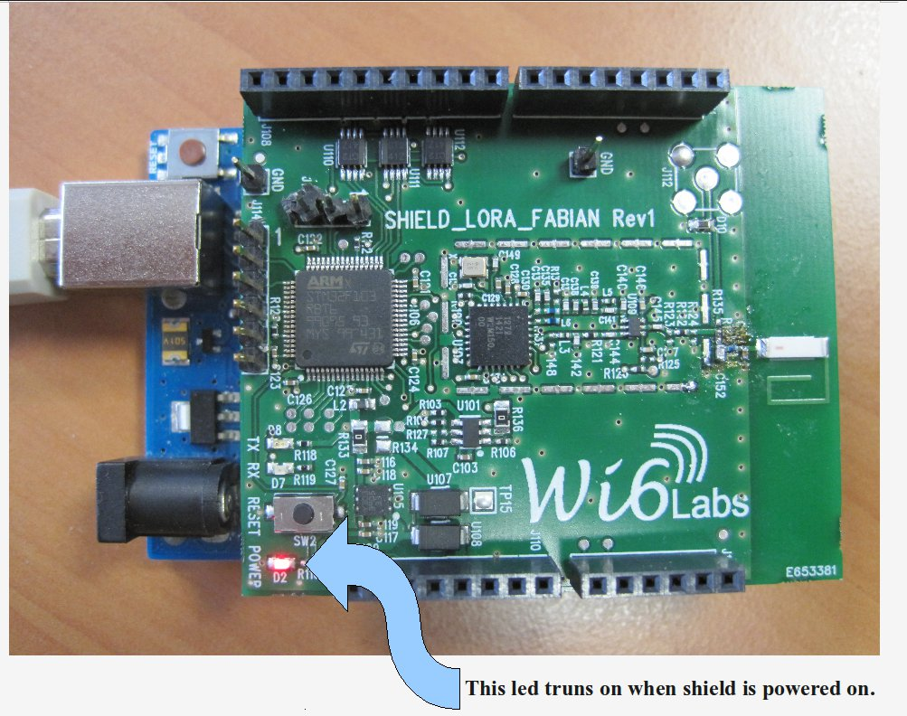

Connect the debugger board to the shield:
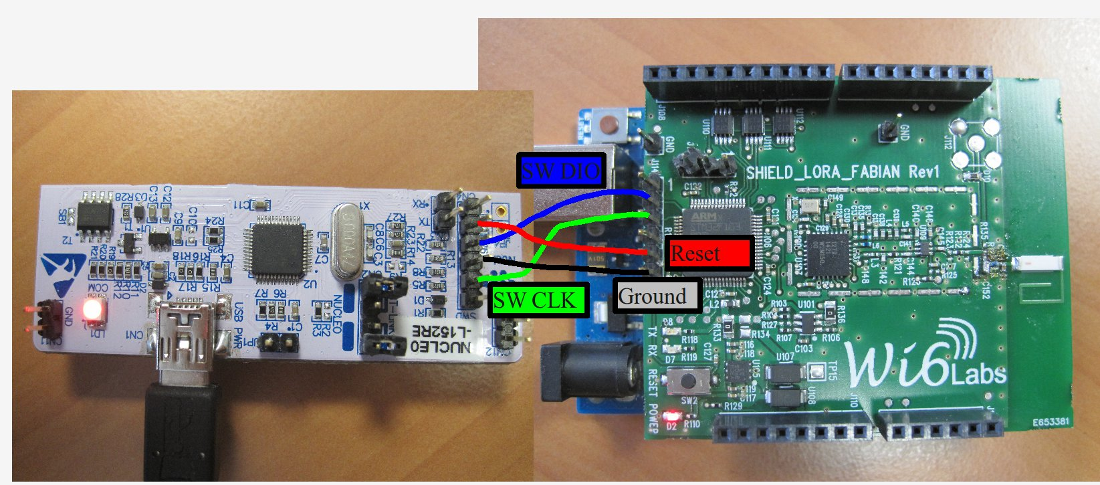
Note: If you plan to flash several boards, we advise you to build a dedicated connector.

Run the flash command inside the example directory :
$ st-flash write Generated_binary_file_name.bin 0x8000000

If the flashing proceeds correctly you should see a sequence of messages looking like that:
2014-09-26T15:46:10 INFO src/stlink-usb.c: Reseting STLINK
2014-09-26T15:46:10 INFO src/stlink-common.c: Loading device parameters....
2014-09-26T15:46:10 INFO src/stlink-common.c: Device connected is: F1 Medium-density device, id 0x20036410
2014-09-26T15:46:10 INFO src/stlink-common.c: SRAM size: 0x5000 bytes (20 KiB), Flash: 0x20000 bytes (128 KiB) in pages of 1024 bytes
2014-09-26T15:46:10 INFO src/stlink-common.c: Attempting to write 23868 (0x5d3c) bytes to stm32 address: 134217728 (0x8000000)
Flash page at addr: 0x08005c00 erased
2014-09-26T15:46:10 INFO src/stlink-common.c: Finished erasing 24 pages of 1024 (0x400) bytes
2014-09-26T15:46:10 INFO src/stlink-common.c: Starting Flash write for VL/F0 core id
2014-09-26T15:46:10 INFO src/stlink-common.c: Successfully loaded flash loader in sram
23/23 pages written
2014-09-26T15:46:12 INFO src/stlink-common.c: Starting verification of write complete
2014-09-26T15:46:12 INFO src/stlink-common.c: Flash written and verified! jolly good!

Note: As the debugger is mbed (http://mbed.org/) compliant, when you plug it to your PC, it will connect as a “USB mass storage” device. That's why a file browser is usually automatically launched.
This can cause conflict with st-flash utility.
If you have problems while using st-flash, you can try this command. It will ignore the device when connected.
modprobe -r usb-storage && modprobe usb-storage quirks=483:374b:i

The effect of the command will only be available during a session. For a definitive solution add "options usb-storage quirks=483:374b:i" to /etc/modprobe.conf

Traces

STM32 micro controller outputs traces ( printf() ) on an UART of the shields. And the debug board is able to act as an UART logger. Here is how to connect to get traces:
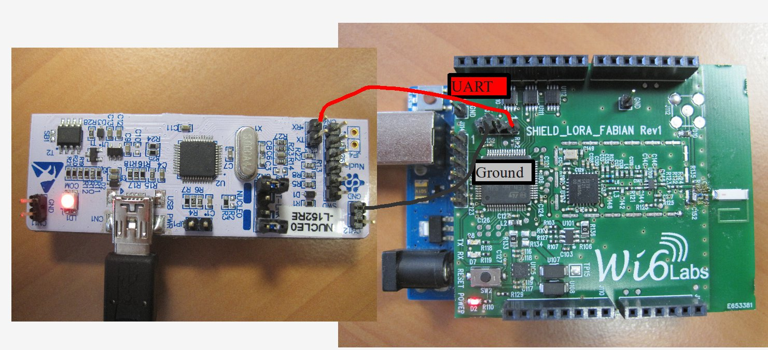

When connected to the linux PC, the debugger is automatically mounted as a ttyACM interface. Use the command dmesg to know which one has been mounted when you just connected the debugger.

Here is an example of dmesg output:
[ 3065.631734] usb 1-1.1.3: Product: STM32 STLink
[ 3065.631738] usb 1-1.1.3: Manufacturer: STMicroelectronics
[ 3065.631743] usb 1-1.1.3: SerialNumber: 0675FF534951775087211425
[ 3065.683592] cdc_acm 1-1.1.3:1.2: This device cannot do calls on its own. It is not a modem.
[ 3065.683635] cdc_acm 1-1.1.3:1.2: ttyACM1: USB ACM device
[ 3065.761997] Initializing USB Mass Storage driver...
[ 3065.762275] usb-storage 1-1.1.3:1.1: device ignored
[ 3065.762358] usbcore: registered new interface driver usb-storage
[ 3065.762361] USB Mass Storage support registered.

To display traces you can use a logger software like putty (http://www.putty.org/). To install it on linux, run:
$ sudo apt-get install putty

Important: As putty access HW peripherals of your system it must be run with root privileges.

UART speed : 115200 bauds
Here is an example of putty configuration:
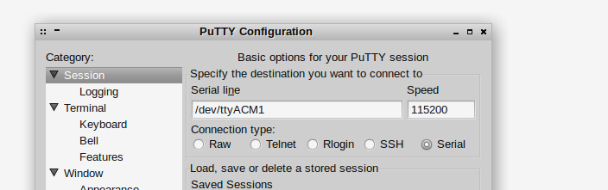

Debugging

For debug use the same connection as for flashing.
The debugger we use is ddd.
$ sudo apt-get install ddd
Then you have to open two terminals. In the first one run st-util. This software has be installed at the same time than st-flash:
$ st-util
Terminal output should be like that
2014-09-30T17:19:24 INFO src/stlink-usb.c: Reseting STLINK
2014-09-30T17:19:24 INFO src/stlink-common.c: Loading device parameters....
2014-09-30T17:19:24 INFO src/stlink-common.c: Device connected is: F1 Medium-density device, id 0x20036410
2014-09-30T17:19:24 INFO src/stlink-common.c: SRAM size: 0x5000 bytes (20 KiB), Flash: 0x20000 bytes (128 KiB) in pages of 1024 bytes
Chip ID is 00000410, Core ID is 1ba01477.
Target voltage is 3244 mV.
Listening at *:4242...

In the second terminal you must move inside your example directory and run st_debbug.sh:
contiki/examples/lorafabian/hello_world$ ./st_debbug.sh

ddd will normaly launch and you can start debugging.

Enjoy!

